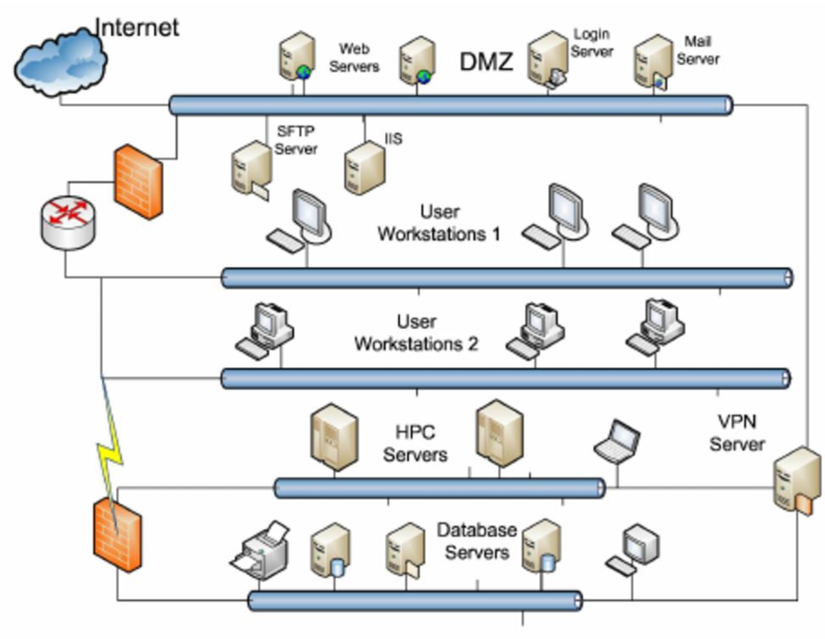
Background
The diagram above shows a small enterprise network. The network includes five subnets:
1 - DMZ (Demilitarized Zone) that hosts 75 publicly accessible servers
2 - two internal subnets used for 1000 user workstations
3- a high-performance computing servers subnet consisting of 10 servers
4. – a database servers subnet consisting of 50 servers and other related devices
The organization was issued a block of 6 IP addresses. The general firewall configuration allows the Internet to visit the servers in DMZ through the respective ports. Some of the hosts in the two workstation subnets can reach the database servers and the HPC servers.
Provide the following information:
- The IP address of 147.129.25.10 is associated with what part of the diagram?
User Workstations 1 part of the diagram.
- What class is this address and what is the default subnet mask for this class?
The above IP address belong IPv4 IP address class B.
The default subnet mask for class B is 255.255.0.0.
- Create a network IP range for each of the 5 subnets and justify your answer.
Given the IP address 147.129.25.10 is part of the network, and there are 1135 hosts in the network, the network IP address will be 147.129.24.0/21. Applying the concepts of CIDR and VLSM in the creations of the subnets to maximize use of IP address space and leave space for expansion of the network, one will follow below steps.
Step 1: Come up with a list of possible subnets.
- DMZ need 75 IP addresses
- User Workstations 1 need 500 hosts IP addresses
- User Workstations 2 need 500 hosts IP addresses
- Database server need 50 hosts IP addresses
- HPC servers need 10 hosts IP addresses
Step 2: Sort the subnets in descending order
- User Workstations 1 need 500 hosts IP addresses
- User Workstations 2 need 500 hosts IP addresses
- DMZ need 75 IP addresses
- Database server need 50 hosts IP addresses
- HPC servers need 10 hosts IP addresses
Step 3: Allocating IP addresses to the subnets starting with the largest subnets, followed by second largest, then third largest and ending with the smallest subnet. Below is the allocation.
Subnet Name | Needed Size | Allocated Size | Address | Mask | Dec Mask | Assignable Range | Broadcast
User Workstations 1 | 500 | 510 | 147.129.24.0 | /23 | 255.255.254.0 | 147.129.24.1 - 147.129.25.254 | 147.129.25.255
User Workstations 2 | 500 | 510 | 147.129.26.0 | /23 | 255.255.254.0 | 147.129.26.1 - 147.129.27.254 | 147.129.27.255
DMZ | 75 | 126 | 147.129.28.0 | /25 | 255.255.255.128 | 147.129.28.1 - 147.129.28.126 | 147.129.28.127
Database Servers | 50 | 62 | 147.129.28.128 | /26 | 255.255.255.192 | 147.129.28.129 - 147.129.28.190 | 147.129.28.191
HPC Servers | 10 | 14 | 147.129.28.192 | /28 | 255.255.255.240 | 147.129.28.193 - 147.129.28.206 | 147.129.28.207

- The total number of hosts is around five hundreds. If you were creating a custom subnet mask for the two host networks, what subnet mask would you use and why?
255.255.255.0 as we need 8 hosts bits since we want an address space of 250 host IP addresses and 8 host bits can accommodate a maximum of 2⁸-2 (254) hosts and thus it is enough for the needs of each of the two subnets as each of them has 250 (500/2) hosts.
- What is the purpose of the DMZ?
To offer an additional layer of security to the organization’s secure internal LAN by hosting all the devices that will be access by persons outside the organization’s Local Area Network at a separate intranet.
- Why is there a firewall and router between the DMZ and the two internal subnets used for user workstations?
The firewall is for filtering traffic to allow only a fraction of traffic that originate from the DMZ segment and not from the external internet and thus prevent compromise of the protected network in case of the DMZ get compromised.
The router is for hiding the internal LAN from the internet and the less secure DMZ LAN. The router is for connecting the internal LAN to the DMZ LAN (which has been configured as an external LAN) and to keep the internal LAN hidden from the DMZ LAN and the internet (Rouse, Irei, & Scarpati, 2018).
- Can someone accessing the webservers in the DMZ access the database server subnet? Explain your answer.
No. The Web Servers is in the DMZ LAN while Database Server is in the internal LAN and thus DMZ and Database server are in different and clearly separated LANs.
- Can traffic from the HPC servers access the database servers? Explain your answer.
Yes. The two subnets are in the same LAN and behind the same firewall.
- Why is the VPN server not in the DMZ?
To offer maximum security to the users’ data by having a complete tunnel from the VPN client installed in the user’s device to VPN server that is in the internal LAN and thus offer end-to-end data encryption for the data that originate from the internal LAN as ending the tunnel at the DMZ will expose data to higher risk of unauthorized access as anyone can access data that is at the DMZ (Ibe, 1999).
- Which of the servers or client machines would be a target of attackers? Explain your answer.
The servers that are in the DMZ LAN since it will be easy to compromise the servers that are in the DMZ LAN as they are protected by less security controls and more, they can be used as a stepping-stone for the attacker who intend to gain access to the internal LAN that is behind the router and the firewall (Clemmer, Dalton, Rogers, & Polsuns, 2003). For example, in our network set up, an attacker might target the web server that is in the DMZ LAN so as to access the internal LAN’s database server.

References
Clemmer, J. J., Dalton, M., Rogers, R., & Polsuns, J. (2003). SSCP Systems Security Certified Practitioner Study Guide and DVD Training System. Rockland, MA: Syngress.
Ibe, O. C. (1999). Firewalls and Virtual Private Networks. In O. C. Ibe, Remote Access Network Networks and Services: The Internet Companion (pp. 185-207). New York: Wiley. Retrieved from https://www.wiley.com/legacy/compbooks/press/0471348201_09.pdf
Rouse, M., Irei, A., & Scarpati, J. (2018, December). Router. Retrieved January 21, 2019, from TechTarget: https://searchnetworking.techtarget.com/definition/router

