Covid-19 Research Project
Student’s Name
Course Department, Institution
Course Code, Course Name
Instructor’s Name
Date

Contents
Abstract 3
1.0 Introduction 3
2.0 Data Set 4
3.0 Methodology 6
4.0 Analysis 6
5.0 Results 6
6.0 Conclusion 12
7.0 References 14
Tables and Graphics 15

Abstract
Polynomial and Linear regression was used in investigating the outbreaks of Covid-19 in India and different states using the data presented in Kaggle and hawkleraning data. The polynomial regression model of different states in India was estimated up to 23rd October 2020. The model is used in predicting the number of patients in different states of India. Based on the analysis conducted, Maharashtra, Gujrat, Delhi and Tamil Nadu will remain the most states affected in India.

1.0 Introduction
Covid-19 was transmitted to humans after originating from bats. Since the outbreak of the virus, there have been above o.5 deaths across the globe and above 2 million confirmed cases. In India, there have been 34 968 deaths and 1583792 confirmed cases by 23rd October 2020. Machine learning helps to learn without programming them. Machine learning is based on unsupervised and supervised learning. In supervised learning, the data is analyzed by input and output relationship (Chaurasia & Pal, 2020). Techniques of autoregression, the model of SEIR, and the seasoned periodic regression model are applied in predicting the outbreak of the virus. Suspected-infected-recovered-dead (SIRD) model is used to estimate the parameters of the virus such as morality, recovery and infection rates. Important tools for analyzing real-time data involve statistical models. The paper aims at using liner and polynomial regression models using recovered, confirmed and death cases in India, helping to predict the expected number of deaths and cases in the future. Polynomial regression is used in estimating the time and cases of Covid1-19 in India. The prediction made in the paper are of high-quality deviating from the tends of the coming days due to changes in the pattern of the virus.

2.0 Data Set
The data were obtained from official websites provided by the lecturer on Covid-19 cases. The linear regression model was applied in estimating the case fatality rate and recovery rate using the data up to 23rd October 2020. The cumulative number of confirmed cases were considered as predictable variables such as deaths and recovery were used to measure the outcomes. The day the first case was spotted in India was used as the beginning point in the linear regression model reducing the influence of case fatality rate and recovery rate. The coefficient determination of R2 was used in evaluating and determining the best analysis model. In India, initially, covid-19 was controlled through the lockdown. The analysis has involved cases in different states of India in terms of recovered, death and confirmed cases. To estimate the case fatality rate and recovery rate, the slope of the fitted line was put into use. A confidence interval of 95% was used in calculating the standard error of the slop as the polynomial regression model was used in forecasting the number of patients expected in future days. The least-square polynomial was determined for each state in India and the results presented using statistical analysis.
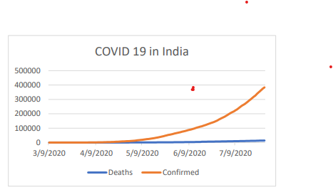
Figure 1: Recovered and Confirmed Cases of Covid-19 in India.
The Data Set of different states of India were obtained from Kaggle Websites (Arora, Kumar & Panigrahi, 2020). The numbers of cases in Kerala are less as compared to other states like Tamil Nadu.
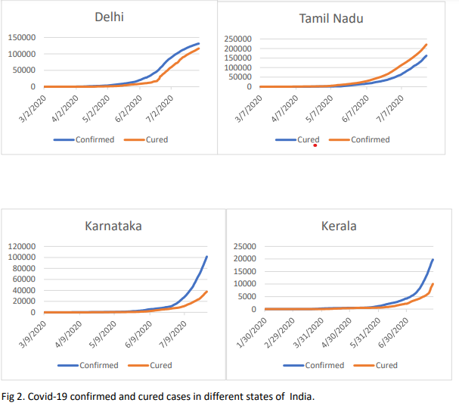
Analysis of linear regression and polynomial regression was modeled using software of MATLAB. The effects of the virus were also analyzed. A link between the variable was modeled using the analysis of the regression. The variables that were considered were mortality and confirmed cases.

3.0 Methodology
The method used in collecting data was a review of already online existing data presented by the professor. The data was obtained from different platforms. After accessing the data, linear regression was used to analyze the data because the study aims to predict the future spread of the virus in India (Pandey, et al., 2020). The variables used included case fatal rates, recovery rate and confirmed cases in India.

4.0 Analysis
The effects of Covi-19 in different states of India were analyzed using regression analysis such as polynomial and linear. The results were different due to the different sets of data considered. The analysis was done while considering recovered and confirmed cases. The analysis of the data showed that mortality and confirmed cases will increase in the future as the speared in the community has commenced. Maharashtra state was confirmed to have the highest confirmed cases, 441228 and 15576 deaths. 158764 cases and 1474 deaths were confirmed in Andhra Pradesh. Uttar Pradesh has 92921 cases and deaths of 1730. 75516 cases and 1678 were recorded in West Bengal (Raji & GR, 2020). Madhya Pradesh confirmed 886 deaths and 33535 cases. Mizoram and Lakshadweep were unique by recording a zero mortality rate as of the 3rd of August. Almost all the states of India were affected by the virus and provided with access to quality healthcare.

5.0 Results
The results from the data showed that the rate of increase of covid-19 cases in India is increasing. The results for linear regression are presented in the figures below. From the linear results, it clear that Karnata almost matched the set of expected data as other states had a slight deviation (CKER & GAIHA, 2020). In the initial stages of the virus, the states made efforts of controlling the virus by taking people to quarantine. But the numbers of cases were still increasing. The mortality rate of states of Kerala was less as compared to other states based on the presented data. This was due to the tracing contacts mechanism that was initiated by the state.
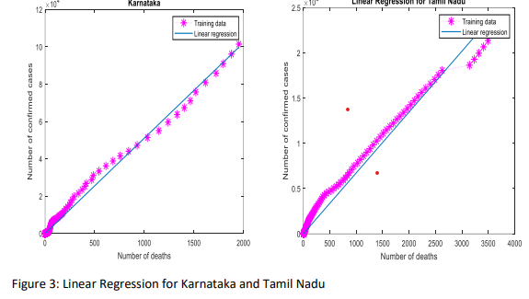
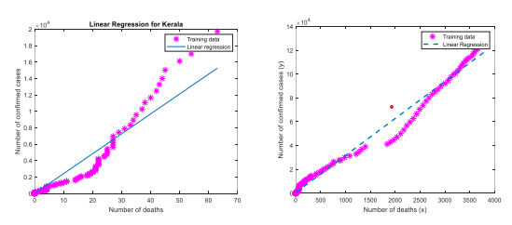
Figure 4: Linear regression Fit for Kerala and Delhi
For the above 12 000 cases in Karnataka, 2000 deaths were confirmed. More cases were confirmed in Tamil Nadu as compared to other states. Delhi and Tamil Nadu have almost the same mortality rate though the number of cases is different. The number of covid-19 cases was 134818 and 2496 deaths in Karnataka as of 3rd August 2020. In Delhi, there were 4000 deaths and 137676 cases. Tamil Nadu registered 257613 cases and 4133 deaths as Kerala had only 82 deaths and 25911 cases. The hugest number of cases and the mortality rate were registered in Maharashtra. The results obtained were important in keeping track of the future of the spread of the virus in India. The analysis of polynomial regression was done by considering the first case which was reported on 30th Jan 202. The rise in cases was considered as from March as in February only three cases had been reported. As a function of the number of days, the number of confirmed cases was considered helping in coming up with the polynomial regression graphs. The best fit of the data of India was estimated considering the least square third-degree polynomial with R2 being 0.999. The model was then tested and validated using root mean square error. This helped in predicting the number of Covid-19 cases in the future. Since the polynomial analysis was also done, the results were as shown below for different states in India:
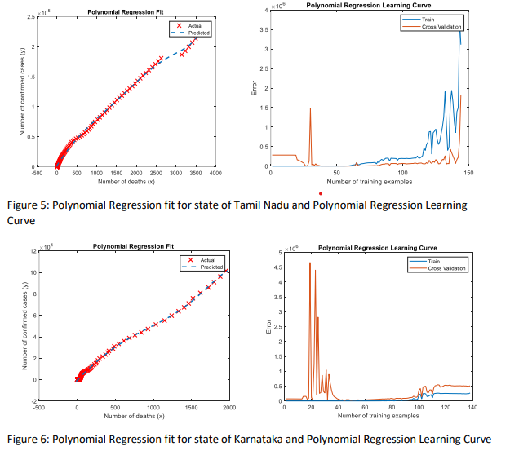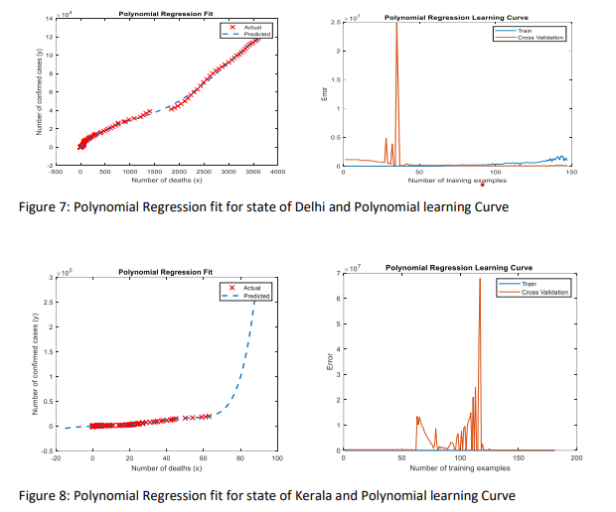
Polynomial regression was done while making use of the Kaggle dataset. The results obtained almost matched the polynomial graphs for different states in India. This showed the results were accurate and can be used in determining the nature of the virus in India.
The regression table for the results is:
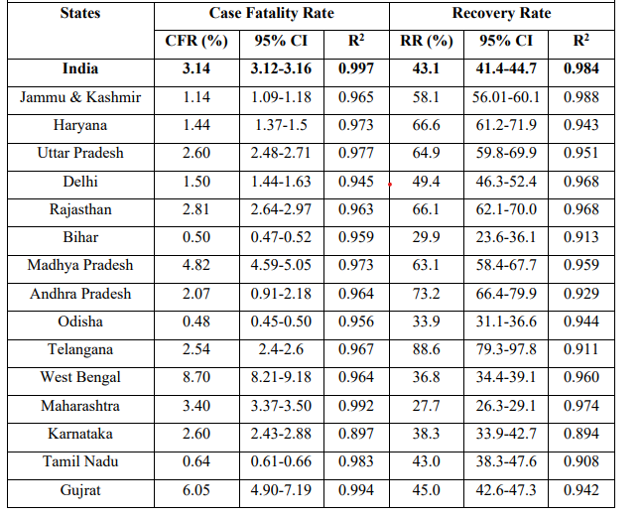
Table 1: Regression table for Covid-19 Cases in the Indian States
The number of recovered or death cases as a function of total cases for different states of India are as shown in table 2. R2 showed the confirmed cases against recovered cases for different states. Varying from 0.897 to 0.994.

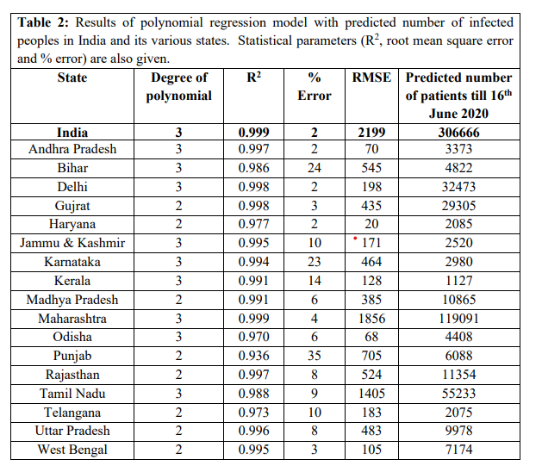

6.0 Conclusion
Regression analysis was performed to investigate the outbreak of covid-19 in India and its states. A linear regression model was applied to help in estimating recovery and case fatality rates in India and its different states using data up to 23rd October 2020. The case fatality rate was estimated to be 3.24% having a confidence interval of 95% The reconvey rate was 43.1% with a confidence of 95%. The case fatality rate of West Bengal was higher than the national rate whereas the recovery rate of Telangana was the highest (Srivastava, et al., 2020). The polynomial regression model was applied in predicting the numbers of cases in the future which was validated with the test of calculating statical and percentage error. The predicted number of patients in India is to increase. Based on the analysis of the polynomial regression, Maharashtra, Gujrat, Delhi and Tamil Nadu will continue to be the most affected states in India.

7.0 References
Arora, P., Kumar, H., & Panigrahi, B. K. (2020). Prediction and analysis of COVID-19 positive cases using deep learning models: A descriptive case study of India. Chaos, Solitons & Fractals, 139, 110017. Retrieved from: https://www.kaggle.com/datasets
Chaurasia, V., & Pal, S. (2020). Application of machine learning time series analysis for prediction COVID-19 pandemic. Research on Biomedical Engineering, 1-13.
CKER, N. K., & GAIHA, R. (2020). The severity of the Covid-19 Pandemic in India The Case of 3 States: Maharashtra, Jharkhand & Meghalaya. Retrieved from: https://www.dataquest.io/blog/free-datasets-for-projects/
Pandey, G., Chaudhary, P., Gupta, R., & Pal, S. (2020). SEIR and Regression Model-based COVID-19 outbreak predictions in India. arXiv preprint arXiv:2004.00958.
Raji, P., & GR, D. L. (2020). Covid Pandemic Analysis using Regression. medRxiv.
Srivastava, A., Tamrakar, V., Moradhvaj, M., Akhtar, S. N., Kumar, K., Saini, T. C., ... & Saikia, N. (2020). Geographical Variation in COVID-19 Cases, Prevalence, Recovery and Fatality Rate by Phase of National Lockdown in India, March 14-May 29, 2020. medRxiv. Retrieved from: https://www.hawkslearning.com/statistics/dis/dataset/html

Tables and Graphics
- Tables
Table 1: Regression table for Covid-19 Cases in the Indian States

- Figures
Figure 1: Recovered and Confirmed Cases of Covid-19 in India.

Figure 4: Linear regression Fit for Kerala and Delhi

