Statistics and EV
Name of student
Institutional affiliation
Date

Question one: Decision tree
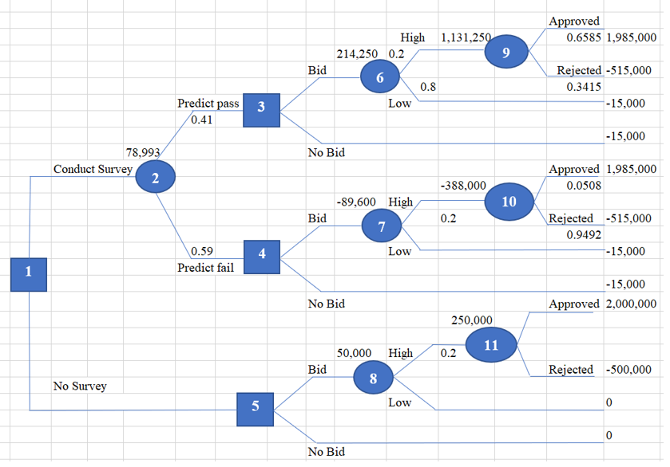
2.Calculate the value of payoff for each outcome
EV at node 9 (approved)= total revenue -total cost - Survey cost
= (15000000-130000) = 15000 = 1985000
EV at node 9 (rejected) = - (survey cost + deposite during bid * (10% of $5M)
= ((5000000*0.1) + 15000))
= -(500000 + 15000) = -$515000
EV at node 6 = Survey cost
=-$15000
EV at node 3 = Survey cost
=-$15000
EV at node 10 (approved) = Total revenue-total cost)- Survey cost
= (15000000-130000) – 15000
=2000000-15000 = $1985000
EV at node 10 (rejected) = deposite during bid * (10% of $5M) +survey cost)
= -((5000000 * 0.10) + 15000
= -(500000+15000)
=-$515000
EV at node 7 = Survey cost
=-$15000
EV at node 4 = Survey cost
=-$15000
EV at node 11 (approved) = Total revenue – total cost
=15000000-130000
=$2000000
EV at node 11 (rejected) = Deposite during bid * (10% of $5M)
=-(5000000*0.10)
=-$500000
EV at node 8 = Low bid (No cost or revenue involved
=$0
EV at node 5 = Low bid (No cost or revenue involved
=$0
Question two: Unavailable market information
The unavailability of market research information to ODC is denoted by node 5. Without a bid being placed at the node, then the company wouldn’t get any cost or revenue. The company’s payoff in the case would be zero ($0). If we submit a bid of $5M. it was estimated that a 20% chance is available for the bid to be accepted. With the acceptance of the bid, it is estimated that a chance of 30% occurs to effect the change of the zoning and allow building of condos. With the change of the zoning failing to be passed, then it’s assumed a deposit of $500k will be forfeited and purchase of the property will complete.
The expected values will be calculated as follows:
EV (11) = 0.3 ($2000000) + 0.7 (-$500000)
=$250000
EV (8) = 0.2 ($250, 000) + 0.8 (0)
= $50000
Since we have a positive expected value for bid placing, we can therefore implement this strategy. However, the possibility of deposit loss with the changing zone not being approved does not get approved by voters.
3. A decision strategy that Berthoud should follow
Assuming the $5M is submitted, we estimate a 20% probability of acceptance of the bid. With the bid being accepted, it is estimated that we shall have a 30% probability for changing of zoning to allow the condos to be built. With the changing of the zoning not being passed, it is assumed that they will forfeit a deposit amount of $500k and the purchase of the property will complete.
4. A recommendation as to whether Berthoud should employ EMRC
Because the value of placing a bid is going to be positive, as expected, we can implement the strategy. However, there is a probability of deposit loss if the zoning change does not get approved by the voters as shown below
The expected values will be calculated as follows:
EV (11) = 0.3 ($2000000) + 0.7 (-$500000)
=$250000
EV (8) = 0.2 ($250, 000) + 0.8 (0)
= $50000

