Statistics Assessment
a) 2017 Boxplot
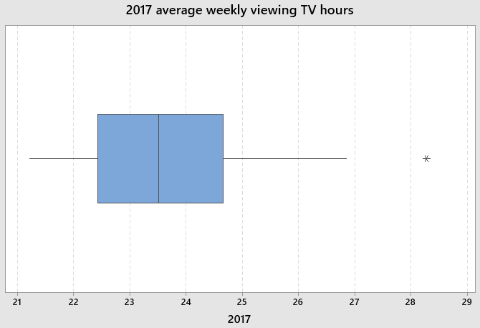
2018 Boxplot
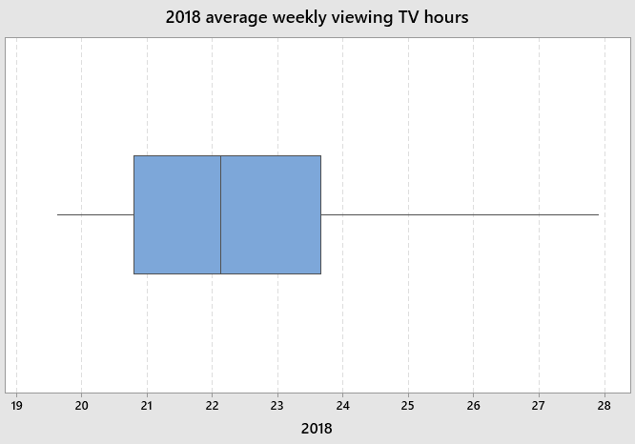
b) 2018 boxplot is right skewed because the right whisker is large
c) The median of viewing hours in 2017 and 2018 are very close to each other but the range is much higher for weekly viewing in 2018 than in 2017. The interquartile range is more spread for 2018 than in 2017. In 2017, an outlier value occurs approximately at 28th week which is denoted by an asterisk as it out of the bounds of the whisker. On the other hand, we do not observe any outlier values for weekly TV viewing hours in 2018.

Q2
f_{i} = Number of households
x_{i} = Number of cars or vans
Σf_{i}x_{i} = (1634 x 0) + (2801 x 1) + (2411 x 2)
Σf_{i}x_{i} = 7623
Σf_{i} = 6846
Mean = $\frac{Σf_{i}x_{i}}{Σf_{i}}$
Mean = $\frac{7623}{6846}$
Mean = 1.11
σ² = $\frac{Σf_{i}x_{i}^{2}}{Σf_{i}}$ – ($\frac{Σf_{i}x_{i}}{Σf_{i}}$)²
$Σf_{i}x_{i}^{2}$ = (1634 x 0) + (2801 x 1) + (2411 x 4) = 12445
($\frac{Σf_{i}x_{i}}{Σf_{i}}$)² = 1.2321
σ² = 1.8178– 1.2321
σ = 0.765

Q3
a) Real earnings of November 2018 = $\frac{176.8}{107.0}$ x 100%
Real earnings of November 2018 = 165.23
Real earnings of November 2019 = $\frac{183.9}{108.5}$ x 100%
Real earnings of November 2019 = 169.49
Percentage = $\frac{169.49}{165.23}$ x 100%
Percentage = 102.6%
Percentage change = 102.6 -100
Percentage change = 2.6 %
The percentage change shows that real earnings increase by 2.6 % from November 2018 to November 2019.
Real earnings of December 2018 = $\frac{177.2}{107.1}$ x 100%
Real earnings of December 2018 = 165.45
Real earnings of December 2019 = $\frac{183.5}{108.5}$ x 100%
Real earnings of December 2019 = 169.12
Percentage = $\frac{169.12}{165.45}$ x 100%
Percentage = 102.2%
Percentage change = 102.2 -100
Percentage change = 2.2 %
The percentage change shows that real earnings increase by 2.2 % from December 2018 to December 2019.

Q5
a) Median Position = $\frac{36+71+30+121+23+1}{2}$
Median Position = 141
At 141st position, the median response is going to be 4

b) The population median is 4. If we have a larger sample size, the closer the sample median is going to be to population median. Therefore, Sample 1 corresponds to Figure B as proportion is highest at median response 4. Alternatively, with a small sample size the values are going to be more spread out. Therefore Sample 2 corresponds to Figure C. Finally, Sample 3 is going to correspond to Figure A.

Q6
a) i) The relationship is positive as British pounds exchanged become higher as the number of claims for torn notes increase.
a) ii) The relationship is not linear as the graph does not resembles a straight line
a) iii) The relationship is weak because a points are scattered to a great extent
a) iv) Outliers are extreme values that can cause the data to be skewed. One of the outlier lies at 18 thousand and the other at 22 thousand claims because at both points their exchange values are not following a positive correlation

b) The regression equation is
y = 3.719 - 0.1013x

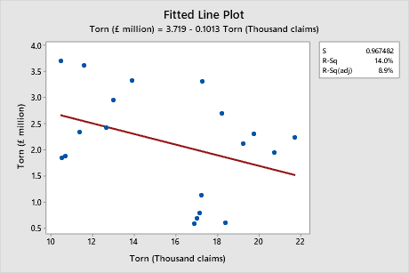
c) Residual plot
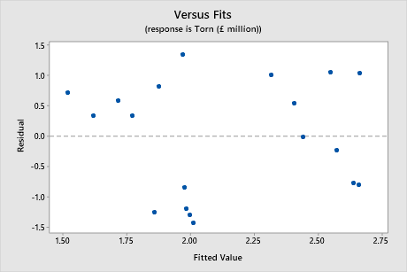
Residual = Observed value – Predicted value
A residual plot shows whether a linear regression analysis is appropriate if the majority of residual values are close to the horizontal axis. If the residual values are randomly scattered then a non-linear regression might be more appropriate.

d) Regression equation is
y = 3.719 - 0.1013x
When x = 12.5
y = 3.719 - 0.1013(12.5)
y = 2.453
The Bank of England would have to pay 2.453 million British pounds
e) No, it would not be appropriate to use regression equation for 4.9 thousand claims because the data that is used to create the model does not include any claim less than ten thousand

