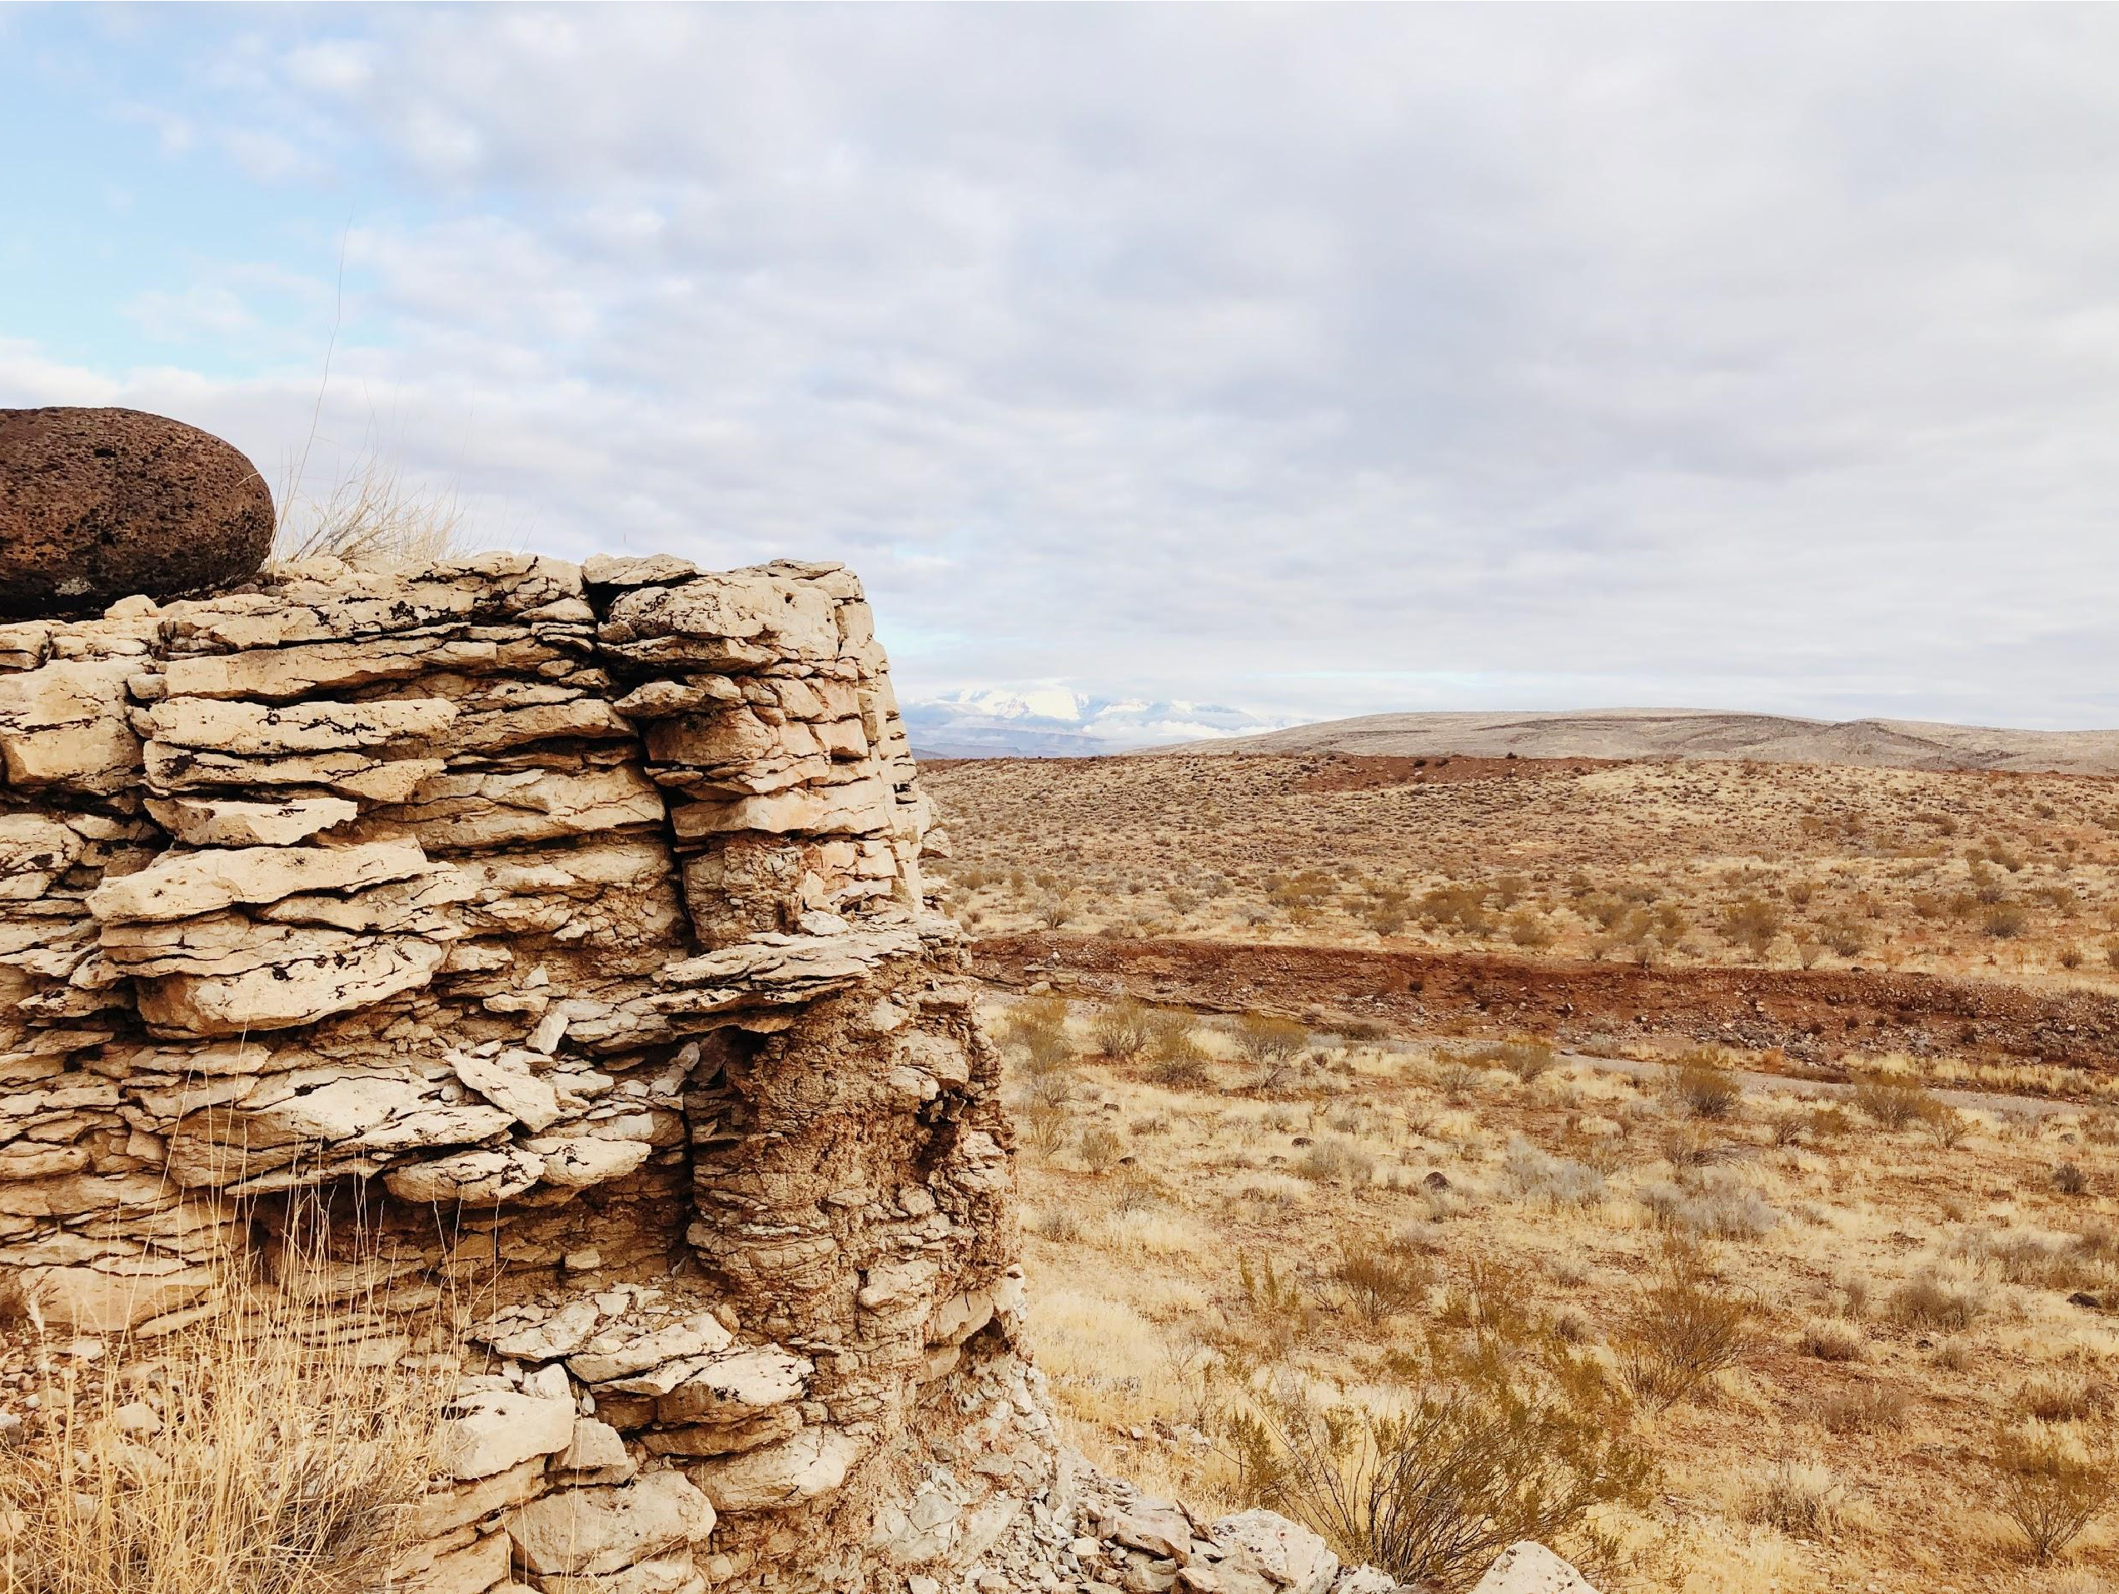



Michigan State University
Year Program
4-

NAHB 2020
Student Competition
Product Development




Alex Beem Danyel Zmudka Eric Fantry
The Team:
Bringing the best to your project with the experience, expertise and care in an
effort to exceed expectations.
WHO WILL?
SPARTANS WILL
.
SPARTAN BUILDING GROUP
Market Analysis
Land Development

Project Management Evan Harless | Sales and marketing Kyle Broccardo | Financials  Aundrea Cole
Developing with the Spartan Building Group is an exciting venture for not only our clients, but for our team. Understanding this is the purchase many people have dreamed and saved for, our group of experts are dedicated to not only satisfy, but exceed expectations. We work to build a collaborative cohesion between neighborhood and construction; to innovate design by taking the classic ideas from the area and blend it into new forms by creating comprehensive layouts, livable community space, and embrace the surrounding settings.
Quality, experience and excellence are the fundamentals we practice. From the foundation up, your home will be in the hands of the area’s top marketing managers, designers, construction and project management leaders, sales and marketing team, financial advisors, and green building fanatics. With our company’s most experienced and passionate individuals, we have comprised an investment opportunity that will highlight exciting financial benefits.


Table of Contents
Executive Summary.…………………………………………………... 4
1.0 Market Analysis...…………………………………………………. 5
2.0 Land Development………………………………………………... 12
3.0 Product Development…………………………………………….. 17
4.0 Sustainability………………………………………………………. 24
5.0 Project Management ……………………………………………... 26
6.0 Estimates and Schedule………………………………………..... 29
7.0 Financial and Risk Analysis…………………..………………….. 37
8.0 Sales and Marketing ……………………………………………... 47
3
Executive Summaries

Market Analysis
St. George, Utah has maintained a thriving housing market since the early 2000s. The area is renowned as one of the premium retirement locations in the country. A sunny and warm year round climate makes the area appealing for the active adult age group (55+) which is flocking to the area. Abundant outdoor activities, including nationally ranked golf courses, three of the most pristine national parks, gorgeous views, and reasonable drive times to cities such as Las Vegas, make the St. George experience incredibly entertaining. In addition, residents reap the benefits of a low cost of living which is a welcomed adjustment for consumers leaving Southern California, Seattle, WA, and Portland, OR. These areas are significantly more expensive than St. George. Terra Valley creating and economic gain for many incoming residents. Terra Valley is the ideal place for active adults seeking a quality home that allows them to age in place while. All while benefiting from high appreciation rates an providing endless entertainment in the beautiful desert mountains of Southern Utah.

Land Development
Located between Interstate 15 and N-7 (Southern Parkway), the site has limitless potential. The site is currently split zoned at R-1-10 and mining and grazing; Spartan Building Group will rezone the entire parcel to R-1-10, residential single family homes. Spartan Building Group’s main goal is to create a neighborhood centered around healthy and active living. Promoted by vast open space with winding walk paths and landscaped with native vegetation. Our lot sizes start at 9,900 sq. ft. to 12,000 sq. ft. Spartan Building Group has two premium categories based on lot size and location.

Product Development
The Terra Valley active adult community offers six distinct home models to choose from with multiple options for customizability based of the Desert Colors Community guidelines. Each home offers high quality standard features and amenities with the opportunity to upgrade to top of the line features. The models incorporate design solutions that cater to active adult residents, are universally designed, and incorporate sustainable practices.

Sustainability
Sustainability initiatives have been in place according to the ICC 700 National Green Building Standard which will encompass construction, land development, and product design.

Project Management
The Project management Team for Terra Valley will work closely with our partnered builders within the site to ensure that the highest quality and best cost products are brought to the market. Our Operations team will have 2 superintendents, one vertical and one horizontal, to deal with the day to day operations and one project manager to focus on the big picture. Through Four Phases, and an average duration of 454 Days, we will be able complete the project in 5 years.

Estimates and Schedules
Spartan Building Group has set our schedule to complete the project in 5 years. This is achieved through efficient scheduling, placing larger crew sizes, and utilizing our trade bases in the area to push the project to completion.

Financials and Risk Analysis
Spartan Building Group is proud to display 5 cost flow scenarios based on shifts in both market demand and economic shifting that may occur during the 5 years of the project. These Scenarios display internal Rates of return varying from 3.1% to 21.4%. Our risks have been identified and we have taken steps to mitigate this risks outlined in the subsequent sections of this chapter.

Sales and Marketing
Within our Sales and Marketing we envision capturing the 55+ marketing through strategic online marketing, an efficient sales force, and both national and local media outlets to garner attention from buyers. Our goal is to maximize our budget to assist in the sale of homes and produce cash flow.
4

1.1 Competitive Market Area
The proposed site, located in St. George, Utah (Census tract 2717.02) as shown in Figure 1.1 is indicated by the red triangle. Our competitive market analysis (CMA) is based on the average drive times from competing communities to the center of St. George. The hub of most activities is the St. George city center, therefore it was chosen as the centerpoint of our CMA. The blue polygon represents an 11 minute drive while the orange polygon represents a 25 minute drive. Areas of Washington and Ivins are included in this radius, but the primary inclusion is the city of St. George.

1.1.1 Demographics
1.0
Market Analysis
Summary
Terra Valley at Desert Color on the outskirts of St. George, provides stunning views of mountains,
many close attractions and walkability while providing every resident a million dollar view. The Market
in St. George is thriving and is driven by out of state residents moving to the area seeking out better
weather, more space and the view.
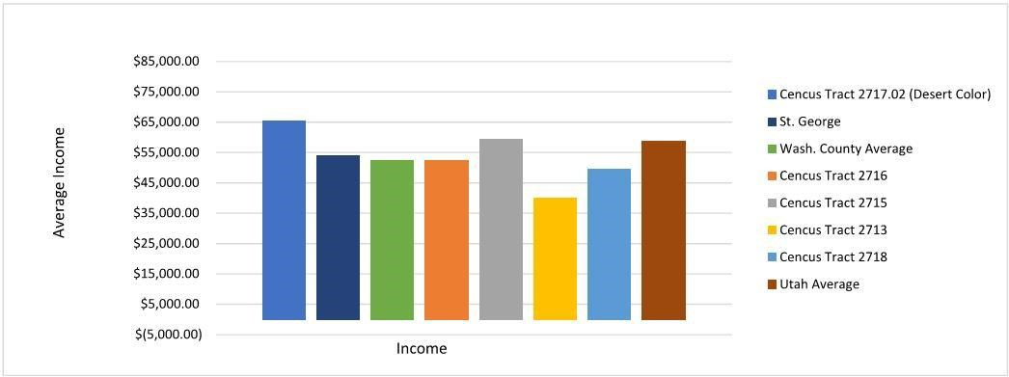
Demographics within the CMA are focused on census Tract 2717.02 where

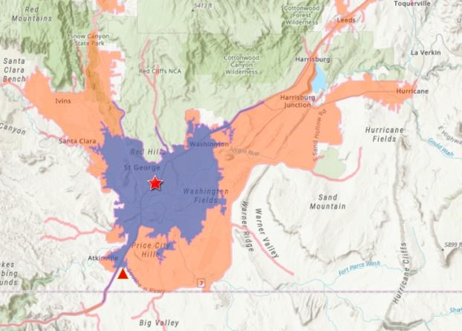

Figure 1.1- Competitive Market Area

our site is located. As seen in Figure 1.2, the income distribution of our census tract is higher than the surrounding areas and the national average. We attribute this to out of state buyers from Southern California, Seattle, WA, Portland, OR, and Las Vegas, NV. In addition, retirees from affluent areas of Northern Utah, like the suburbs of Salt Lake City and Ogden, increase the income distribution as well. We have seen that these buyers typically
sell their current homes and retire in the Figure 1.2 - Income Data
community, or they buy a second home and only live in the area a few months out of the year, commonly referred to as “Snow Birds”.

Figure 1.3 - Population Data
Population trends acquired from the United States census bureau, indicate a constant rate of growth from 2016 to 2020’s projections. In fact, St. George is the third fastest growing United States city. As seen in figure 1.3, the largest increases in population are experienced in the 49 and under age groups. As St. George grows increasingly faster there is an increase in the 55+ age groups. This is due to the desire for many 55+ adults to live near their children and grandchildren. Therefore, the accelerated increase in the younger demographics can be expected to impose an increase in the 55+ demographic as a correlated externality. Furthermore, nationally the 55+ age group is the fastest growing age bracket which is reflected in St. George’s growing population trends. New businesses in all industries, including outdoor activities, are providing more options for shopping, food, and entertainment. Also, they desire to live actively and participate in activities such as golf and hiking are fueling the demand for active adult communities. These consumer trends, in parallel with the amenities in St. George, are fueling the market for active adult communities in the area and make it one of the top areas to retire in. By providing unparalleled quality and value to its residents, Terra Valley will meet and exceed the demands of the active adult community flooding into St. George.
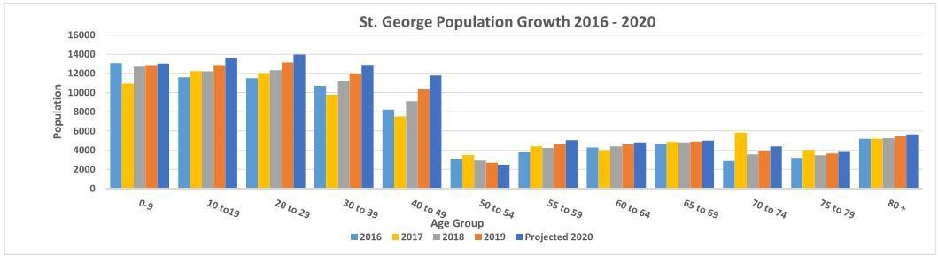
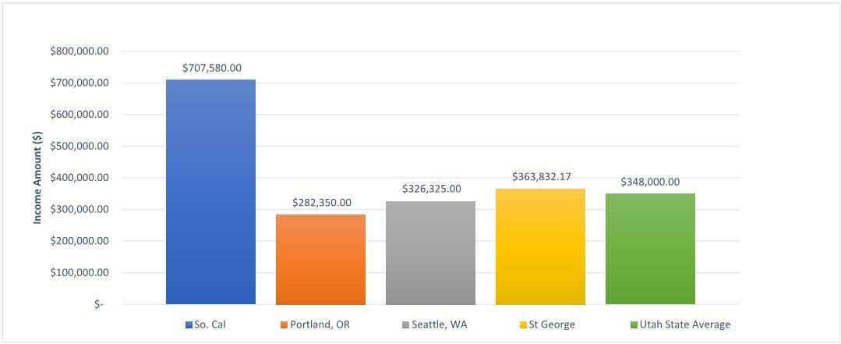
Due to the large quantity of customers moving mainly, but not restricted to, Southern California, Seattle, WA, Portland, OR, and Northern Utah, from the income analysis takes these areas economic trends into account. Many of the buyers coming from out of area sell their current residence and purchase a new
home in

Figure 1.4 - Target Demographic Property Value Comparison
St. George. A large majority of these out of state buyers are paying cash for homes in St. George. This is consequently due to the cost of living and housing prices in St. George being drastically lower than that in Southern California, Northern Utah, and many other states on the west coast. As shown in Figure 1.4, the average cost of a home in these areas
6
is approximately $549,000 which is 2.4 times higher than the national average, and 1.5 times higher than St. George. This creates a large margin of profit for potential residents when selling a home in these areas and purchasing one in the St. George average. The equity position from relocating and avoiding the high cost of living in these areas makes St. George the perfect place for retirement.
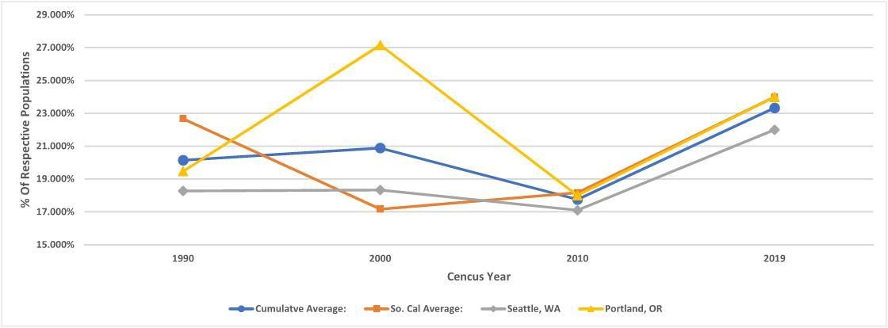

Figure 1.5 - 55+ Age Demographic Trends
Figure 1.5 represents the portion of the total population in the targeted out of state markets that are in the 55+ age demographic. Southern California, Seattle, WA, and Portland, OR have been identified as key out of state markets from which people are relocating to St. George. As indicated by the graph, our targeted age demographic has increased in these areas over the past decade. Consequently, these areas represent a growing population of potential relocations to our area.
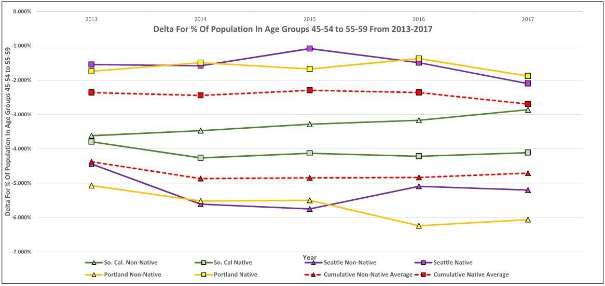

Figure 1.6 Delta From 45-54 and 55-59 Age Demographics
As indicated above, these out of state target areas are experiencing an increase in the 55+ demographic from out of state residents moving into the area. However, the trend for native born and non-native residents living in the area prior to turning 55 indicates a trend of moving out of state. These residents moving out of the target areas become our potential customers who are moving into the St. George area.
7

1.1.2 Attractions and Amenities
As seen in figure 1.7, the St. George area offers ample recreational activities for the active adult community. Buyers are eager to get out and enjoy the outdoor activities such as state and national parks, hiking trails, tennis, pickleball, and golf. This active lifestyle is widely advertised in the area, supported by many new businesses. St. George is also home to a renowned hospital in the region, Dixie Regional Medical Center, which offers state of the art cancer treatment, and is home to a wound and emergency center. Furthermore, the hospital provides top quality healthcare at rates 4% lower than the national average which is attractive when active adults are looking for a new home. The hospital recently completed a $300 million addition for pediatrics, hyperbaric medicine, wound care in patient neuro-speciality rehab, and in patient general neuro care.
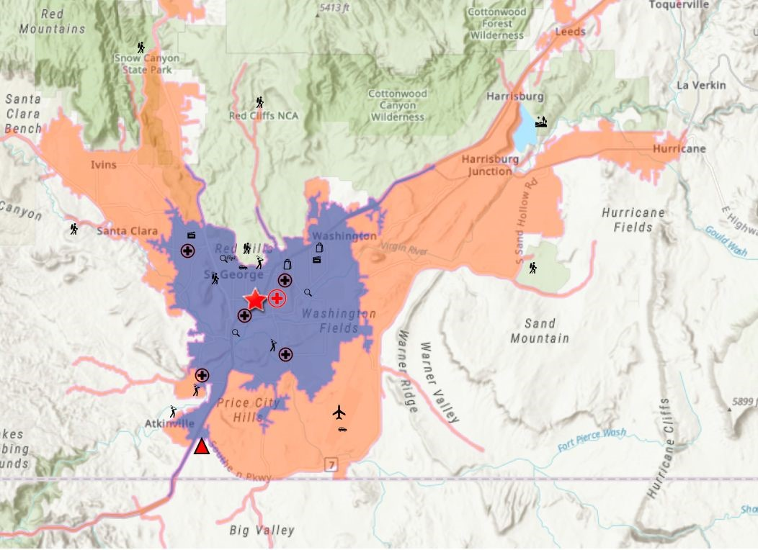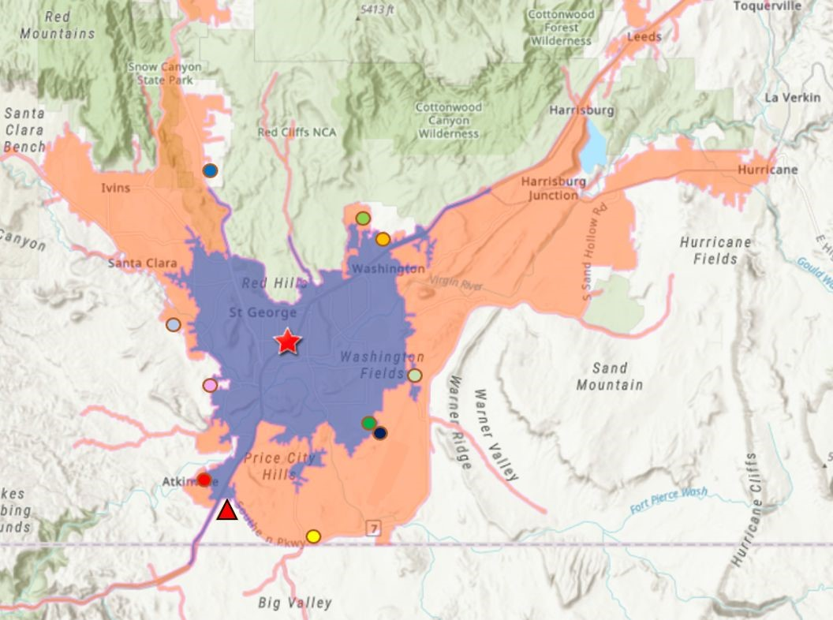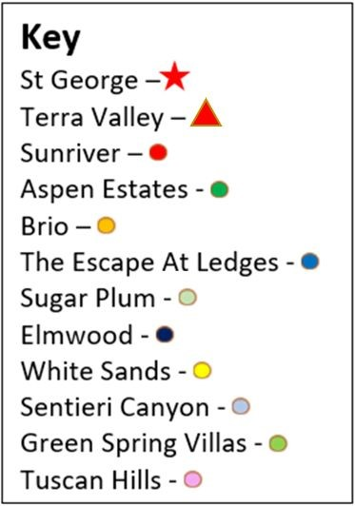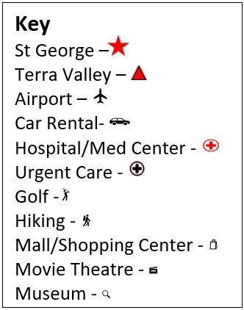

Figure 1.7 - Attractions and Amenities Figure 1.8 - Competitor Community Locations

1.2 Housing Market Data

1.2.1 - New Housing Supply
Terra Valley at Desert Color will be entering the market at the peak of demand. The Sunriver development, Terra Valley’s newest competitor, is currently selling the few remaining lots in the last phase of the development. This creates a unique opportunity to draw interest from buyers looking in the location without a neighboring competitor. Furthermore, it allows Terra Valley to capitalize on its superior quality and prices while its closest competitor has little ability to adjust their outputs. Other developments in the area include Brio, The Escape at the Ledges, and White Sands. These larger developments offer a variety of amenities with an HOA fee of only $100 per month, while keeping home prices at market value. However, the site plats often aim to maximize the coverage of the property without maintaining many of the natural features and topography that makes the area so unique. In contrast, Terra Valley capitalizes on the natural beauty of the desert and tailors the site design to maximize the residents’ enjoyment of the scenery.
8

1.2.2 New Housing Market Price Comparison
Figure 1.9 shows the comparable model home prices offered by competitors in the CMA. Through the study, it enabled us to set the base prices of our homes.
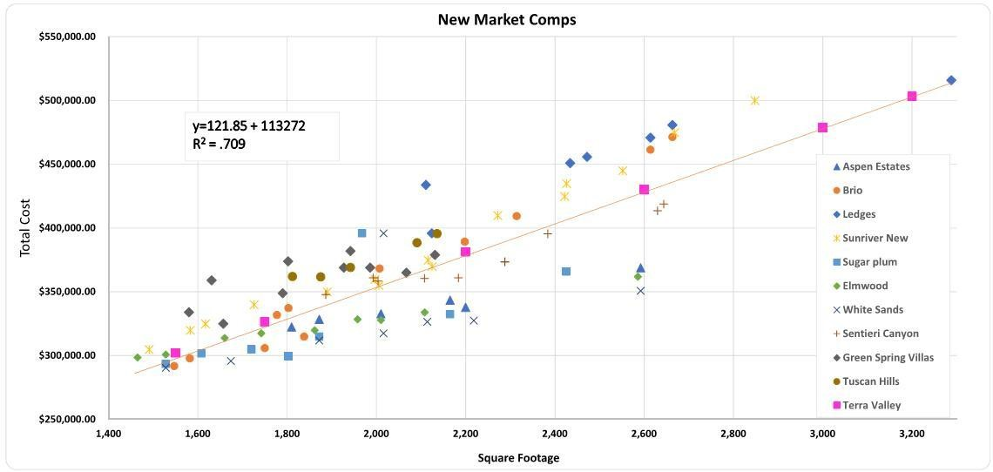

Figure 1.9 - New Home Price Analysis
As seen in figure 1.9, the competitors in the new home market are offering homes ranging from $290,000 to $520,000. Current competitors are in a race to the bottom pricewise which explains why the data is closely grouped in the lower left quadrant. Knowing this helped identify the areas where we have to compete, but also where there is a void in the market. It has been observed that the other developments do not provide larger semi custom homes. By talking with prospective residents and realtors in the area, we were informed that if 3000+ square foot home options were available, they would be preferable to the predominant style of home currently available on the market (1000-2500 SF). Additionally, the market indicates a lack of interest in home sizes 1800-2500 square foot. The regression line is based on the competitor home prices which helped establish the base cost for homes. The data is based on lot sizes ranging between 6,000 and 9,000 square feet.
When Comparing the existing market to new market we learned the quality of existing homes overall is not meeting the expectations of active adult buyers. There are some relatively new homes in the used market with improved quality, Sunriver being the closest and largest of these competitors. What Terra Valley at Desert Color has to offer is a higher quality and lower maintenance home providing greater value for the consumer. In addition, Terra Valley is family friendly and gives no restrictions to whom the residents can bring in and use the facilities with. This appeals to consumers because other active adult communities, such as Sunriver, have extreme restrictions on who can use their facilities and when. These restrictions deter active adults who seek the ability to actively engage with grandchildren and other family members doing activities like swimming at the community’s pool.
9

1.2.3 - Existing House Market Supply
Figure 1.10 shows our analysis of the existing house market across the area. We used these homes to understand the secondary market, the best ways to attract buyers, and to identify the current cost gap.
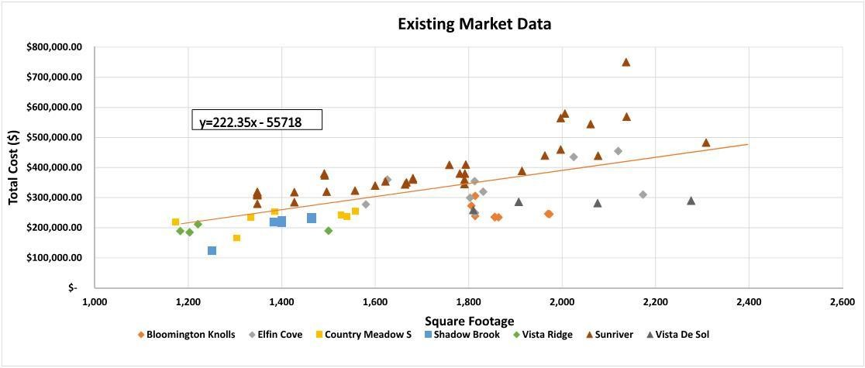

Figure 1.10 - Existing Market Price Comparison

1.2.4 Land Cost Evaluation
The estimated land value of the Terra Valley complex is roughly $14.3 million. Evaluating 80+ parcels of land around the St. George area, all five acres or larger, the Spartan Building Group compiled a land price comparison. By plotting averages against the sales price, a regression equations of Y = 98275X + 1E + 06, was created which allowed for an accurate price evaluation of the land. By entering the Terra Valley area of 130 acres the price of $108,893.22 per acre was calculated. This price is competitive with the dominant market trends. Due to the large size of the parcel and superb location, the price point of $110K per acre was decided on for Terra Valley. Translated into a cumulative price, the 130 acre parcel is valued at $14,300,00.00.
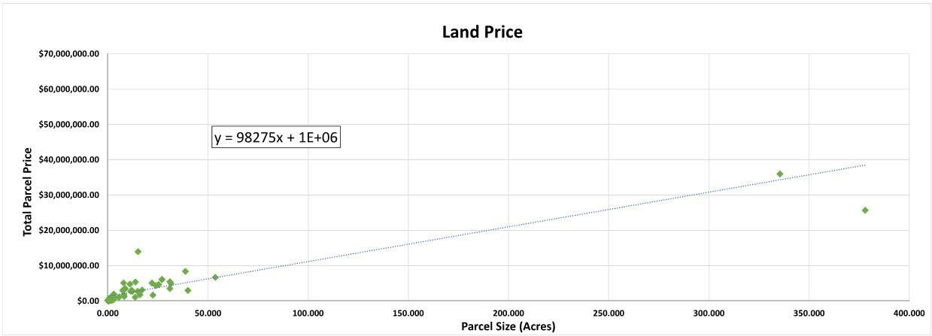

Figure 1.11 - Land Price Comparisons
10

1.2.5 - Market Demand
The housing supply market in St. George is currently experiencing heavy demand. A snapshot analysis of the active to sold listings in the area, in the price range of the different models Spartan Building Group will be offering, is seen in Figure 1.12. The baseline for a high demand market is a 6 month absorption rate, so the 2.6 month absorption, means that if home no new listings entered the market, there would be enough housing supply to last 2.6 months. Additionally, the area in which Terra Valley is to be built sits within the an area that touts the sixth highest appreciation rate in Southern Utah.
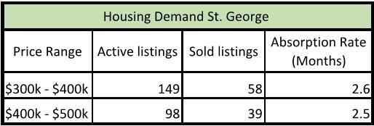
Of the residential new construction permits issued in St. George over the past seven years (approximately 2,400 per year), 80% (approximately 1,920) were issued for single family detached (SFD) homes (Figure 1.13). This not only supports the demand for this housing type in the area, but indicates
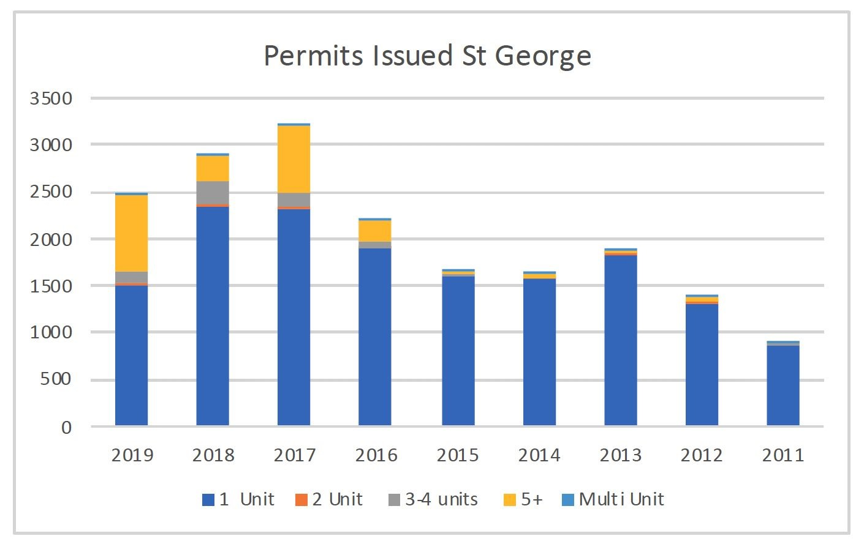
the strength of the new construction Figure 1.12 - Housing Demand Data market in St. George. New permits for SFD homes are expected to top 1,600 in 2019. We expect to capture a conservative 6% of the total new SFD market with Terra Valley, resulting in an assumed sales pace of 8 homes per month.
Figure 1.13 - Permit Data

1.3 Target Market Analysis
After a thorough analysis of the St. George Area, our key buyer market is the active adult community
(Ages 55+) , who are preparing to retire or retiring primarily from Northern Utah, Southern California, Seattle, WA, and Portland, OR. Terra Valley at Desert Color offers many of the locally desired amenities on site, and within a short drive that many buyers are looking for.
Median homes sales prices are growing at a steady rate of 3% from last year, and an expected growth of 4% within the next year. The proposed homes fall within the accepted values of home prices within the area, and have added appeal over our competition based on features we offer.
Based on the absorption rate, discussions with developers in the area, and the physical constraints placed on labor resources, 24 home sales per quarter is a feasible number. This represents 6% of the current market, which allows us to establish ourselves as a player, while surpassing any other communities on the basis of price, quality and location.
11

2.0 Land Development

Summary
This chapter covers evaluation of the site's potential, elaborating on site layout due to existing conditions, while setting conservation goals for our neighborhood. The priority within land development is to set the stage for the community that Spartan Building Group is aiming to create.

Overview
Inspired by the natural contour of Big Valley and the waterways it creates, Spartan Building Group designed a low impact development consisting of 368 lots to accommodate 18 variation of homes, featuring 12 foot wide cart paths and 6 ft. wide walking paths winding through the neighborhood.

2.1 Existing Conditions
The 130+/- acre site is located in the southwest corner of Utah, just east of Interstate 15; 7 miles from the center of St. George, Utah. The site is currently split zoned as R-1-10 and grazing and mining, Spartan Building Group will unify and rezone the parcel into R-1-10 to provide an active adult community within the larger Desert Color master plan. Figure 2.1 shows Big Valley vast desert-like landscape seen on the site. The site location creates a 360 degree view of the surrounding mountains.
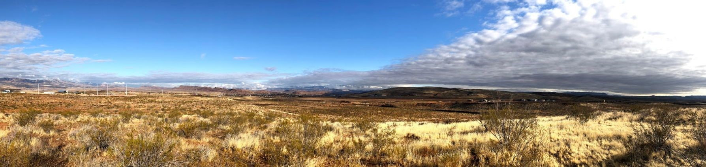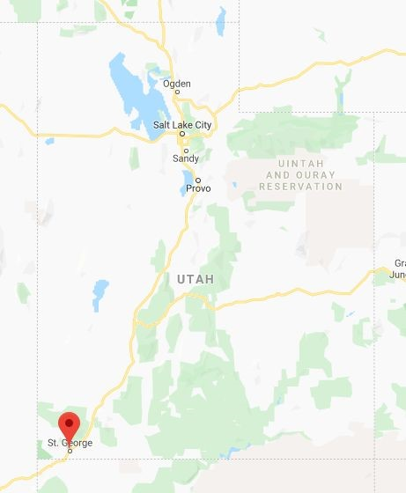Figure 2.2 - Location of St.
Figure 2.1 - Photo of development parcel in existing condition.
Spartan Building Group Design Goals
2.2
Spartan Building Group's primary goal is to create an active living adult

neighborhood within the Desert Color community that is centered

around healthy living and environmental stewardship. Our site design

draws from the natural contours of the landscape and natural plant life

to create wildlife habitats within the neighborhood. By allowing natural

barriers to guide our design, Spartan Building Group created a site plan

invites its residents to explore their surroundings while preserving

natural habitats and wash ways.

2.3
Terra Valley at Desert Color Goals
The site design for Terra Valley at Desert Color abides by the Desert

Color South Area Zoning Plan and Design guidelines. Spartan Building

Group's mission is to respect green lot design, preparation and

development. The site design intent is to avoid detrimental

environmental impacts, minimize any unavoidable impacts, and mitigate

any potential damages to the natural environment through enhancing

the natural features and environmental quality within our neighborhood.
George, Utah

2.4 Site Design
The proposed site contains 368 single-family lots ranging from 9,900 square foot to 12,000 square foot.
The site has 3 main entrances from the northwest, northeast and southeast adjacent neighborhoods.
Due to the blue clay deposits on this land, and the recommendations from the geotechnical survey, we opted to not place any lots on the predicted clay deposit locations and instead reserve this area for natural space. Creating a walking path 6 feet in width in the natural space will discourage golf carts but allow for walkers, joggers, bikers to pass with ease and enjoy nature.
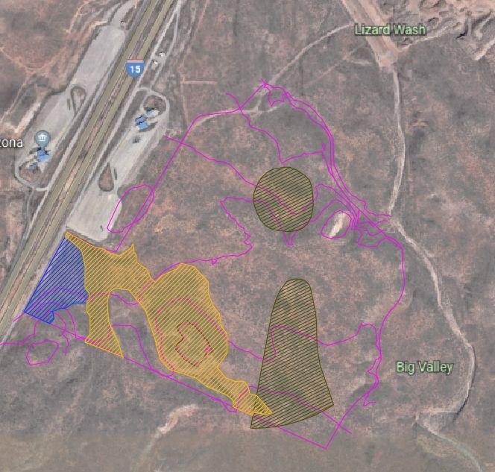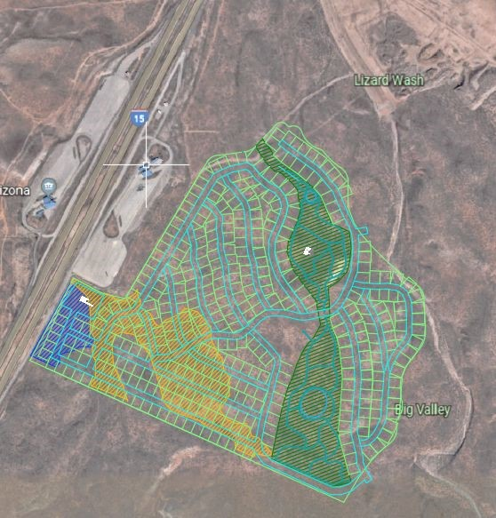
Figure 2.3: Overlay of clay deposit (brown), topography major lines (pink) and floodplain maps (blue - Zone A, yellow - category High).

2.5 Soil Erosion and Sediment Control
Erosion and sediment control practices were based on the Utah Department of Environmental Quality, through Construction Stormwater Permit from the Division of Water Quality. Efforts will be made to minimize clearing and disturbances, avoid erodible slopes and provide adequate controls to prevent sediment-laden runoff from the existing project development areas. Silt fencing along the perimeter of the property as well as sediment bags will be used for any down flow drains to prevent sediment runoff.

2.6 Floodplain and Floodway
The Utah Geological Survey Division flood hazard map shows only the southwest corner of the property lays within Zone A, requiring these residents to purchase flood insurance. Due to this we will provide upgrades worth $15,000 free to the homebuyer. At a cost to us of $9,900 per home for the 20 lots in Zone A.

2.7 Geotechnical Conservation
Soils on the site have been classified as alluvial sand, silt, and gravel that overlays bedrock varying from siltstone, shale, limestone, and claystone, as identified in the site geotechnical survey. Due to the nature of the various hard bedrock and the expansive claystone bedrock, the soil features are unfavorable for basements. Therefore our product design does not include basements; however the soil is suitable for slab on grade and foundation wall construction. Because of the presence of expansive clay (Figure 2.3) and alluvial souls on the site, we further evaluated site soils for their susceptibility and potential for expansion and/or collapse. Our team reviewed the “Expansive Soil and Rock Susceptibility Map for the St. George-Hurricane Metropolitan Area” map produced by the Utah Geological Survey.
13
The site is located in an area identified as having soils with a low susceptibility for volumetric change (Figure 2.4). This finding gives us more confidence that we will not encounter expansive soils outside of the blue clay areas identified in the geotechnical survey. However, our home estimates carry additional contingencies for constructing post-tensioned mat foundations if such soils are encountered during excavation (see Section 6.1.2 - Land Acquisition and Development Costs.)

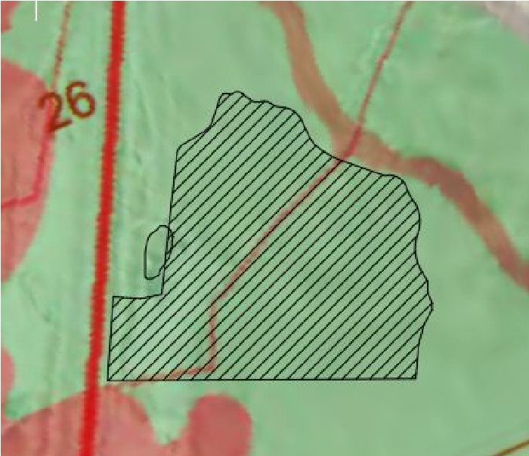
2.8 Open Space
The open space within our site includes the predicted expansive clay deposits throughout the site. Within these open spaces, the neighborhood includes open areas for recreation, social gatherings, and lounging. We will also feature a community center with a community pool with a club house, dog park, tennis and pickleball courts, gym, and outdoor gathering space.
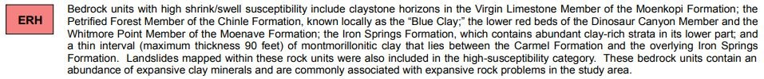

Figure 2.4 - Expansive soil and rock susceptibility map for St. George-Hurricane Metropolitan Area

2.9 Landscaping
The landscaping plan within Terra Valley at Desert Color is designed to limit water and energy used while preserving and enhancing the natural environment. A hydrozoning plan will be used to group plants with similar watering needs together to use water efficiently during all seasons. Throughout the open space will be native plantlife to create a “wildlife backyard” and natural habitats for the wildlife. Around the community center will be a intermediate of non native plants to create diversity in the plant life while also creating natural privacy for the pool area. Additionally, we will limit the use of grass and plants requiring irrigation. This is discussed further in section 5-Sustainability.
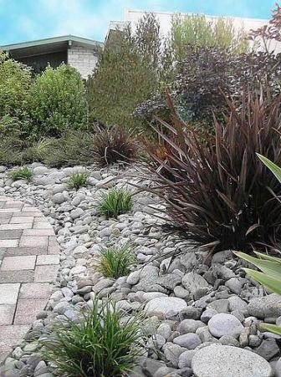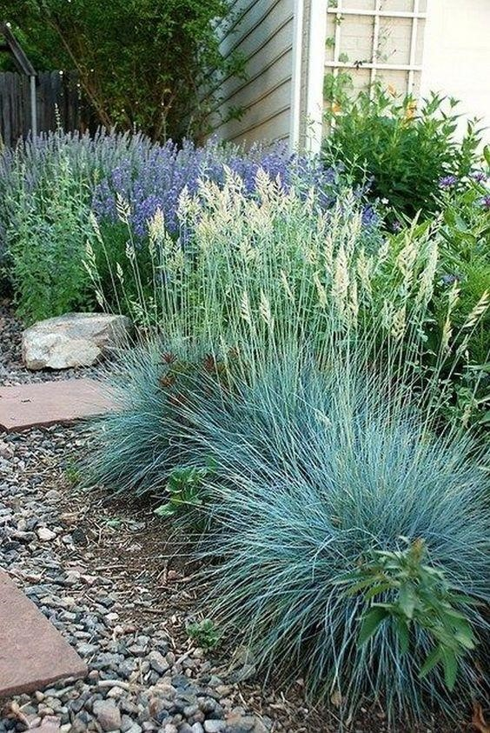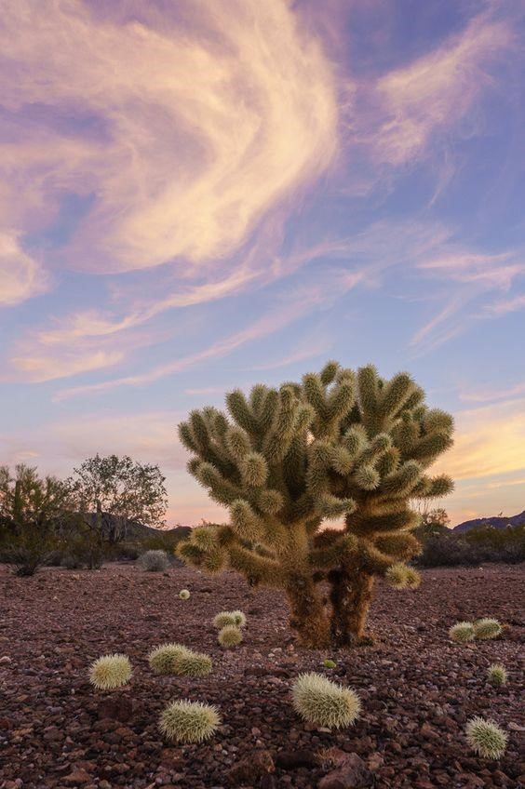
14

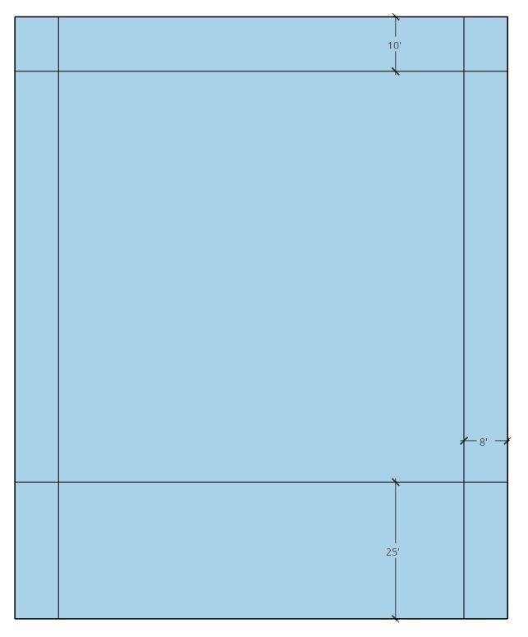
2.10 Zoning
Currently the site is zoned for mining and grazing or R-1-10, we will be unifying the zone to be entirely R-1-10 residential single family. The total buildable lot area is 104 acres. Within Terra Valley at Desert Color, the minimum lot width is ninety feet wide. Figure 2.5 demonstrates the minimum size based on R-1-10 restrictions. Measured in feet, the interior box portrays a home, with its surrounding yard. Figure 2.6 and below detail sidewalk and motor cart path below. The minimum lot area is .23 acres or .27 square feet.

2.11 Roadways
All roadways are designed in accordance to residential single-family
standards. The roadways for our site are designed to have a Figure 2.5 - lot restrictions curvilinear layout to maximize natural standards. The roadways for for zone R-1-10 our site are designed to have a curvilinear layout to maximize natural views, create privacy for homeowners, as well as create a safer neighborhood due to the lack of straightaways. We will have a speed limit of 25 mph throughout Terra Valley at Desert Color. The main roads also feature a 12 foot wide motor cart path on one site with a 5 foot wide walking path on the opposite side of the road to create safety for all modes and means of transportation. The overall goal of the roadways in the site is to emphasize the priority of safety and security for Spartan Building Group's communities, while promoting an active lifestyle.
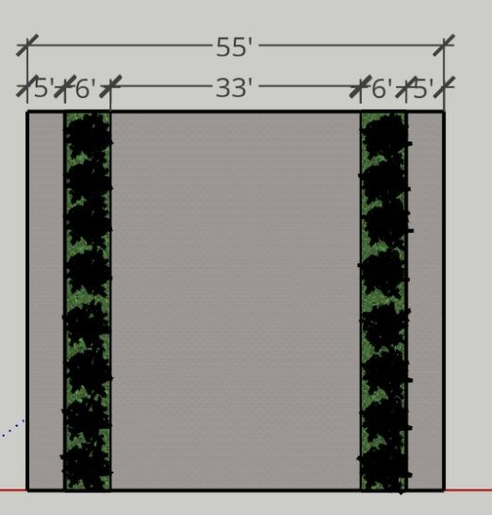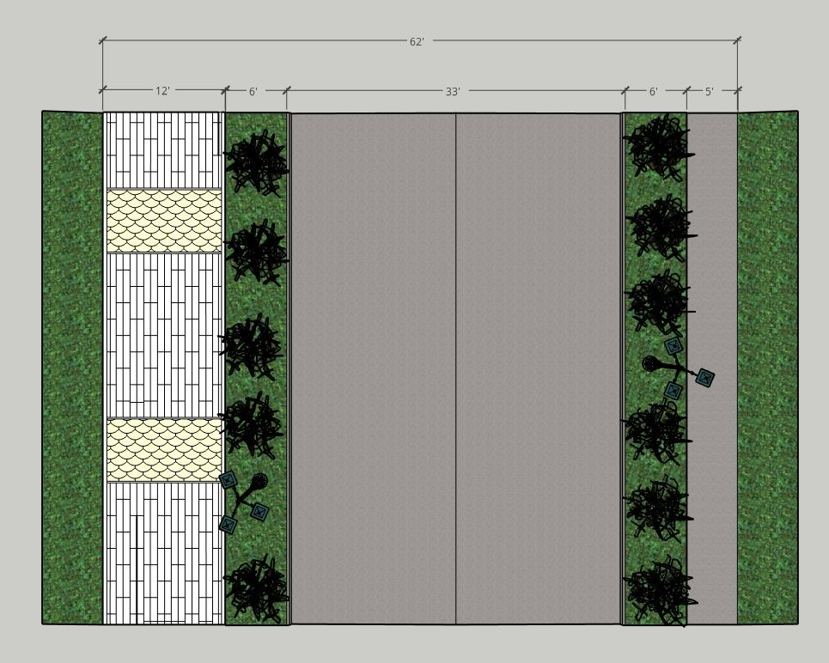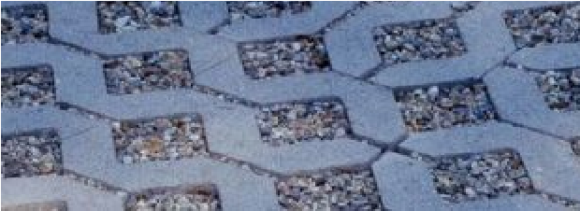
Figure 2.6 - Diagram of road design and permeable paver concept.
15

Land Development



2.12 Master Plan
16
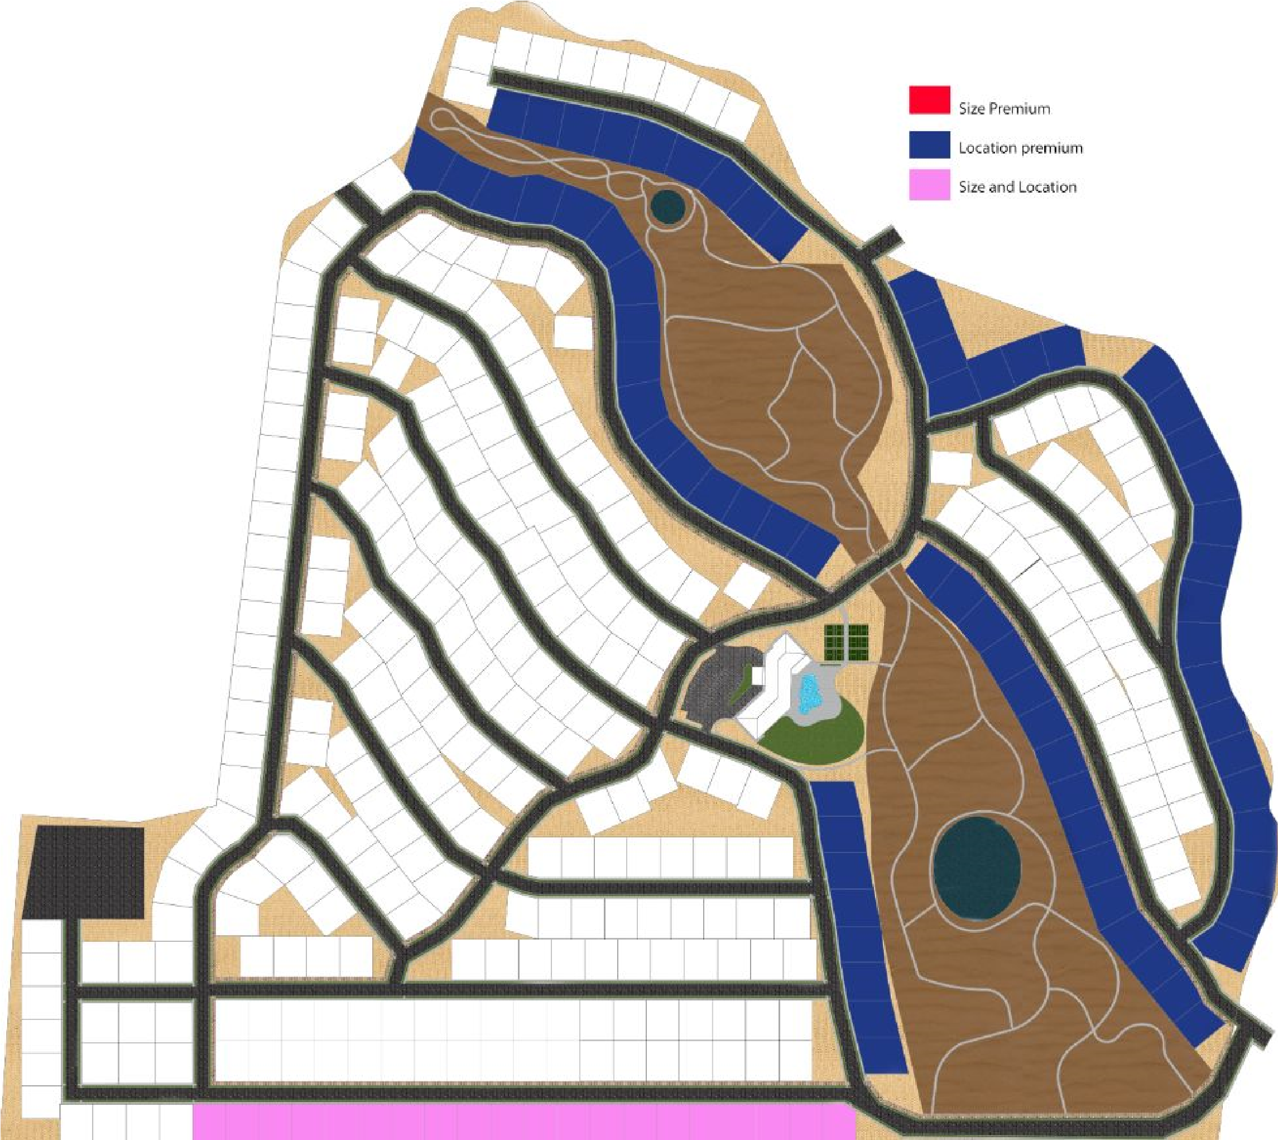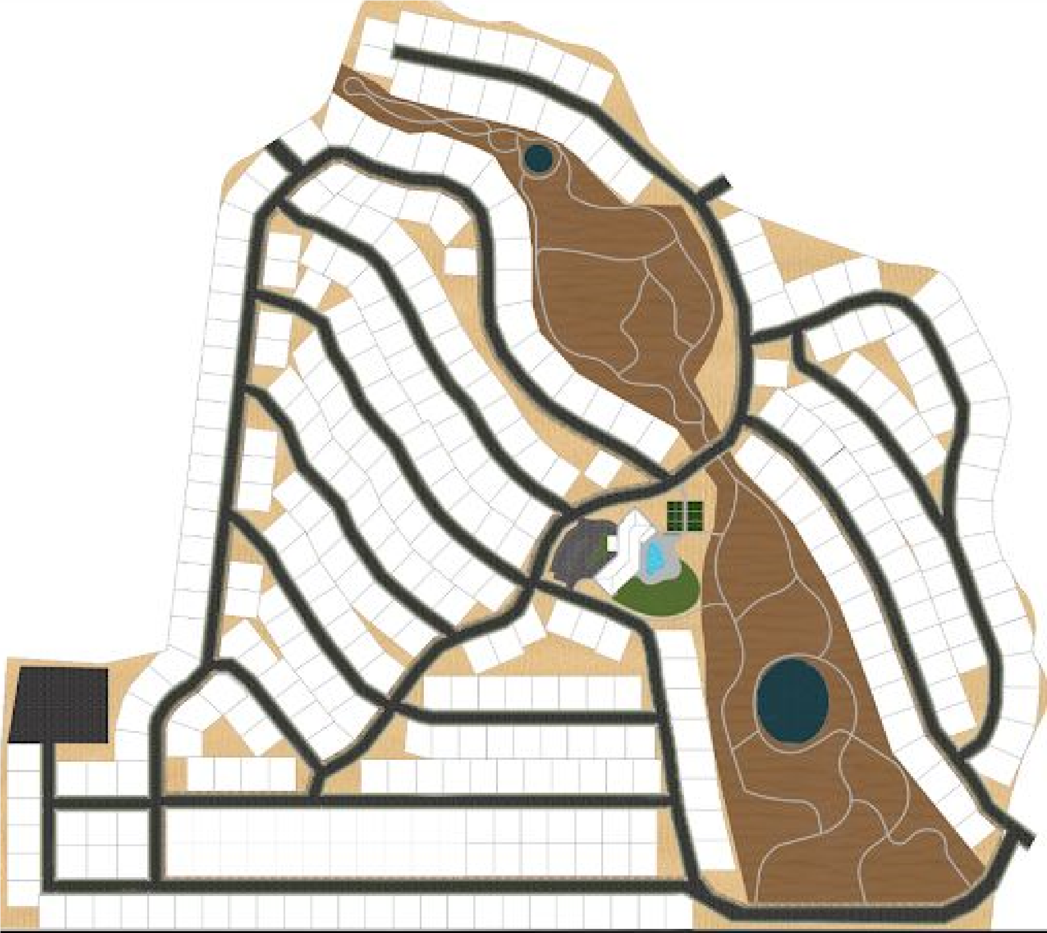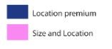
RV
Parking
RV
Parking
Retention
Pond
Retention
Pond
Community
Center
Figure 2.7 - Rendered Site Plan Figure - 2.8 - Premium Lot Identification
*All renderings were created by the Spartan Building Group *All renderings were created by the Spartan Building Group

3.0 Product Development

Summary
Terra Valley Homes are designed with quality and craftsmanship to ensure cohesiveness with the surrounding desert landscape and Desert Color community. The architecture and design of the homes reflect Desert Colors vision for variety and sustainability. Overall, creating an unmatched and unique lifestyle that residents, friends, and guests of the community can enjoy through quality homes, recreation and relaxation. We offer six distinct floor plans that give buyers a variety of sizes and layouts to choose from. The community will offer three elevation styles; desert craftsman, dessert spanish, and dessert modern- which can be applied to any of the six Terra Valley home models. All models are universally designed with the 55 plus home buyer in mind.

3.1 Mission
Terra Valley Active Adult Community has the opportunity to provide 55 plus home buyers with one of six unique detached single-family models on any of our 368 scenic lots. The floor plans range from 1,552 to 3,202 square feet for each single story model. Our larger sized models cater to buyers searching for homes with substantial square footage in the semi-custom home market. Each home is designed to house two primary occupants with the ability to support many guests. The design of our floor plans follow the Desert Color guidelines through the utilization of architectural massing to define the complexity of the interior spaces within the homes. All models are designed to have setback or side loading garages to emphasize a more welcoming home facade. Each of our home models can encompass a backyard pool on any of our lots, with the exception to the Hawthorn and Maverick models. Due to their large footprints, these models can only support a backyard pool when built on our premium lots. Terra Valley offers home buyers the ability to choose from three distinct exterior styles (Figures 3.1-3.3) with the opportunity to personalize the house through a wide selection of finishes, features, and upgrades. The homes utilize building materials that are local to the region, durable and function best in St. George’s hot-dry climate. All models are designed to comply with the St. George zoning regulations, 2015 residential code, and follow the Desert Colors design guidelines.
3.2 House Style Features
Figure 3.1 - Home featuring Desert Craftsman Style | Figure 3.2 - Home featuring Desert Spanish Style | Figure 3.3- Home featuring Desert Modern Style
Features: Flat concrete roof tile; Pitched and gable roof; Mix of stone, stucco and wood exterior; Decorative columns | Features: Clay tile roof; Stucco exterior;  Rounded archways; Covered loggia;  Exposed wood posts and beams | Features: Flat roof; Stucco, stone and wood materials; Simple massing and form; Large windows; Connection to indoor/ outdoor

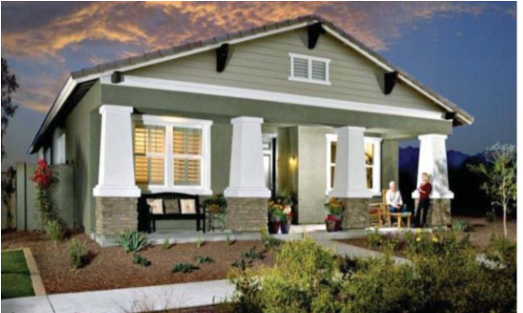
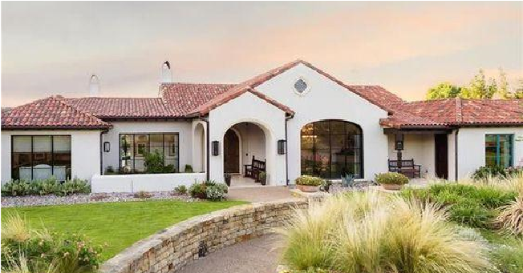
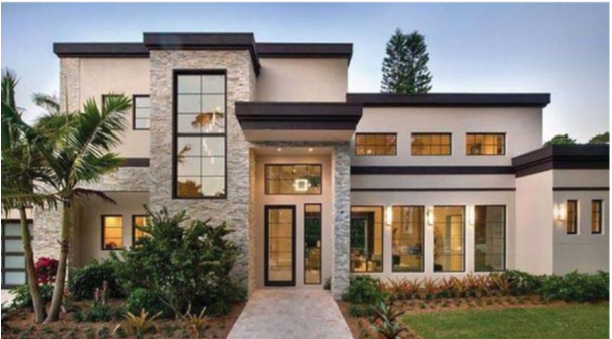
Desert Craftsman Desert Spanish Desert Modern

3.3 - 55 Plus Considerations
Terra Valley offers forever homes that are designed with the 55+ community in mind. Our homes are safe, accessible, and efficient to ensure a high quality of life for the active adult community. Each home utilizes open space to allow for ease of movement between the kitchen, living spaces, and bedrooms. All models will include universal design solutions such as paddle light switches, large hardware pulls, and lever door handles that cater to an adult community. Buyers have the ability to incorporate non-restrictive design solutions such as low reaching upper cabinets, lowered countertops, and roll under surfaces to increase the easability of life. User friendly smart technology such as security systems and appliances will be installed in each home to ensure safety and quality.

Product Development

3.4 Community Center
Equipped with an outdoor pool, fitness center, lounge, and large multi-purpose space, the community center at Terra Valley offers residents and guests a space for socialization and relaxation. The stunning desert Spanish style of the building emulates the surrounding desert landscape and sets a standard of quality and luxury for the Terra Valley community. The community center is the ideal location for hosting weddings, conferences, and other large family events for residents and their guests. Arched loggias surround the perimeter of the building and encompass an astounding lagoon style pool.
The facility comes equipped with a ‘grab-n-go’ style marketplace that offers gourmet food and beverage products. Within the facility, residents have the opportunity to utilize the workout space, attend group fitness classes, and gather in the chef’s kitchen or lounge. Sidewalk access connects guest to the pool, greenspace, dog park, pickleball courts and walking trails in the open space.
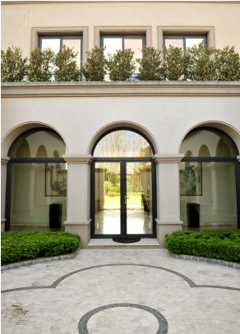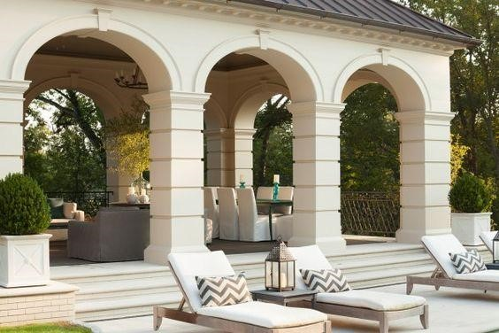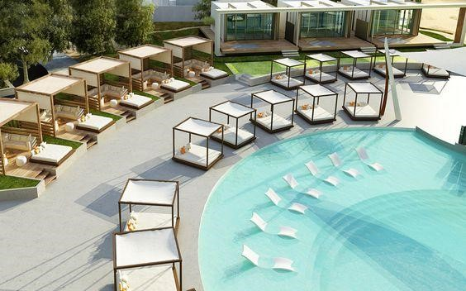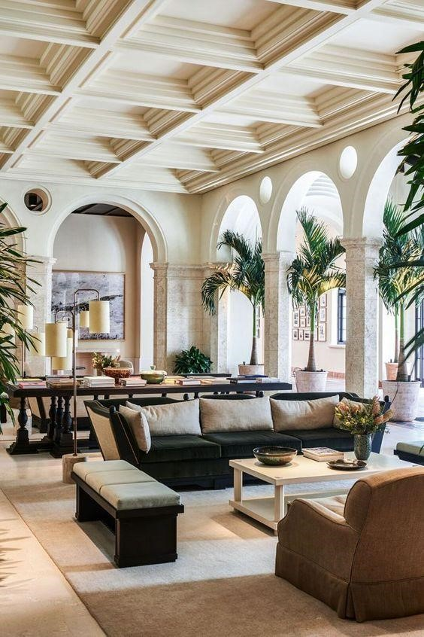
Figure 3.4 - Inspiration Images of Community Center
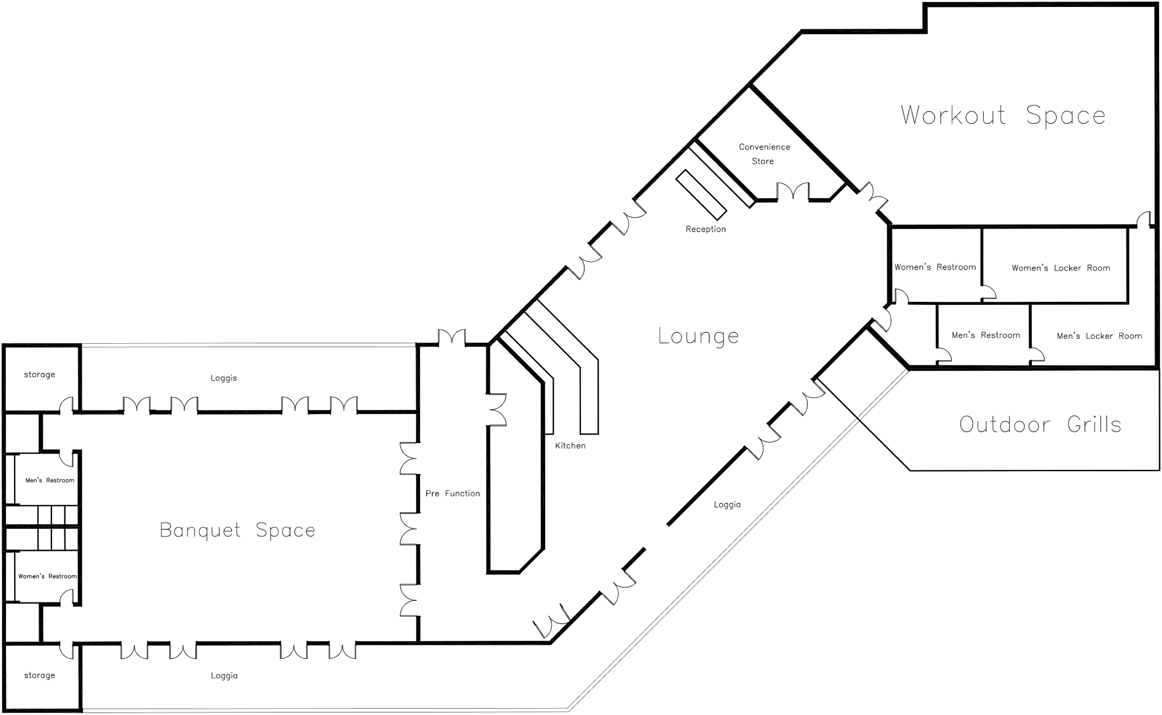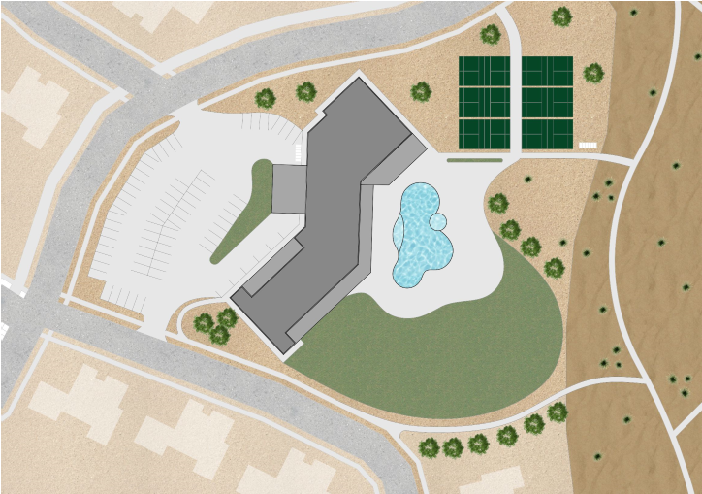
Features:
-
Lounge
-
Kitchen
-
Banquet space
-
Lagoon style pool
-
Patio grills
-
Fitness center
-
Convenience store

Figure 3.5 - Site Plan of Community Center
Figure 3.6 - Floor Plan of Community Center
*All floor plans and renderings were created by the Spartan Building Group
18
3.5 The Ivy  Starting from: $302,140 | 1,552 SQ FT  2 Bed  2 Bath
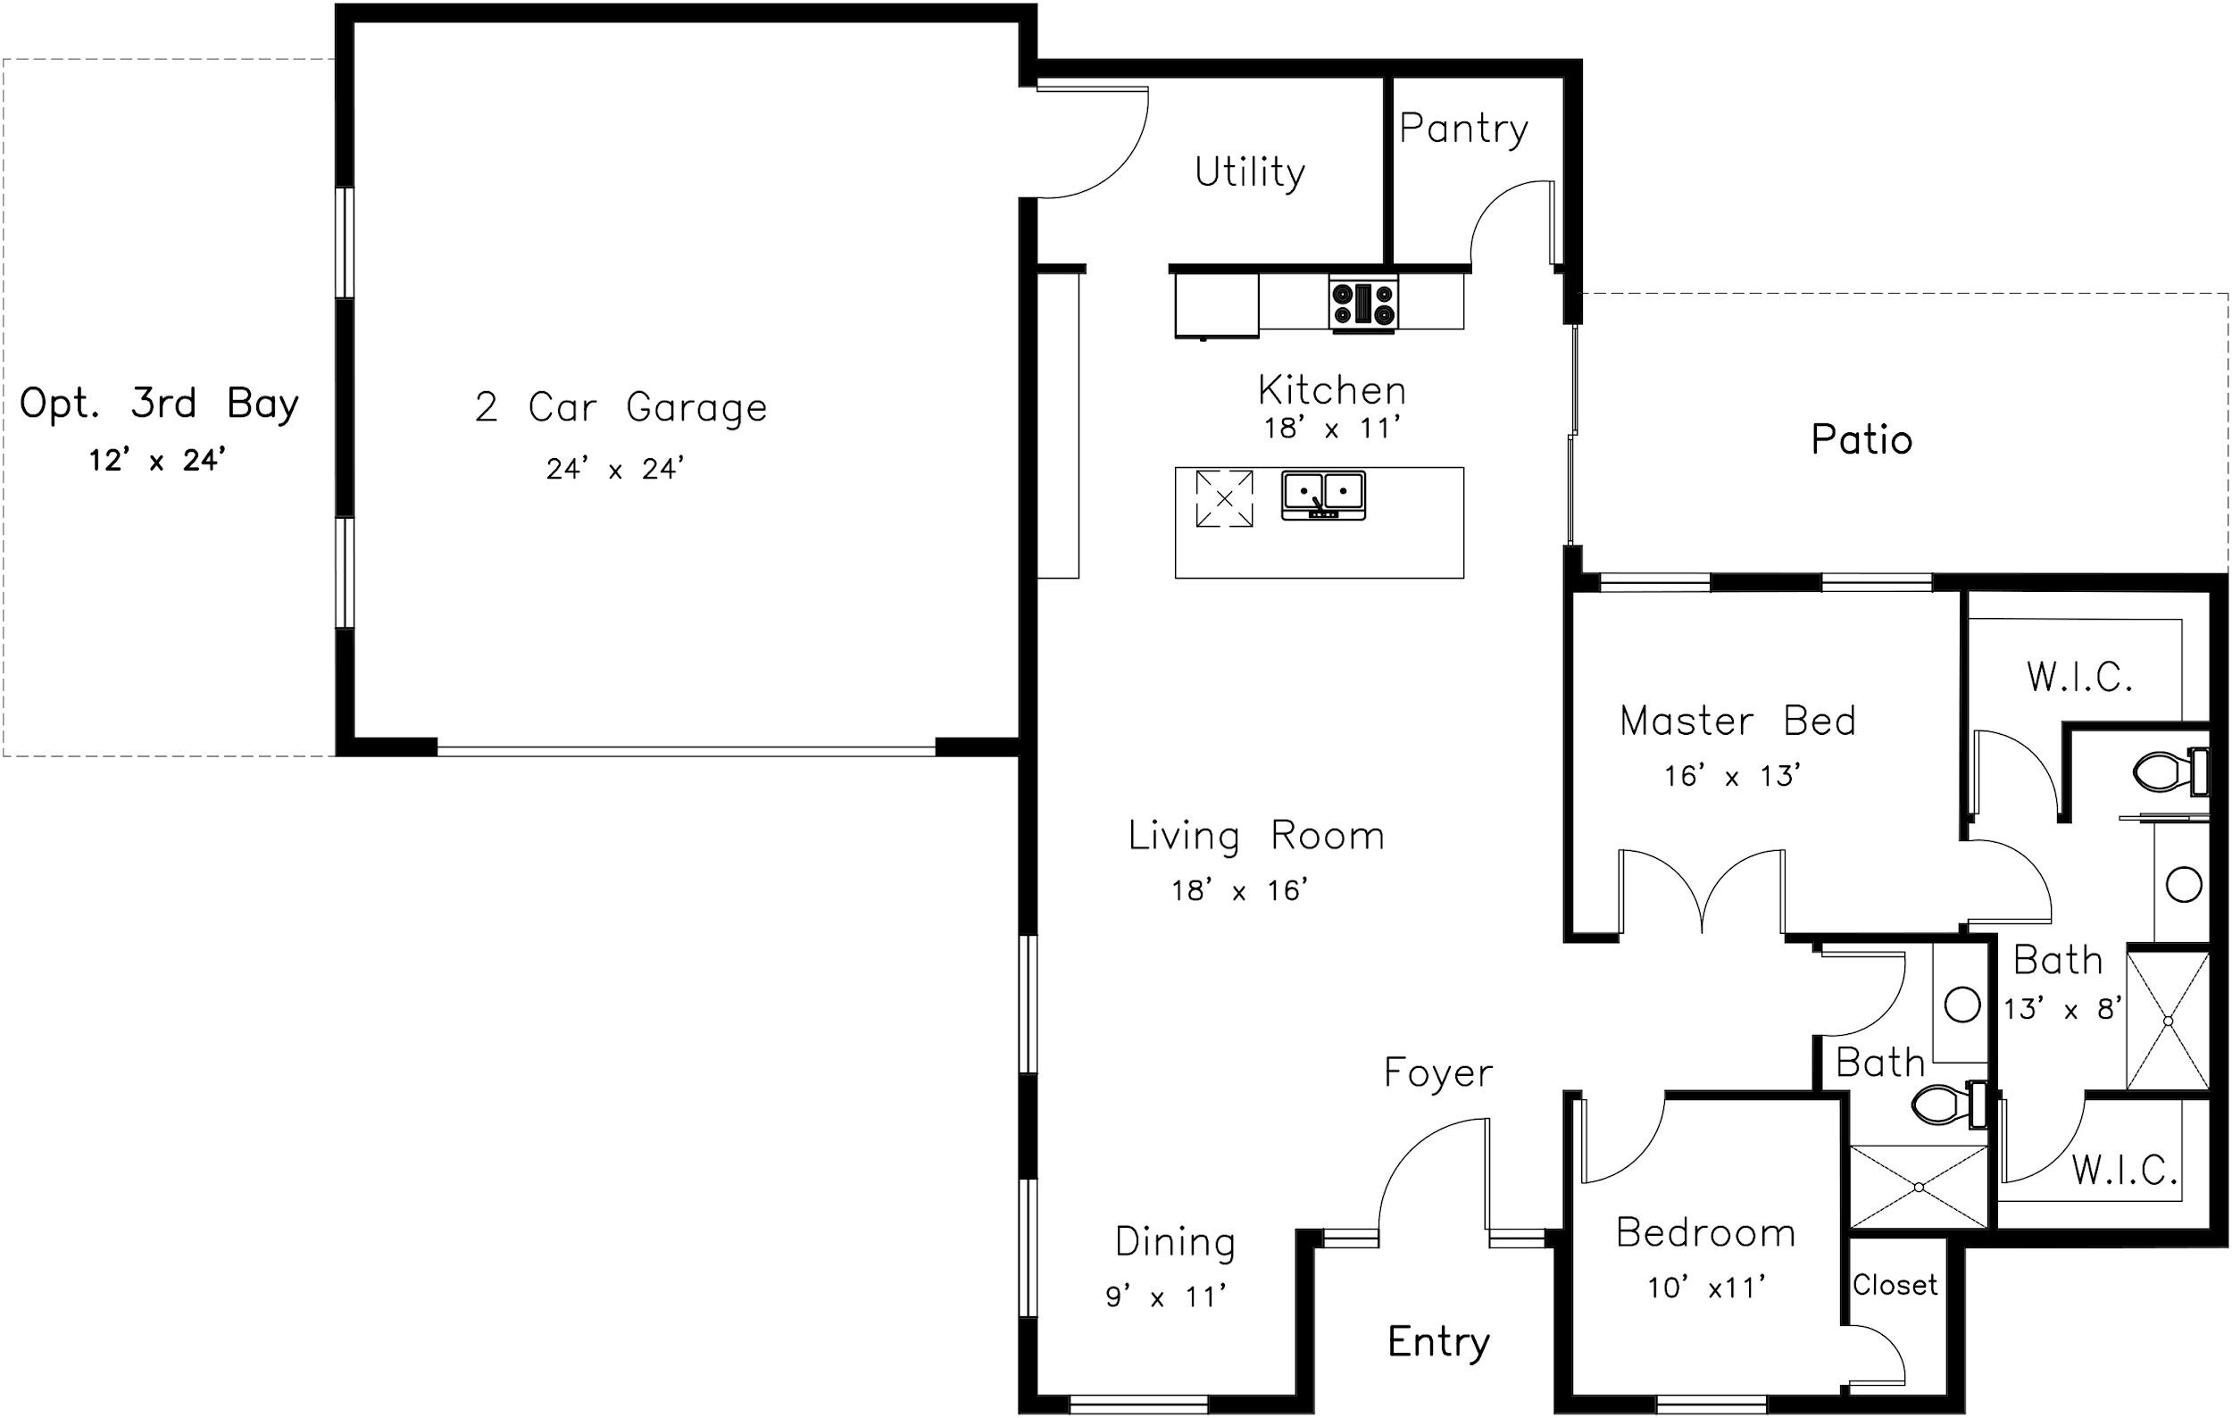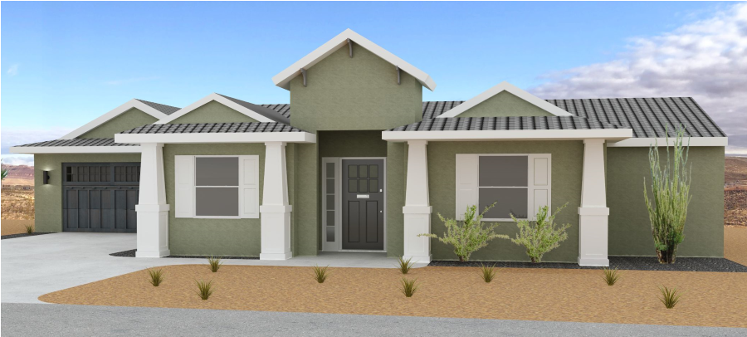
2-
Car Garage
Ivy shown in the Desert Craftsman Style

The Ivy is our most efficient home model. It is
equipped with two bedrooms, two full baths,
and spacious living areas. The layout allows
for a large outdoor entertaining space. This
model is the ideal amount of space for the
active adult who hosts occasional guests.
*All floor plans and renderings were created by the Spartan Building Group

3.6 The Sage  Starting from: $326,510 | 1,756 SQ FT  2 Bed  2 Bath  2-Car Garage
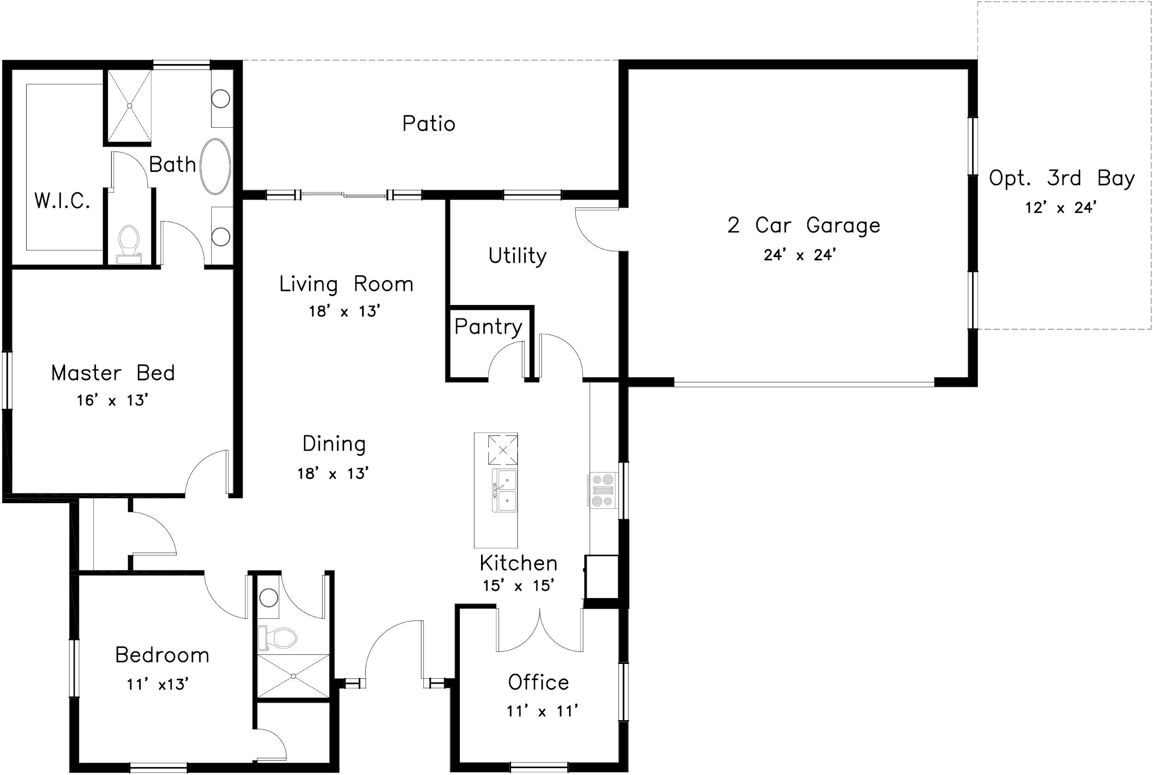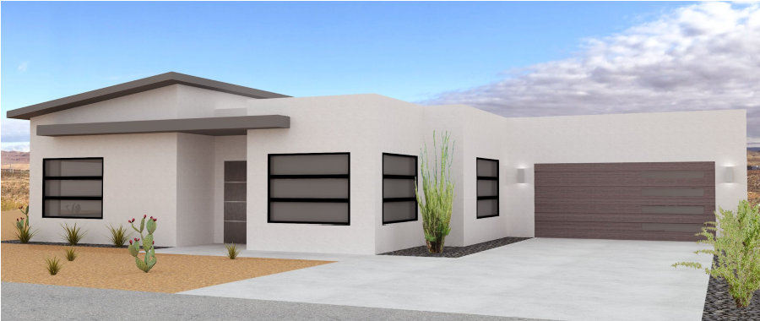
The Sage features two bedrooms, two full
bathrooms with an additional office or flex
space. This floor plan utilizes open floor
space
to
ensure
ease
of
movement
throughout. This model is ideal for adults who
are active inside and outside the home.
Sage shown in the Desert Modern Style

*All floor plans and renderings were created by the Spartan Building Group
19

Product Development

3.7 The Verbena 2,216 SQ FT
Starting from: $381,342 3 Bed
2.5 Bath
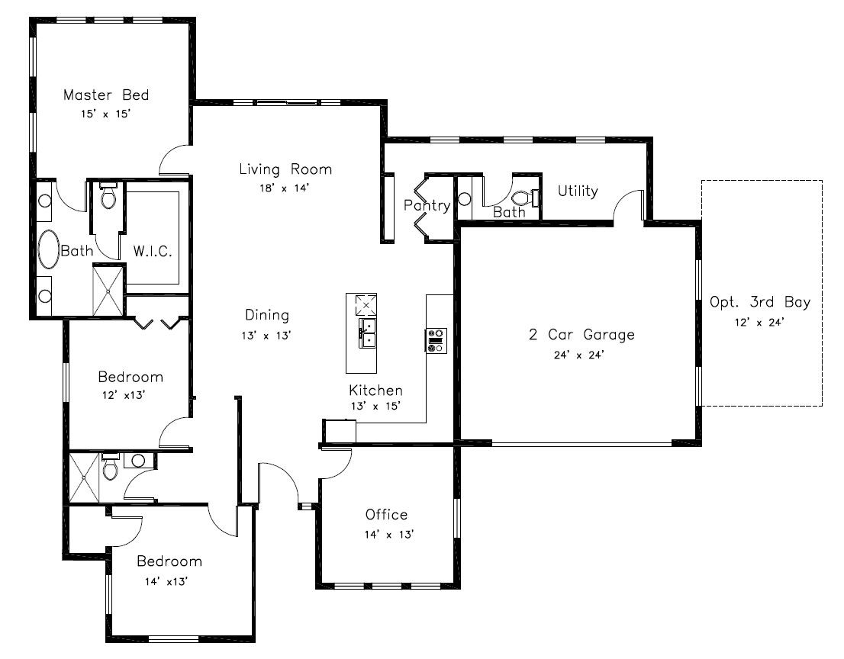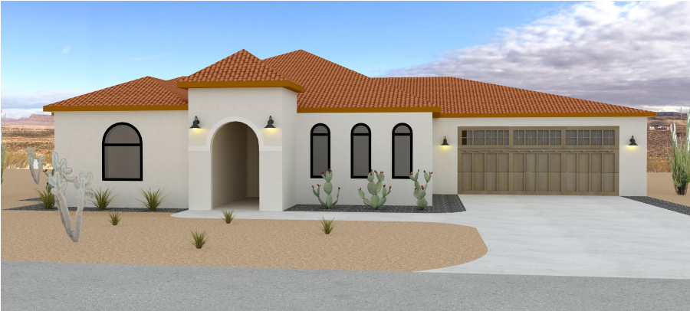
2-
Car Garage
The Verbena features three full bedrooms,
two full bathrooms, and one half bath. This
model offers an additional office or flex
space. A large kitchen and spacious living
area emphasize the open concept floor plan.
This model is ideal for buyers who wish to
entertain and host guests.
Verbena shown in the Desert Spanish Style

*All floor plans and renderings were created by the Spartan Building Group

3.8 The Crimson  Starting from: $430,082 | 2,594 SQ FT  3 Bed
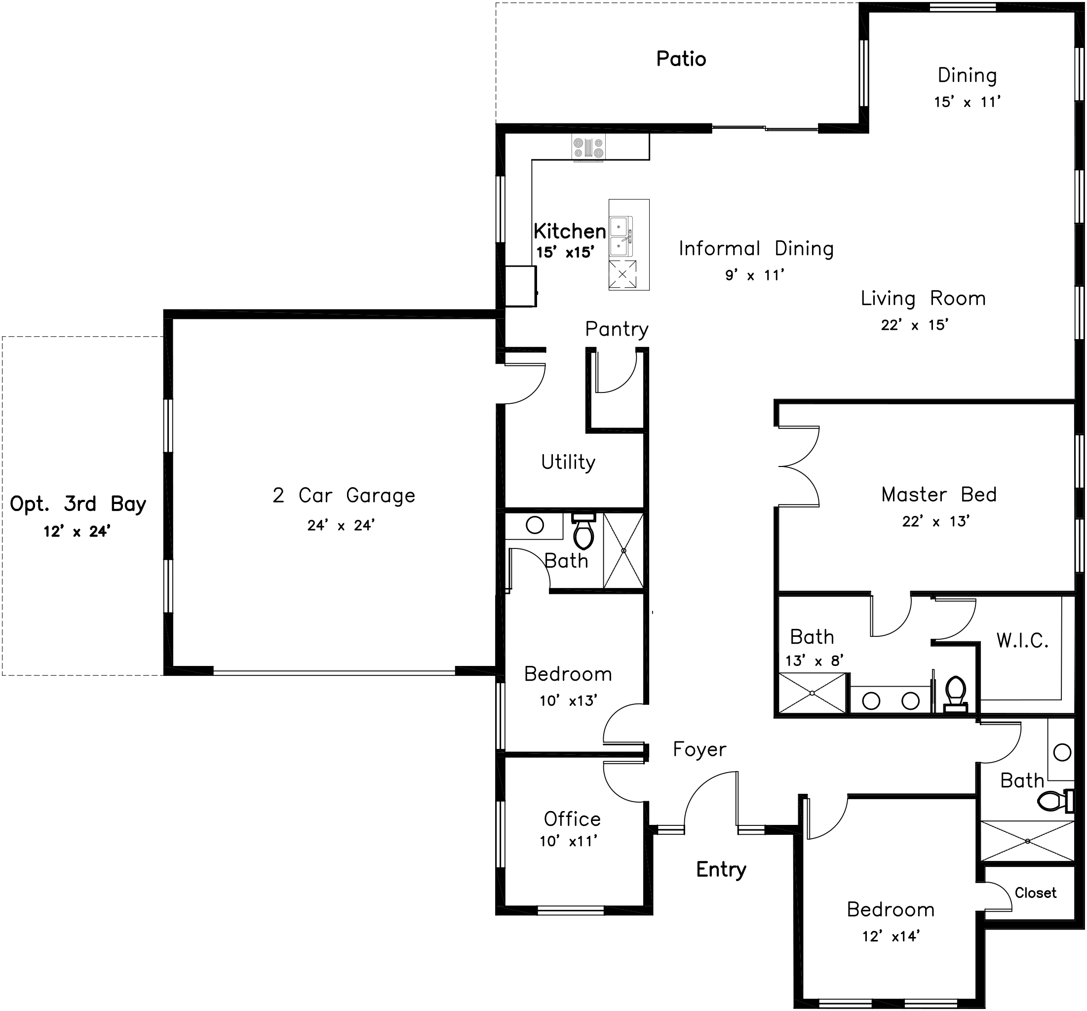
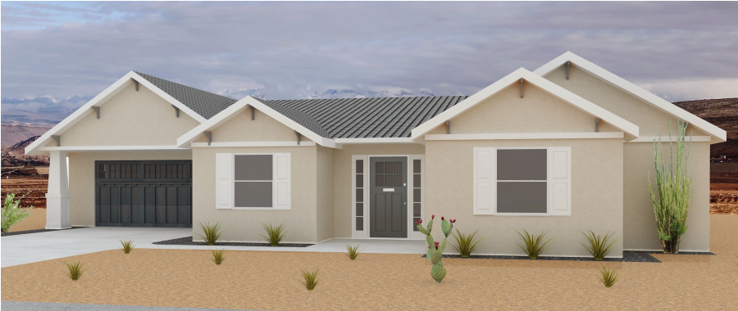
3 Bath
Crimson shown in the Desert Craftsman Style

2-Car Garage
The Crimson features three bedrooms and three full baths, offering buyers and guests private ensuites. The large master bedroom ensures privacy and luxury style living. This model includes informal and formal dining areas for all types of occasions. This makes the space ideal for buyers who wish to host long term guests.
*All floor plans and renderings were created by the Spartan Building Group
20

3.9 The Hawthorn 3,021 SQ FT
Starting from: $478,822 4 Bed
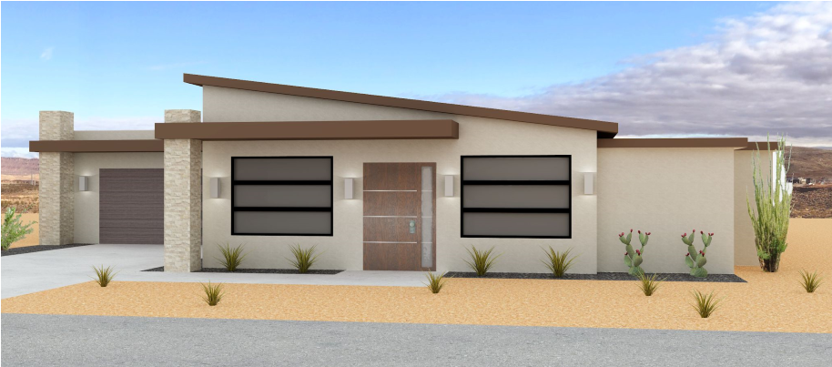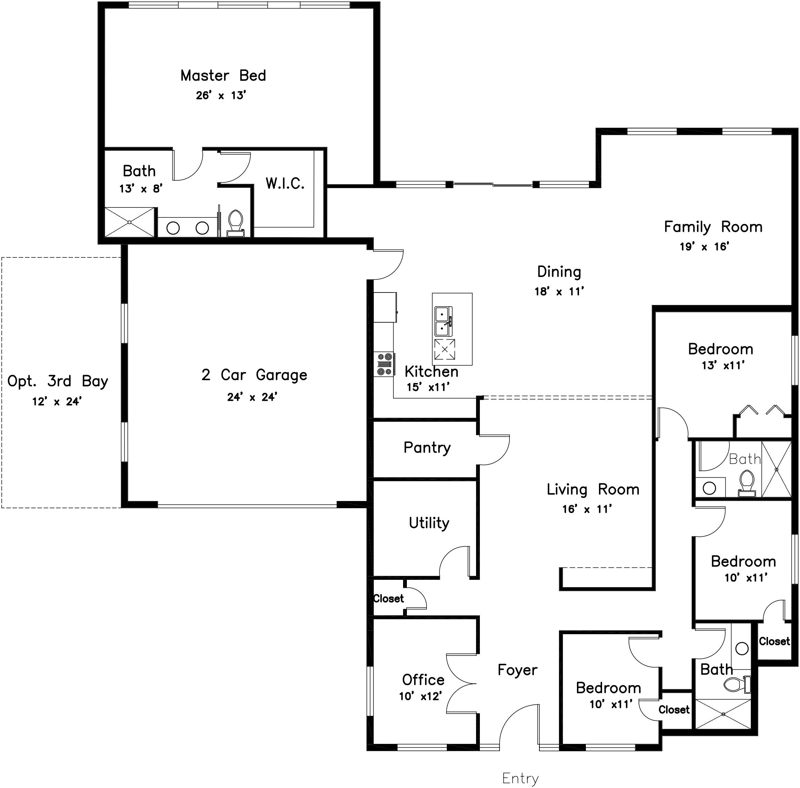3 Bath
2-
Car Garage
The Hawthorn features four bedrooms, three
full baths, an office, and two living spaces.
This additional living room allows residents
and their guests to best utilize the additional
square footage of the home. This home is
ideal for buyers who wish to personalize the
additional bedrooms to be flexible with
unique functions.
Hawthorn shown in the Desert Modern Style

*All floor plans and renderings were created by the Spartan Building Group

3.10 The Maverick 3,202 SQ FT
Starting from: $503,192 4 Bed
3.5 Bath
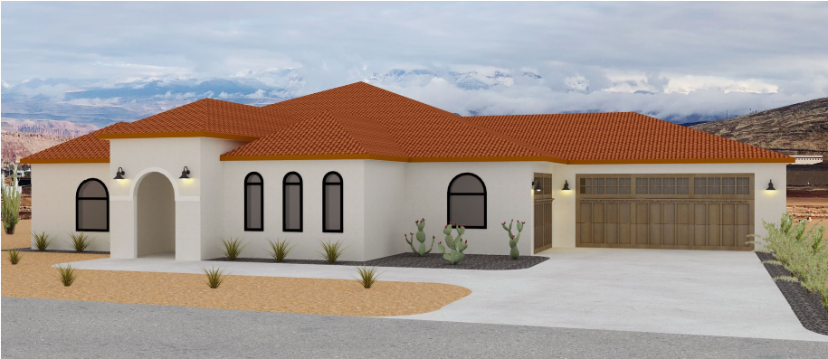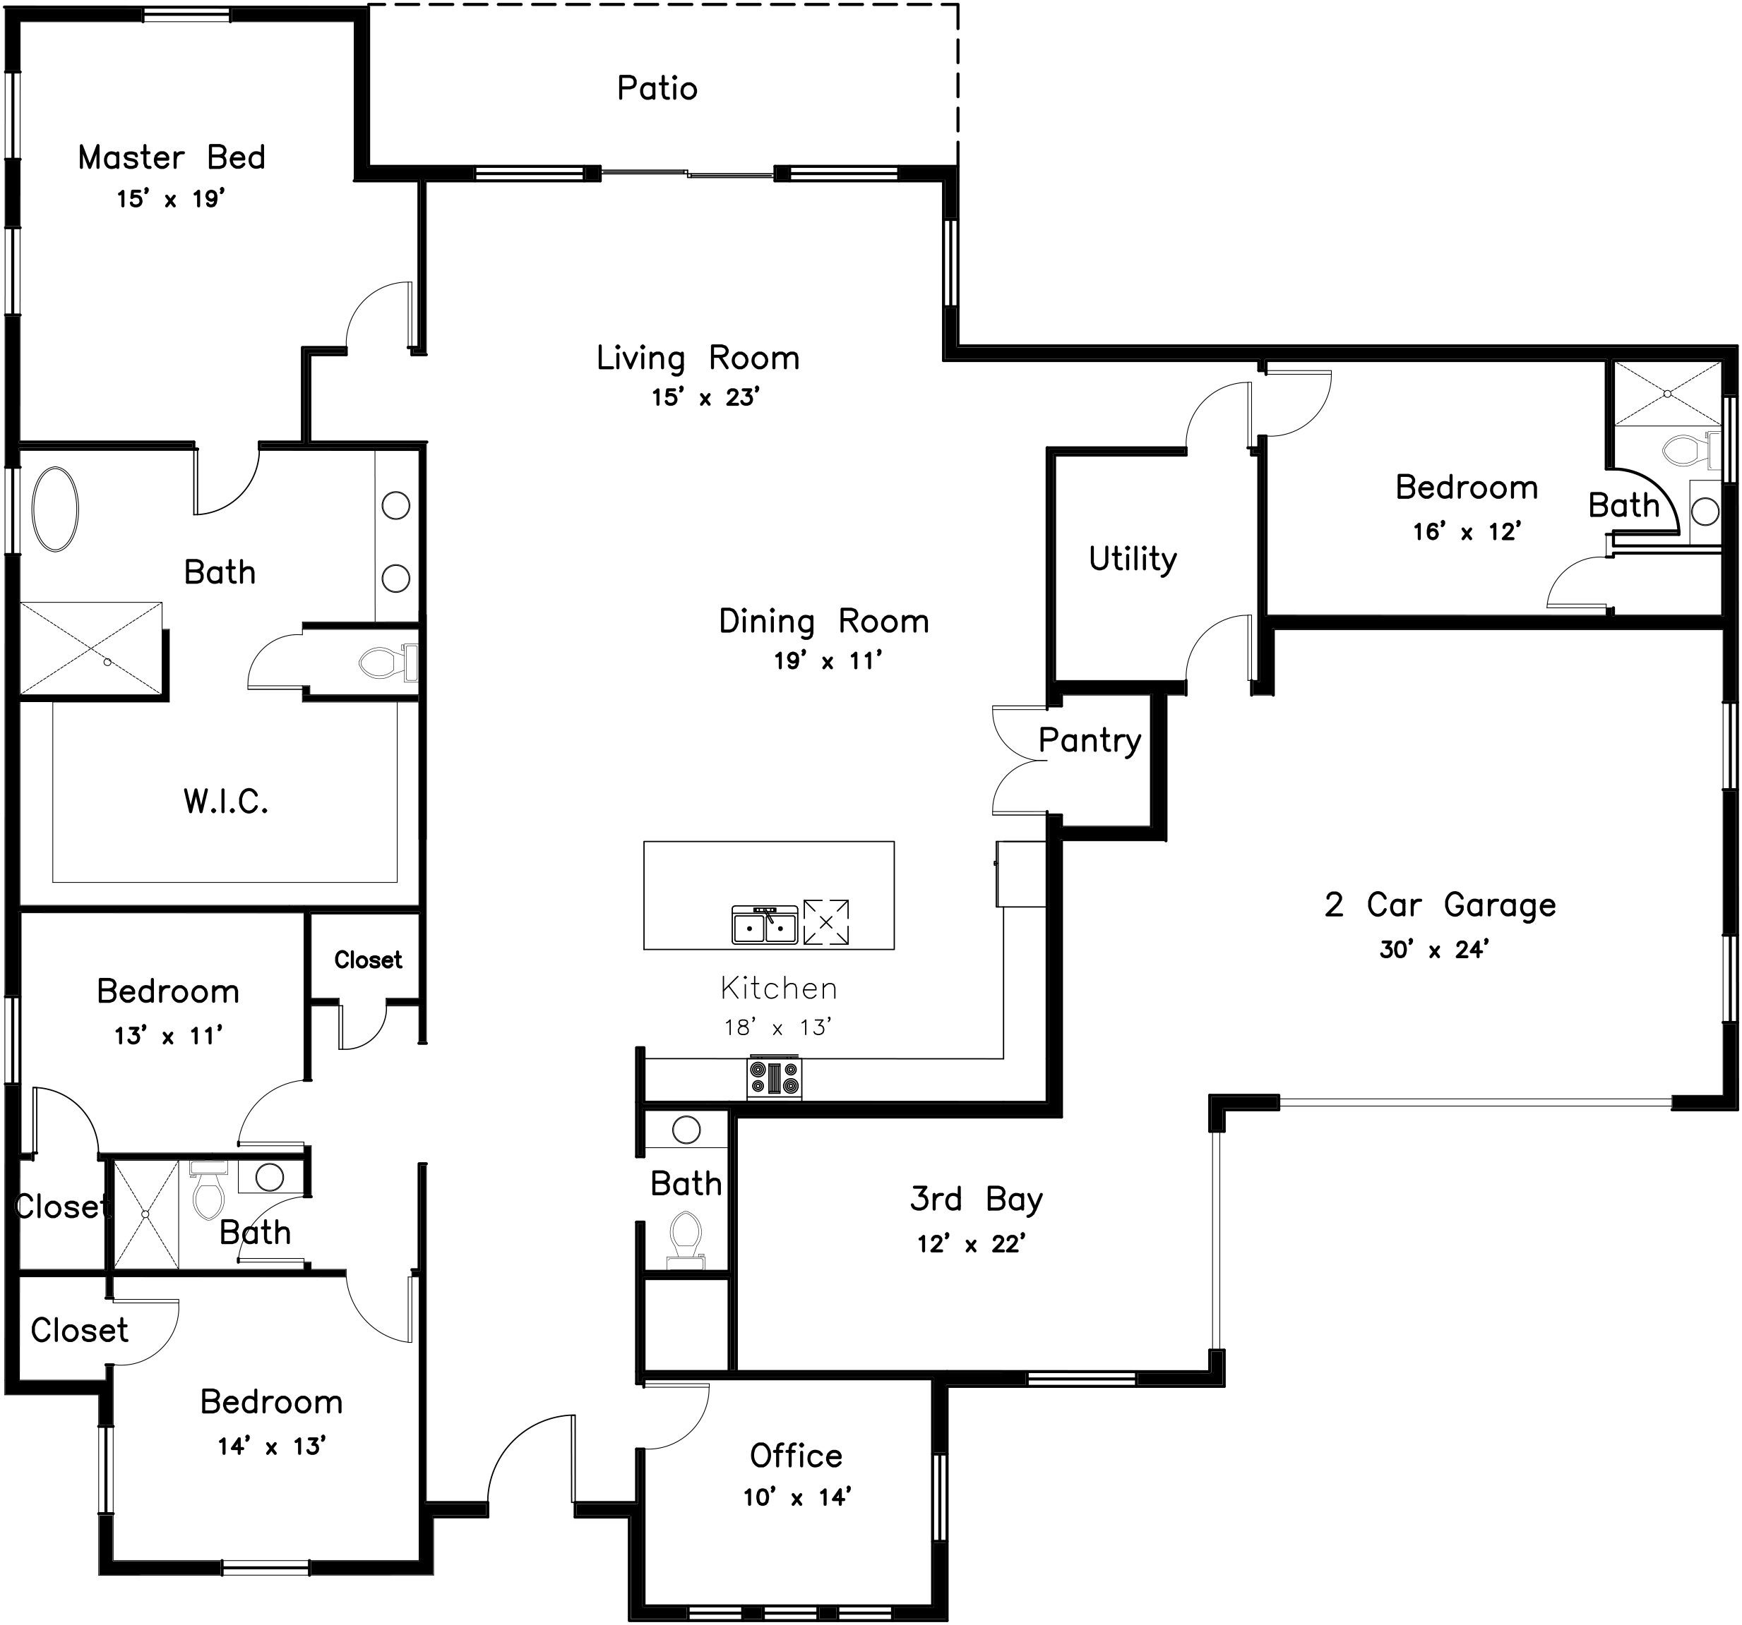
3-
Car Garage
The Maverick appeals to buyers seeking a
larger home in the semi-custom home market.
The model comes equipped with four spacious
bedrooms and the ultimate luxury master suite.
This model includes an additional third bay and
extra storage space throughout. The Maverick
is the perfect home for buyers who wish to host
several guests and enjoy luxurious style living.
Maverick shown in the Desert Spanish Style

*All floor plans and renderings were created by the Spartan Building Group
21

3.11 Standard Home Features

Interiors
- 9’-0” high ceiling with 8’-0” high doors
- 4’-0” wide front entry doors
- Lever door handles; choice of oil rubbed bronze or brushed nickel finish
- Paddle light switches
- Min 5’ clearances in kitchen and living room
- Zero barrier entries into homes
- Walk in closet in master suite
- Rounded drywall corners
- 5 ½” base moldings and 3” door and window casing
- 24” high outlets and receptacles on all walls
- 42” high light switches
- Nest smart thermostats
- Security system
- LED can lighting
- $2,500 lighting fixture allowance
- Carbon monoxide detector
- Durable laminate flooring

● 200-Amp electrical service
- Hardwired smoke alarms
- Cable outlets in living room and bedrooms
- Forced-air heating and central air conditioning
- 50 gallon tank water heater

Laundry/ Utility Room
- LG electric washer and dryer
- Cabinet system with pull out clothes drying rack
- Custom raised panel base and upper
cabinets, choice of stain color and quartz
countertop
- “Drop zone” countertop

ADA Alternative options
- 30” high countertops
- Roll under countertops in kitchen and bathroom
- Kohler luxury grab bars

Kitchen & Bathrooms
- KitchenAid stainless steel appliances
- 3 cm Quartz countertop, choice of color
- Under cabinet tile backsplash
- 8” backsplash in bathrooms
- Raised panel cabinets, choice of stain color

● 3” center to center cabinet pulls ● Kohler touchless kitchen faucet, choice of finish-polished chrome or brushed nickel
- Walk-in pantry in kitchen
- Zero barrier entry tile showers
- Built in bench in master shower
- Towel bars
- Base cabinet vanity in guest bath
- Interior support panel for grab bars on all bathroom and shower walls

Exterior
- Photocell sensor exterior gas lanterns
- 2 car garage
- 3 car garage (Maverick model only)
- Private patios
- Water heater in garage
- Expansion tanks
- Desert landscape package

● Low-E vinyl dual pane energy efficient windows
- Stucco exterior with textured finish
- 2X6 Construction with cavity insulation
- Gutters and downspouts connected to storm sewer
- Steel overhead garage door with two overhead openers
- Two exterior electrical outlets
- Frost protected slab on grade foundation
- Deadbolt locks on exterior door
- Pretreatment termite proofing
- Covered front entry
- Minimum 18 foot wide driveway
- Landscaping package
- Gas impermeable under-slab membrane
22

3.12 Standard Finish Packages

Interiors
Terra Valley homes come equipped with durable and high end finishes. Each home will receive a minimum of two coats of interior paint. Moisture, stain and fade resistant wood texture Laminate flooring will be installed throughout the entire home. Non-porous and scratch resistant 3 cm quartz countertops will be installed on the kitchen and bathroom countertops.

Finish Package One Finish Package Three


Finish Package Two Finish Package Four
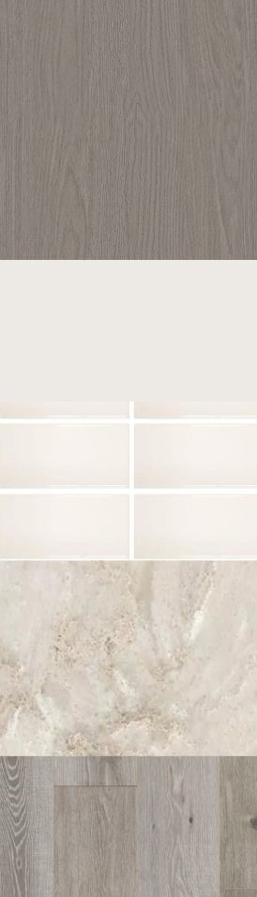
3.13 Upgrades

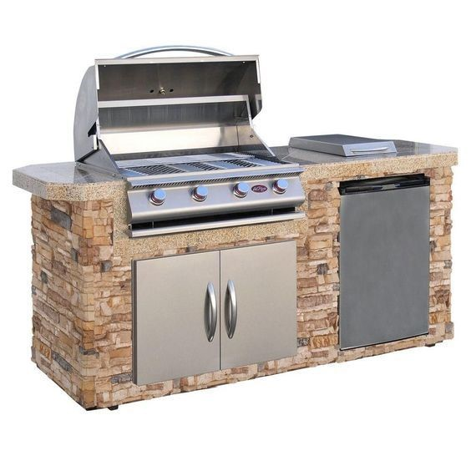
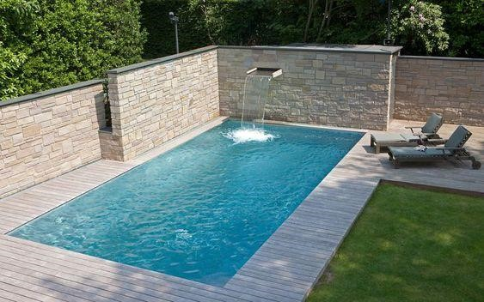
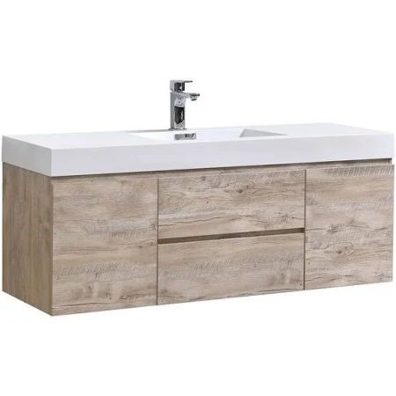
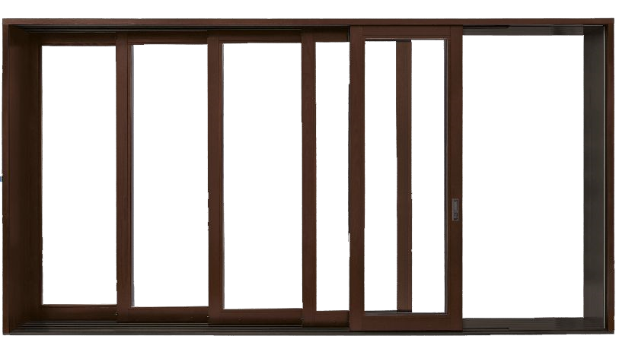
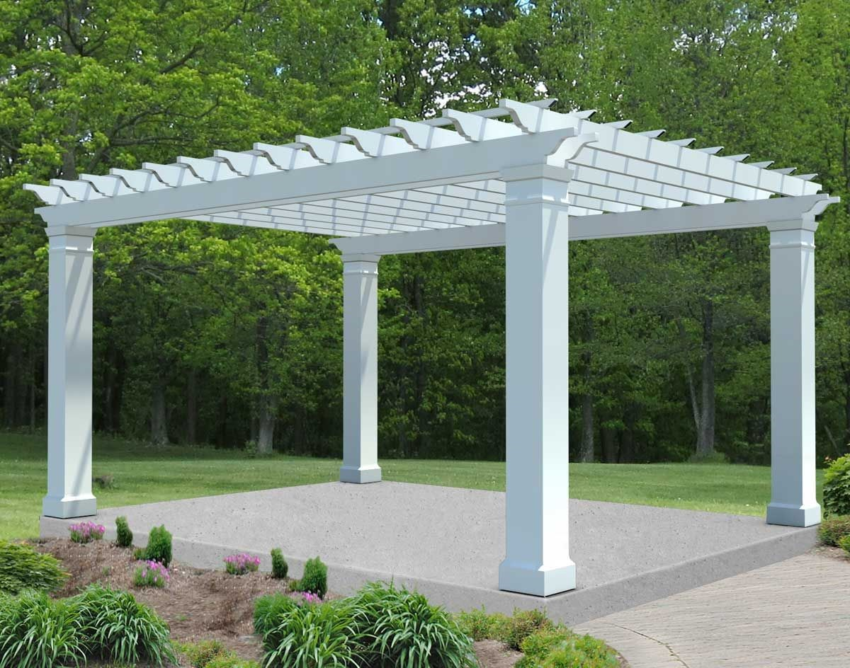
Exterior
Figure 3.7 - Pergola
Figure 3.8 - Outdoor Kitchen
Figure 3.9 - Pool
Figure 3.10 - Floating Vanity
- Pergola Patio Cover
- Third Garage Stall
- Outdoor Kitchen
- Pool
- Privacy Fence
- 60 AMP 240 V Electrical Service for Electric Cars and Golf Carts
- Putting Green
- Synthetic Turf Dog Run

Interior
- Fireplace
- Granite countertops
- Four stack sliding glass door
- Painted cabinets
- Floating bathroom vanity
- Built-in Shower Benches
Figure 3.11 - Four Stack Sliding Glass Door
23

4.1 Construction
During construction Spartan Building Group will have a project checklist off all practices to be implemented during each phase of construction as well as team meetings to assure our contractors are complying to the green standards. To help reduce the amount of construction material waste we will be recycling by providing designated bins to be picked up as needed. Spartan Building Group created a site design with 30% of the site being undisturbed and 50% of the roads aligned with the existing topography reducing the amount of excavation required for this project while also preserving the natural washways in the area. By developing the site into phases we will also minimize the amount of exposed earth to reduce sediment erosion.

4.2 Land development
4.2.1 Site Design
The site design of Terra Valley is projected to achieve a four-star ranking from the National Green Building Standard in the category of “Site Design and Development”. The minimum number of points to achieve the four-star rating is 176, but a score of 210 points has been projected for this neighborhood. This four-star rating has been achieved through our sustainable land development practices.
4.0
Sustainability
Summary
Sustainability is an important aspect in planning and design for the Spartan Building Group and the
Desert Color Community. We plan to incorporate ICC 700 standards to create a neighborhood that
preserves the natural surroundings and encourages low resource usage to maintain its beauty for
generations to come.

Such practices include having a road network in which more than 50 percent of roads follow the natural contour of the land, choosing natural vegetation that will both encourage natural habitats for wildlife and reduce irrigation, along with reducing our environmental impact on the topography of the site and reducing energy consumption during construction. Our proposal also includes an open space that will remain undisturbed which will allow for native life to continue to find a home in the neighborhood. The walking path throughout the site design will be made with impervious pavers to allow for water to soak into the ground. While the majority of construction will be done during the day, we will have LED lighting for construction and in land development for street lighting.


Sustainability

4.2.1 Lot design
Lots were subjected to the same design principles as the site design in order to carry the message of sustainability across the design of the entire community. Individual lot design was reviewed under the sustainability guidelines of chapter 5 of the National Green Building Standard entitled “Lot Design, Preparation, and Development”. Under these guidelines lot design was able to achieve 98 points for a Gold rating (Figure 4.1).

4.2.2 Community Overview
Spartan Building Group’s goal for the community is to promote an active neighborhood in nature. By including thousands of feet of walking trail and bike paths, a vast greenspace and natural area, pool and spa, community gym, and outdoor recreational equipment such as our pickleball courts, reaching the goal for Gold rating (Figure 4.1).
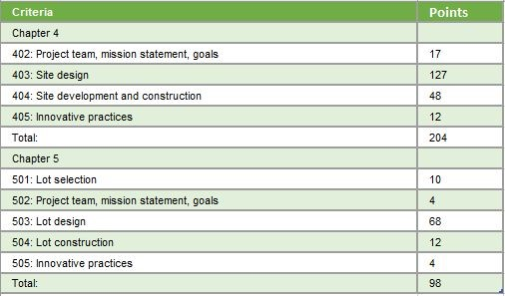

Figure 4.1 - NGBS ICC 700 Land Development Score Chart

4.3 Product Development
Terra Valley homes were created with energy efficiency and environmental impact in mind. Standard features which satisfy the desired requirements for the ICC 700 are included in every model. Such as; low-E windows, LED lighting fixtures and Energy Star products to lower the energy consumption of each home. Spartan Building Group will use locally sourced, recycled, salvaged and FSC-certified materials whenever possible. Our homes offer options for additional shading elements such as pergolas to encourage natural cooling of the homes in a hot desert climate. All models incorporate ample windows around the perimeter of the home to utilize natural daylight and save on energy cost.

5.0 Project Management

Summary
The Project management Team for Terra Valley will work closely with our partnered builders within the site to ensure that the highest quality and best cost products are brought to the market. Our Operations team will have 2 superintendents, one vertical and one horizontal, to deal with the day to day operations and one project manager to focus on the big picture. Through Four Phases, and an average duration of 454 Days, we will be able complete the project in 5 years.

5.1 Construction Operation

5.1.1 Project Management
Our part-time project manager will be responsible for the selection of subcontractors and, overseeing the project team, and tracking the financial and schedule progress internally. The project manager works closely with the financial team in the office to know the current state of the project at any given time.

5.1.2 Horizontal Superintendent
Our site superintendent is the coordinator of the soil erosion and dust control notes within the daily log to track our compliance throughout the Horizontal construction process. It is their responsibility to ensure that the infrastructure is in place to keep home construction on track.

5.1.3 Vertical Superintendent
Our superintendents have the responsibility to monitor between 16-20 homes at any given time. With that, they will be responsible to deliver each home tailored to the needs of each homeowner. Working towards the goal of 8 home turnovers every week, there will be constant rotation of homes in every stage of construction to showcase what each homeowner can expect through their home construction.

5.1.4 Management Software
At Spartan Building Group, we provide our project team with Procore. This software will house the daily logs, schedule, punchlists, and Documentation that flows through the project team. As you can see in Figure 5.1 This is a versatile software which will be utilized on Ipads and Surface computers, which are standard for all team members.

5.2 Phasing
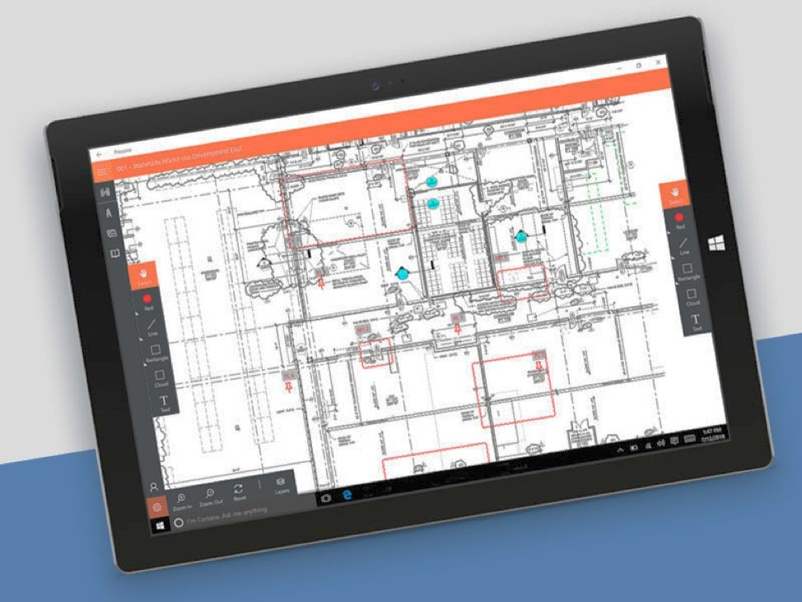
Terra Valley will showcase 4 phases with 368 homes total starting from the west and moving to the east, and will finish by the deadline of 4 years. Phase 1 will house the community center, the open walking paths, and 91 homes, 6 of which will be model homes built near the community center.
Phase 2 will have our RV parking, and 103 homes, this phase serves to take up the Western portion of the site and display our homes to the potential buyers coming in to St George on the highway. Phase 3 will finish the open space and complete 97 homes. This phase ties into the road at the southeast corner of the site, helping establish our construction road for this phase. Figure 5.1 - Procore Software
Phase 4 will round out the development with 77 homes completing the development as shown in Figure 5.2

Project Management
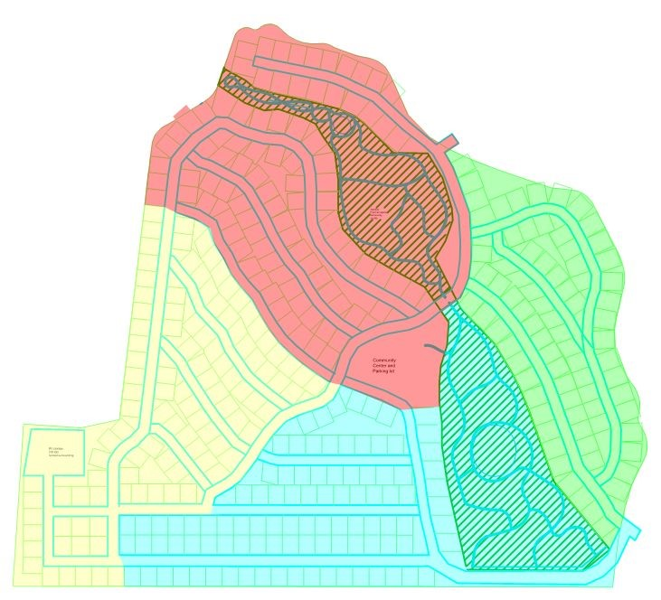
Phase 1
91
Homes
Phase 4
77
Homes
Phase 3
97
Homes
Phase 2
103
Homes

Figure 5.2 - Phasing Diagram

5.3 QUALITY CONTROL

5.3.1 Overall Quality Control
Before the commencement of each phase, we will conduct a pre-construction meeting to establish the quality and reinforce scheduling expectations for that phase of the project. We then will have homebuyers of that phase come in and meet with the superintendent they will be working with on their home and get acquainted with the process.

5.3.2 Individual Quality Control
At Spartan Building Group we take pride in the craftsmanship and attention to detail our partner builders bring to the table, we will conduct walkthroughs at three key phases; preboard, post fixture, and final punch list upon completion. This will leave each home completed one week prior to the turnkey date, and allow us to stay ahead of schedule.

5.3.3 ENVIRONMENTAL CONSIDERATIONS
Our first phase of horizontal construction will get our retention pond and the major arteries of the storm water management system in place, so that in the event of a large rain, runoff does not leave the confines of our site. Silt fence is standard on all of SBG projects, but we go further, controlling runoff on the road by cleaning off all trucks out of the site and sweeping the street at the end of every work week. We will be working closely with the municipality to ensure the criteria of the Dust control and Erosion control are met.
27

Project Management

5.3.4 Construction Risk
Our constructability review of St. George revealed that there is a deficit of trade labor in the area. This is not uncommon across the nation, but is especially severe due to the large number of homes being constructed each year. We have shielded ourselves from this risk by adding 30% to the standard efficiency rates we use for construction and applied them to our home and site construction durations. We also have chosen to panelize the walls to increase the efficiency of the crews we have, when they are not setting panels, they will be constructing them on site for the next set of homes. We also will be running 2 roofing crews, these two areas are typically our longest durations, this helps to maximize the number of homes we can deliver each quarter.

5.3.5 SAFETY
Spartan Building Group puts safety first, safety orientations will be held every morning at 7:30 for trades new to the site. In addition to that, tool box talks will be held every Monday morning to start the week on a positive note and serve to highlight issues pertaining to our site and sites nationwide to keep the trades current on the best practices to stay safe. Superintendents will fill out weekly safety commentaries in their daily logs and track progress throughout the development.
28

6.1 Schedule
Terra Valley at Desert Color will acquire the land parcel on March 2nd 2020, and a full completion on February 12th 2025. The schedule is arranged to include 4 phases, the schedule is based on a home takedown rate of 24 homes per quarter. We have structured our framing, and roofing construction to include 2 crews to help shift our construction starts to 8 days apart. We will be running homes in sets of 3 to help us get to our goal of constructing 24 homes per quarter. A majority of our home's components are critical of one another's completion outside of installing windows, exterior siding and gutter installation. The visual detailing our home scheduling can be found on page 37. Phase One of vertical construction will begin on the 22nd of September 2020, Phase Two on September 28th 2021, Phase Three on November 2nd 2022 and Phase Four on November 29th 2023. The number of homes per phase has been described in Figure 5.2.
6.0
Estimates and Schedule
Summary
Spartan Building Group has set our schedule to complete the project in 5 years. This is achieved
through efficient scheduling, placing larger crew sizes, and utilizing our trade bases in the area to push
the project to completion.
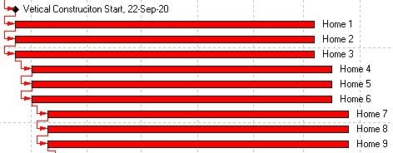

Figure 6.1 - Home Phasing
Home foundation construction will take between 10 and 21 days. This time period of work will include the placement of slab on grade, and frost protected shallow foundations. After the slab on grade is complete, we will begin constructing and setting exterior wall panels with an average duration of 8 days. Exterior work, including windows, stucco and clay tile roofing will follow to fully enclose the house. The exterior work durations range from 15 - 31 days across the range of models. Once the roofing is installed, we begin interior rough-in work. Followed by insulation, gypsum board, flooring, wall finishes, cabinets, and interior doors which averages 59 days. While interior work is occurring, exterior finishes and improvements can begin. This includes driveway paving, landscaping and planting. Based on our crew productivity, there will not be an added duration to construct the Desert Modern style of home featuring the flat roof and the stone exteriors

Estimate and Schedule

6.2 Schedule Description
Before construction begins, we have to submit for replatting and approval through Washington County. We have allowed 6 work weeks for this process, with individual permits we have allowed 3 work weeks, as the city is seeing a large volume of permits come through each month. Once approved, we can begin sitework on the 27th of April 2020. Site work will follow with four separate phases, as described previously in Figure 5.2and ends on the 12th of February 2025. The start of our site work activities are dependent on one another's finish, such as mobilization, silt fence installation, clear & grub and cut & fill. Although, as clear and grub begins, we begin to stagger utility excavation and installation by a few days. We do so with the utility activities themselves as well. Staggering activities allows us to expedite the utility installation process while not forcing utility subcontractors to work around one another. We have also selected to begin vertical construction prior to the final completion for sitework, this will happen after the placement of the roads first paving, this provides simple access for the home constructors while already having the necessary utilities in place to support the new homes being built.
We have selected a six day work week for our project schedule to maintain our projected finish date, while including expected holidays. We intend on Phase two opening after 75% of phase one is sold and phase three will open after 75% of phase two is completed.

6.3 Deliveries and Coordination
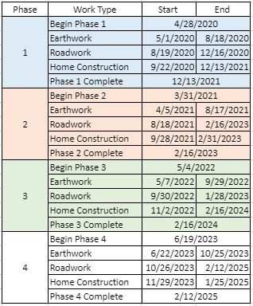
With the panelized wall sections we will be utilizing, it is in our best interest to utilize Just-In-Time deliveries. We will see less stockpiling on site, and mitigate the risk of an Unforeseen weather event harming the material for wall panels waiting to be constructed and erected.

6.4 Milestones
Figure 6.2 shows our most important milestones within each of the phases.
Figure 6.2 - Site work phasing
30

Estimate and Schedule

6.5 Site Work Estimate
The scope for the site work is divided into 6 main categories. These Categories include Earthwork, Road work, Utilities, Soil Erosion, Assemblies and Miscellaneous. The primary cost of our site work exist within road work, which is roughly $8 million. Over 1 million dollars of that cost comes from having to excavate, fill and compact before we can lay our binder course for the road. Each phase starts and finishes with earthwork activities, as the wear course is the method of construction road and the wearing course is our finishing touch before we turn over the phase completely. With the area of the clay being utilized for open space, we will only be grading the roads and the lots totalling around 105 acres. We also have included a contingency of $164,783 to cover any unforeseen clay that is not been identified in the geotechnical report. As you can see, the costs of this type of road construction are very high, so our bid is based on encountering and extra 100 lineal feet of this road type.
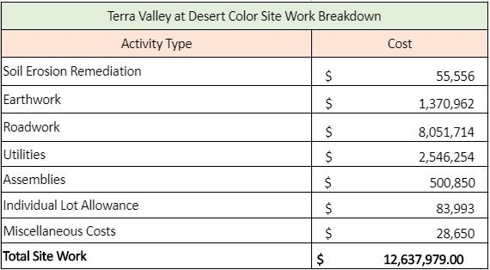

Figure - 6.3 Site work breakdown

6.6 Home Estimates
Home price evaluations were developed through the information we obtained in the market analysis. We utilized the competitor pricing and our own cost databases to estimate the costs for construction. Our home costs range from $178,000 in the Ivy model to $347,213 in the Maverick model. Our average square foot construction cost is $108.44 per square foot. See table for a detailed estimate for each home model. Included with our financials is a contingency for the homes that is not carried as a line in the home estimates please see page 33 for a detailed explanation of the carried amount.
31

Estimate and Schedule

6.7 Site Work Estimate
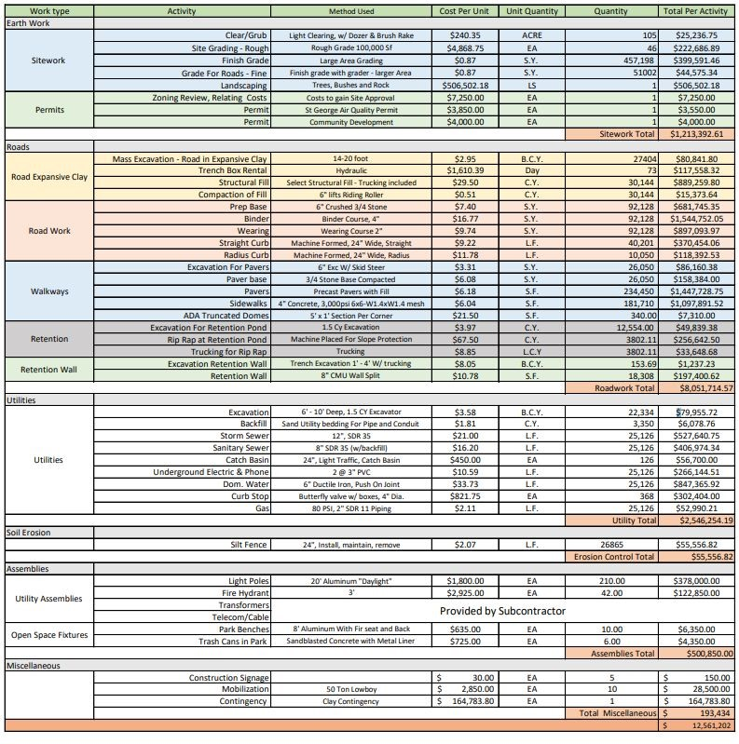
32


Estimates/ Schedules
33

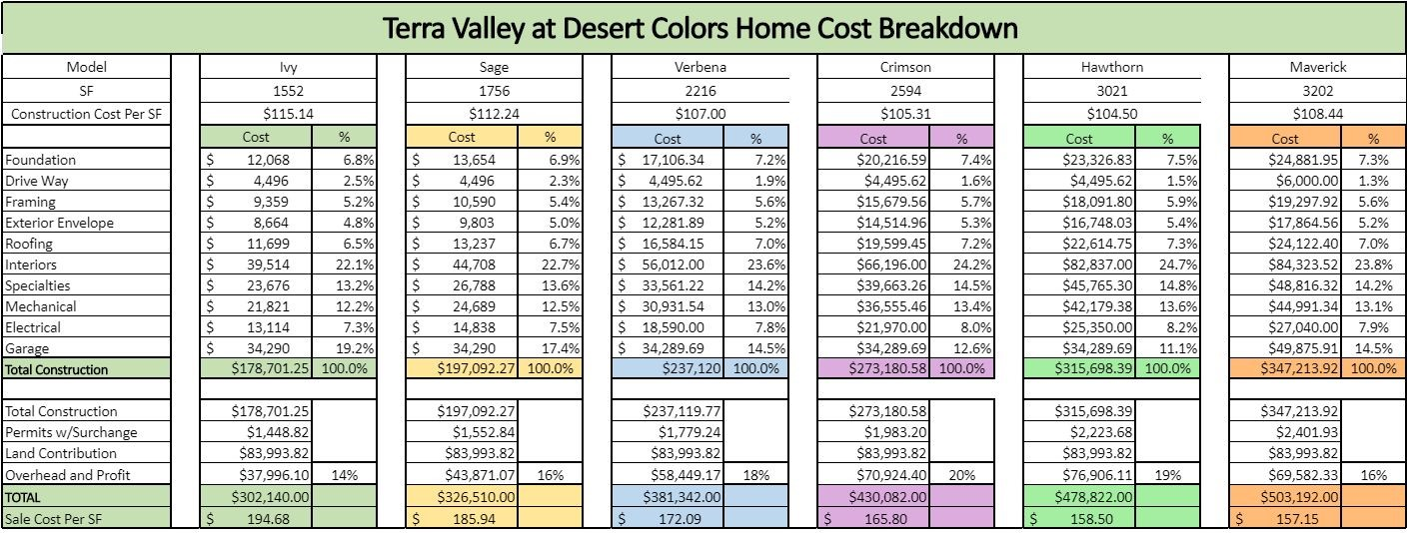
Figure 6.4 Home Estimate

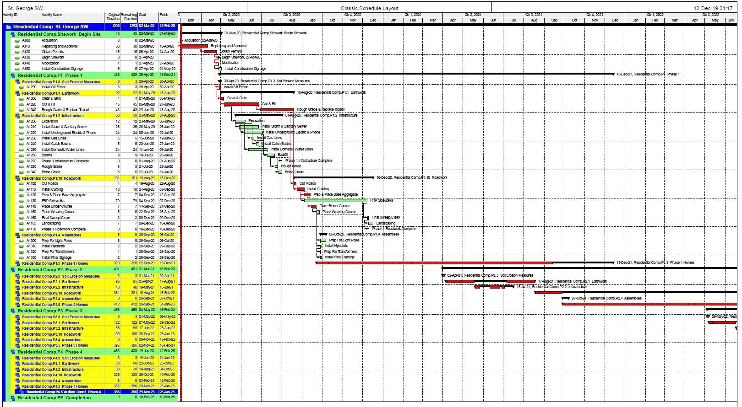
Estimates and Schedules: Site Work Schedule
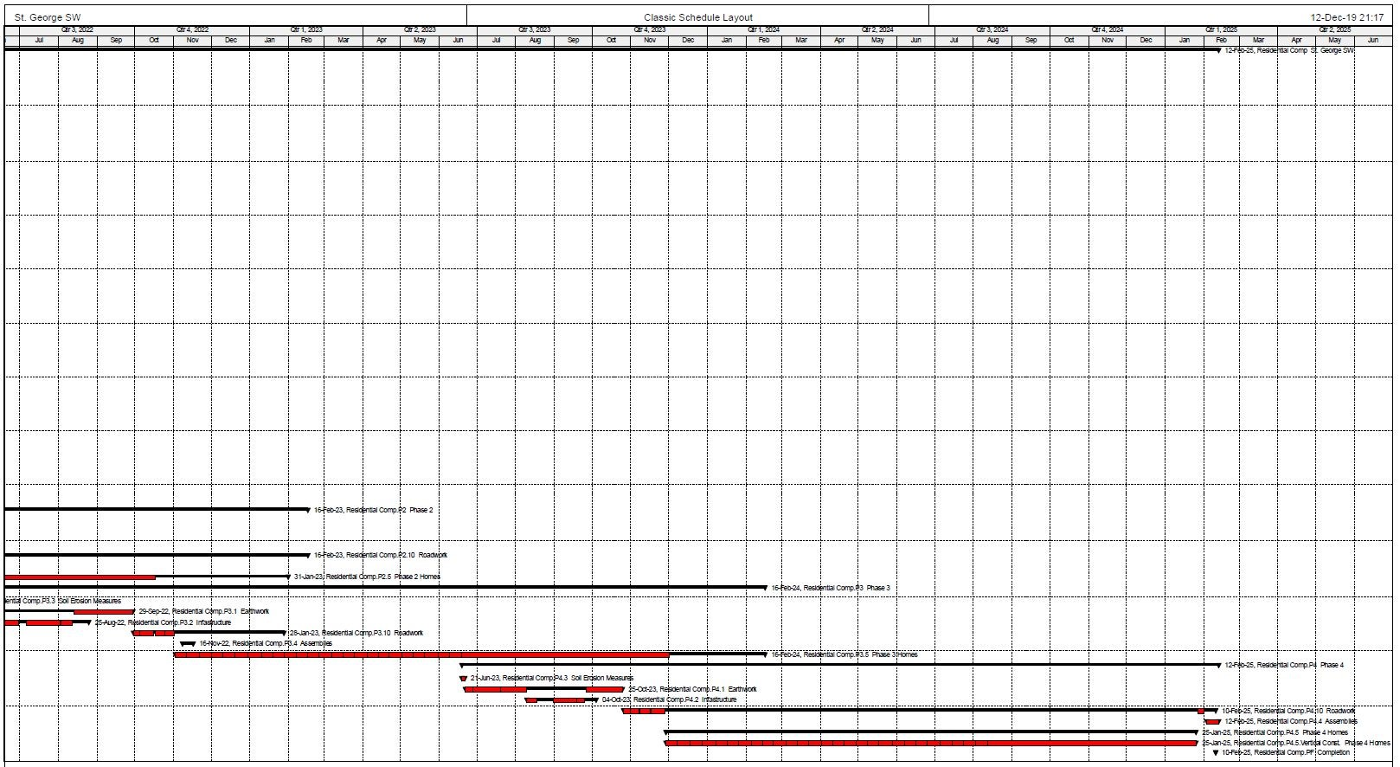
Estimates and Schedules: Site work Schedule

Estimates and Schedules: Home Schedule
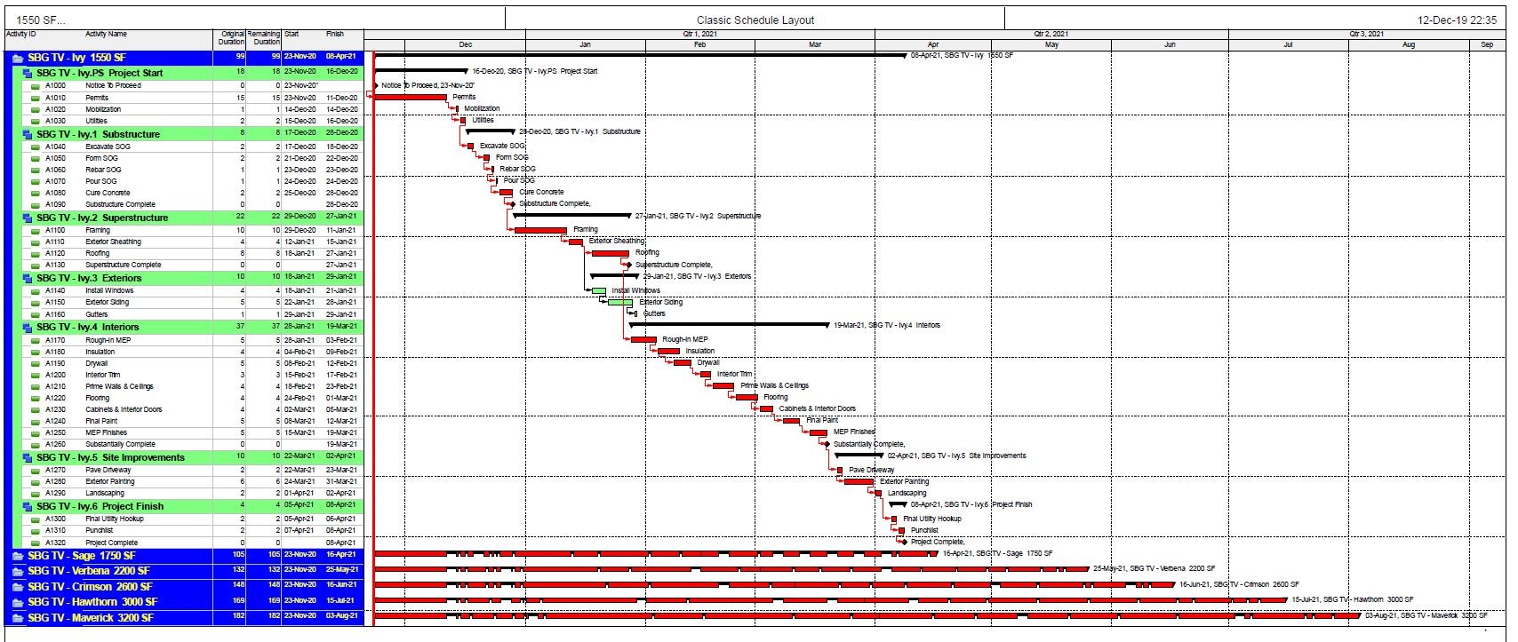

7.0 Financial and Risk Analysis
Spartan Building Group is proud to display 5 cost flow scenarios based on shifts in both market demand and economic shifting that may occur during the 5 years of the project. These Scenarios display internal Rates of return varying from 3.1% to 21.4%. Our risks have been identified and we have taken steps to mitigate this risks outlined in the subsequent sections of this chapter.

7.1 Financial Summary
We have analyzed several cash flow scenarios our base scenario Spartan Building Group has performed several cash flow scenarios based on shifts in consumer preference and economic prosperity. The base scenario pro forma is presented in its entirety in this section. In total we completed 4 separate proformas, but for brevity we have included the major highlights in the later portions of this chapter.
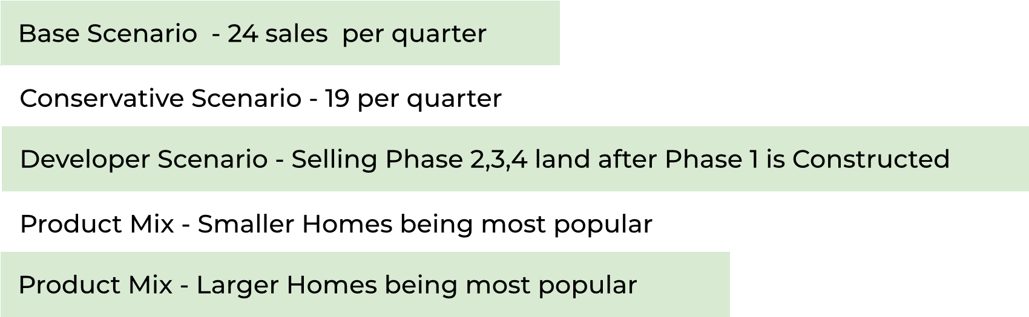
We have isolated project risk to a few key areas including: 1) financial, 2) legal and 3)construction and schedule risks. This information has allowed us to create our scenarios and format our schedules to adjust for the market conditions. These cash flow scenarios produced internal rate of return values ranging from 3.1% - 21.4%, with our baseline scenario at 20.5%. For brevity we have included key pieces of information from each scenario, we can provide a full backup of the various Cash flow scenarios upon request.

7.1.2 Land Acquisition and Development Costs
Spartan Building Group will be submitting an offer of $12,870,000 for the 130 acre parcel. This number was reached by calculating the average land costs in the area, totalling between $110,000 and $130,000 per acre.
Based on the subsurface clay shown in the geotechnical report, we calculated the number of acres we would be unable to economically build on as a percentage of the total parcel as 19%. Realizing this percentage as a reduction in the offer price was unreasonable, we met in the middle at 10% which we felt was fair for both ourselves and the seller. Table 7.1 shows the different values we calculated to get to our total offer price for the land. Table 7.2 shows the estimated costs and durations added to our schedule and estimates due to the clay, which ultimately helped us decide to avoid constructing on it, and instead create community open space.
We have 20 homes in the flood plane as shown in section 2.6, we have included a $15,000 value of upgrades for these residents which is the value of flood insurance over the typical 15 year home ownership to encourage them to purchase these less desirable properties,
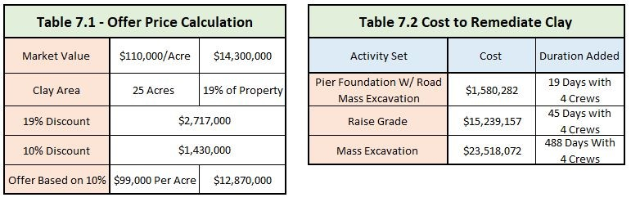

7.1.3 Building Construction Costs
Spartan Building Group is proposing the following building construction costs as shown in Table 7.3, this shows our average construction cost per square foot of each of our homes. The sale price and sales cost per square foot are representative of our market analysis and cover all of our costs associated with construction.

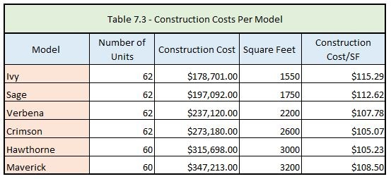
38

7.1.4 Sales Cost
Spartan Building Group is proposing the following sale prices for our various models based on our market analysis regression equation from section 1. This includes the individual lot contributions to the site work as well as the individual home construction costs.
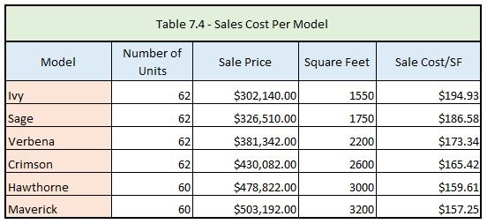
Our base cash flow scenario is based on a realistic approach to the St. George Market to establish our sales and home construction pace. Table 7.5 highlights the major financial parameters we used in our base cash flow scenario, as well as the results it yielded. Figure 6.5 is the financial pro forma that these variables are associated with, subsequent proformas with key variables will be in a table, such as Table 6.5, for your convenience but can be provided at your request.
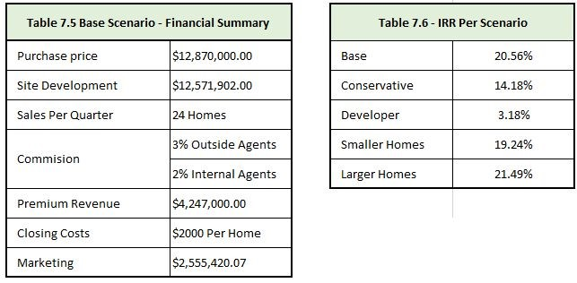
39

7.2.1 Return on Investment
Based on our expected cash flow which is premised on the sales pace of 24 homes per quarter, we can achieve an IRR of 22%, with a total sales revenue of $19,200,704 and a completion of March 2025. We also have analyzed the results a less aggressive sales pace, shift in market demand to sell more of either the larger homes, or the smaller homes, and a developer scenario with us developing the site and selling the lots. All yielding a positive IRR as shown in Table 7.7.

7.2.2 Base Cash Flow Assumptions
- Pro - Forma begins March 1st with the acquisition of land.
- Replatting and Permits Push our Site work Start back to April 27th 2020.
- Based on 6 working days for the first phase and all home construction, standard on site work phases 2 and 3, holidays off.
- First Home closing March 2021 and last home closed on December 2024
- Project completion February 2025
- Inflation rate of 2.5% applied to the NPV calculation. ● Based on paying the cost of the site up front in full.

7.2.3 Base Cash Flow Scenario
The expansion of table 7.7 below, is shown in Figure 7.6 with a project completion of the 1st quarter in 2025, or the 20th quarter of the total project.
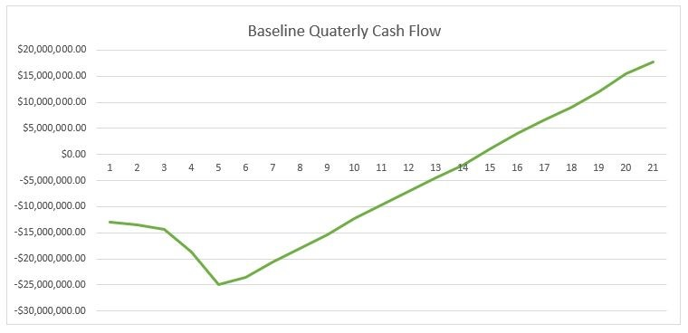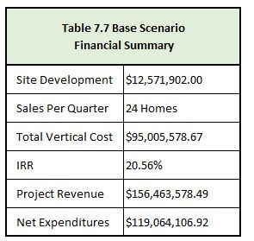
Figure 7.1 - Baseline Cash flow Scenario
40

7.3 Alternative Cash Flow Scenarios
As previously mentioned, for brevity we have included the highlights of the financial pro forma for the other cost scenarios as shown in Figure 7.7 and can provide the full breakdown at your request.

7.3.1 Conservative Cash Flow Scenario
Our conservative cash flow is driven by a sales pace of 19 homes per quarter, which would push our completion date back to the 1st quarter of 2026. We understand this does not meet the time restriction we are provided, if this route is the one we must take, we will coordinate with Desert color to ensure minimal impact to the surrounding neighborhoods. Figure 7.2 shows our cash flow in this scenario, as you can see it pushes back the break even point to the 15th quarter. Table 7.8 shows the parameters and results of the proforma for our conservative scenario cash flow scenario.
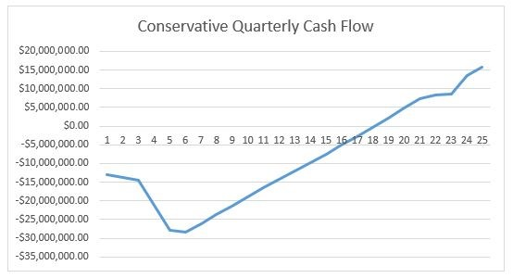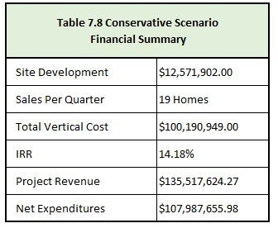
Figure 7.2 - Conservative Scenario Cash Flows

41

7.3.2 Asset Liquidation Cash Flow Scenario
Our asset liquidation cash flow scenario is based on constructing the 91 homes and the community center in the first phase, selling the remaining 89 acres at $99,000 an acre, and sell memberships to the community center until we sell it as well in the 12th quarter of the project. . These rates are at $100 per month to an expected 100 people living in the community and others outside of the development until we sell everything in quarter 12. This yields a 3.1% IRR, which is not as high as we hoped for, but still shows in the event of an economic downturn we can remain profitable on the project. Table 7.9 shows the parameters and results yielded with the asset liquidation cash flow scenario.
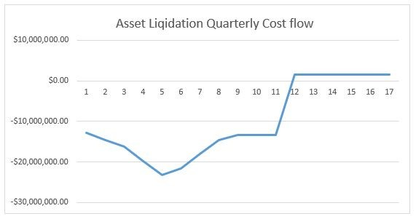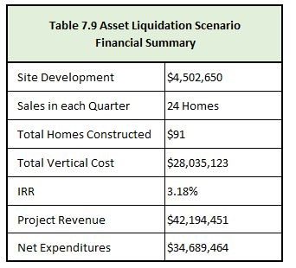
Figure 7.3 - Asset Liquidation Scenario Cash Flow
42

7.3.3 Small Homes Cash Flow Scenario
Our small homes cash flow scenario is based on a sales pace of 24 homes per quarter and achieves an
IRR of 21.7%. We have included a higher percentage of the Ivy, Sage, and Verbena models at 28%, 22% and 20% respectively.In the event that our larger models, the Crimson and the Maverick are not as popular as we had expected. Our risk surrounding the larger model is that there are few homes that size offered in the semi-custom home market. We feel that this will not be the representation, but shows that we can still achieve a positive IRR with a change in consumer demand. Table 7.10 shows the parameters and results associated with the pro forma for the small homes cash scenario.
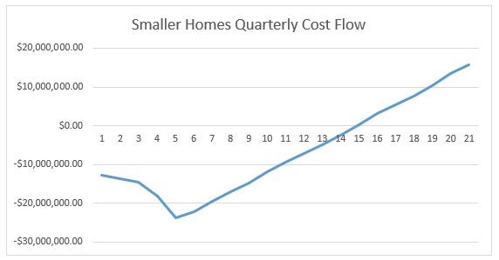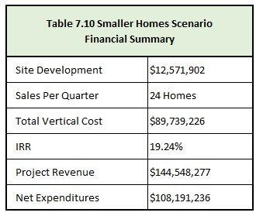
Figure 7.4 - Small Homes Scenario Cash Flow
43

7.3.4 Larger Homes Cash Flow Scenario
Our large homes cash flow scenario is based on a sales pace of 24 homes per quarter and achieves an IRR of 25.8%. We have included a higher percentage of the Maverick and Crimson at 28% and 22 percent respectively. We kept the Verbena at 20% as we feel that interest for that home will not change significantly over the different scenarios, and we included lower percentages of the Ivy and Sage. With our competitors not offering the larger homes, we feel that our larger homes may represent a larger percentage of the home distribution. Table 7.11 shows the parameters and results achieved through the pro forma of the larger homes cash flow scenario.
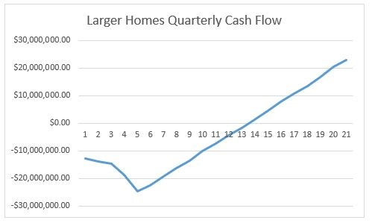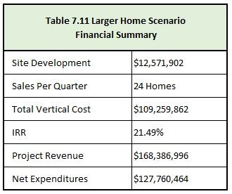
Figure 7.5 - Larger Homes Quarterly Cash Flow
44

7.4 Risk Analysis
Spartan Building Group has made it a priority to retain our attention to detail, and with a project of this size and the time constraints, it is important to ensure our teams have the right tools to rise above the competitors. We have identified the following risks associated with Terra Valley at Desert Color as seen below, we feel that we have mitigated against these risks appropriately.

7.4.1 Financial Risk
Because we are self financing this project, it is especially important to ensure that all items are accounted for and that we have built in enough time and contingency to shield ourselves from a possible market shift. As identified in our different cash flow scenarios, we are able to produce a positive IRR under several different circumstances, which we feel is a key factor in mitigating the financial risk associated with this project. With that, we also have the site work and home contingencies, these are designed to mitigate the financial risk associated with a geotechnical error.Our surface soil is non-collapsible, so therefore we have not included any provisions in the costs of the home to mitigate this, we have however included post-tensioning tendons in a $1,000 per home cost outlined as a separate line item in all the cost scenarios, and broken out as a line item in our pro forma.

7.4.2 Legal Risk
Spartan Building Group has a track record of well constructed, long lasting homes. In continuing this practice, we prepare our trades to build to a higher standard and coordinating weekly with major trades on site to ensure that the expectation is understood and either met or exceeded.

7.4.3 Construction Risk
As previously stated in the project management section, we have a large deposit of subsurface expansive clay covering roughly 25 acres of the site. We have identified the financial side of this above. From a construction standpoint, we have mitigated this risk by keeping any of the vertical construction out of the areas containing this clay, and keeping our roads over that area to a minimum to prevent heaving with the expansive nature of this clay.

7.4.4 Schedule Risk
In the St. George area, we have observed a significant trades labor shortage , as mentioned in the project management section. To mitigate this risk, we are adding a 30% increase to scheduled durations to account for the lack of trades, and we have set up panelizing of wall sections to retain the crews once they arrive on site.We feel that our best method of mitigation in this area, is to keep our crews on site once they mobilize it is in part why we are running 3 homes in parallel, this tactic also allows us to get to our quarterly take down rates and ultimately complete this schedule before our deadline.

7.4.5 Recommendation
Terra Valley at Desert Color is sure to provide each homeowner the ability to customize their homes exactly how they would like. With the wide range of options, elevations and floor plans, there is sure to be something for everyone. We have committed ourselves to providing a comprehensive analysis of the risks in the market, and have adequately shielded ourselves from these. Therefore, Spartan Building Group is formally recommended the discussed plan the discussed plan for 368 single-family detached lots with an IRR of 20.5%
45

Financial and Risk Analysis

7.5 - Baseline Financial Pro Forma
46
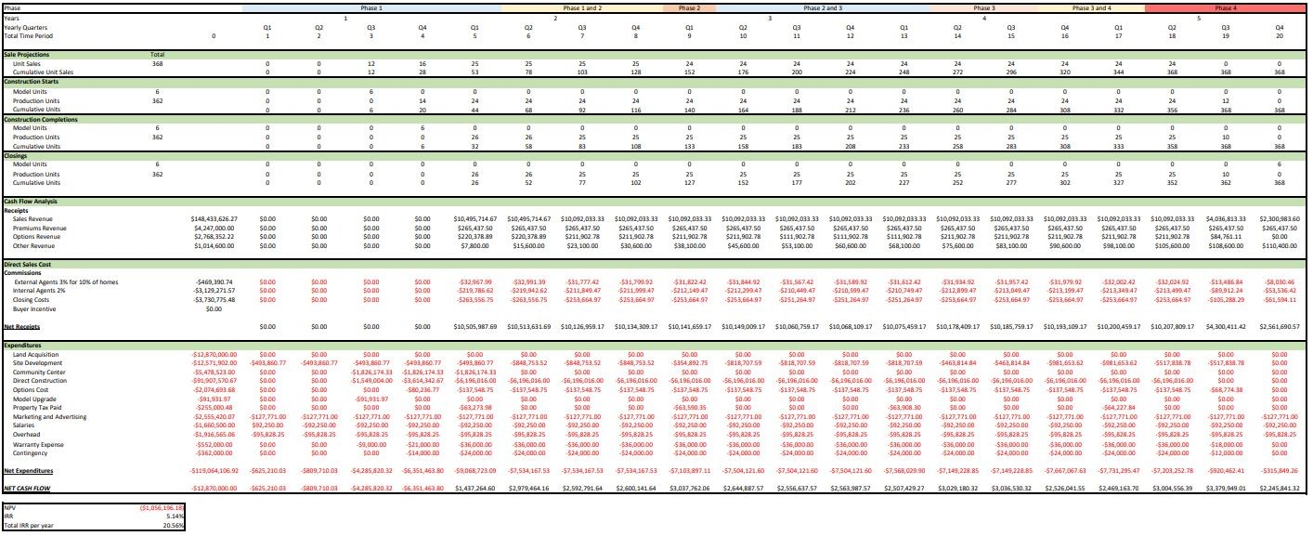
Figure 7.6 - Baseline Financial Pro Forma

8.1 Core Values
Spartan Building Group is determined to be the leading builder in the St. George and greater Washington county area. We pride ourselves on establishing a desirable community and delivering upon the quality and designs we hold ourselves accountable for. Our objective is to make the transition for our customers into a new home as smooth and stress free as possible.

8.2 Sales Strategy
We plan to offer each customer a custom experience as they look forward to buying one of our attractive homes. Each model will be suited to this individual style of every customer with its amenities and upgrade options. Our staff will personally sit down with each customer to make sure the model they are seeking is laid out in detail. The sales team will have golf carts available to see to it our clients are well taken care of during model visits.
The age of our clientele suggests that there may be interest in buying homes using a reverse mortgage. This plan, with the help of the bank of Utah, will be presented to potential buyers. If they express interest, we hope to make the buying process simple and help our clients enjoy the active lifestyle that comes with activities outside or within the great state of Utah. Our sales team will be knowledgeable of the many natural wonders, sites and trips that buyers may wish to see when they make the move to Utah.

8.2.1 Sales Team
8.0
Sales and Marketing
Summary
Within our Sales and Marketing we envision capturing the 55+ marketing through strategic online
marketing, an efficient sales force, and both national and local media outlets to garner attention from
buyers. Our goal is to maximize our budget to assist in the sale of homes and produce cash flow.

Our sales team will be well informed on the multiple models and upgrades that can potentially capture a buyer’s attention. Each of our sales team members will be paid a base salary, and we reward our team with a 2% commission for each home sold. For the holiday season, starting in late November to the beginning of January we offer a 0.50% commission increase as a bonus. Our goal is to keep our sales team motivated to personally see that customers needs are being met and to ensure timely sales. At Spartan Building Group we welcome outside realtors! To meet this goal, our inside sales team will host broker open houses and invite local realtors to visit our model. Special broker and realtor events will also be held every three months. Our inside sales team will continue to earn a 2% commission on a home sold by an outside agent, and we are offering a full 3% commission to outside realtors.

8.2.2 Sales schedule
Sales prices of our homes will average $173/sf while the competitor’s price per square foot is $178. We believe this gives us a great foothold within the market and allows for a solid foundation to build our sales platform and realistic sales schedule. The sales schedule is expected as shown in the table below. The schedule was created through an in-depth calculation of the sale expectancy of each home plan, combined with construction starts and total closings per month. Figure 7.1 gives a good sense of when Terra Valley’s peak sales are expected to be throughout the year. The model home sales have also been estimated to sell in the Spring of 2024 with potential to begin selling as early as the spring of 2023 with buyer understanding of a closing date set for October, 2024.
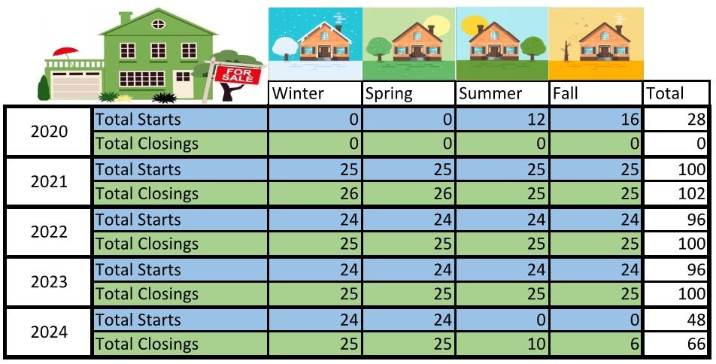

Figure 8.1 - Starts/Closings

8.3 Model
We will have six fully upgraded model homes ready and available for tours, so that we are able to keep the needs of all buyers in mind. The model homes will be the last available homes for sale. In the first year of development, our six model homes will act as speculative homes. They will be located very close to our community center, allowing prospective home buyers to see all that Terra Valley will have to offer. Our sales staff of 4 realtors will work every day of the week on a staggered schedule. Office hours will be available Monday 10am-8pm, Tuesday 12am-8pm, Wednesday 12am-8pm, Thursday 10am-8pm, Friday 10am-8pm, Saturday and Sunday 9am-8pm..

8.4 HOA
Terra Valley will include an affordable HOA fee, with several beneficial features. HOA fees will be $100 per month, and we plan to keep fees at a fixed rate for the term of our community ownership. This will be achieved through the lease of Recreational Vehicle (RV) lots to our residents. The fees collected from these lots will allow us to avoid any increases that may be necessary for the HOA fee to remain fixed.
Fees will also cover community pool maintenance, trash removal services and landscape maintenance for community areas and entrances. Pest control inspections to prevent any pest infestations, standard mailboxes and repairs, and road and sidewalk maintenance are also included.
Some great features that we plan to incorporate into our community include a community dog park available to all residents and monthly transportation to and from surrounding state and national parks. We believe these are great ways to get our community involved with one another and to be able to enjoy the location in which they have chosen to live. If the community shows interest we may also include quarterly trips to Las Vegas for extended and holiday weekends
48

8. 5 Marketing and Social Media
We will be partnering with a national marketing agency, Bloom. The majority of has been a part of many active adult communities’ marketing campaigns, and with our target market coming from out of state, we believe their national reach is what is needed for such a campaign. Bloom will assist with our strategic marketing plan. Such assistance comes in the form of website design and management, online marketing techniques, print, direct mail, and management of other marketing platforms. Bloom will also help our community define a sense of our brand and what would appeal to our demographic. With Bloom we can expect to deliver robust outreach the adult community living in the western United State.
Bloom will dedicate time to engaging our audience in a meaningful way on social media sites, with a primary focus on Facebook. Bloom states it will primarily focus on Facebook as a means to target our demographic by posting relevant topics, photos and community updates. Other social media platforms will be updated similarly to that of Facebook and with the help of a search engine optimization, we will have the internet traffic desired to ensure that our message and community is presented accordingly. Facebook analytics will be used to see what posts have the most positive impacts and interaction with our audience and similar posts will be increasingly uploaded to our platforms. Based on targeted analytics for Seattle, Portland, Southern California, Salt Lake City, our social media budget will yield upwards of 6,400 impressions per day among men and women aged 55+ with an interest in residential real estate. This yields over 2.3 million impressions annually. Of the 55+ community, 70% are active on Facebook with many being active on additional social media outlets.
As well as the assistance from Bloom, extra marketing techniques including the Parade of Homes and paid advertising in “Where to Retire Magazine” Terra Valley’s marketing path. The annual new home Parade of Homes is held in February of every year and will feature two of our models homes. The average year brings through thousands of potential clients. Where to Retire Magazine is nationally recognized and will generate additional outreach.

8.6 Partnerships
Spartan Building Group will partner with local businesses such as AWI Networking and the Bank of
Utah for lending. Our business with a local entity is valuable to our belief in community building and
AWI promises to offer great packages for fiber optic internet. With our partnership with AWI Networking and the low costs they provide, we aim to please our buyers with the very best internet support. Through our partnership with The Bank of Utah we aim to assist our buyers in the purchase of a new home. We believe our clients will really benefit from the lower rates that we are able to promote. The Bank of Utah has helped many of retirement age to secure a reverse mortgage. Buyers will also be pleased to hear that our partnership with DirecTv will secure discounted home phone and television packages. Other local partnerships include discounted rates with Taylor Made Fencing to help buyers with fencing installation at their new home, St. George Lawn Care for any gardening services that homeowners may require, and St. George Grocery Delivery to help our retirement age buyers with lower delivery costs on everyday grocery items.

8.7 Buyers Incentives
In order to keep our buyers motivated during low sale seasons, Spartan Building group will be applying .5% of our projected sales revenue towards incentives as well as a flat rate of $2,000 towards closing costs. As a standard, we will apply $1,000 per home towards a signing upgrade of the buyer’s choice. This would be a total package of $3,000 per home to be applied to upgrade countertops, a higher appliance package, or credited all towards closing costs.
49
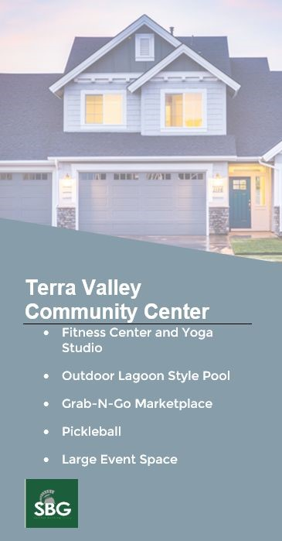
Customers who close on one of our model homes homes will have the interior of their home freshly painted, professionally cleaned, and $1,000 provided towards closing costs. This promotion is valued at $5,000.

8.8 Terra Valley Amenities
It is our belief that our community is of greater quality than our other St. George 55+ counterpart, Sunriver. At Terra Valley our design team will assist buyers in customizing one of our quality homes. We also are accepting of all ages within the community. We understand that many residents have grown disgruntled from Sunriver policies on younger visitors within the community. At Terra Valley, we have heard those complaints and welcome residents to have families or grandchildren to visit and fully partake in the community.

8.9 Lot Premiums
We have analyzed the market trends in the St. George and Washington County area to develop premiums to generate additional revenue. Figure 8.2 details additional revenue for lot premiums.
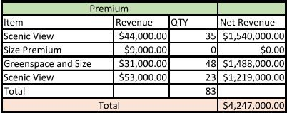 Figure 8.3 - Pamphlet Example

Figure 8.2 - Lot Premium Sales Price
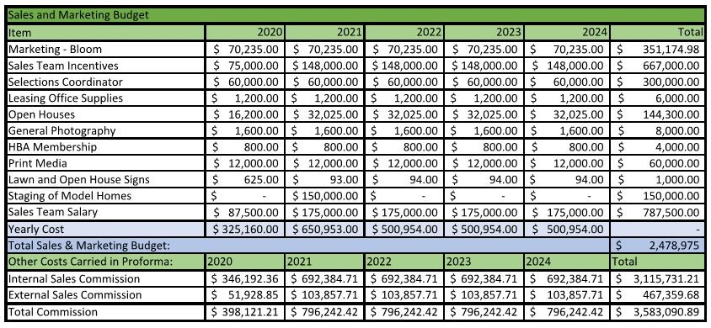

Figure 8.4 - Budget Breakdown
50

