Impact of Total Quality Management Practices on Customer Satisfaction case study at Makkah Water Company (SAFA)

LITERATURE REVIEWS
- Use analytical review NOT theoretical
- Analytical review contains hypothesis, results, techniques, tools has been used for data collection. write about it
- Find the gap and write about gap or the flaws in the review
- The independent variable is the customer satisfaction
- The dependent variables are:
- contentious improvement
- information Technology
- management of process quality
- quality reporting and benchmarking
- 5-7 reviews for each variable
- Each variable at least 4 pages of reviews
- Sort it by years as follow: Variable one:
- Name (2011)
- According to name (2012)
- Noted by (name 2013)
- Total number of pages for the literature review 17-20 pages
- The resources must be within 5 years
- Apa style
- Use Each variable as headings sthe resources include: Journal article Academic research Peer-reviewed journal article
- 16-20 resources

NO Plagiarism

The title gives two perspective views first the independent variable which is the Customer Satisfaction. Second the Total Quality Management brings 4 dependent variables to Practices on Customer Satisfaction. The 4 dependent variables have been chosen in the study is:
- Continuous improvement
- Information technology
- Management of process quality
- Reporting and benchmarking
Each variable has a sub-factors to organize the study in specific points. Talk about the variables and the sub-factors of it.

1-Continuous improvement

The technique the company uses when it comes to their Continuous improvement is six sigma.
Under Continuous improvement there are several important areas that must be met for a Lean Six Sigma program to be successful.
Critical Success Factors
• Commitment: A senior leader who can set priorities, commit resources, break down barriers, overcome resistance and is committed to improving the customer satisfaction
• Disciplined approach: Regular customer satisfaction reviews should be conducted with process owners and senior management.
• Common tools and language: Training needs to be used to develop common language, knowledge and problem-solving approaches customer satisfaction

2- Management of Process Quality variable
I used PDAC method in Management of Process Quality.
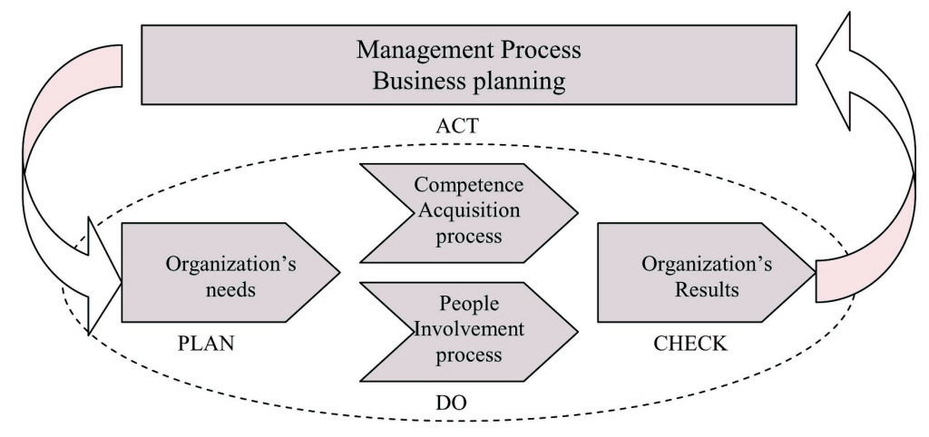

3- Information Technology variable
• Communication and Relationship: Business-to-Customers communication and relationship, satisfies customers and impact their intension to repurchase. the ability to provide online answers to problems through resolution guides, archives of commonly encountered problems and electronic mail interaction 24hours a day, 365 days a year, impacts customer confidence, satisfaction and retention.
• Accessibility: adopting advanced IT leads to increased information accessibility, which increase the speed and effectiveness with which customers can change information into decision. Customers would naturally stick to the Internet merchants whose website is easier to surf and who gives them the detailed information.
• Convenience: save efforts of driving, pushing trolley around the mall in search of products and loading/offloading products from vehicles. The extra value that consumers derive from online transactions stems from loosening the day-of-week and time-of-day constraints of traditional markets by offering a nearly continuous shopping convenience.
• Speedy Process: IT enables movement of information to occur immediately, without any delay with respect to the in-process inventory that permit customers to place order, make payment via credit cards and have their products delivered at their doorsteps
4-Reporting and Benchmarking variable
To measure customer satisfaction with benchmarking. First define what to benchmarking. Which is customer satisfaction in this study. Second define appropriate comparators. The company uses SERVQUAL which measures "service + quality." With 5 elements: RATER. Reliability, Assurance, Tangibles, Empathy and Responsiveness. The questions in the survey summarized the 5 elements of SERVQUAL scale.
- Reliability - the ability to deliver the promised service in a consistent and accurate manner.
- Assurance - the knowledge level and politeness of the employees and to what extent they create trust and confidence.
- Tangibles - the appearance; of e.g. the building, website, equipment and employees.
- Empathy - to what extent employees care and give individual attention.
- Responsiveness - how willing the employees are to offer a speedy service

