THE DECLINING ELASTICITY OF US HOUSING SUPPLY
Student name
Institution
Course
Date

Summary of the article
The article summary is about the declining elasticity of US housing supply. The housing prices in the United States have rose by about 30% in the past six years. The supply of houses in US has substantially decreased despite of the increase in the price of the houses. There have been two housing booms which have had a similar price improvement but on the other hand they have experienced a weak recovery construction. Housing market is defined as a group of various markets and it consists of many features that does not only include terms of geography but also differential regional housing prices. According to Gyokuro, the regulatory constituents are measured by the use of Wharton Regulatory Land Use Index. This regulatory index measures the specific time and financial cost that is acquired through building permits and construction of new homes. In the housing market, supply has a unique reaction to the demand that driven by the change of the house prices. Therefore, housing supply is separated from housing demand by using an instrument called variable IV approach. The housing prices cause a shift in the demand curve but does not affect the shift in housing supply curve. The instruments that does not affect the housing supply in the US are income and crime rates in the society. Declining housing supply in the United States of America is the one that has led to effectiveness of the monetary policy for the financial stocks of the aggregate stock.
Analysis of the article
In the normal circumstances, an increase in the price of any given commodity or service, it follows a high supply 0f the same commodity in the market. This is different to the housing market in the United States where the increase in the price o houses does not lead to the shifting of the demand curve of houses to the right. According to Haughwout, he states that there are many different reasons why there is no quick response of supply to house prices. Supply has generally declined due to the tighter land and cautionary reasons. Keukenhof states that, “elasticities have declined in most of the areas where regulation has tightened more.” The state of the housing market in the United States differs across the Metropolitan Statistical areas. Housing elasticities indicate that there has been a decline since the last house boom from 2.63% to 1.75% in the year 2012. There are unique reasons that make the supply of houses in the US Metropolitan areas to differ such as some areas geographical areas steep grounds and large water bodies which make it difficulty to construct uses at locations even if there is an increase in house prices. The areas such as the Coastal areas which experienced the lowest elasticities in the end had a large decline in elasticity of the two booms.
The figure below shows price developments across booms
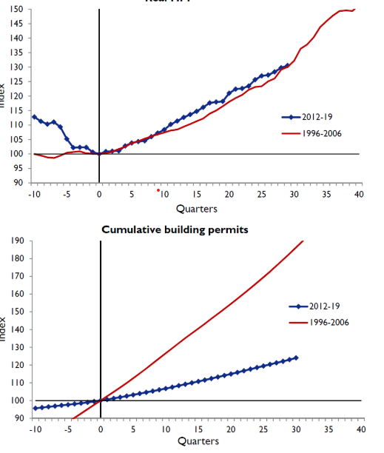
Thinking critically.
United States of America has experienced a decline in the housing supply despite the increase of the house prices. According to Paul, “the monetary policy has become more effective for the financial variables.” This explains the fact that if there is a cumulative shock that will cause the demand of houses, it can be neutralized by adjusting the prices. Therefore, the policy actions that arouse demand of houses can have inadvertent impacts by raising house prices.
References;
https://voxeu.org/article/declining-elasticity-us-housing-supply

