
LAW CAREER PORTFOLIO

Lawyer with 10+ years experience representing environmental advocacy groups in citizen suit claims seeking damages, Child support services including programs and services from organizations besides CPS, and injunctive relief under the federal Clean Air Act and Clean Water Act. Specialist in facilitating aggressive enforcement of environmental protection statutes and assisting plaintiffs to seek maximum recovery for personal injury, property damage, and medical monitoring based on exposure to hazardous substances. Member of Environmental Law Institute and have obtained advantageous settlements in 90%+ of cases. Looking to leverage my expertise as environmental attorney.

Law License

Bar Association
Member in good standing of the Smallville Bar Association

Professional Experience

Attorney
Victor and Allan LLC, Louisville, KY
Aug 2012–Present
- Defended high profile corporate client against alleged breach of Kentucky Clean Air Regulations, achieving successful outcome in highly publicized trial. Won settlement for client in subsequent civil action.
- Achieved advantageous pre-trial settlement in 95% of class action toxic tort cases where plaintiffs sought recovery for personal injury.
- Mean client net promoter score of 9.
- Maintained annual average of 2000 billable hours.
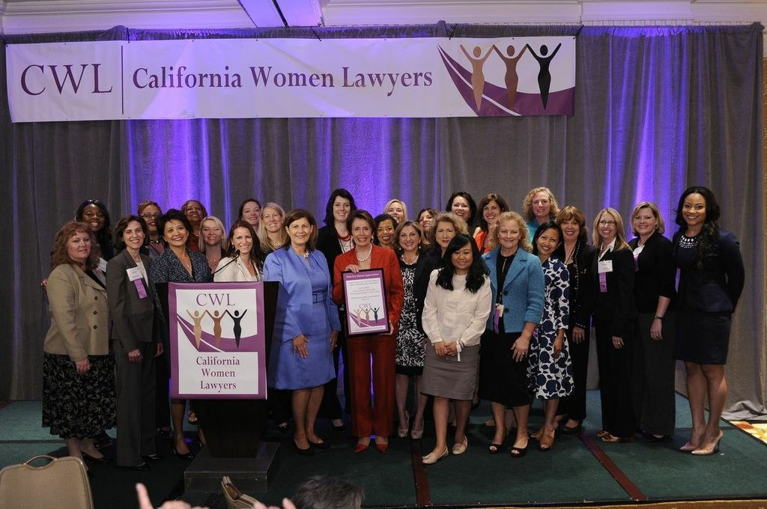

Junior Attorney
Novel and Cathy Associates
Nov 2008–Aug 2012
- Assisted senior attorneys with pre-trial research for corporate clients defending against enforcement actions relating to violations of discharge permits. Contributed to successful outcome in +90% of cases
- Developed strategies specific to not-for-profit organizations, increasing mean client net promoter score from 6.5 to 8.
- Interpreted laws, rulings and regulations regarding environmental quality
- Maintained annual average of 2100 billable hours

Education

Juris Doctor
University of Kentucky, 2005–2008
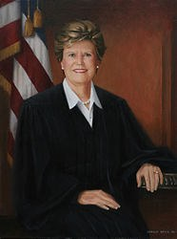
- Pursued a concentration in environmental law
- Winning team, Earle E. Zehmer Moot Court Competition 2007
- Published faculty/student paper in conjunction with Professor Agnes Acopio in Environmental Law Review ‘Geopolitical Consequences of Environmental Regulation’


Bachelor of Science
University of Kentucky, 2002–2004
- Major in Economics
- Minor in French
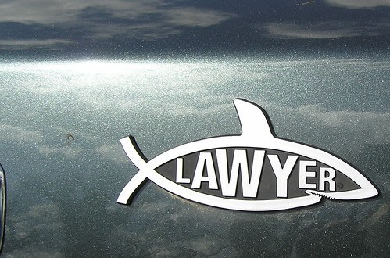
Key Skills

- Ability to craft winning arguments for court—achieved successful outcome in 90% of contested cases.
- Adaptable to change—led on training in implementation and practice of new state and federal environmental legislation and regulations
- Knowledge of key environmental protection legislation—subject matter expert in CERCLA, RCRA, mini-Superfund statute, chemical handling, and registration laws.
- Knowledgeable in Child support services and advocacy for child rights.
- French—Fluent

Journals

- Environmental Justice: A Growing Union 124 Tennessee L. Rev. 1001, 1011 (2013)

Conferences
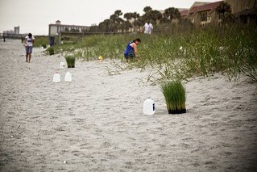
- Mid-South Agricultural and Environmental Law Conference—Spoke on panel about waste water discharge regulations 2017
- Southeastern Environmental Law & Regulation Conference, keynote speaker 2014-2018

Community Work

- Volunteer lecturer for Kentucky Association for Environmental Education
- Board member Kentucky Conservation Committee
- Pro bono work for Bluegrass Land Conservancy


