Trade Wars

Student’s Name
Institutional Affiliation
Date

President Donald Trump ordered the companies in the United States to stop the trade ties with China. This had the effect of shaking the foundation upon which the international trade was based. He did this by imposing heavy tariffs on goods worth billions of dollars from Canada, Mexico, the EU, and China in particular. He stated that the United States was losing billions of dollars on its trade with countries such as China and that the gains would benefit the U.S. in offering assistance to the needy countries. This would have indirect negative effects on the consumers and the businesses in both countries. The farm producers would also be affected by the imposition of the new tariffs as they would affect the market served (Bolt et al., 2019).
Reasons for President Trump’s Use of Tariffs in Trade War
Former President Trump saw it good to use the trade war through the imposition of a 10% levy on hundreds of billion dollars worth of products from China. He argued that the $100bn that would be gained from those tariffs would be useful in helping the United States purchase agricultural products. These agricultural products would then be used to help the countries suffering from poverty and starvation. In other words, he would use it for humanitarian assistance. Another reason why he used the trade war was that he felt that China had been using unfair practices in trade from the time he assumed office as the president (Hosain & Hossain, 2019).
Imposing the tariffs on China by the United States was a practice unworthy of undertaking from the great harm it caused. The majority of the net income for the U.S. comes from those services. Trump administration’s goal was protectionism. That is, he wanted to protect the United States against foreign competition. This would negatively affect U.S. consumers in the long run because the companies in the U.S. would require raw materials. Accessing them would mean that the prices of the raw materials would have to be pushed up. Another method would have worked better for both countries (Swanson, 2018).
Effect of Tariffs on Farm Business
Tariffs may affect the business involving the production of farm outputs. Being a farmer in Lowa, I would greatly suffer as a result of the imposition of tariffs by the United States on China. My business would go down because of the loss of the market for my exported products. The pie chart below shows the relationship between different imports of the United States by China.
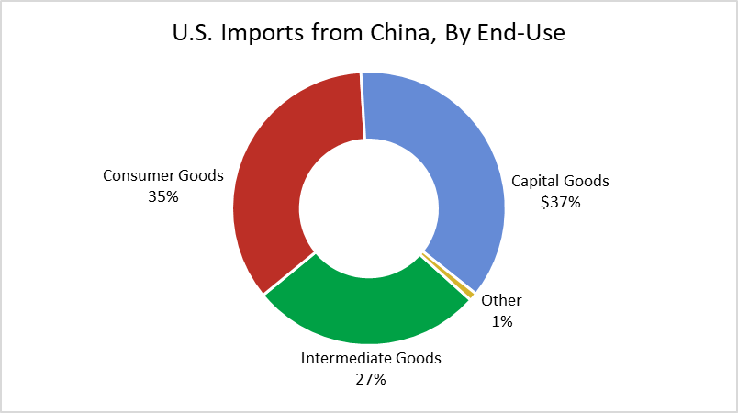
Figure 1: Imports of United States from China.
From the chart above, it is clear that 35% of the goods that United States imports from China is comprised of the consumer good. This forms the biggest proportion of goods where my farm products would fall. Where tariffs are placed on farm products, it would lead to a rise in prices for both producers and consumers. This would lead to depression in the economy where my business would also not be left out. On the widest part, the cost of living for the farm producers would increase because it would then be impossible to lead the earlier used life where accessing necessities would be possible. I would be depressed economically whereby I would be left with an option to shift to another sector of the economy (Swanson, 2018).
Effects of Tariffs on Individuals and Businesses in the United States and China
The tariffs by the United States would have an indirect impact on both businesses and individual consumers. For instance, they would indirectly raise the prices incurred by the consumers because firms would pass the increased costs of production into the prices of the products produced (Hosain & Hossain, 2019).
On the part of the Chinese, the tariffs imposed by the United States would affect such businesses as vehicles industries, soybeans, aircraft as well as chemicals industries. The United States administration also targeted industries such as electronics, engines, metals, generators, pharmaceutical industries, and rubber products among others. The effect that the tariffs would have on the prices of the products may differ from one industry to another. A greater effect would be felt by the consumers of electrical equipment, accumulators as well as batteries. The United States imports a third of the listed products from which a good number are imported from China. This means that the tariffs would lead to inflation on the prices of the products and impact the respective industries (Zheng et al., 2018).
Lastly, the tariffs on weapons, metals, pharmaceutical products as well as transport equipment would not experience a lot of effects. These products are made in China and they do not account for a big number of imported structures in the U.S. Therefore, it would be possible for the manufacturers in the United States to replace these products by importing from other countries. However, tariffs on some products whose costs of switching are high may lead to an inflation of the prices incurred for inputs. This is the case for the consumers of weapons, metals, pharmaceutical products as well as transport equipment (Hosain & Hossain, 2019).
In conclusion, a trade war in form of tariffs imposed by President Trump resulted in more harm than benefits. As much as he was trying to protect his economy from foreign competition, many sectors of the economy in both countries were greatly hit. Instead of the trade war with the Chinese, Trump would have sought a better method of dealing with the issue. In the future, the two countries should have a peaceful productive agreement that will see to their benefit without harm to any of them. This way, the consumers and the businesses will have been protected against collapsing. Being super powerful nations in the world, I don’t think any of the two countries will submit to the other so that a decision to end the rivalry is agreed upon. However, an earlier realization that they need each other for economic progress will save them from the drastic economic depression.

References
Bolt, W., Mavromatis, K., & Wijnbergen, S. (2019).The Global Macroeconomics of a Trade War: The EAGLE model on the US-China trade conflict.
Hosain, S., & Hossain, S. (2019). US-China Trade War: Was It Really Necessary? International Journal of Business and Economics, 4(1), 21-32.
Swanson, A. (2018). US and China Expand Trade War as Beijing Matches Trumpʼs Tariffs.
Varas, J. (2018). The Economic Impact of U.S Tariffs on China. Retrieved from https://www.americanactionforum.org/wp-content/uploads/2018/06/china-imports.png
Zheng, Y., Wood, D., Wang, H. H., & Jones, J. P. (2018). Predicting potential impacts of China’s retaliatory tariffs on the US farm sector. Choices, 33(2), 1-6.

