Radiologic technology
Name
Institution
Course
Date

Radiologic technology, pathology, and patient care
Introduction
With the number of hip arthroscopies rapidly growing in the last few years, hip arthroscopy is one of the fastest increasing procedures of surgery carried out by orthopaedic medics (Blankenbaker & Tuite, 2008). The growths in the surgical prevalence are at least in place because of prearthritic hip pathology increased awareness. The prearthritic hip conditions diagnoses are made through appropriate selection, a comprehensive history, and physical examination modalities of diagnostic imaging. In the last decade, the capacities of assessing and treating injuries about hips have tremendously increased. The hip arthroscopies number is expected to increase in the U.S. This is an enormous part because of greater comprehensions of hip pain causes and the ability of visualizing the pathologies with enhances imaging methods and techniques (Brian, Bernard, & Flemming, 2010). The painful pre-arthritic hip differential diagnosis is broad and beyond this review scope, nevertheless, the approaches to these populations of patients need to be reproducible and systematic. The painful pre-arthritic hip evaluation needs to start with thorough clinical examinations. Immediately the differential diagnoses have been narrowed, the modalities of the appropriate imaging need to be executed to confirm diagnoses as well as to determine and appreciate concomitant extra-articular and intra-articular pathologies which could guide and affect the plan of management. Generally, the hip diagnostic imaging may be accomplished with a number of modalities that include MRI or CT, magnetic resonance imaging (MRI), computed tomography, ultrasound, and radiography following intra-articular contrast injections (Kong, Van der Vliet, & Zadow, 2007). Extra-articular or intra-articular diagnostic injection under fluoroscopic or ultrasound guidance is also in place to help in the hip pain diagnoses.
Radiography
Following a physical examination as well as a thorough history, the initial technique of imaging showed is radiography (Matsuda, 2011). The radiography global objective is in refining the preliminary differential diagnoses obtained at the time of physical examinations and history. The groin pain or hip standard radiographic assessment need to start with the pelvis true anteroposterior (AP) radiograph and at least a single affected hip lateral view. Care needs to be taken in ensuring the proper x-ray beam centering and correct distance of film-focus in preventing altered joint morphology false impressions. This is particularly true for the radiography of AP pelvis, where the coccyx needs to be centered 1.5 – 2.0 cm and obturator foramina need to appear symmetric above the symphysis in avoiding acetabular over or under-coverage false interpretations. Additional affected hip imaging need to involve a view of lateral radiographic and true anteroposterior (AP) to quantify asphericity and offsets of the junctions of femoral head-neck (Martin, Irrgang, & Sekiya, 2008). Ultimately, affected hip false-profile radiography may be useful in obtaining general assessments of the anterior joint space status and anterior coverage of the femoral head.
The medic should carry out systematic reviews in ensuring comprehensive evaluations of all structures of osseous hip immediately the appropriate radiographs are obtained (Blankenbaker & Tuite, 2008). These reviews need to start with the true anteroposterior (AP) and essential reviews need to start with proper acetabular landmarks and lines identification that includes the sourcil (acetabular roof), the tear drop, the posterior acetabular wall, the anterior acetabular wall, the iliopectineal line, as well as the ilioischial (Kohler's) line. The version of the acetabular is examined by the assessment of the relationships between the between the radiographic lines which are representations of the posterior and anterior walls of acetabular. The posterior rims are seen lateral to the rims of anterior in normal individuals with a version of physiologic anterior acetabular. When the 2 rim lines cross to form a “cross sign” or “figure of eight”, this shows cranial or focal retroversion as experienced in femoroacetabular impingement (FAI) pincer-type (Brian, Bernard, & Flemming, 2010). Nevertheless, care should be taken not to make a mistake of down-sloping or prominent anterior inferior iliac spine (AIIS) with the sign of crossover to avoid errant rim recession risk in the focal retroversion absence. The anterior inferior iliac spine (AIIS) inferior extension may overlap the rim of anterior superior acetabular and be completely or partially responsible for crossover sign appearance even in well positioned and standardized AP pelvis as well as anteverted acetabulum settings (Matsuda, 2011). There should be careful anterior inferior iliac spine (AIIS) inspections on radiographs and further acetabular version quantitative assessment with advanced sectional imaging when there are concerns for retroversion of relative acetabular. The over-coverage of the global acetabular is examined between the acetabular fossa and ilioischial line. The line of the acetabular is lateral to the line of the ilioischial in the normal variant of hip, while in protrusio and coxa profunda, the femoral head and the acetabular fossa floor may be medial to the line of acetabular respectively. A negative angle of Tönnis is also a pathologic femoroacetabular impingement (FAI) pincer-type and the over-coverage representative (Kong, Van der Vliet, & Zadow, 2007). The false view of the profile is valuable in addition to the AP pelvis to determine the anterior acetabular coverage amount of the femoral head and evaluation of joint-space of contrecoup than narrow at the margin of postero-inferior acetabular.
The proximal femur assessments are also conducted on the elongated neck lateral views and the AP hip. The parameters which need to be measured for every patient are the angle of femoral neck-shaft, offset of femoral head-neck, beta angle, as well as alpha angle (Martin, Irrgang, & Sekiya, 2008). A radiograph is also fundamental for the evaluations of conditions in which intervention of the arthroscopic would be contraindicated. For instance, femur or acetabulum fractures may appear on the radiograph. Moreover, a radiograph is paramount for osteoarthrosis, characterized by the formation of a sub-chondral cyst, sclerosis, narrowing of asymmetric joint-space, and formation of osteophyte.
Ultrasound
Ultrasounds serve significant roles in evaluating the soft tissues of peri-articular in the patients with painful prearthritic hips (Blankenbaker & Tuite, 2008). These become increasingly important in the athletic patients with the dynamic catching or snapping with particular athletic activities provocative maneuvers. Ultrasound-guided injections and dynamic ultrasounds are usually executed to make coxa saltans interna or externa diagnosis (Matsuda, 2011). Ultrasound may be utilized in the evaluation of the abnormalities of intra-articular hip, although it is less reliable as compared to modalities of alternative imaging. The effusions of hip joints are diagnosed with the anechoic presence or anterior recess distention of the capsule of the hip over the femoral neck. The pathology of labral may be rudimentarily determined as detachment or hypoechoic in otherwise low sensitivity and triangular-shaped, smooth, and hyper-echoic labrum (Brian, Bernard, & Flemming, 2010). With enhancing technology and resolution, ultrasound may be utilized in the evaluation of the topography and extent of the cam deformities.
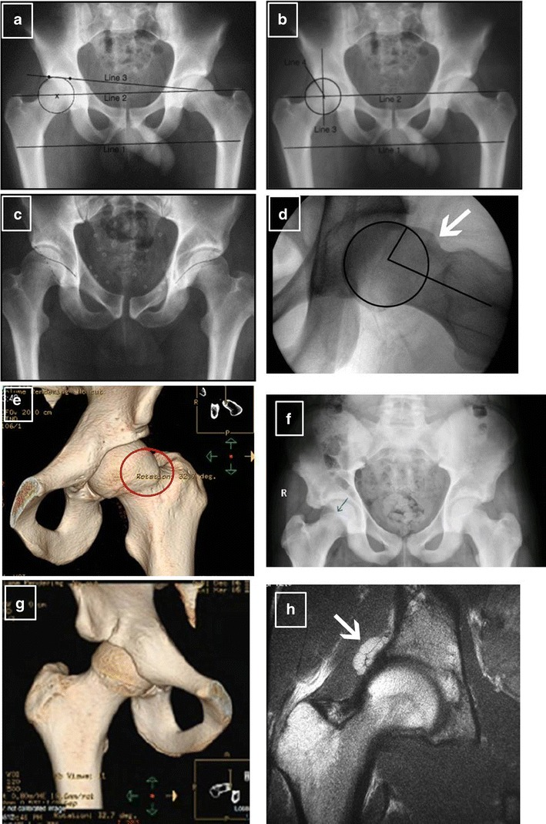
Computed tomography
Computed tomography is invaluable for the definition of static and dynamic abnormalities in young patients with hip pains (Blankenbaker & Tuite, 2008). Acetabular versions are not a single "global" value and cannot be defined on radiographs alone but, instead, are defined by the posterior and anterior walls relative relationships and are variable at various locations of clock face along the rims. These relationships cannot be described on radiographs as they are highly vulnerable to errors from radiographic technique subtle changes and obliquity or tilt of the pelvis or beam. Because the distal femur epicondylar axis must be defined, radiographs cannot be used to reliably measure the femoral torsion. Additionally, “cephalad retroversion,” or over-coverage of the focal anterior may be challenging in distinguishing from retroversion of true acetabular on radiographs (Brian, Bernard, & Flemming, 2010). Because the treatment approaches and plans for 2 pathomorphologies are not the same, distinguishing these lesions is important. The over-coverage of acetabular may need corrections with anteverting of peri-acetabular osteotomies.
Magnetic resonance imaging
Magnetic resonance arthrography (MRA) and Magnetic resonance imaging are modalities of imaging regularly used in the evaluation of periarticular soft tissues such as muscles, bursae, or tendons; joint capsule; articular cartilage, as well as the acetabular labrum (Kong, Van der Vliet, & Zadow, 2007). In general, the magnetic resonance imaging and magnetic resonance arthrography benefits include the applications of non-ionizing radiations and their non-invasive property. Images can be reformatted into oblique planes, sagittal, axial, and coronal, and may be acquired in slices that are thin. The coronal image offers the optimal orientations for articular cartilage and superior labrum examination of the lateral acetabular dome and suprafoveal femoral head. The coronal images or planes are also important for the evaluation of the units of iliopsoas muscle-tendon, ischiofemoral space, short external rotators, and hip abductors. The anterior labrum is evaluated best the sagittal planes and the acetabular dome and femoral head articular cartilage may also be examined in these orientations (Matsuda, 2011). The axial image allows for excellent visualization of obturator nerves, femoral, the sciatic, and iliopsoas tendon, as well as the posterior and anterior acetabular chondrolabral complex.

References
Blankenbaker, D. G., & Tuite, M. J. (2008, March). Iliopsoas musculotendinous unit. In Seminars in musculoskeletal radiology (Vol. 12, No. 01, pp. 013-027). © Thieme Medical Publishers.
Brian, P., Bernard, S., & Flemming, D. (2010, October). Femoroacetabular impingement: screening and definitive imaging. In Seminars in roentgenology (Vol. 45, No. 4, pp. 228-237). Elsevier.
Kong, A., Van der Vliet, A., & Zadow, S. (2007). MRI and US of gluteal tendinopathy in greater trochanteric pain syndrome. European radiology, 17(7), 1772-1783.
Matsuda, D. K. (2011). Hip arthroscopy: update, advances, and future applications. AAOS Now, 5(8), 1-8.
Martin, R. L., Irrgang, J. J., & Sekiya, J. K. (2008). The diagnostic accuracy of a clinical examination in determining intra-articular hip pain for potential hip arthroscopy candidates. Arthroscopy: the journal of arthroscopic & related surgery, 24(9), 1013-1018.

