Inflammatory Response
Student's Name
Institution
Date of Submission

1. Normal body temperature ranges at about 37 degrees Celsius. Our bodies adapt their temperature to the conditions of the surrounding environment. It moves up when we carry out an exercise and moves down mostly at night. Our internal body temperatures are controlled by our brain, known as the hypothalamus. It regulates our body temperature and contrasts it with the ordinary temperature of about 37 degrees Celsius. When our body temperatures are very low, the hypothalamus ensures that our bodies produce and sustain heat. However, when the body temperature rises, it removes the fever through various methods such as sweating to cool the skin. Additionally, most fevers are caused by bacterial infections. Everyone can contract fever as the body tries to kill the bacteria or even the virus causing the infection. The majority of the viruses and bacteria perform very well when your body is at normal temperature. On the other hand, it isn't very easy for them to survive if you have a fever. Therefore, the immune system of the body is activated by fever.
2. Inflammatory response occurs when tissues are injured by trauma, heat, bacteria, virus, toxins, or any other cause related to a localized inflammatory reaction. Erythematous, swelling with fluid level, and dullness are linked with a response of localized inflammatory. Causes of swelling with fluid levels are side effects of cure, such as high blood pressure, estrogens, steroid medicine, and specific diabetes treatments known as thiazolidinediones. In addition, bulging with fluid levels can be caused by overeating salty food. Bulging with fluid levels can also signify more dangerous diseases such as congestive heart failure, kidney failure disease, kidney impairment, destruction of veins, shortage of lymphatic system, and serious long-term protein deficiency. On the other hand, erythematous is caused by; electrical treatment, infection, acne medication, exercise, solar radiation, allergies, acute radiation syndrome, toxicity, mercury blister agents, and tweezing of the hairs (Sugimoto et al., 2019).
3. a. Complete blood count refers to a group of tests conducted to evaluate the cells that circulate in the blood: platelets, red blood cells, and white blood cells. If one has an infection caused by bacteria, the amount of white blood cells increases hastily since they are used to find an infection. When the count of red blood cells decreases, the body is not acquiring the oxygen it needs. Therefore, there is an infection causing anemia. On the other hand, when the count of red blood cells is very high, it's tough for them to carry oxygen because they will clump together and block the capillaries(de Lucena et al., 2020). Therefore, there is an infection causing a condition known as polycythemia. Finally, when there are very few platelets in the blood, uncontrolled
bleeding may be a challenge, indicating an infection.
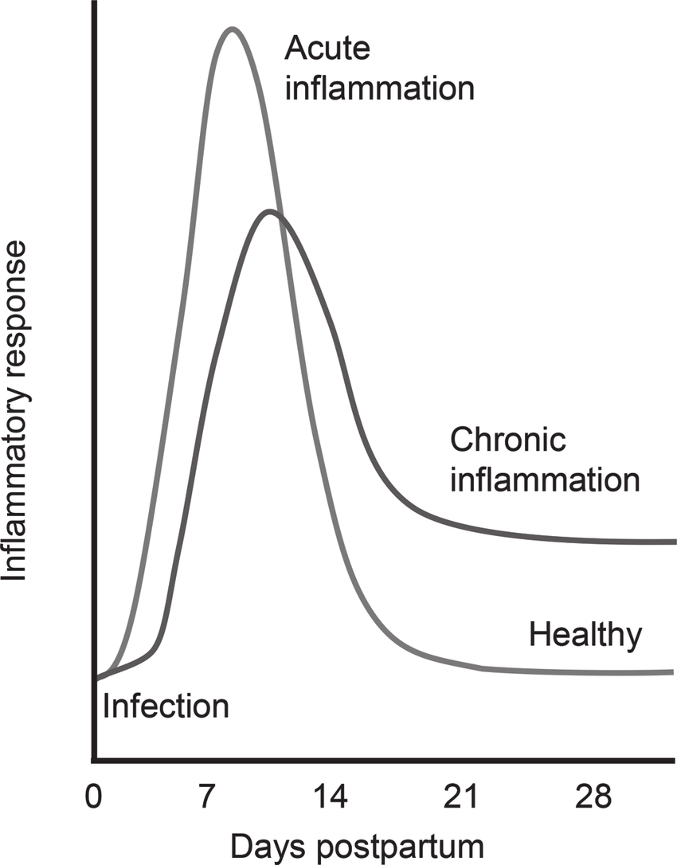
b. Systemic response to the infection is also known as sepsis. It took place when chemicals produced in the bloodstream to resist conditions activating inflammation throughout the body. Erythematous is a manifestation of a systematic response to the infection(Elahi et al., 2020).

References
de Lucena, T. M. C., da Silva Santos, A. F., de Lima, B. R., de Albuquerque Borborema, M. E., & de Azevêdo Silva, J. (2020). Mechanism of inflammatory response in associated comorbidities in COVID-19. Diabetes & Metabolic Syndrome: Clinical Research & Reviews, 14(4), 597-600.
Elahi, S., Vega-López, M. A., Herman-Miguel, V., Ramírez-Estudillo, C., Mancilla-Ramírez, J., Motyka, B., ... & Oyegbami, O. (2020). CD71+ erythroid cells in human neonates exhibit immunosuppressive properties and compromise immune response against systemic infection in neonatal mice. Frontiers in immunology, 11.
Sugimoto, M. A., Vago, J. P., Perretti, M., & Teixeira, M. M. (2019). Mediators of the resolution of the inflammatory response. Trends in Immunology, 40(3), 212-227.

