Introduction
This lab is aimed at determining the kinds of volcanos, elevation, history, and the activity of each of them. Volcanos refer to ruptures in the crust of a planetary mass object, for instance, the earth where it lets the lava erupt and flow causing some deaths. Activities associated with volcanos have been linked to causing earthquakes and other geological activities on the earth such as altering the shape and size of the mountains, creation of new rocks, and re-creation of various kinds of rocks.
Methods
During this lab, each learner will be required to carry out research for twelve volcanoes found in various places. The students will also be required to answer each of the ten questions and take a screenshot of each of the volcanoes while recording about its history as well as its activities. After having researched on all volcanoes, the students were able to find out the location of each of the volcanoes, their latitude, longitude and their elevations. The group also found out about the types of the volcanoes, and concluded whether they were cinder cone, stratovolcano, or shield, and if they were inactive or active. All the volcanoes have the potential of erupting and causing deaths, thus, the students found out the last time when the volcanoes had erupted, if is still erupting, the damage caused and the number of people who died when it last erupted. They also found out where the volcanoes where located, whether they were in divergent plate, convergent boundary plate, or in hotspot.
List of Materials used in the Lab
- Google search
- Pen
- Google earth
Results

- Kilauea
- Pacific Ocean in Hawaii, North America, Northern Hemisphere
- Latitude: 19⁰ 24’ 24.81”N; Longitude: 155⁰ 70’ 00.16”W; Elevation: 4,190’
- Shield
- It is active
- Started March 2018
- Yes
- Caused significant damage to the society surrounding it
- Hotspot
- No deaths were reported
- Lo’ihi
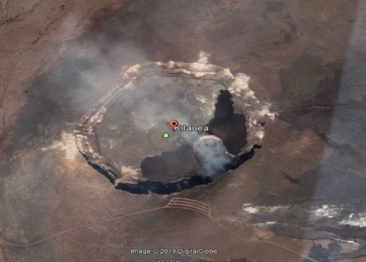
- Mauna Loa
- Pacific Ocean in Hawaii, United States of America, North America, Northern Hemisphere
- Located at (Latitude: 19⁰ 28’46.16”N; Longitude: 155⁰36’10.18”W; Elevation: 13,678’)
- Shield
- Volcano is active
- Started mid April 1984
- No
- Caused damages in stores, nearby homesteads, and gas stations
- Located at hotspot
- None
- Lo’ihi
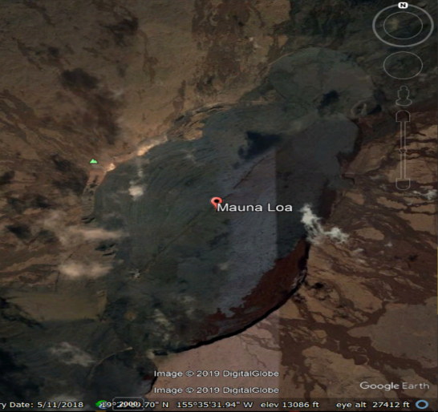
- Mauna Kea
- Located at Hawaii, United States of America; Pacific Ocean; Northern Hemisphere
- Located at (Latitude: 19⁰49’15.31”N; Longitude: 155⁰28’05.42”W; Elevation: 13,669’
- Located at cinder cone
- It is dormant
- Last erupted 2460 B.C
- No
- Damages not recorded
- Hotspot
- None
- Loihi Seamount
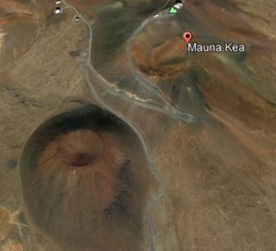

2) Mt. Fujiyama
- Located in Japan, Northen Hemisphere, Asia, Pau’fic
- Located at (Latitude: 35⁰21’ 38.00”N; Longitude: 138⁰43’40.00”W; Elevation: 12,401)
- Stratovolcano
- It is active
- Lastly erupted in December 16th, 1707
- Currently not erupting
- Not recorded
- Located at continental convergent boundary
- No deaths reported
- Has retained a powerful force in Japanese celled

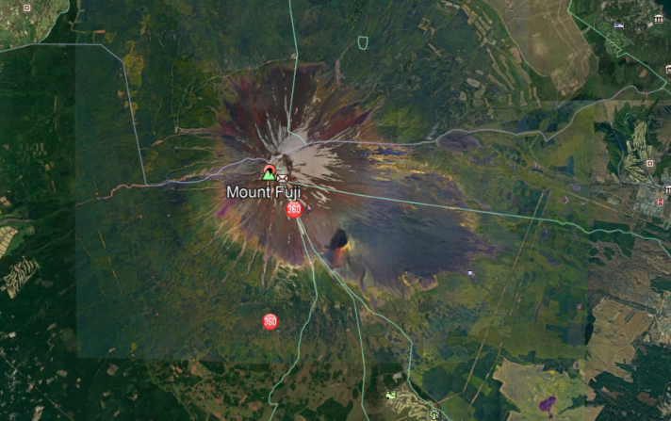
3) Mt. Krakatoa
- Atlantic, South Indonesia, Asia
- Located at (Latitude: 06⁰07’ 07.62”S; Longitude: 105⁰25’22.75”E; Elevation: 2,667’)
- Stratovolcano
- It is active
- Last eruption activity December, 2018
- Currently not erupting
- Brought about a tsunami and there were deaths reported
- Located on a convergent plate boundary
- 373 people died
- The temperature rating in the Northern atmosphere decreased by 1.2⁰C. The weather pattern worsened until 1889 when it became normal again.
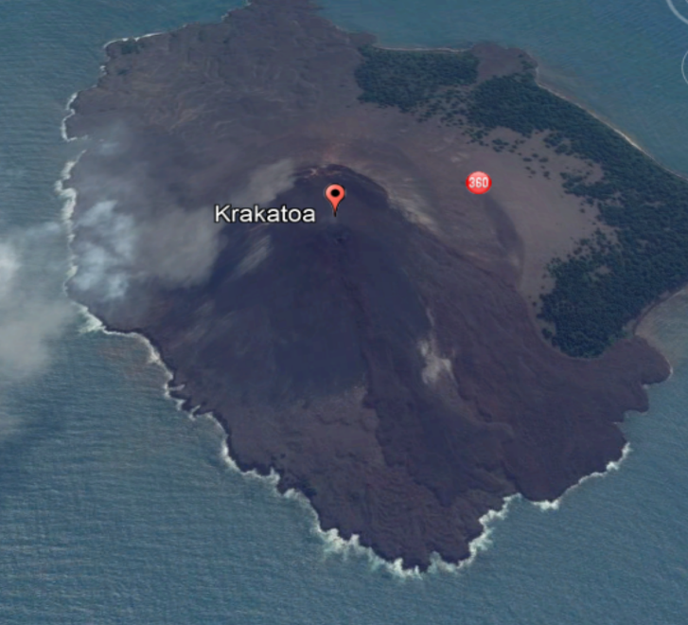
4) Mt. St. Helens
- Located North America, Pacific Ocean in Washington, Northern Hemisphere
- Located at (Latitude: 46⁰ 12’0.1”N; Longitude: 112⁰ 11’12.68”W; Elevation: 8,363’)
- Stratovolcano
- It is active
- Last eruption activity was on July 10th, 2008
- No
- Did not cause much damage
- Located at a convergent
- Fifty-seven people died
- North
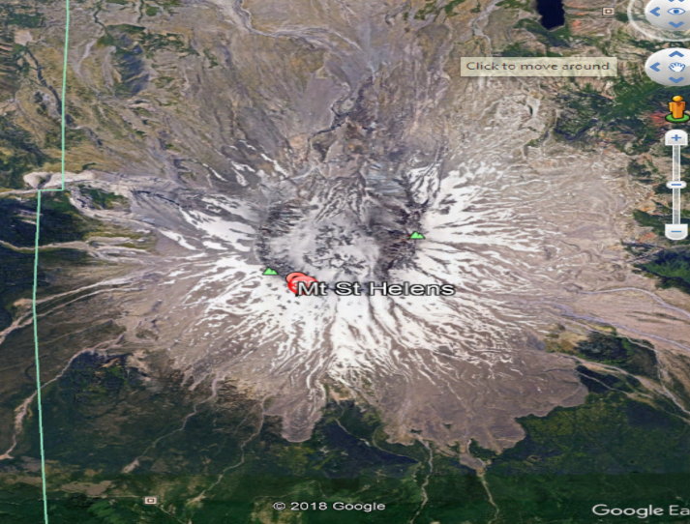
5) Mt. Pelee
- Located in Northern Hemisphere
- Located at (Latitude: 14°48’ 33.72” N; Longitude: Longitude: 61⁰ 09’59.10”W; Elevation: 4,583’)
- Stratovolcano
- It is active
- Last eruption activities were in 1902
- No
- Very many people died, there were only two survivors reported
- Located on a convergent plate boundary
- Thirty-thousand people
- A second dome was formed in the Etang sec caldera and pyroclastic was produced which flowed into the blanche river valley
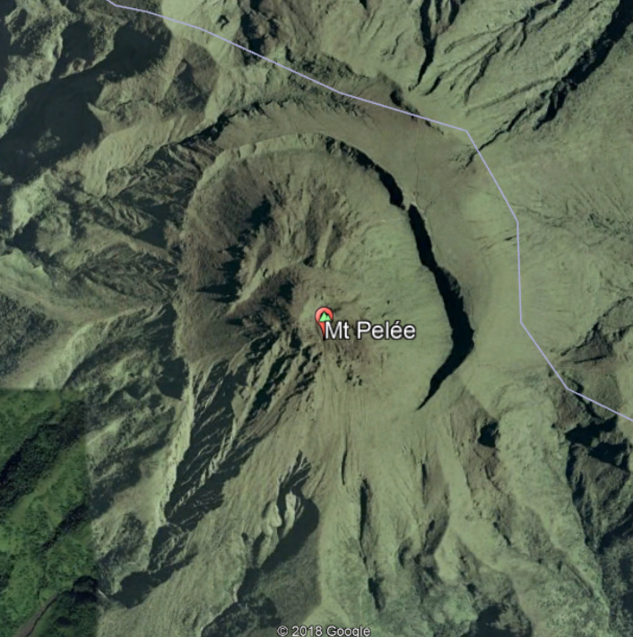
6) Surtsey volcano
- Located at Northern Hemisphere
- Located at (Latitude: 63⁰18 08.24”N; Longitude: 20⁰36’ 03.86”W; Elevation: 509’)
- Shield volcano
- It is still active
- Last eruption activities occurred in November 14th, 1963
- No
- It sent columns of ash to about thirty-thousand feet into the sky.
- Located on a divergent plate boundary
- No deaths reported
- The Island stood at 942 feet; covered an area of about 2 square miles
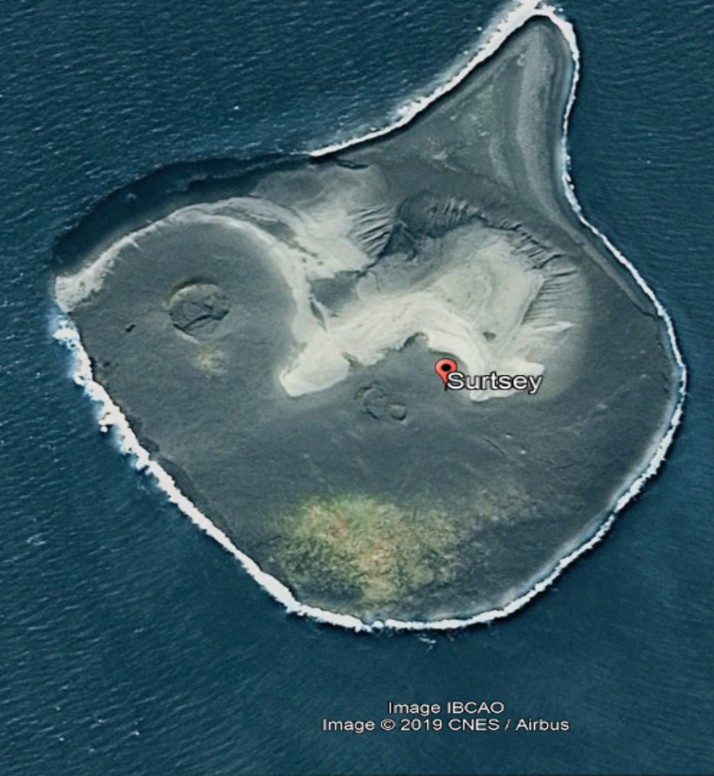
7) Eldfell volcano
- Located at Northern Hemisphere, Atlantic Ocean, Iceland
- Located at (Latitude: 63⁰25’57.79”N; Longitude: 20⁰14’ 58.30”W; Elevation: 650’)
- Cinder cone volcano
- It is still active
- Last eruption activity was in January to June 1973
- No
- Found-hundred buildings were destroyed
- Mid-Atlantic, Hotspot
- 1 person died
- Large amount of water was pumped to cool the flowing lava
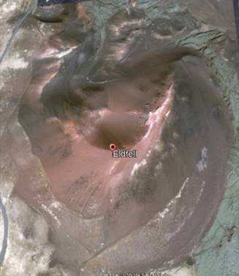
8) Mt. Erebus
- Located at Antarctica, Ross Island, Southern Hemisphere
- Located at (Latitude: 77⁰31’ 48”S; Longitude: 167⁰10’12”E; Elevation: 12,448’)
- Its top is stratovolcano and its bottom is shield
- It is still active
- Between 1977 to 2016
- Yes
- No damage has been reported
- Located on a intraplate and lies on a rift
- No deaths were reported
- It has been the hottest volcano so far reported. Its temperatures reached 1700F.
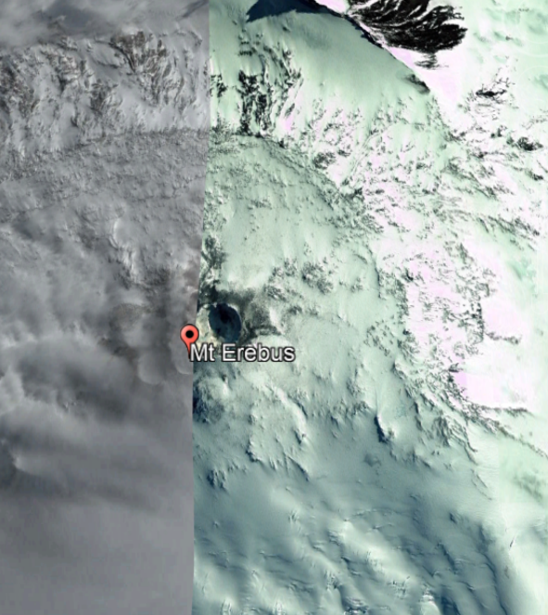
9) Mt. Vesuvius
- Located at Northern Hemisphere, Naples, Italy
- Located at (Latitude: 40⁰49’21”N; Longitude: 14⁰25’44”E; Elevation: 3,190’)
- Stratovolcano-Somma
- It is still active
- Last erupted in March 1944
- Yes
- Damaged villages of Ottavanio, Massa di Somma, and San Sebastiano al Vesuvio
- Hot spot
- No deaths reported
- Its eruption destroyed and buried the twons of Stabiae, Oplontis, Herculaneum and Pompeii
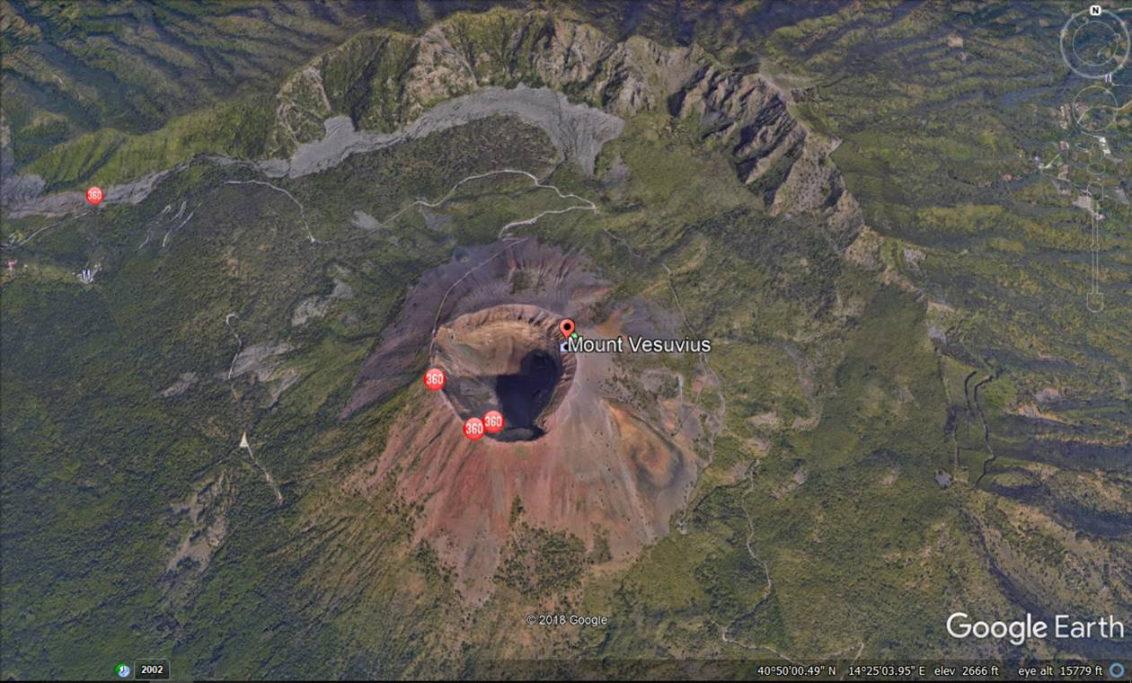
10) Mt. Pinatubo
- Located in Northern Hemisphere, Philippines, Zambales
- Located at (Latitude: 15⁰08’34”N; Longitude: 120⁰20’58”E; Elevation: 3,045’)
- Caldera-Stratovolcano
- It is still active
- Lastly erupted in June 1991
- No
- Damaged buildings among other infrastructures, livestock were killed, reforestation projection were destroyed as well as 2.1 million people were being displaced
- Eurasian plate, convergent plate boundary and Philippine plate
- 847 deaths were reported
- Due to the eruption, US Air force embarked on Operation Fiery Vigil to air lift the American troops and families who were affected. After the incidence, most of the personnel were transferred to other areas such as Hawaii, Okinawa and Guam. However, some of them returned to US.
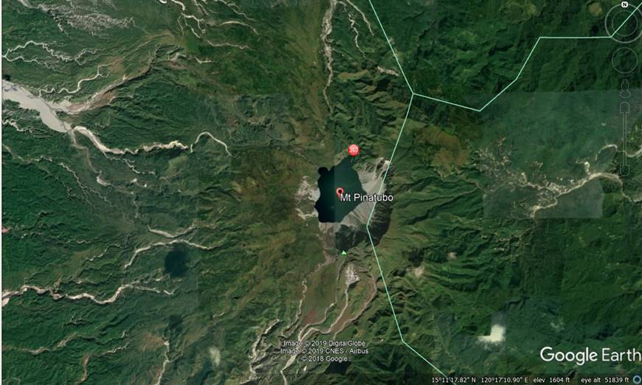
Conclusion
In conclusion, this lab assisted the learners to be able to identify the type of volcanos while at the same time pointing out their differences. They used Google earth and carried out research to answer the questions about damages, deaths, eruptions and their locations.

