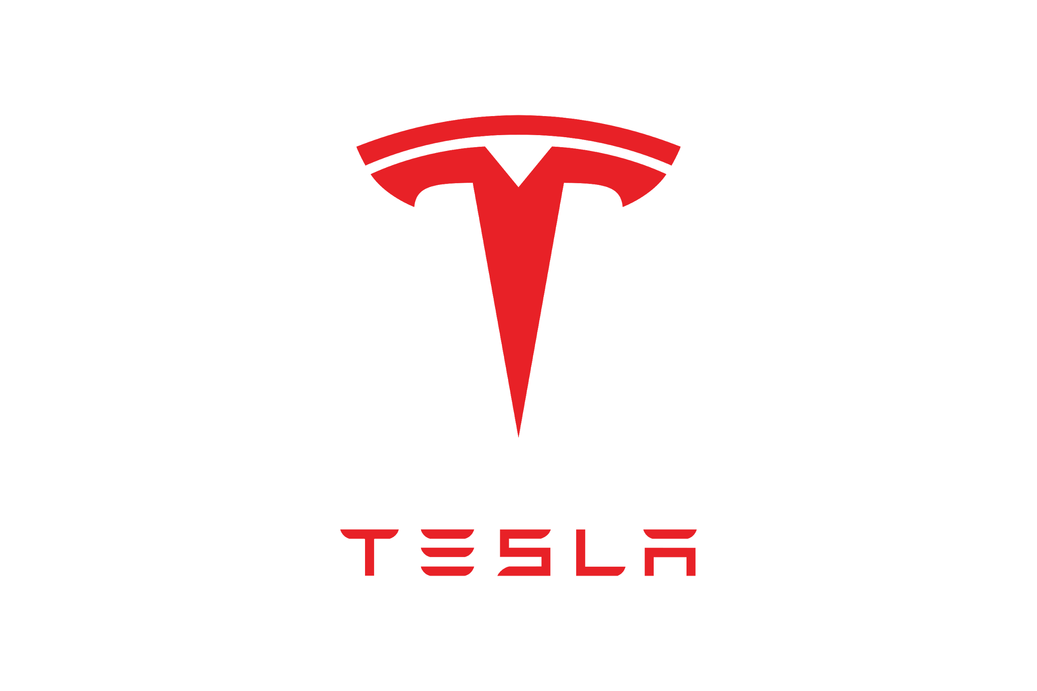
Tesla
12011 W Silver Spring Dr. Milwaukee, WI 53225∙ (414)290-8229

Memorandum

DATE: November 7, 2020

TO: Professor Lyons

FROM: Mohammad Kharroub

SUBJECT: More About Tesla

Mission statement:
Imagine a world where Gas Stations were turned to Charging Stations. Our cars that are fueled by gas generate enormous amounts of toxic carbon dioxide by burning fossil fuels polluting the air we breath and atmosphere we live in. Tesla is on a mission to change not just the car industry but the World as well.
- Tesla’s cars run on solar powered energy.
- Saving people’s money spent on gas and the words atmosphere from carbon dioxide.
- We as a company are working to make our cars as affordable and comfortable as an everyday vehicle to really pursue our goal of saving the world.

Schedule:
- This week from November 8th to 15th I will be working on my progress report. Ensuring I have taken key searches and questions to learn my company inside out.
- From the 15th to the 22th I will be dedicating to writing my rough draft. As well as looking at peers to improve mine as well as give a hand to a peer and edit theirs.
- Lastly, from November 22nd to December 13th I will be editing my rough draft including key detail and transitions to truly persuade the audience.

Why Tesla?
- I chose Tesla due to my idolization and admiratization towards Elon Musk. I have followed Elon Musk my whole life and have been blown by the things he has been able to accomplish. Elon Musk isn’t a regular billionaire. Elon thrives to help people, the world we live in, and makes money by doing so.

- My objective of being a financial advisor is help people, help the world, and make money while doing so. Tesla is a great company that has thrived in the last few years please allow me to choose Tesla for my final project.

Very Respectfully,

Mohammad Kharroub

