TEST2 (Take Home Exam)
CS 425, Spring 2021
(Any evidence of similarity with another student will lead to 0 score)
DUE DATE: SATURDAY, 12 NOON
It is important, for each problem show the details. If you writing by hand, must make sure to write clearly, using white paper and BLACK INK pen, so that your scanned document looks nice. If you want to type, that will be great too.

Hashing, Graph Theory

- Consider the Graph given below:
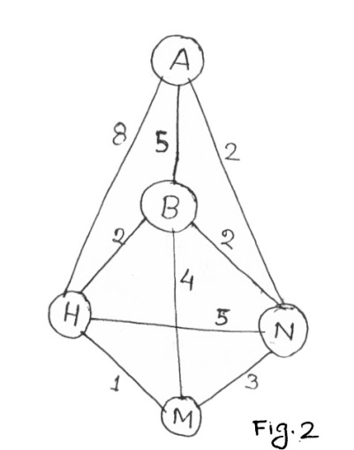
- Write down the adjacency matrix?
- Is this a Complete Graph? If not how many additional edges you need to make it a complete graph?
- Use Kruskal’s algorithm to find the MST of this graph. Explain the steps.

- Consider the graph in the next page. Find out the shortest path for each vertex using Dijkstra algorithm.

Use Vertex C as the source. 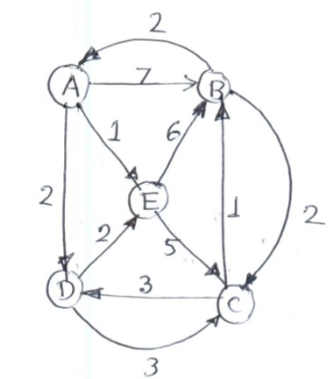

- Given a graph in the following matrix form, draw the graph and find out the minimum spanning tree for the graph using Prim’s algorithm.

0 2 4 1 0 0

2 0 0 3 10 0

4 0 0 2 0 5

1 3 2 0 7 8

0 10 0 7 0 0

0 0 5 8 0 0

4. Given the following keys: 7, 16, 4, 40, 32
Use hash function, h(k) = k mod m and create a hash table of size 11.
- Use Quadratic Probing method to resolve the collision. Take C1 = 1, and C2 = 2.

b) How would the Hash table be different if you use double hashing in place of quadratic probing, with h₂(k) = 10 – (k mod 10)
5. Using the Graph given below, illustrate Floyd-Warshall algorithm to determine the all-pairs shortest path and the questions given below from your final table. All answers must come from final table. Draw all intermediate tables.
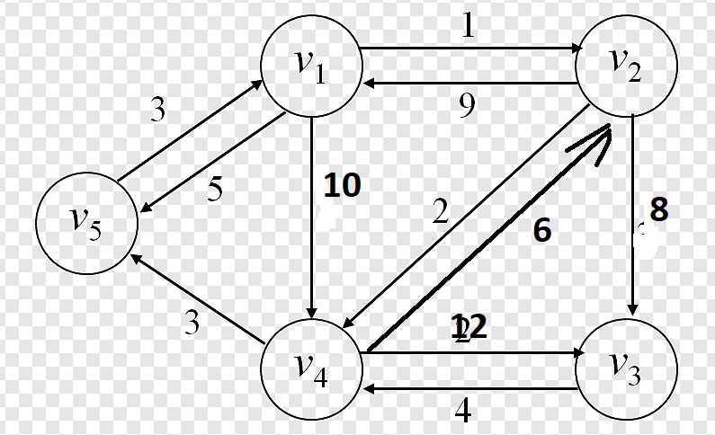
- Determine the shortest path from vertex 1 to vertex 3
- Determine the shortest path from vertex 4 to 1
- Determine the shortest path from vertex 5 to 4

