Q1 -12
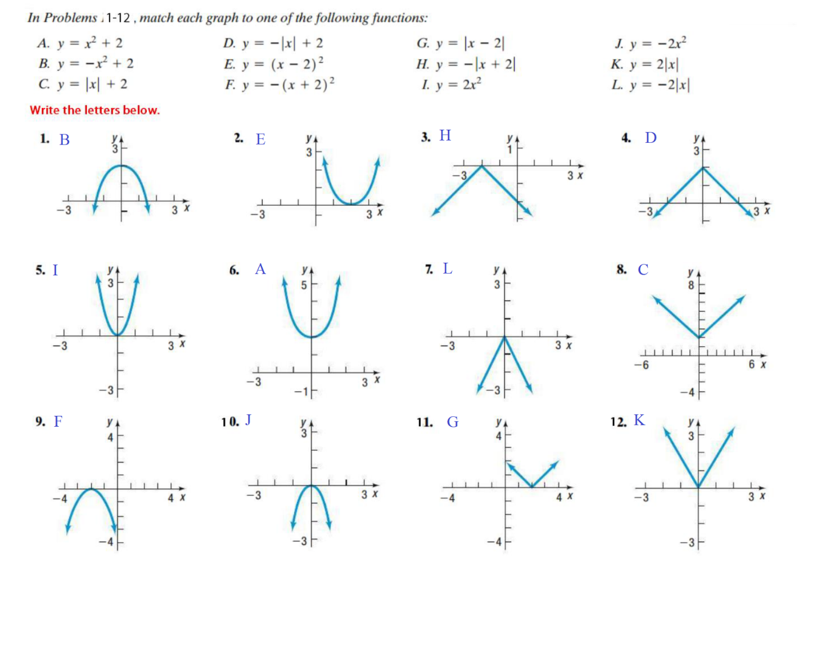
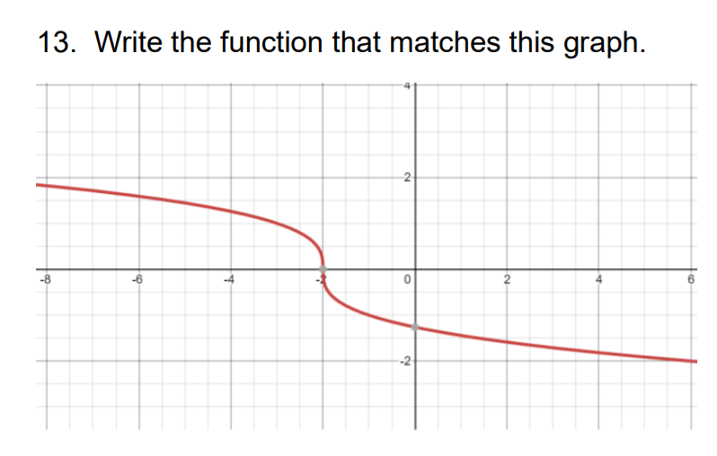
Solution
Graph of ${x=y}^{3}$is as follows
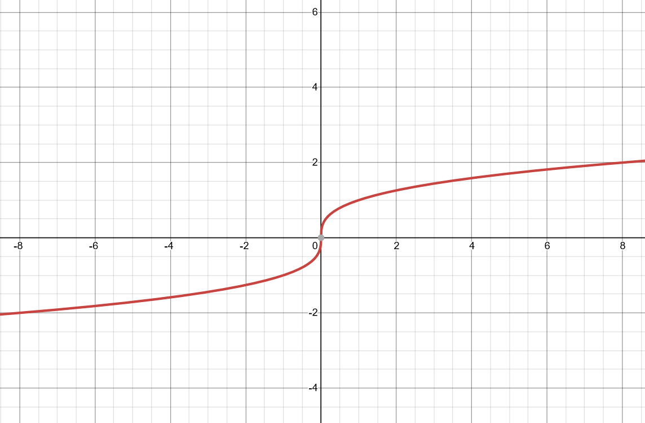
Now we plot the graph of $x= -y^{3}$, by mirroring the graph about y-axis
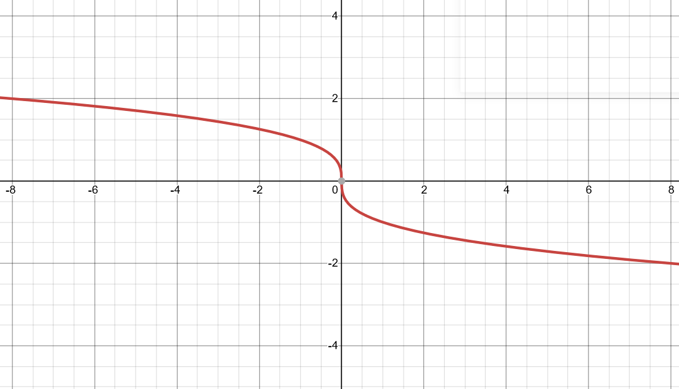
Now we shift the origin by 2 units left, so the equation becomes $x={-y}^{3}-2$ and graph is as follows
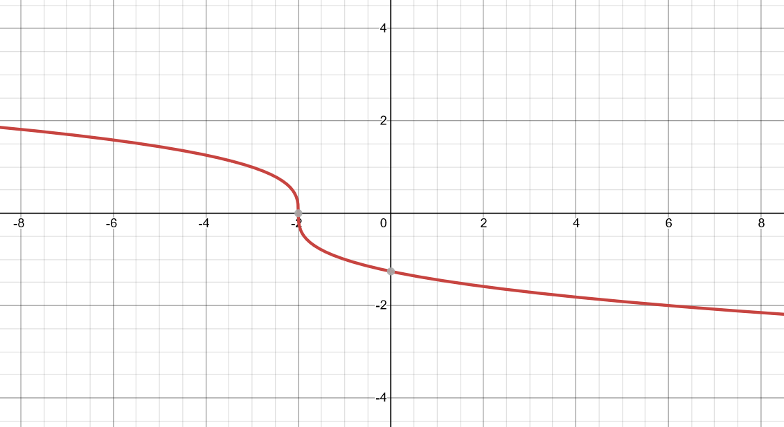
So the equation is $x= -y^{3}-2$
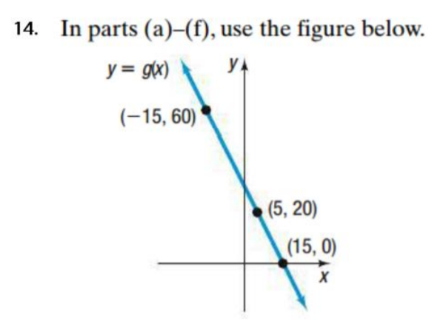
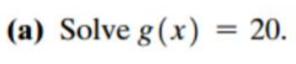
From the graph it can be seen that g(x) = 20, for the value of x = 5
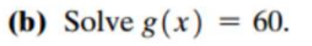
From the graph it can be seen that g(x) = 60, for the value of x = -15

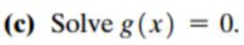
From the graph it can be seen that g(x) = 0, for the value of x = 15
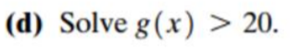
This region is shown where g(x) is greater than 20
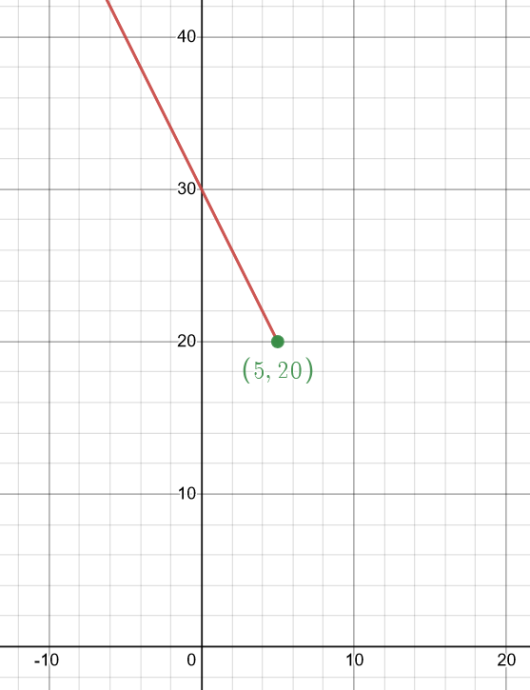
Equation of the line through (5,20) and (15,0) is given by
$$\frac{y-0}{x-15}=\frac{0-20}{15-5}→\frac{y}{x-15}= -2$$
$$y=30-2x$$
$$g\left(x\right)=30-2x$$
$g\left(x\right)>20$ is shown as

$$30-2x>20→10>2x→ x<5$$
Also shown in the graph

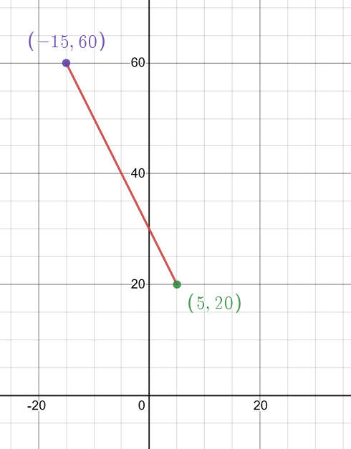
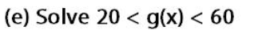
$20<g\left(x\right)<60$ is shown as

$$20<30-2x<60→ -15<x<60$$
Also shown in the graph

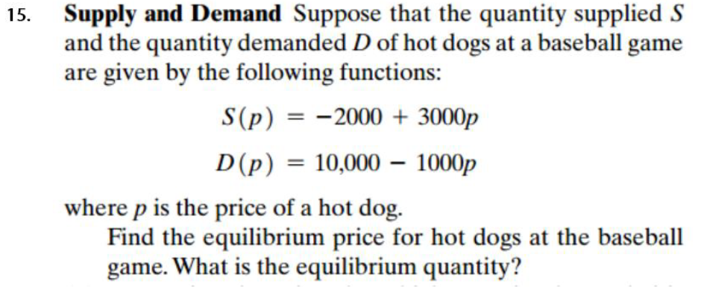
Solution: We are given
$$S\left(p\right)= -2000+3000p$$
$$D\left(p\right)=10000-1000p$$
To find equilibrium price for hot dogs at the baseball game
$$S\left(p\right)=D\left(p\right)$$
$$→ -2000+3000p=10000-1000p$$
$$→4000p=12000→p=3$$
Therefore, the equilibrium price for the hot dog is $3
To find the equilibrium quantity we put p = 3 in S(p), we get
$$S\left(3\right)= -2000+3000×3$$
$$S\left(3\right)=7000 hot dogs$$
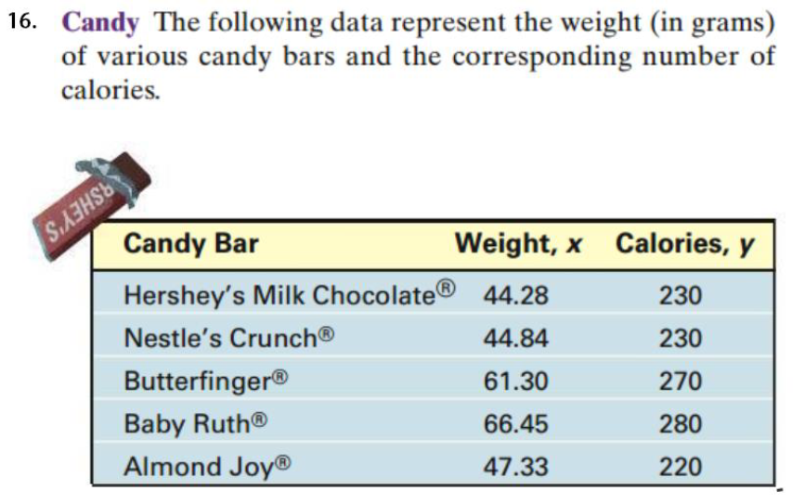
Candy with least weight is Hershey’s Milk Chocolate weight, x = 44.28, calories, y = 230
Candy with greatest weight is Baby Ruth weight, x = 66.45, calorie, y = 280
So the equation if line through (44.28, 230) and (66.45,280) is given by
$$\frac{y-280}{x-66.45}=\frac{280-230}{66.45-44.28}→\frac{y-280}{x-66.45}=\frac{50}{22.17}$$
Further solving,
$$22.17 \left(y-280\right)=50\left(x-66.45\right)$$
$$22.17y -6207.6=50x-3322.5$$
$$y=2.2553x+130.135$$
$$y =2.26 x+130.14$$
In the above obtained equation, we put x = 68.3 to get the values of calories
$$y =2.26×68.3+130.14$$
$$y=284.498 \sim 284.5$$
Estimated calories for candy bar that weighs 68.3g is 284.5
Using technology, we get equation as
$$y=2.53041x+112.29322$$
Rounding to 2 digits
$$y=2.53x+112.29$$
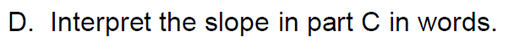
By using least square method we get the line of best fit for a set of paired data allowing us to estimate the value of a dependent variable y from a given independent variable x.
The line of best fit is described by the equation $y=2.53x+112.29,$where slope of the equation obtained is 2.53 and 112.29 is the intercept

Vertex
Comparing equation y = 4a(x-h)^2 + k
Vertex = (h,k) = (1,32)
Axis of symmetry
From graph, x = 1
y-intercept
At y intercept x = 0, substituting
$$y= -2{\left(0-1\right)}^{2}+32$$
$$y= -2+32=30$$
y-intercept (0,30)
Convert to standard form $ax^{2}+bx+c$
$$y= -2{\left(x-1\right)}^{2}+32$$
$$→y= -2\left(x^{2}-2x+1\right)+32$$
$$→y= -2x^{2}+4x-2+32$$
$$→y= -2x^{2}+4x+30$$
x-intercept
At x-intercept y = 0, substituting
$$0= -2{\left(x-1\right)}^{2}+32→2{\left(x-1\right)}^{2}=32$$
$$→{\left(x-1\right)}^{2}=16$$
$$→\left(x-1\right)= ±4$$
$$\left(x-1\right)=4$$  $$x=5$$  $$x-intercept (5,0)$$ | $$\left(x-1\right)= -4$$  $$x=-3$$  $$x-intercept =(-3,0)$$
From above data we plot the graph as follows
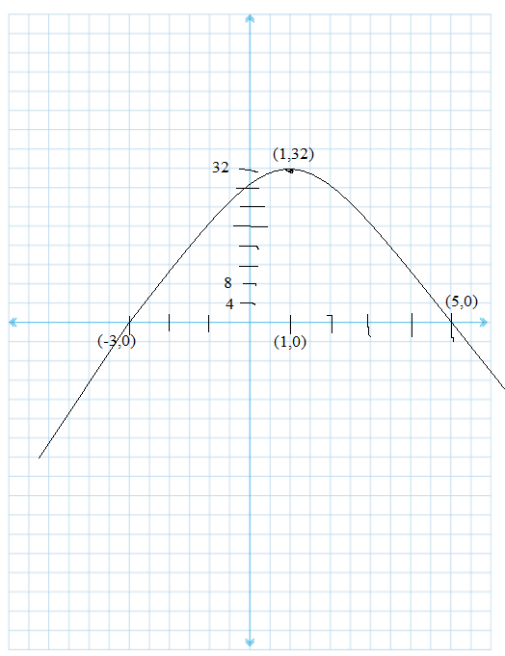

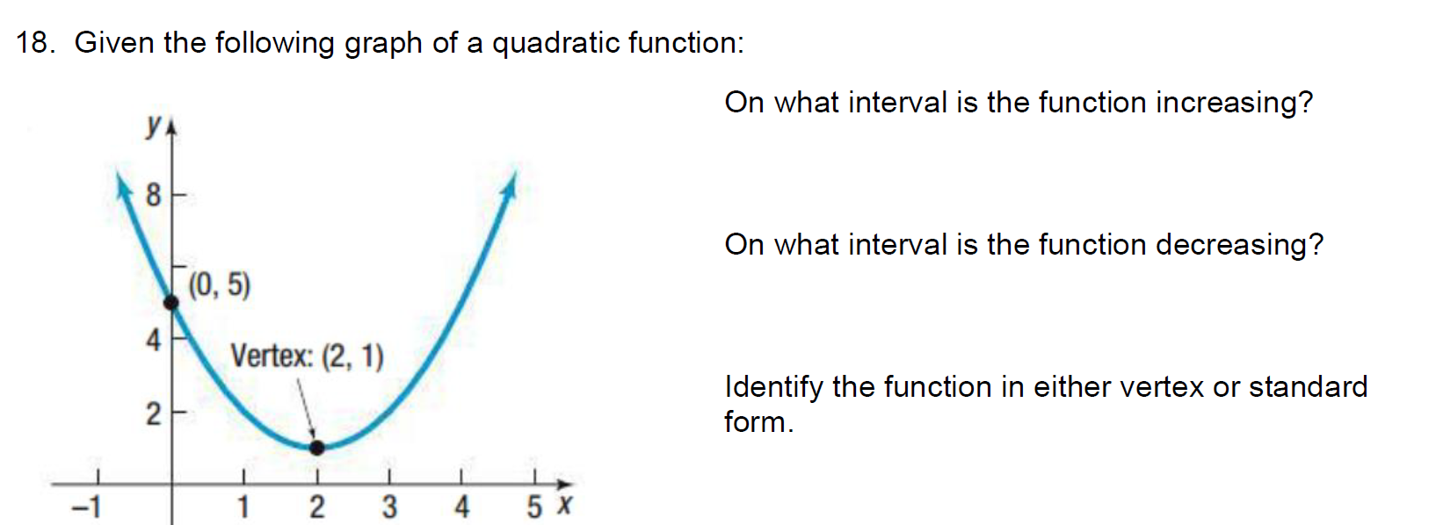
Function is said to be increasing if for every increase in value of x there is increase in value of y,
From graph it is clearly seen that function is increasing from $\left(2, ∞\right)$
Function is said to decreasing if for every increase in value of x there is decrease in value of y
From graph it is clearly seen that function is decreasing from $\left(∞,2\right)$
Equation of the function
We are given vertex (2,1) and point (0,5)
The equation of parabola with vertex (h,k) is $y=a{\left(x-h\right)}^{2}+k$
Thus, the equation of parabola is $y=a{\left(x-2\right)}^{2}+1$
To find a, we know that parabola passes through (0,5), substituting
$$5=4a+1→a=1$$
Thus, the equation of parabola is $y={\left(x-2\right)}^{2}+1$

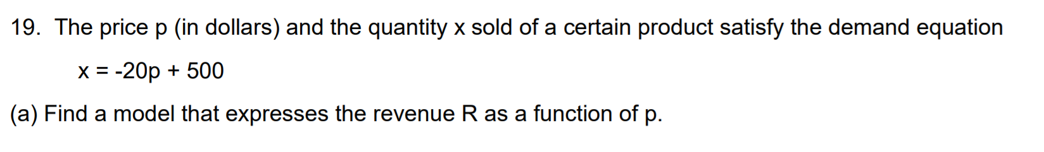
Revenue is given by
$$R=xp$$
$$R=\left(-20p+500\right)p$$
$$R= -20p^{2}+500p$$
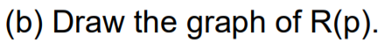

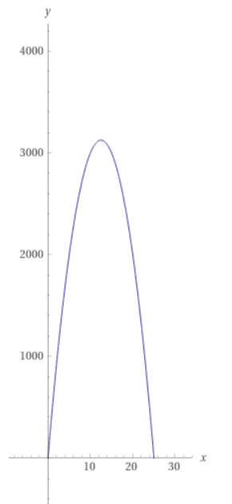

Revenue R, is the quadratic equation with $a= -20, b=500, c=0$
Since a < 0
The vertex is the highest point on the parabola, Revenue R is maximum when the price
$$p= -\frac{b}{2a}= -\frac{500}{2\left(-20\right)}=\$12.5$$
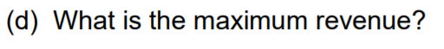
$$R\left(12.5\right)= -20{\left(12.5\right)}^{2}+500×\left(12.5\right)$$
$$R\left(12.5\right)= -3125+6250=3125$$
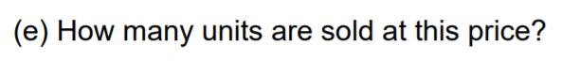
No of products sold is given by demand equation
$$x= -20p+500$$
$$→ -20×12.5 +500 = -25+500=475$$
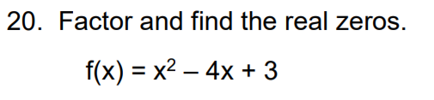
$$f\left(x\right)=x^{2}-4x+3$$
$$→x^{2}-x-3x+3$$
$$→x\left(x-1\right)-3\left(x-1\right)$$
$$→\left(x-3\right)\left(x-1\right)$$
So the zeroes of the polynomial is -4,-2,3
$$f(x)=\left(x-\left(-4\right)\right)\left(x-\left(-2\right)\right)\left(x-3\right)$$
$$f\left(x\right)=\left(x+4\right)\left(x+2\right)\left(x-3\right)$$
$$f\left(x\right)=\left(x^{2}+6x+8\right)\left(x-3\right)$$
$$f\left(x\right)=x^{3}+3x^{2}-10x-24$$
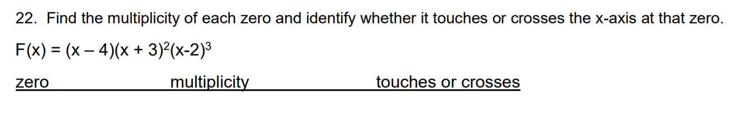
$f(x)$ has zeroes of 4, -3, 2
In the given function, (x-4) is raised to the power 1, therefore, multiplicity of zero at x = 4 is 1 i.e. odd
(x + 3) are raised to the power 2, so, multiplicity of zero at x = -3 is 2 i.e. even.
(x-2) is raised to the power 3, therefore, multiplicity of zero at x = 2 is 3 i.e. odd
If the multiplicity of zero is odd, the graph crosses the x-axis and if the multiplicity is even , the graph touches the x-axis.
Zero 4 multiplicity of 1 crosses
Zero -3 multiplicity of 2 touches
Zero 2 multiplicity of 3 crosses
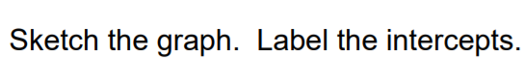
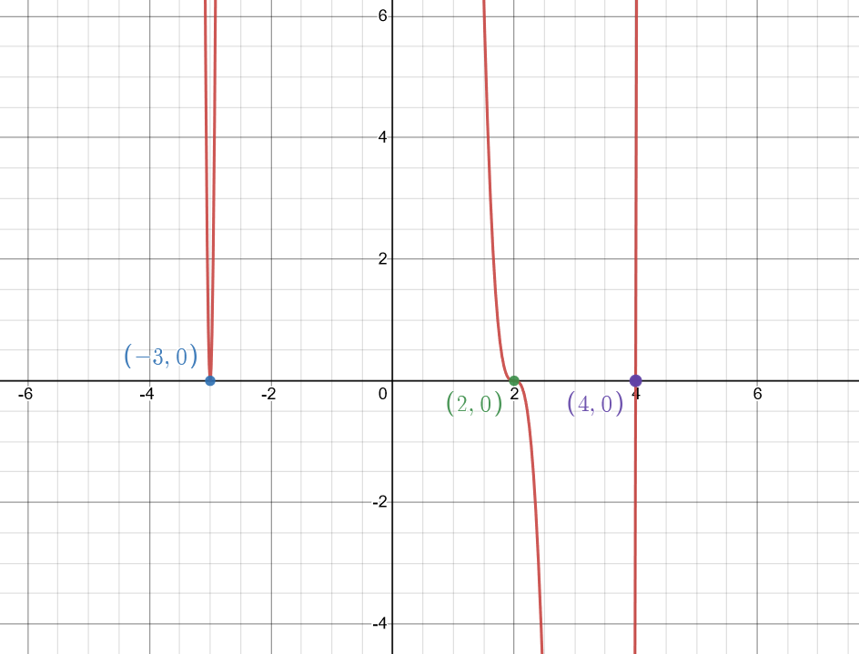
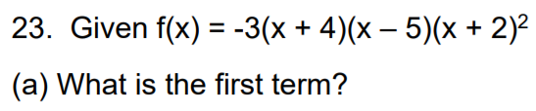
First term is
$$→ -3⋅x⋅x⋅x^{2}= -3x^{4}$$
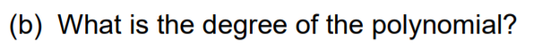
Degree of polynomial
$$1+1+2=4$$
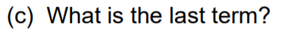
Last term is
$$→ -3×4×\left(-5\right)×2=120$$
Number of turning point = Number of degree - 1
$$→4-1=3$$
3 number of turning points

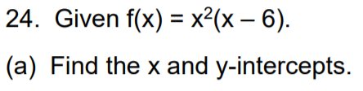
x-intercept
At x- intercept y = 0 , substituting
$$0=x^{2}\left(x-6\right)$$
$$→x=0 , x=6$$
x-intercept $\left(0,0\right), \left(6,0\right)$
y -intercept
At y-intercept x = 0, substituting
$$y=0^{2}\left(0-6\right)=0$$
y-intercept (0,0)

Using technology
Local minima (4,-32)
Local maxima (0,0)

