1.6 Theoretical Framework
1.6.1 Definition of Onsite Children Center
Approach to human resource management through the welfarist approach has emerged in the past due to changes in the demographic patterns in the workforce. While the conventional emphasis was on benefits to individual workers, family provisions have emerged to be heart of the new corporate welfarism. In spite of family leave and employer-assisted childcare being the defining features of contemporary corporate welfarism, current research focuses only on employer-supported childcare. In his article, Friedman (1986) gives statistics that suggest childcare is becoming a major component of employee benefits. More than 3,500 organizations in the United States provided employee benefit through childcare support in the late 1980s; 775 of these organizations offered on-site child care centers.
On-site child care centers can be perceived as one form of family friendly practice, which depicts a program that is designed to eradicate individual conflict in matters of family and work. It encompasses childcare support, family leave policies, and flexible work schedules. Day care is largely regarded as a system of service for infants un families who require supplemental support outside the home settings for a particular duration each day; this care is provided by adults who have invested in nurturing children by responding to their social, physical, and education needs (Milkovich & Gomez, 1976). The Department of Social Development’s Guidelines for Day Care (April 2001) postulates that the objective of a day care is to offer care to children in the temporary absence of their parents. These facilities have a responsibility of facilitating the development of a child socially, culturally, morally, emotionally, psychologically, mentally, and physically. Supporters of daycare argue that a well- managed and well-designed facility can positively affect the work behaviors of parents by relieving them the concern about their children’s safety and development (Friedman 2001; Milkovich & Gomez 1976). Balancing between work and family life has become increasingly vital for both employers and employees across the universal corporate environment. Regardless, it is the most significant issue affecting families in the twenty first century (Walker, Wang, and Redmond, 2008).
In the last decade, policies and programs for corporate work and life have flourished and employer interest and action in this facet has continued to grow in spite of the economic challenges. The demographics of the US workforce is changing with an observed increase in participation of women in the labor force. This is the primary factor cited for the rise in the implementation of work-family programs. In the quest for stress mitigation, enhancing productivity, bolstering performance, minimizing cost and improving profitability in the workplace, companies evolve strategies to develop psychological relationships with their staffs. However, work-life balance is still a challenge, especially in the industrialized world (Aryasri and Babu, 2007). Most policies and programs involving work and family issues are flexible scheduling, maternity and paternity leave, unpaid parental leave, information on common day care, elder care assistance, assistance on day care costs, and on-site day care. On-site day cares are advantageous in that instead of dropping children at day care facilities before rushing to work and having to rush again in the evening to pick them, the staffs can bring the children right into the workplace and place them to the allocated facility until end of the day. They will not only save on time and cost of transport, but they can also attend to their kids in the event of an illness in the middle of the day
1.6.2 Employee’s Performance
The performance of individual employees is a principal concept within work and organizational psychology. In the last 10 to 15 years, researchers have made key milestones in extending and clarifying the concept of employee’s performance (Campbell, 1990). In addition, progress has been made in specifying the major predictors of processes linked to individual performance. In spite of the immense reverence to individual performance and the vase use of job performance as a measure of outcome in empirical research, there is relatively little effort in clarifying the concept of performance. In 1990, Campbell provided literature on the framework and content of performance in his publication of “a virtual desert”. Nevertheless, a review of the past 15 years would depict an increasing interest in defining performance and specifying the details of the concept.
There is a consensus among scholars that conceptualization of performance would require differentiation between action or behavioral aspect and the outcome aspect of performance Campbell, 1990). The behavioral aspect entails the activities of an individual employee in the work location. Examples of such behaviors include performing heart surgery, teaching basic reading skills to children in elementary school, selling personal computers, or assembling parts of a vehicle engine. Not every work behavior is put under the concept of performance; only those that are relevant to the organization goals are checked. McCloy et al. present the concept of performance as what one is hired do and do well by an organization (McCloy, Campbell, and Cudeck, 1994)). This suggests that performance is not based on the action itself but by the evaluative and judgement processes (Ilgen & Schneider, 1991; Motowidlo, Borman, & Schmit, 1997). Only actions that can be measured are considered to constitute the concept of performance.
Perceived Organization Support (POS) is a crucial concept in when discussing employee performance. It refers to the perception that employees have concerning value that the organization put on their contribution and cares on their well-being. It has a significant impact on the well-being and performance of employees. Research on Perceived Organization Support started with the observation that employees tend to be more focused to an organization when managers demonstrate concern on their commitment to the organization as well as their well-being (Eisenberger et al., 1986). Organization support theory postulates that employees develop Perceived Organization Support for them to meet the needs for approval, assess the benefits of increased work commitment, and enhance self-esteem. POS enhances employees’ feeling of obligation to facilitate achievement of organizational objectives. It also improve their affective commitment to the organization as well as their expectation of rewards upon improvement of performance. Behavioral results of POS include reduction in withdrawal behaviors such as turnover and absenteeism and lead to increase in in-role and extra-role performance. Consequently, employers would expect a decrease in absenteeism and an upsurge in productivity. Moreover, provision of childcare assistance at the workplace would lead to an increase in perceived supportiveness of companies towards the demands of work and family life among their employees. Such supportive programs would promote employee participation and initiative; they will feel obligated to perform and give extra at the workplace as an appreciation of the assisted childcare (Lambert, 2000).
1.6.3 Motivation Level
According to Harmer (2007), Motivation is an internal drive that push someone to perform various tasks to achieve a particular preset goal. William and Burden (1997) had described motivation as a set of cognitive arouse which provokes a need to act. The result is sustained physical or intellectual effort to achieve the set goal. A crucial theory of motivation is the Maslow hierarchy of needs. It is the earliest and most acceptable theory of motivation that was postulated by Abraham Maslow in 1943. The theory is places needs into five categories in the order in which they need to be fulfilled. In a hierarchical pyramid, Maslow ordered them starting from the most basic of the needs followed by others based on urgency and effort to satisfy them. They begin with basic psychological needs such as food, water, shelter, and sleep, followed by the need for safety and security, need for love and belongingness, self-esteem and finally self-actualization. In his theory, the lowest needs that are unsatisfied become the most powerful, dominant, and significant need (Healy, 2016). They motivate an individual to act and fulfill them. Satisfied needs do not motivate; instead, individuals pursues a need higher in the hierarchy when the lower needs are fulfilled.
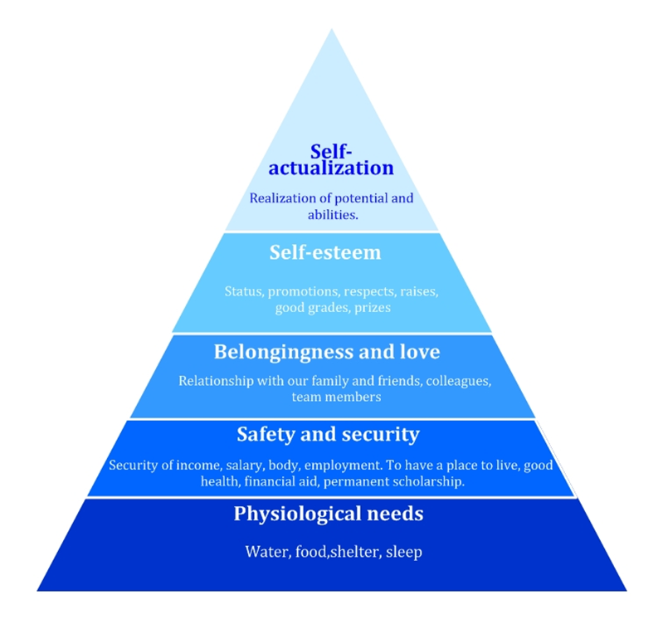
While the hierarchy of needs are represented in form of a pyramid, Maslow himself never drew the pyramid to describe the different levels of human needs. However, the pyramid has become the typical way to represent his hierarchy and scholars have agreed on its use.
- Physiological needs (food, water, shelter, and sleep)
These are the most basic of the human needs that are essential for survival. Maslow emphasized that the body and mind cannot function efficiently and effectively if these needs are not satisfied. They all the most dominant of all human needs. Therefore, if someone misses everything in life, perhaps, the major motivation would be to satisfy the physiological needs more than anything else. A person who lack food, love, safety, and esteem would doubtless seek food as the dominant need; he would look for money to buy food. If all the needs are unfulfilled and the individual is overruled by the physiological needs, all other needs become latent and remain in the background. Every effort is driven towards satisfying the need for food and everything else become secondary.
- Safety and Security
The needs in this level involve the security of income, salary, body, and employment. Satisfaction of the physiological needs allow for the motivation of other need which will arise immediately. Safety needs refer to the desire for security or protection for any form of threat be it physical, social, or income. Sometimes everything appear to be less significant than safety needs, perhaps even physiological needs. Peaceful environment with sure safety and unwavering calmness make people to feel safe from natural disasters, murders, and aggravated assaults, among others. When such a situation is achieved the individual would no longer have need for safety as the first-line motivator to act. Safety and security needs would include such as facets as health and wellbeing, financial security, personal security, and safety measures against accidents, illnesses, and other adverse impacts. Realistically, when people are in danger or trauma such as criminal assault, natural catastrophes, murder, or the motivation to seek safety become active and would be the first-line and dominant mobilizer of individuals.
- Belongingness and Love
These needs encompass integration into social groups and feeling part of a community or a group. Affectionate relationships are also covered in this level of needs. When both the physiological ad safety needs are satisfied, the need for love affection, and belongingness become dominant. Maslow indicated that people have an innate need to belong and be accepted in a social group. The size of the group does not matter as social groups can be large or small. Individuals feel the need to love and be loved both in the sexual and non-sexual perspective. Based on the power of the social groups, these needs can overshadow the physiological and security needs. For instance, losing a loved one can cause someone to lose appetite and fail to eat for several days or even reverts to self-harm as they become obsessed with the satisfaction of love. Love needs entail giving and receiving affection and it is not synonymous with sex, which is depicted as a physiological need. When such needs are unfulfilled, an individual would seek to eliminate the lack of friends, peers, and a partner. Lack of love or belongingness to a social group causes people to suffer from clinical depression, social isolation, loneliness, and social nervousness.
- Esteem
These need involves respect of oneself as a useful and honorable human being. In society, people feel the need for stability and high valuation of themselves. Esteem involve being valued, appreciated, and respected by others. For people to survive in life, they need to feel valued and being important and necessary to society. Those with low self-esteem often feel the need of approval from others. Maslow divided esteem needs into two sub-categories; a lower version and a higher version. The lower one involve the need for respect from others, for instance, accepting their opinion, social status, prestige, and attention. The higher version encompasses the need for self- respect. For instance, self-confidence, freedom, and independence. Stable and healthy self-esteem emanates from being respected by others. While unwarranted adulation and external fame barely makes someone attain self-esteem, it makes someone feel better for a while.
- Self-Actualization
Typically, individual desire to grow and develop to their fullest potential as claimed by Maslow that what humans can be must be. Self-actualization highlights people’s desire to grow and reach their fullest potential. Through availability of opportunities, people choose their own versions of themselves and focus on challenging positions and creative tasks. As described by Maslow, this level demonstrates the need to achieve everything that one can and become the most that one can be. At this level of needs, differences among individuals become apparent.
When each need is satisfied adequately, humans get motivated to seek the fulfillment of the need in the next level in the hierarchy with new and higher needs always coming. This justifies the use of the pyramid in the depiction of the basic human needs. Life experiences such as loss of job or divorce, make individuals to fluctuate between various levels of needs in the hierarchy. These five levels of needs were further sub-divided into two distinctive groups; deficiency and growth needs.
Deficiency needs involve the very basis needs for survival and security. They include esteem needs, social needs (love and belongingness), safety and security needs, and physiological needs. Perhaps, a physical indication may lack when the deficiency needs are not fulfilled but people often demonstrate anxiety and tense moods. The most basic needs must be satisfied before an individual can focus on secondary needs, among others in the higher levels. Growth needs are the motivations for personal growth and fulfillment for personal potential. They include the self-actualization needs. While on paper the hierarchy appears rigid and would suggest that it is the protocol used by people in the satisfaction of needs, in real life, some are bypassed and others are satisfied before others. For instance, to some people, self-actualization or self-esteem seem to be more dominant than other needs such as love or belongingness and they tend to satisfy them first. Regardless, the global acceptance of the theory of motivation is rooted in its simplicity and logic.
ERG theory: Existence Needs, Relatedness Needs and Growth Needs
Another scholar by the name Alderfer postulated the concept of needs to be three classes or three steps i.e. existence, relatedness, and growth (Furnham, 2008). Maslow’s physiological and safety needs are put into the class of existence needs. Relatedness is harmonized with esteem of others and belongingness while growth is similar to Maslow’s self-actualization and self-esteem. Both scholars sought to explain how these needs become more or less important to individual as they satisfy each of them.
Existence needs: these entail the needs for basic material requirements for survival in life. It covers the dynamics of physiological and physical safety needs.
Relatedness needs: they explain human needs for connection with others i.e. family, and peers. They cover needs for love and belongingness and the motivation towards acquisition of recognition and public fame. This class of needs contain the external components of esteem needs and social needs as depicted in the Maslow’s hierarchy.
Growth needs: these are the needs for personal growth, development, and advancement. They satisfy the needs for intrinsic components of esteem needs and the self-actualization needs.
Alderfer agrees to Maslow’s postulate that unsatisfied needs motivate people and individuals generally move up the hierarchy of needs to satisfy them from lower order moving up to the higher order needs. As lower order needs are satisfied, they become less significant. Alderfer postulated that as higher order needs are satisfied, their importance become more apparent (Lăzăroiu, 2015). He believed that when higher categorized needs are not consequent, individual multiply the level of effort used in a lower category need.
Adam’s Equity Theory
In his theory of equity, Adam postulated that people are only motivated if they are treated equitably and receive what they would consider fair dues for their effort. The theory was suggested in 1965 and was based on the Social Exchange Theory. According to the theory, people compare their contribution to work and the cost of their actions to the benefits that are expected as a result of their contribution (Ryan, 2016). If people perceive that their contribution is not equal to the benefits they accrue, they become motivated to reduce the inequities. This association is represented in figure 2 below.
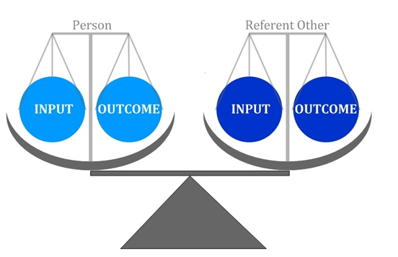
In workplace environments, employees put various inputs into the job including their energy, effort, experience, and education and expect to get equitable outcomes of salary, verbal recognition, promotion, and reward. They outcomes are expected to be equal to the level of inputs as depicted in figure 3 below.
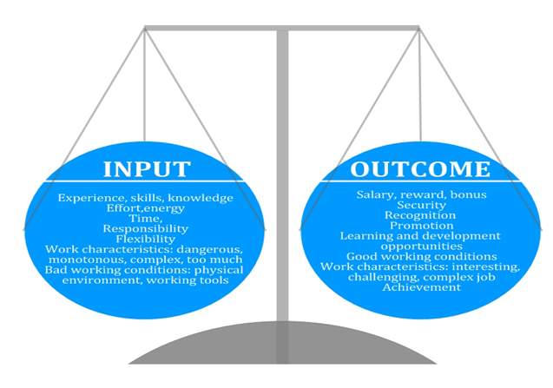

The theory of equity is not only realistic in the workplace, but also in school. For example, in the same oral exam, two students perform differently getting different marks thereby suggesting inequity. In this scenario, the student who receives lower marks would lose his/her motivation learn thereby leading to reduction of efforts. They also persuade the teacher to give them better grades or change the perception of the reference person’s performance. It would be demotivating to students if an individual who never studies or never work harder than the others always gets good marks. The more inequity there is, the greater the level of distress to an individual, which will motivate their quest for inputs and outcomes that are comparable to the reference person (Ryan, 2016). When inequities exist, a person might quit the situation, change the reference person, adjust his/her person of the reference person, or adjust inputs by either reducing or increasing them.
1.6.4 Absenteeism Rate
Generally, absenteeism is the term to employees’ absence from the workplaces. Some of the causes of absenteeism are legal such as family issues or personal illnesses while other factors illegal factors would cause it including lack of devotion to work, reduced work environment. Absenteeism normally has a negative impact to the operation of a business entity and finally its success. Measurement of absenteeism is crucial for the management to administer evaluations of person absence and departmental absences. It enables an organization to recognize the patterns of employee absence (Kocakulah et al., 2016). There are different ways to measure absenteeism with the most common being the person frequency formula and the lost time rate formula.
Rate of absenteeism = number of days lost x 100%
Individual frequency = $\frac{number of emloyees who are absent}{average number of employees}$ * 100
Absenteeism is classified in four different categories including authorized absenteeism, unauthorized absenteeism, willful absenteeism, and absenteeism caused by factors beyond an individual’s control. In authorized absenteeism, an employee fails to report to work by taking permission from his boss or applying for leave; if an employee fails to report to work without informing his boss or taking permission, then it is unauthorized absenteeism. To recognize the various causes of absenteeism among employees, a proper report is necessary to keep track of the various reported cases (Kocakulah et al., 2016). Some of the reasons that cause absenteeism in work include poor working conditions, low level of wages, habits of gambling and alcoholism, indebtedness, lack of interest, irregular transport facilities, poor control, accidents, and absence of regular leave arrangement.

References
Aryasri, A. R., & Babu, S. S. (2007). Work-Life Balance-A holistic Approach. Siddhant-A Journal of Decision Making, 7(1), 1-11.
Campbell, J. P. (1990). Modeling the performance prediction problem in industrial and organizational psychology.
Eisenberger, R., Huntington, R., Hutchison, S., & Sowa, D. (1986). Perceived organizational support. Journal of Applied psychology, 71(3), 500.
Friedman, D. E. (1986). Child-Care For Employees Kids. Harvard Business Review, 64(2), 28.
Harmer, J. (2007). The practice of English language teaching. Harlow: Pearson Longman,.
Healy, K. (2016). A Theory of Human Motivation by Abraham H. Maslow (1942). The British Journal of Psychiatry, 208(4), 313-313.
Ilgen, D. R., & Schneider, J. (1991). Performance measurement: A multi-discipline view. International review of industrial and organizational psychology, 6(1), 71-108.
Kocakulah, M. C., Kelley, A. G., Mitchell, K. M., & Ruggieri, M. P. (2016). Absenteeism problems and costs: causes, effects and cures. International Business & Economics Research Journal (IBER), 15(3), 89-96.
Lăzăroiu, G. (2015). Employee motivation and job performance. Linguistic and Philosophical Investigations, (14), 97-102.
McCloy, R. A., Campbell, J. P., & Cudeck, R. (1994). A confirmatory test of a model of performance determinants. Journal of applied psychology, 79(4), 493.
Milkovich, G. T., & Gomez, L. R. (1976). Day care and selected employee work behaviors. Academy of Management Journal, 19(1), 111-115.
Motowildo, S. J., Borman, W. C., & Schmit, M. J. (1997). A theory of individual differences in task and contextual performance. Human performance, 10(2), 71-83.
Ryan, J. C. (2016). Old knowledge for new impacts: Equity theory and workforce nationalization. Journal of Business Research, 69(5), 1587-1592.
Walker, E., Wang, C., & Redmond, J. (2008). Women and work-life balance: is home-based business ownership the solution?. Equal Opportunities International, 27(3), 258-275.
Williams, M., & Burden, R. L. (1997). Psychology for Language Teachers: A Social Constructivist Approach. Cambridge University Press, 40 West 20th Street, New York, NY 10011-4211 (paperback: ISBN-0-521-49880-5; hardback: ISBN-0-521-49528-8)..

