Week 6: Ch 16 and Ch 22: Antecedent Control Procedures/Token Economy
55 unread replies.55 replies.
If you need help understanding the material, I will discuss it Monday/Thursday during the chat.
After reviewing the material below you will provide an example of the following:
1. Using Antecedent Control Procedures to Increase a Behavior- describe a way you made a change in your environment to increase a behavior
2. Using Antecedent Control Procedures to Decrease a Behavior- describe a way you made a change in your environment to decrease a behavior
3. Create a token system for either an adult or a child- identify the behavior you are trying to increase; tell me what you are using for tokens; tell me how many tokens need to be earned; tell me how the tokens will be earned (refer back to the behavior you are trying to increase); how often can the tokens be redeemed; what can the tokens be traded in for. Again, think about how we use money (generalized token system) to buy things (backup reinforcers). Just don't use money as your example :-)
Antecedent Control Procedures
In my world we call this "antecedent manipulation," which sounds awful, but trust me, it's not. Antecedent control/manipulation means we are changing something in our surrounding/environment to either increase or decrease a behavior. We do this by providing cues or SDs to remind us to do something. The Sds/cues can be something we physically do in the environment (moving your book bag closer to door so you don't forget it when you leave for campus) or something that is social (my mom had "The Eye" that she would give whenever we, as kids, would start to act up). Do you see how I have highlighted, bolded, and underlined these discussion posts? Those were my physical SDs to you all to let you know that something important was mentioned in the writing.
Establishing Operations (EOs) and Abolishing Operations (AOs)
Remember early on in the class we talked about reinforcers and punishers (if don't, it's okay- here is a refresher).
An effective reinforcer is anything that makes you willing to engage in a behavior to obtain it. Like money for example. Many people like money and are willing to work in jobs they don't enjoy in order to get it.(reinforcers increase behaviors, good or bad)
An effective punisher is anything that makes you willing to engage in a behavior to avoid it. Most people don't like jail and therefore do not engage in criminal behaviors that lead to being imprisoned. (punishers decrease behaviors, good or bad).
Now that we are done with the refresher, let's talk about establishing operations/EOs. All this fancy word means is that something happens that increases the value of the reinforcer. Imagine I have a glass of ice cold water or hot tea for you to drink....which one is more reinforcing? Well if you just came in from walking in -30 degree weather and I give you a glass of ice water, you probably aren't going to want it very much. It's ICE WATER and you're already cold. The ice water has no establishing operation on your behavior to drink it. It has ZERO value. But if I offer you the hot tea...well game changer! You value the HOT tea more because you are cold. The cold weather has an EO on you drinking the hot tea because you value the hot tea more in your frozen state. Now imagine it is the middle of the Texas summer, 105 degrees out, and you just came in from cutting the grass. And you are THIRSTY and all you can think about is something to drink. The hot weather creates an EO for which drink choice? Ice water or hot tea? If you said ice water, then you are correct.
Simply put, EOs make a reinforcer more effective. Now let's look at another example of an EO. Let's say you ate a big meal right before you went home from work ( you are full). But when you get home, your spouse surprises you with your favorite dinner. What would be the value of that dinner? Would you be hungry for it after eating that big meal just a little while ago? Probably not. The EO for that home cooked dinner is not there and you value it less.
Now look this scenario. You woke up late and did not eat breakfast. Work was hectic and you missed lunch as well. Before you know it, it's time to go home. As you walk in the house, you smell sloppy joes, not your favorite meal in the world (note: I hate sloppy joes). But you are STARVING and eat not one but TWO servings. What was the EO that made this least preferred reinforcer effective?
EO: did not eat all day -> increased the value of the sloppy joe->behavior= eating the sloppy joe
So even though it was not a "favorite or preferred" reinforcer, the starving stomach made it an EFFECTIVE reinforcer and you were more willing to eat it. Now if you had a big meal before coming home, then the sloppy joe probably would not have been eaten because there was not EO to make it valuable.
Abolishing Operations means the value of the reinforcer has decreased (you don;t want it anymore). With the ice water and hot tea examples, once you drank the ice water (summer heat) and have cooled off, you no longer are dying for that glass of water. Have you ever ate so much of one type of food that you got sick that when offered that one item, you refuse it, even though it usually is something you like? You had an Ao for that food which decreased its value to you.

Decreasing Response Effort to Increase Desired Behavior
(Pretty much making it easy for the behavior to happen).
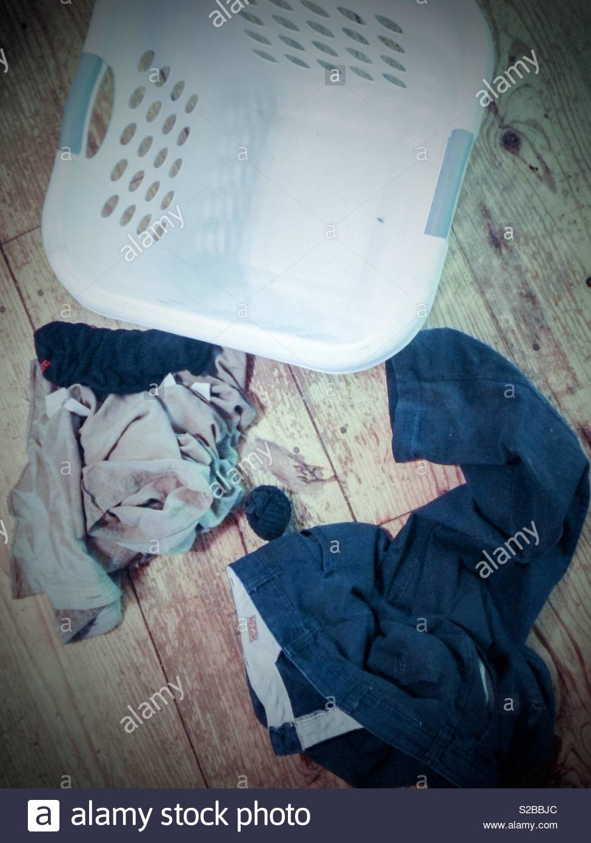
One way to do antecedent manipulation is to change the environment so that it is easier for the behavior to occur. For example, two of my sons had a bad habit of putting their dirty clothes everywhere but in the laundry basket in the bathroom (typically their bedroom). So to increase the behavior of getting the clothes in a laundry basket, I put a laundry basket in their bedrooms. I made it easier (decreased response effort) for them to get the clothes into a basket by placing the baskets in two locations. When using this approach, all you are doing it simply creating ways to make it easier for the behavior to occur. Eventually you can fade out the manipulations (I removed the basket from the bathroom and they only have the one in their rooms) so that the behaviors happens more naturally. Now that they are older, I have a basket in the bathroom and imagine that, they actually put their clothes in it! We call that generalization across settings!!
Increasing Response Effort for Undesirable Behaviors
This means manipulating the environment so that it is harder for the behavior to happen. The book gave a great example. If you are trying to eat healthy, you can remove all of the unhealthy food options out of your house. This limits your ability to cheat AND if you really wanted to eat something unhealthy, you have to go out of your way to do so! Now if you pair this with the above procedure and keep healthy foods in your house, you are more likely going to eat the healthy because it is there (easy) rather than leave the house to get junk food (harder).
Motivating Operations
Since we are all adults, let's use adult examples. Why do you get up and go to work? Money. We need it for EVERYTHING in this society. So we are motivated to get up and go to work because we want that reinforcer (paycheck). Everyone is motivated by something and, if the MO is just right, will engage in a behavior to obtain that reinforcer. Don't believe me? Two Words. Fear Factor. That tv show had people engage in some of THE CRAZIEST behaviors in order to win $50k (or something along those lines). They created strong MOs to elicit those crazy behaviors. Drink this blended cocktail of hissing cock roaches, cow testicles, and a floating spider as a cherry. Sit in this tank while we pour bugs/snakes/(insert creepy creature of your choice). Jump off this skyscraper with just a harness on. Do all this and you can win the money. Motivating operations are just that. They motivate you to engage in a particular behavior to obtain the reinforcer/reward.
https://www.youtube.com/watch?v=EKlI2o16SYM (Links to an external site.)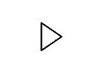

The Token Economy
This is a pretty straight forward chapter. Our entire society is built on a token economy. Money. Tokens are considered generalized reinforcers because by themselves, they are not reinforcing. It is what you can trade them in for that makes them appealing. With all the apps today, you can even download apps (Chore Monster is a favorite as it uses the token system and the kids get to help pick out the reinforcers which are displayed for them- great for kids with devices). We use a mixture of both real and digital token systems with the boys.
The token boards can be as elaborate or basic as you want (I've used scratch paper and Xs before), but they have to be specific and understood by the person earning them.
What behaviors will earn them a token?
How many do they have to earn before they can be redeemed?
How often can they be redeemed?
Do you really want to put a 4 year old on a monthly schedule or is that a bit of a stretch for them? Make sure the schedule of reinforcement is age appropriate. Adults can go on a monthly schedule (paid first of the month) all the way to a daily schedule (day jobs), to even every time they do something (Lyft, Uber, Food drivers).
When can they be redeemed? Hourly, daily, weekly, monthly?
What can they redeem them for (list of reinforcers)?
Some examples:
3 year old: to earn one hour on his ipad he has to complete five "brain games," each worth one sticker. He gets to choose the five brain games (brain games is parent code for anything educational). Board games, reading a book (or 3), doing work sheets, playing ABCmouse, coloring, playdough...he has a whole wall of things to choose fro. As we complete an activity, he gets one sticker (of his choice) that he puts on his paper board. he can complete as many or as little in one sitting. If it takes 2 days, then it takes two days. It takes 20 minutes, then so be it. But the key is he can't get access to his ipad until he gets the 5 stickers. But it works at his pace. His motivation is what determines when he gets his ipad.

11 year old: to earn 90 minutes of computer time after school, he has to make sure he has checked off the following items: feed dogs, clothes off the floor, homework is done, 30 minutes playing with his baby brother, and one hour of Khan Academy. He has a checklist that he puts a magnet beside once it is done. Because he is an early bird, he typically gets everything done except his homework and playing with his brother before he goes to school. If the magnets are all up there, he can use his 90 minutes that day or bank them for another time (typically the weekend).
So get your creative juices flowing and create a token system that is age appropriate, behavior specific, and feasible to do (low response cost). The last thing you want to do is create something so elaborate that no one follows it because it takes too much work (response cost is too high)

