Celestial bodies

Author
Institutional Affiliation
Instructor
Course code
Date of submission

Triton
Triton refers to the largest Neptune’s satellite discovered in October 1846 just 17 days after the discovery of the planet Neptune itself. The planet has 13 moons out of which Triton is the largest. Broadfoot et al. (1989) stated Triton’s uniqueness arguing that, out of the large moons currently orbiting the solar system, it is the only large moon that moves in the opposite direction. Just like the earth’s moon, Triton has synchronous rotation with Neptune with one side facing the planet all through the year. However, considering its unusual rotation, it is imperative to understand that Triton's polar regions take turns facing the sun.
Images obtained by NASA spacecraft have images of a sparsely cratered surface with smooth volcanic plains. It is believed that the crust of the moon is composed of frozen nitrogen covering the interior core of rock and metal. Triton arguably has a higher density compared to the satellites of Uranus and Saturn. It is believed that the moon’s atmosphere consists of nitrogen and traces of methane gases. Astronomists believe that the composition of Triton’s atmosphere is influenced by its volcanic activity. Observably, other than the Earth and Venus planets, Triton and Io are the only bodies within the solar system that are still volcanically active.
Evidence drawn from 1989’s flyby by NASA’s Voyager 2 indicated very low surface temperatures at -235ºc, which has attributed to the moon’s nitrogenous atmosphere which is usually condensed as frost giving it the icy-shiny sheen reflecting 70% of the incoming sunlight (NASA, 2019).
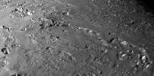
An image showing Triton’s surface. Credits: NASA Voyager 2.
Ceres
Ceres is considered the largest object present in the asteroid belt having been reclassified as a dwarf planet even though it is arguably smaller than Pluto. Ceres is located within the inner Asteroid belt specifically between the Mars and Jupiter planets. Ceres was previously discovered in 180, with its first classification as a planet which only lasted for a year, followed by classification as an asteroid, then later as a dwarf planet in 2006 (Schmidt et al., 2017). I believe it is interesting to consider it for discussion being the only dwarf planet that has received a visit from a spacecraft. Similarly, it is the only dwarf planet that is located within the inner circle of the solar system.
Ceres found within Neptune’s orbit is believed to have been formed about 4.5 billion years ago with the influence of gravitational force pulling the swirling gas and dust together to form a dwarf planet. Scientists believe that Ceres had begun to form as a planet but however failed to finish particularly due to the stronger gravitational pull exerted by Neptune. Ceres revolves around the sun using the between Mars and Jupiter, taking approximately 4.6 earth years to make one complete revolution. Images obtained from spacecraft have shown icy and rocky surface, covered in small countless young craters.
One of the major findings on the surface of Ceres is the discovery of water vapour in January 2014, indicating that it could be meteorologically active with a special type of volcano called cryovolcano.
Ceres represents one of the few regions within the solar system where scientists are prospecting for life. There are plans to continue explorations on the dwarf planets to determine the possibility of life sustenance, especially due to the presence of water.
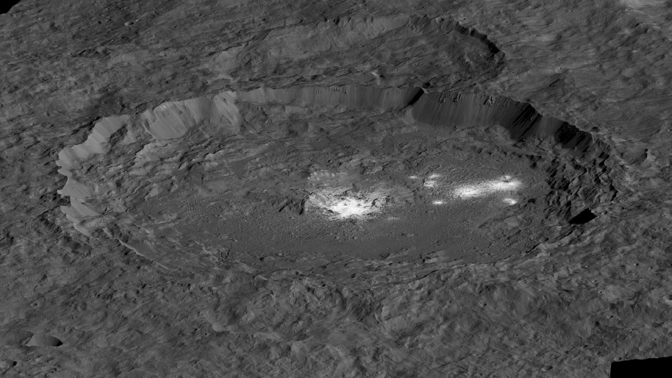
Bright areas in Ceres are indicative of geologic activity cc. NASA @2020
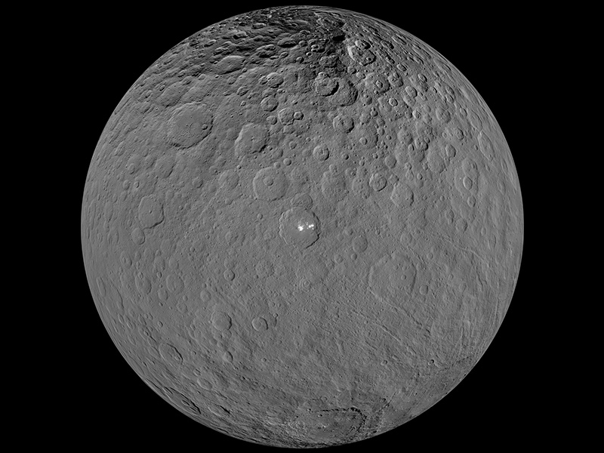
Image of dwarf planet Ceres as seen by NASA's Dawn spacecraft. Credits: NASA@2019
References
Broadfoot, A. L., Atreya, S. K., Bertaux, J. L., Blamont, J. E., Dessler, A. J., Donahue, T. M., ... & Hunter, D. M. (1989). Ultraviolet spectrometer observations of Neptune and Triton. Science, 246(4936), 1459-1466.
Schmidt, B. E., Hughson, K. H., Chilton, H. T., Scully, J. E., Platz, T., Nathues, A., ... & O’Brien, D. P. (2017). Geomorphological evidence for ground ice on dwarf planet Ceres. Nature Geoscience, 10(5), 338-343.
NASA. (, 2019). Solar System Exploration; Triton. Retrieved: https://solarsystem.nasa.gov/moons/neptune-moons/triton/in-depth/

