CORPORATE AWARD PROGRAMME
ASSIGNMENT FRONT SHEET
STUDENT MEMBERSHIP NUMBER | 005701250
COHORT NAME and NUMBER | ADNOC Cohort 2
ASSESSMENT CODE | PDV
MODULE TITLE | Driving value through Procurement and Supplier  Managing Expenditure with Supplier
SUBMISSION DEADLINE DATE | 18/11/2018
WORD COUNT | 3165

Please do not change or remove the wording in this front sheet as this is required for all submissions under the Corporate Award Programme. Any submissions received without the correct front sheet will be returned to the candidate for amendment and re-submission and may delay marking.
- Please ensure that you complete and attach this form to the front of your submission. It will not be accepted if it as sent as a separate file to the submission itself.
- Before submission, please ensure that your name does not appear anywhere on your work.
- By submitting your work, you are confirming that your work is your own and that you have read and understand CIPS rules regarding plagiarism and the consequences that will arise should you submit plagiarised work.

Table of Contents
1. Executive Summary 4
2. Introduction 6
2.1. Our organization 6
2.2. Adnoc Ruwais Hospital 8
3. Product Overview 8
3.1. What is an X-ray? 11
3.2. Why is an X-ray performed? 11
3.3. X-Ray Equipment Risk Assessment 12
3.3.1. Hazards 12
3.3.2. Risk 12
3.3.3. Risk Rating 13
3.3.4. People at Risk 13
3.4. Kraljic Portfolio Purchasing Model 13
4. Importance & impact to the stakeholders 14
5. Market Overview 16
6. Market Risk analysis 17
7. Procurement function 20
8. Recommendations 26
8.1. Price 26

8.2. Environmentally Friendly 26
8.3. Usage 26
8.4. End-Users 27
8.5. Service Contract 27
8.6. Technical Support and System Updates 28
8.7. Availability of Parts and Consumables 28
9. Value for money outcome 29
10. Conclusion 30
11. References 31
12. Table of Figures 31

Executive Summary
This report is about the analysis and evaluation of a procurement method for X-Ray Machines and exploring ways to reduce costs for ADNOC and the Group Companies.
Abu Dhabi National Oil Company runs operations of a hospital and provides medical services at its onshore and offshore facilities, as the state oil firm focuses on developing its core business.
Market analysis of the equipment was done using various marketing tools .
Procurement of X-Ray Machine is categorized as medium spend item owing to price and risk. ADNOC can better its procurement functions to get more products with great value go the service and save costs on the competitive processes.
My recommendations to improve the procurement of X-Ray Machine from the market are:
- The procurement process of the whole group must be consolidated
- Verify if supplier is financially sound to cater to ADNOC requirements
- Instead of top quality products, procure products that do the job
- ADNOC Group must unify the specification & standards to improve procurement process

Introduction
ADNOC introduced CIPS certification program in order to improve the business professionalism and enhance the skills of her employees by international certification and its standards. In this assessment the following modules of learning will be conducted:
- Driving value through procurement and Supply
- Managing Expenditure with suppliers
During the preparation of this assignment the candidate will go through an in-depth study of the aspects listed below:
- Knowledge and understanding gained through the programme
- Ability to research
- Analyse the problem
- Resolve the related challenges

Our organization
We are one of the world's leading energy producers, and a primary catalyst for Abu Dhabi’s growth and diversification.
We operate across the entire hydrocarbon value chain, through a network of fully-integrated businesses, with interests that range from exploration, production, storage, refining and distribution, to the development of a wide-range of petrochemical products.

For over 46 years, we have played an integral role in Abu Dhabi’s economic development, managing, producing and preserving the Emirate’s hydrocarbon reserves on behalf of the Abu Dhabi Government. We are the principle catalyst of growth in the Emirate, and our work has had a positive and lasting impact on the quality of millions of lives. Since 1971, we have created thousands of jobs, driven the growth of a diverse knowledge-based economy, and played a key role in Abu Dhabi’s global emergence.
Today, we continue to look for new and innovative ways to maximize the value of our resources, pioneering those approaches and technologies that will ensure we are able to meet the demands of an ever-changing energy market, and continue to have a positive impact on the Abu Dhabi economy for generations to come
ADNOC has been entrusted with managing, developing and preserving Abu Dhabi's hydrocarbon reserves. This role comes with many responsibilities - to our shareholders, neighbours, customers, communities and our environment.
The values of our company, and our country, are inspired by our founding father, the late Sheikh Zayed bin Sultan Al Nahyan. They are the bedrock of our entire philosophy, and inspire and inform the way that we conduct ourselves every day.
Our values are the core principles that guide our decision making, and ensure consistency in our employees’ actions and behaviours. They represent our organization’s collective commitment to set, achieve and exceed ambitious targets.
www.adnoc.ae/

Adnoc Ruwais Hospital
Adnoc Ruwais Hospital extends medical services to its employees and people in Ruwais and border Al Dhafra region.
ADNOC’S commitment to the welfare of our employees and the communities in which we operate,” Adnoc’s director of business and commercial support, Rashed Al Shamsi, said. “it will ensure our people and their families, our contractors and the wider communities will continue to have access to the highest quality diagnostic services and medical treatment.”
As part of its 2030 strategy, ADNOC is focusing on core strengths to achieve its business goals, while partnering with qualified companies, including those with the right expertise from the private sector to provide best-in-class services in company’s non-core business areas.
Expanding the range of services, we are able to demonstrate to our employees and the Ruwais community our commitment to further improving the already excellent medical services at Ruwais Hospital.”
https://gulfnews.com/uae/health

Product Overview
In this assessment we focus medical diagnostic equipment, x-ray machine.
Medical imaging is an extremely important element in medical practice in this day and age, but have you ever stopped to consider its true importance? Medical imaging has changed the face of the healthcare industry and allowed practitioners and scientists to learn more about the human body than ever before.

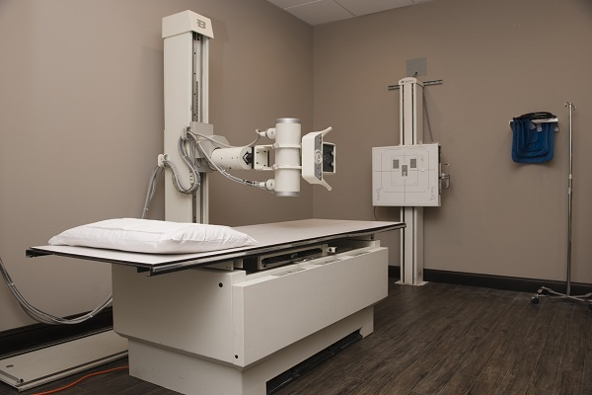
Figure 3.1: X-Ray Equipment
(https://theaerospacenews.com/global-medical-x-ray-generators-market-2018)
In diagnosing an ailment or illness, physicians frequently order diagnostic scans such as an x-ray, CT scan, or MRI. While medical knowledge and discernment forms the basis of health practitioner diagnoses and decisions, medical imaging is a vital part of confirming any diagnosis. Medical imaging can also assist in decisions regarding treatment and future care of the issue. As technology advances, medical imaging can inform the doctor of internal problems that a basic external examination would fail to detect. Medical imaging is absolutely necessary when tracking the progress of an ongoing illness. MRI’s and CT scans allow the physician to monitor the effectiveness of treatment and adjust protocols as necessary. The detailed information generated by medical imaging provides patients with better, more comprehensive care. The use of ultrasound imaging is extremely important for expectant mothers. Ultrasound technology has advanced significantly over the past decade, and sonogram images are now

produced with a much higher resolution, creating finely detailed images. This gives obstetricians a vastly improved picture of the baby’s health and progress in the womb, allowing them to ascertain any issues of concern much earlier on in the pregnancy. As well as obstetrics, ultrasound is extensively used on other parts of the body including the soft tissues of the neck, breasts, abdomen, pelvis, and soft tissues of the extremities. It is also used as a guide for biopsies of soft tissues and for some treatments.
One further benefit of medical imaging is its function in preventative care. Recommended evaluations such as mammography can help detect early signs of breast cancer. An increase in the use of mammograms has been suggested to account for a 30% decrease in breast cancer fatalities since 1990.
Medical imaging also is used by surgeons as an aid in surgical procedures. One example of medical imaging as an effective surgical tool is in the case of endoscopic sinus surgery. The extensive network of the sinus can be examined closely prior to the procedure through study of a CT scan. CT scans can provide 3D images of various cross-sections of the body–images which are of absolute necessity when preparing to operate on such an area. CT scans are also
being utilised more frequently during surgical procedures, for a similar purpose of guiding physicians throughout a delicate internal operation.
Medical imaging is truly a vital element of the healthcare world–an essential tool for physicians to assist with diagnostics, treatment, and prevention. As technology continues to advance at a rapid rate, we will see growth in medical imaging technology as well. With scientific advancement and a continued effective use, medical imaging will continue to help with earlier detection of health issues, aid in easier treatment, and provide increased preventative care.

(https://www.xray.com.au/importance-of-medical-imaging/)

What is an X-ray?
An X-ray is a common imaging test that’s been used for decades. It can help a doctor view the inside of patient’s body without having to make an incision. This can help them diagnose, monitor, and treat many medical conditions.
Different types of X-rays are used for different purposes. For example, the doctor may order a mammogram to examine patient’s breasts. Or they may order an X-ray with a barium enema to get a closer look at patient’s gastrointestinal tract.

Why is an X-ray performed?
A doctor may order an X-ray to:
- examine an area where you’re experiencing pain or discomfort
- monitor the progression of a diagnosed disease, such as osteoporosis
- check how well a prescribed treatment is working
Conditions that may call for an X-ray include:

- bone cancer
- breast tumors
- enlarged heart
- blocked blood vessels
- conditions affecting your lungs
- digestive problems
- fractures
- infections
- osteoporosis
- arthritis
- tooth decay
- needing to retrieve swallowed items
(https://www.healthline.com)

X-Ray Equipment Risk Assessment

Hazards
The hazard most associated with X-rays is exposure to a high dose rate beam of X-rays, albeit often well collimated. As with all electrical equipment, there are also hazards associated with high voltage.

Risk
Risk assessments of work using X-rays should take account of:
- exposures, usually to hands, which may result in:
  - the annual dose limit being exceeded in a relatively short space of time (as short as a few seconds)
  - a radiation burn.
- use by inexperienced personnel
- alignment procedures at the critical period of use.
- An example of the risk is if a pregnant lady is exposed to X rays the developing fetus is probably to be affected with Leukemia during childhood. And for this pregnant women should be purely isolated from X rays

Risk Rating
Without control measures, or the operational procedures listed below, X-rays represent an intolerable risk (likely, extremely harmful) under guidance given in BS 8800.

People at Risk
Anyone using X-ray equipment is potentially at risk, but particularly inexperienced or insufficiently trained personnel.
Also the unprotected individuals who don’t wear the right gears when entering the Xray room are at risk
Long term patients who use X rays for their medication are also purely still at a larger risk
(https://app.croneri.co.uk/topics/laboratory-equipment/x-ray-equipment-risk-assessment)

Kraljic Portfolio Purchasing Model
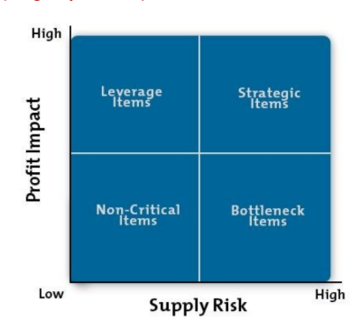
Figure 3.4.1: Kraljic Matrix (Mind Tools)
ADNOC group’s internal risk assessment bases Medical equipment rank with Financial risk impact score (4) and Supply risk score (3.5) as mentioned in ADNOC internal risk register.
Medical Equipment falls under the Strategic category segment as represented in the Kraljic Matrix shown in below Figure 3.4.2.
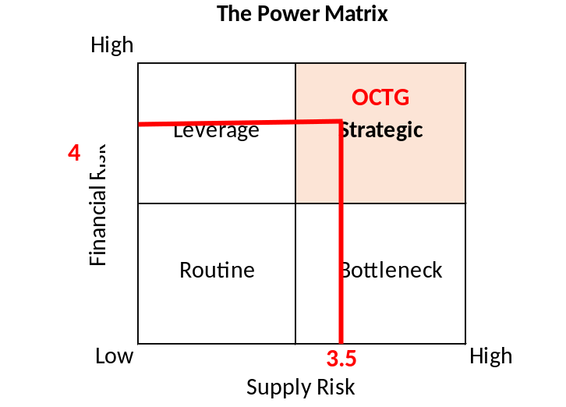
Figure 3.4.2: Kraljic Matrix

Importance & impact to the stakeholders
Ruwais being a remote area distant from city scape (around 230 Km) require a state of the art medical services to serve the employees (on shore and off shore) and their families, contractors and the wider communities in Ruwais and border Al Dhafra region.
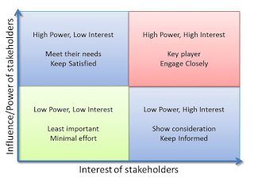
Figure 4.1: Mendelow Matrix (Jackson, P., Crocker, B & Carter B 2016 p 108.)
Stakeholder Management Matrix (Mind Tools)
The effect of X-Ray machine procurement on ADNOC Stakeholders are as follows:
Internal: The Management, Shareholders, Commercial Directory Department, Group Procurement Department and Ruwais Medical Department.
Commercial Directory include of the Department registers and prequalifies suppliers to make sure they can do the job and meet ADNOC criteria.
Group Procurement Department evaluates suppliers technically and commercially.
ADNOC Management awards the supplier selected by accessing them appropriately.
Shareholders give advice on procurement function decisions. And also gives a correction of what should be done or implemented accordingly.

Ruwais Medical Department are the End users of X-Ray machine and technical authority, setting X-Ray Machines requirements.
External: This include of the Community & other group companies
Other Group Companies Employees are Onshore and offshore employees , contract staff and their families will utilize the medical facilities since city is around 200km away.
Community of Al Ruwais and Al Dhafra Region will utilize the medical facilities since city is around 200km away

Market Overview
Market for X-Ray machine has divided into various groups by:
- Product (Flat Panel Detectors, Line Scan Detectors, Computed Radiography Detectors, Charge Coupled Device Detectors [CCD]),
- Technology (Computed Radiography [CR], Direct Radiography [DR], Others),
- Portability (Fixed Systems, Portable Systems),
- Application (Dental, Veterinary, Mammography, Chest, Cardiovascular, Orthopedics, Others),
- End-use (Diagnostic Centers, Hospitals, Others)
Major Suppliers / Manufacturers are from Japan, Germany, USA, Netherlands, etc.
The main manufacturers in the Medical X-ray are:
Medical X rays are of great use in visualizing of the body and in particular the bones and also some body organs. The main manufacturers of this products are as follows below and they produce likely the same products but it can be considered with different characteristics and properties.

- Siemens Healthcare

- GE Healthcare
- Canon
- Philips Healthcare
- Hitachi Medical
- Shimadzu

Market Risk analysis

The Five Forces are brought together in Figure 5.1, below:
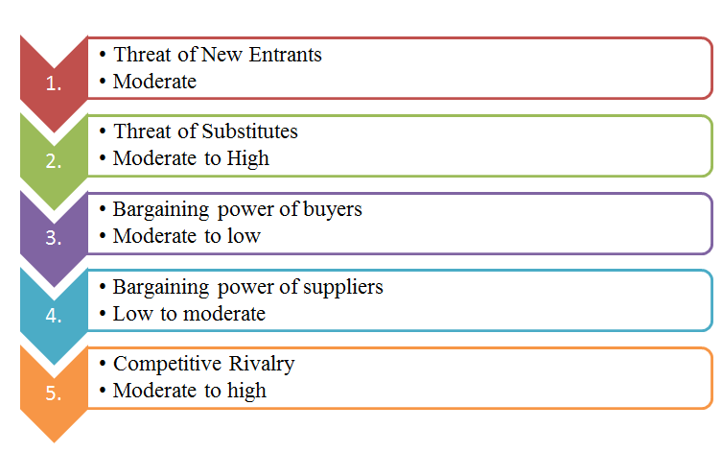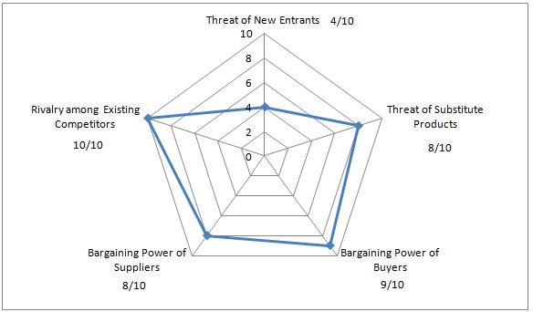
Figure 6.1: Porter’s Five Forces (Mind Tools)

- Competitive Rivalry is high with high competition and well-established market.
- New Entrants is high and possibility of of new entry by suppliers into the market is highly possible. Suppliers need to consider new technology in medical advancement
- Supplier Power is medium due to high number of Suppliers and a lot of competitors trying to challenge and compete. Also, X-ray machine suppliers depend on medical industry demand. ADNOC has goodwill and so suppliers like to work with ADNOC
- Buyer power is high as ADNOC has better payment terms, and the demand for x-rays is limited to Medical field, and ADNOC has good number of prequalified suppliers.

Procurement function
ADNOC is committed to developing and maintaining a competitive and sustainable supply chain of partners and service providers. This in also enhancing that the service is provided to all
As part of ADNOC Group's evolution into an efficient and performance-driven organization, we are launching a new initiative for improving and streamlining our supplier registration, sourcing, procurement, and accounts payable processes by implementing an automated e-commerce solution effective from January 2017.
If not already registered, suppliers should register to the ADNOC Commercial Directory in order to be considered for tendering opportunities from across the Group. The Directory has the following features:
- Online and real time supplier registration system for all ADNOC Group company suppliers

- Track your prequalification status online
- Update your company profile online
- Get invitations for tenders based on your profile (only for ADNOC HQ suppliers)
- Access automated and online tender, RFx and bidding tool (only for ADNOC HQ suppliers)
- Communication between bidders and ADNOC, including document sharing
- Automated notifications and reminder workflow between ADNOC and participating suppliers
All new suppliers should complete a one-time registration on the ADNOC Commercial Directory to do business with any of the ADNOC Group companies. Existing suppliers of ADNOC Group companies have been pre-registered as part of this initiative.
www.adnoc.ae/

Procurement activity can be well followed by the flow chat below: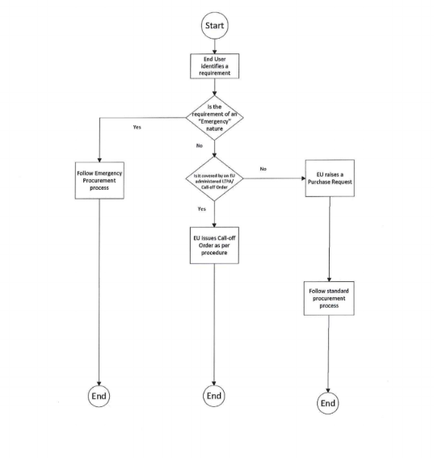
Figure 7.1: Procurement process flow – initiation

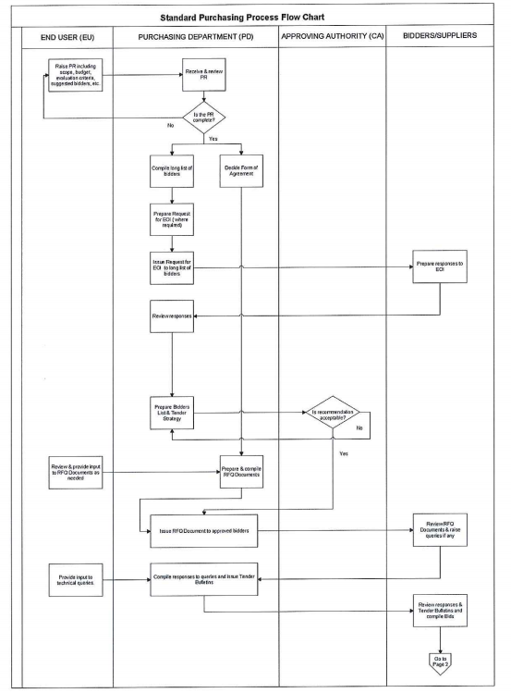
Figure 7.2: Standard Purchasing process flow chart part 1

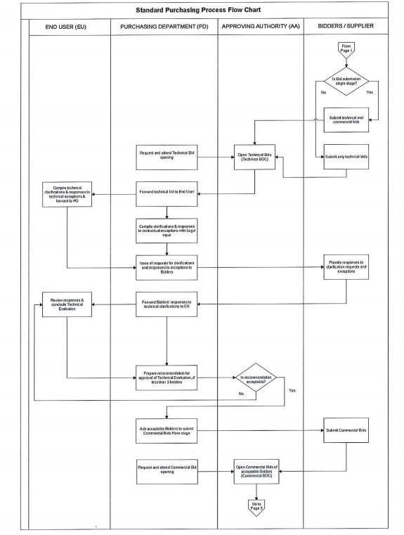
Figure 7.3: Standard Purchasing process flow chart part 2

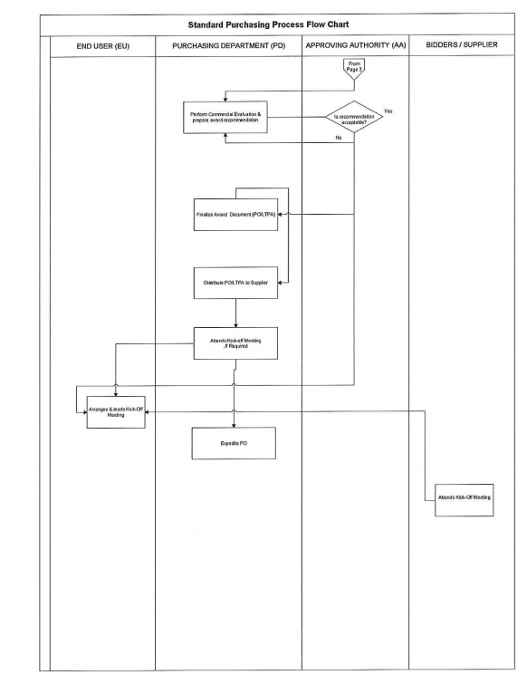
Figure 7.3: Standard purchasing process flow chart part 3

Recommendations
Here are seven tips to consider before buying new diagnostic imaging equipment:

Price
When purchasing new or refurbished diagnostic imaging equipment, price is always a major concern. Not only should the purchase price be taken into consideration, but also consider how much will it cost to properly maintain the equipment over its lifetime. How much are replacement parts or consumables, and how does the purchase price compare to other similar makes and models on the market? Creating an easy to read side-by-side chart may help with the decision-making process.

Environmentally Friendly
If being environmentally friendly is important to your organization, the selection of green diagnostic imaging equipment is limited and the product features available may or may not meet your wish list needs. The initial purchase might be more than anticipated; however, the maintenance costs over its lifetime are usually significantly reduced.

Usage
Another determining factor when considering the purchase of new or refurbished diagnostic imaging equipment is usage. How often and in what environment will the equipment be used? The questions posed in the opening paragraph are great examples of details to consider; the circumstances in which the equipment will be utilized will help determine the list of product features necessary to get the job done well and in a timely manner. It might be worth taking a quick survey of the technicians as well to figure out the true needs of the patients.

End-Users
The skill levels of the technicians using the diagnostic imaging equipment should be given some serious thought before making a significant purchase. If you are purchasing the most

technologically advanced CT scanner for example, will the end-users require additional training on how to properly operate the equipment or how to optimize clinical protocols? And is training provided online or offline and at what cost? Will the end-users have unlimited access to online usage, maintenance, and vendor performance reports and will those reports be provided at no cost?

Service Contract
First and foremost, find out the duration of the manufacturer warranty because it varies from manufacturer to manufacturer. After that warranty period expires, it is extremely important to consider what service contract terms and conditions are available and at what cost. Is the service contract long or short-term; is there an auto-renewal clause; what are the cancellation fees; is there a guaranteed response time; and are parts and travel included in the contract cost?
Before entering into any contract with the Original Equipment Manufacturer (OEM) or third-party vendor, it is vital to understand exactly what you are signing. Don’t make the mistake of assuming the contract has favorable terms and conditions. The consumer should always consult an expert before signing a contract, regardless of any sales tactics deployed at the initial purchase of the diagnostic imaging equipment. There are ways to negotiate favorable contract terms and conditions. Furthermore, the organization’s negotiating leverage is completely lost after the service contract has been signed. Alternatives to the traditional service contracts are available – time and materials, preventative maintenance only, loaner or depot service, or utilizing an Equipment Maintenance Management Program (EMMP).

Technical Support and System Updates
Technical support and system updates are often bundled in the terms and conditions with the purchase of an expensive service contract. Since organizations have alternatives to the traditional service contract, it would be advantageous to negotiate technical support and system updates at the initial purchase of costly diagnostic imaging equipment. Technical support should be easily accessed via a toll-free number and system updates should be provided at no cost since their goal is to eliminate a manufacturer malfunction or enhance the overall performance of the equipment.

Availability of Parts and Consumables
Decide whether you prefer OEM certified parts and new consumables versus refurbished parts and consumables. The pros and cons for each need to be considered. Which parts and consumables are more readily available, new or refurbished, and do the prices fall within your equipment maintenance budget? It’s important to review the language concerning parts and consumables in the service contract or interview possible time and material service vendors who can perform the required maintenance on the diagnostic imaging equipment being considered.
(http://www.diagnosticimaging.com)

Value for money outcome
As we adhere to the following general principles while executing procurement on behalf of our organisation:
- Best value for money
- Fairness, integrity and transparency

- Effective international competition
- The interest of ADNOC
Best value for money' means selection of the offer which presents the optimum combination of life-cycle costs and benefits, and meets the business unit’s criteria.
Best value for money should not be equated with the lowest price option. Rather, it requires an integrated assessment of technical, organisational and pricing factors in light of their relative importance, for example, reliability, quality, experience, reputation, past performance, cost/fee realism and reasonableness. A business unit’s parameters can also include social, environmental and other strategic objectives once identified in a procurement plan.
As competition is the basis for efficient, impartial and transparent procurement, Business Units are therefore, responsible for protecting the integrity of the procurement process and maintaining fairness in treatment of all offers
Sound procurement (that is: openness of process, probity, complete and accurate record-keeping, accountability, and confidentiality) establishes and then maintains rules and procedures that are attainable and unambiguous.
The objective of competitive processes is to provide all eligible prospective offers with timely and adequate notification of requirements, and equal opportunity to tender for the required goods, civil works and services.
Business units should ensure that restrictions are not placed on the competitive processes limiting the pool of potential offers, as UNDP does not accept procurement awarded to exclusive contractors or countries, unless otherwise explicitly mentioned in a donor agreement.

However, any such restrictive procurement provisions within an agreement must obtain prior approval as per Deligation of Authority.
In practice, the specific procurement rules and procedures established for the implementation of a programme are contingent upon the individual circumstances of a particular requirement. However, four considerations consistently guide the organisation’s interest for the acquisition of inputs:
The need for economy and efficiency in the implementation of the programme, including the procurement of goods, civil works, and services involved.
The access to procurement opportunities for all interested and qualified offers worldwide, except where other criteria are mandated by the Security Council or General Assembly.

Conclusion
Being a part of ADNOC, the Vision, Mission, standard and commitment of ADNOC has to be filter down in to each and every activity. Our each procuring job has to be timely, quality oriented with value for money.

References
- www.adnoc.ae/ 7
https://gulfnews.com/uae/health 8
(https://theaerospacenews.com/global-medical-x-ray-generators-market-2018) 9
(https://www.xray.com.au/importance-of-medical-imaging/) 11
(https://www.healthline.com) 12
(https://app.croneri.co.uk/topics/laboratory-equipment/x-ray-equipment-risk-assessment) 13

Stakeholder Management Matrix (Mind Tools) 15
www.adnoc.ae/ 21
(http://www.diagnosticimaging.com) 28

Table of Figures
Figure 3.1: X-Ray Equipment 9
Figure 3.4.1: Kraljic Matrix (Mind Tools) 13
Figure 3.4.2: Kraljic Matrix 14
Figure 6.1: Porter’s Five Forces (Mind Tools) 18
Figure 7.1: Procurement process flow - initiation 22
Figure 7.2: Standard Purchasing process flow chart part 1 23
Figure 7.3: Standard Purchasing process flow chart part 2 24
Figure 7.3: Standard Purchasing process flow chart part 3 25

