//before compiling check the spaces in the header files to help you run it
/*the public linux machinbe have gcc installed with OpenbMP , all you need to do is use the -fopenmp on the command line*/
//the below code should be executed as gcc –fopenmp hellosmp.c –o hellosmp

//Include the omp.h file and then add in #pragma and other constructs. Here is a simple example:

#include <stdio.h>
#include <stdlib.h>
#ifdef _OPENMP
#include <omp.h>
#endif

int main() {
int tid = -1;
#pragma omp parallel private(tid) // Start of parallel region: forks threads
{
tid = omp_get_thread_num(); // default is number of CPUs on machine
printf("Hello from Thread %d\n",tid);
if(tid ==0) {
printf("Number of threads = %d\n", omp_get_num_threads());
}
} // ** end of the the parallel: joins threads
return 0;
}

Compiling and Running
- In your C source file #include <omp.h>
- Then compile with -f openmp:
- gcc -Wall -g -o hello hello.c -f openmp
- Then just run the executable from the command line:
- ./hello
If you run top -H in another terminal you can see the multiple threads running (for something that runs longer than the hello example)

/ OpenMP program to print Hello World
// using C language

// OpenMP header
#include <omp.h>

#include <stdio.h>
#include <stdlib.h>

int main(int argc, char* argv[])
{

// Beginning of parallel region
#pragma omp parallel
{

printf("Hello World... from thread = %d\n",
omp_get_thread_num());
}
// Ending of parallel region
}

//the variables in the below code are private

}

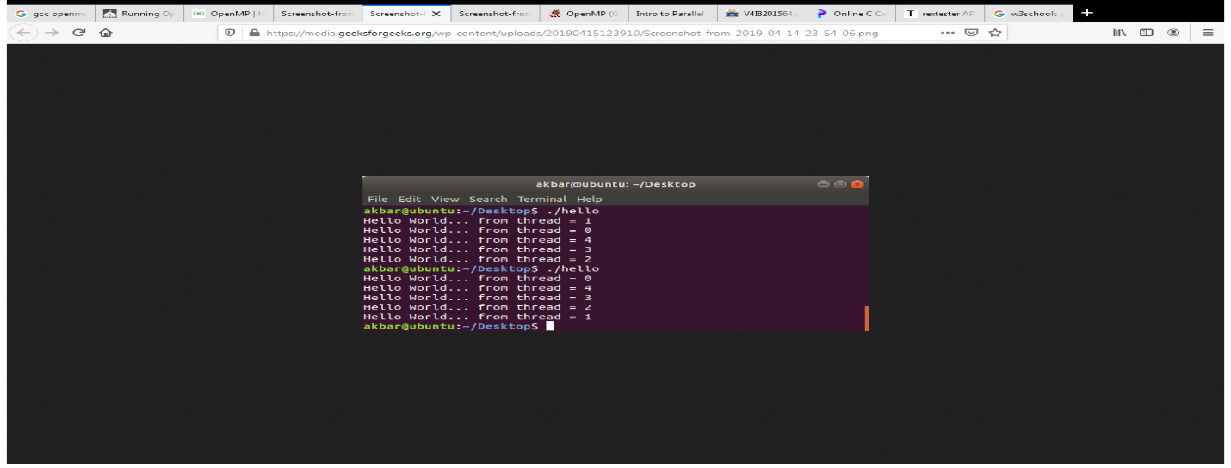
/* Compute values of array c = a+b in parallel. */
#pragma omp parallel shared(a, b, c) private(i)
{
#pragma omp for
for (i = 0; i < N; i++) {
c[i] = a[i] + b[i];
printf ("%f\n", c[10]);
}
}
}

#include <stdio.h>

int main() {

const int N=100;
int a[N];

//initialize
for (int i=0; i < N; i++)
a[i] = i;

//compute sum
int local_sum, sum;
#pragma omp parallel private(local_sum) shared(sum)
{
local_sum =0;

//the array is distributde statically between threads
#pragma omp for schedule(static,1)
for (int i=0; i< N; i++) {
local_sum += a[i];
}

//each thread calculated its local_sum. ALl threads have to add to
//the global sum. It is critical that this operation is atomic.

#pragma omp critical
sum += local_sum;
}

printf("sum=%d should be %d\n", sum, N*(N-1)/2);
}

}

#include <stdio.h>
#include <omp.h>

int main(void) {
int count = 0;
#pragma omp parallel shared(count)
{
#pragma omp atomic
count++; // count is updated by only a single thread at a time
}
printf("Number of threads:Â %d\n", count);
}

#include <stdio.h>
#include <omp.h>

int main()
{
void wrong()
{
int temp=0;
#pragma omp for private(tmp)
for(int j=0;j<1000;++j)
temp+=j; //tmp was not initialized

printf(“%d\n”,temp);
return 0;
}
}

// the below code is a #pragma startup and exit
#include<stdio.h>

void func1();
void func2();

#pragma startup func1
#pragma exit func2

void func1()
{
printf("Inside func1()\n");
}
void func2()
{
printf("Inside func2()\n");
}

int main()
{
printf("Inside main()\n");

return 0;
}

#include<stdio.h>
int main()
{
//this is a threadprivate example
int counter=0;
#pragma omp threadprivate (counter)
int increment_counter()
{
counter++;
printf(“\n”);
return (counter);
}

}

#include<stdio.h>
#include<omp.h>
int main(){
double A[1000];

#pragma omp parallel num_threads(4)

{
int ID=omp_get_thread_num();// THIS IS A RUNTIME FUNCTION THAT RETURNS A THREAD ID
pooh(ID,A);

}
}

