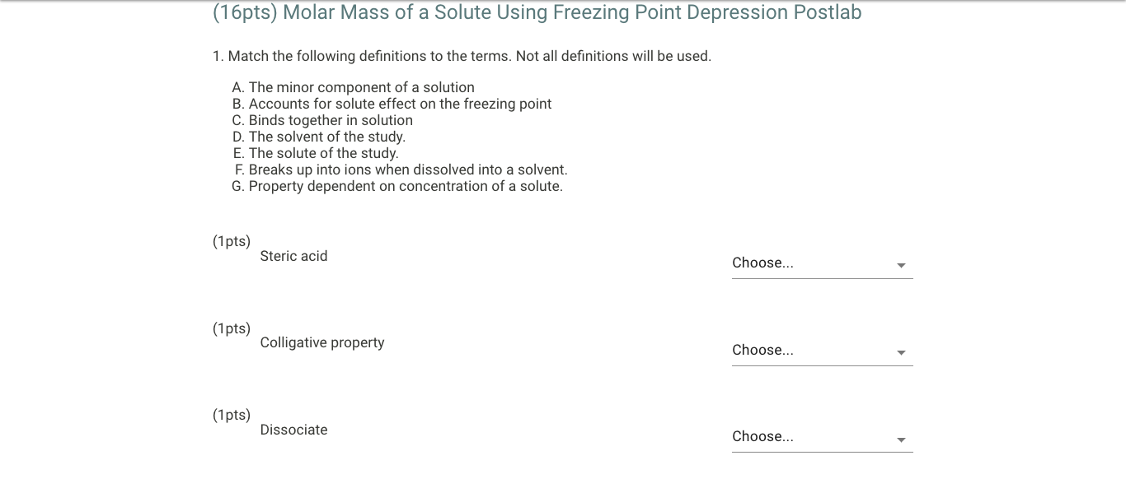
1.
Steric Acid: The solvent of the study (D)
Colligative property: Property dependent on concentration of solute (G)
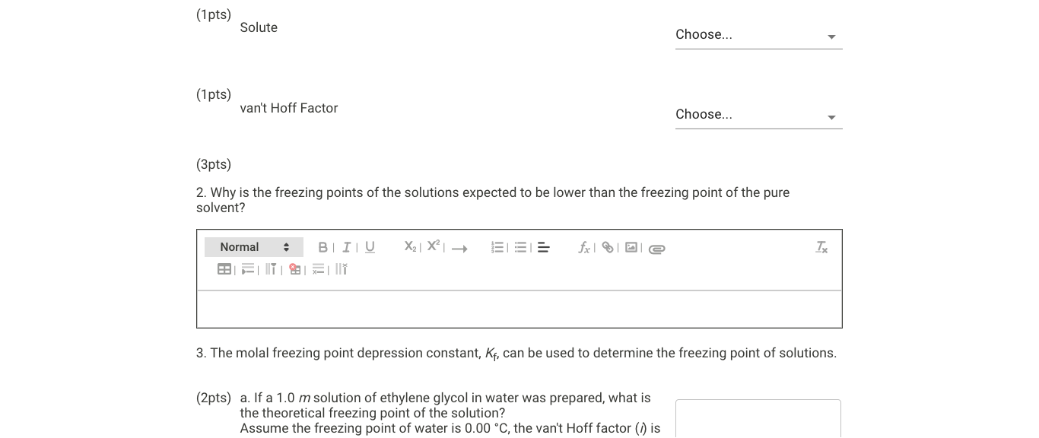
Dissociate: Breaks up into ions when dissolved into a solvent (F)

Solute: The minor component of a solution (A)
Van’t Hoff Factor: Accounts for solute effect on the freezing point (B)
2. A solvent freezes when, after lowering temperature and removing energy, the intermolecular forces of the solvent molecules are strong enough (due to the molecules being closer and moving around less) for the molecules to join together and organize in solid crystals. The molecules of a non-volatile solute interfere with this process, getting in the way of the solvent molecules and preventing the formation of the crystals unless more energy is removed (temperature decreases more) and that way the intermolecular solvent forces can defeat the solute interference and form the crystals. This is why the freezing point for a solution is lower than for a pure solvent.
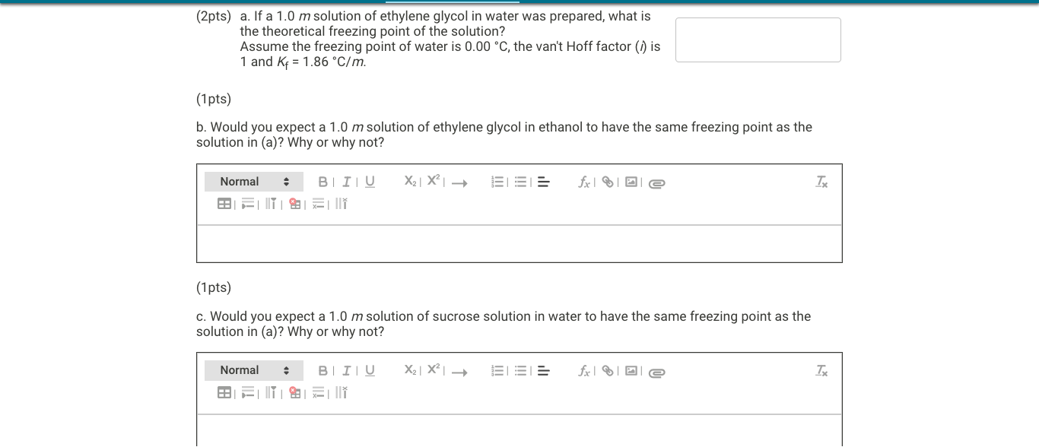

3.
- $∆T_{f}=i∙K_{f}∙m=1∙1.86∙1=1.86 °C={T_{f, solvent}- T}_{f, solution}$
$$T_{f, solution}=0-1.86=-1.86 °C$$
- No, because ethanol is a solvent different from water, so its intermolecular interactions are different (presence of a hydrocarbon chain). This means its cryoscopic constant, which measures how much a solute disrupts its normal interactions, will be different, and the freezing point depression will also be different.
- Since it is the same solvent with the same solute molarity, and the solute’s van’t Hoff factor is also 1 (since sucrose is a non-electrolyte, so it remains whole in solution), the same freezing point depression would be expected (as long as the solution behaves ideally or close to it).
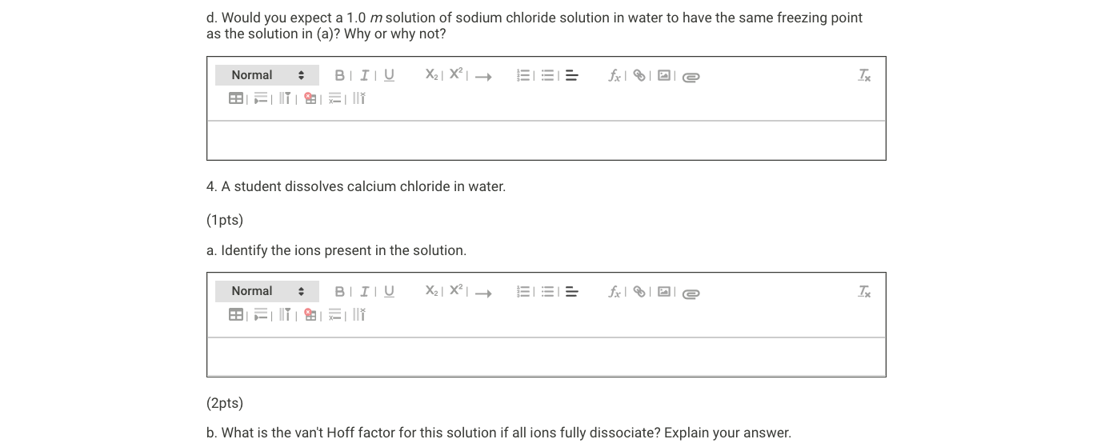
- No, because sodium chloride is a strong electrolyte that dissociates in two ions per molecule of salt. This translates to a van’t Hoff factor of 2 instead of 1 (to account the appearance of both ions). This means the freezing point depression will be twice than the depression in solution a.
4.
a. $Ca^{+2}, Cl^{-}$
b. The dissociation is $CaCl_{2}\left(s\right)→Ca^{+2}\left(aq\right)+2Cl^{-}(aq)$. From one unit of salt, three molecules are formed from the dissociation. This means the van’t Hoff factor is 3, since the triple presence of ions triples the effect of the solute in the solvent.
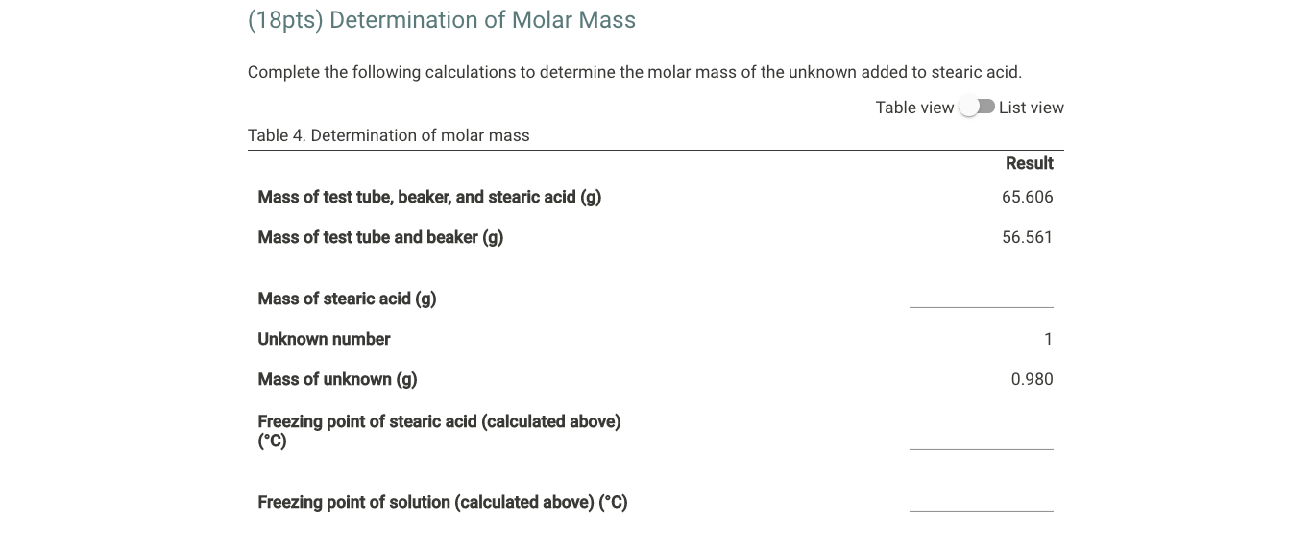
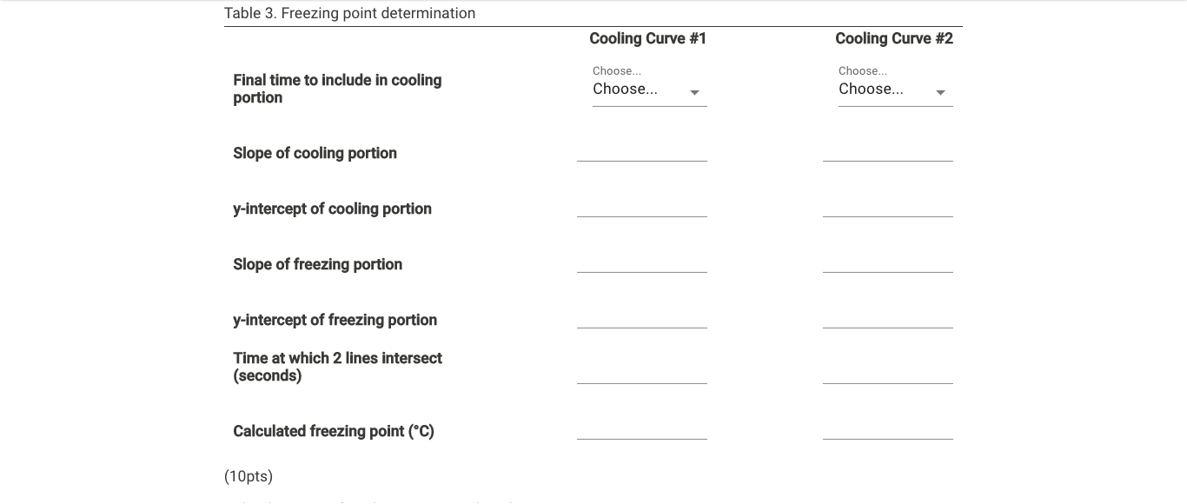
Final time to include…. | 510 | 510
Slope of cooling portion |  | -0.0394
y-intercept of cooling portion |  | 84.191
Slope of freezing portion |  | -0,0011
y-intercept of freezing portion |  | 65,227
Time of intersection |  | 495.14
Calculated freezing point |  | 64.68
$$Mass stearic acid=65.606-56.561=9.045 g$$



