Students name:
Student ID:
CRN:

Submission date:
PARALLEL COMPUTING
Introduction
Parallel computing is a form of computation in which it involves many simultaneous calculations. These calculations are a form of processes. A lot of research has analyzed new cyber-attack patterns which exist in emerging technologies. Computers have a significant role in scientific computation. There has been a wide range of rapid changes of vendors and other systems such as technologies and architectures. In the past decades, despite the rapid changes, two things remain consistent in computational science. They include the demand for a straightforward system that is complete and the need for a computational power existing at a given point.
Homogeneous distributed memory multiprocessor systems are more designed to compact and deal with high-performance parallel computing. It also deals with a small number. The property of the system is relatively easy to break, which makes it expensive to keep and maintain. Homogeneously distributed memory needs to allow different users simultaneously to simultaneously run and use their applications in the same set of processors. The main idea of this is that different identical processors sometimes may have different workloads. This means that these processors may demonstrate other runs in various applications based on external computations and communications.
In distributed memory multiprocessor also known as non-uniform memory access [NUMA]), each processor is usually distributed to its own memory module. This means that each processor can access its own memory. Message passing (MP) mechanism is usually used to allow the memories to access the modules used by the other processors. Message passing interface (MPI) is mainly used as protocol in the communication. This makes the memory access not uniform since it is based on which module the processor is accessing.
Distributed-memory multiprocessor consist of similar processors (identical). It is also referred to as a symmetric multiprocessor. In cases were the distributed memory processor consists of heterogeneous processors it’s referred to as symmetric multiprocessor (ASMP).
Homogeneous means of the same kind of the same type. Homogeneous architecture usually has the same structure. Homogeneous architecture is typically easy to program and compute for parallelism. Therefore, it is used in cases where a program uses the whole core; in cases where the core has different instruction sets from the users. Also, it is more applicable in cases where an application naturally lends itself to be partitioned into long-lived threads of control. This is specifically on the issues which have little or regular communication. Using this system is more applicable because it can be put manually in partitions onto the cores, specifically designed to perform these specific tasks.
• Sequential Algorithm- it is also known as a sequential algorithm. As the name suggests, it is more executed sequentially from start to finish. However, the other processes are not performed in this algorithm.
• Parallel Algorithm- in the parallel algorithm, a lot of instructions are usually executed. These instructions are executed simultaneously on different processing devices. This means that these processes combine different outputs from the users to produce one final result in a specific time after execution (Almasi & Gottlieb, 2014).
Logs of progress.
OPENMP macro, which is usually explained by the compiler
• Conditional compilation of OpenMP library calls
• Enclose within: #ifdef _OPENMP /* C/C++ (or Fortran code) calling OpenMP runtime lib */ whoami = omp_which we attain_thread_num() + 1; #endif
• Continue by !$/C$/c$/*$ in Fortran: !$ whoami which is equals to omp_get_thread_num() + & !$ & 1
• All terms and conditions apply when formatting
Sequence problem sample
The first number in the sequence is 4.
Program problem
Real A (4)
DO I=1,4
A(I) = 10.0
ENDDO
C$OMP PARALLEL FIRSTPRIVATE (A)
C$OMP DO LASTPRIVATE (A)
DO I=1,4 A(I) is equal to A(I) + LOG(A(I)) ENDDO C$OMP
The final result of the sequence problem is A C$OMP END PARALLEL print.
This means that each process in the sequence algorithm can retrieve each neighbor’s base_ptr, which usually translates to MPI_WIN_SHARED_QUERY.
When a user uses an info key, "alloc_shared_noncontig," the MPI library normally computes the process of the users into portions, specifically window portions. These portions are divided into one-page boundaries.
int x = 0;
#pragma omp parallel for private(x)
For (int y = 0; y < height; y++)
For (x = 0; x< width; x++) pDest[x+y*width] = (pSrc[x*4 + y*4*width + 0]*3735 + pSrc[x*4 + y*4*width + 1]*19234+ pSrc[x*4 + y*4*width + 2]*9797)>>15;
Penalization methods
Loop Parallelization
Loop parallelization is a form of programming which is in the form of software. It is usually focused on extracting parallel tasks from loops. The main challenge in this type of penalization method arises when computing data is stored randomly in the computing programs. This means that the data usually iterates over the data structure. This makes it a challenge since each index is operated in a sequence of one at a time. This slows up data hence resulting in data clogging. This makes the programs use multiple threads or processes, which usually have and need to operate on each index produced in the sequence one at a time.
Also, data needs to be synchronized when it is affected by the inner loop. This means that the inner circle needs to be referred to as the main loop for the update. The primary purpose of the inner loop is to distribute the data on the different processes in the processors. The main loop usually adds and sums up the data synchronization. Therefore, this means that a user using a partial parallelization of a circle will reduce the load imbalance. However, the communication will be higher since there will be synchronization. For example, if a user needs to print the HELLO WORLD more than 500 times via a single loop, it will take more time to execute sequentially. However, it will take a little time to run in parallel. In parallel, several and different computing processors are usually used in computing; hence this makes it easy for the computation process to give the final result (Gupta & Nim, 2018).
In sequential program code to print HELLO WORLD is translated as:
1: 500 Disp(Hello World) then End
In parallel program code to print the same word is
Matlabpool local ten \\ to start ten workers Parfori=1: 500 \\ parfor is similar for loop Disp(Hello World) then end
According to the above coding programs, it is evident that multiple works take less time since, in this coding system, different workers are distributed with the outcome. This makes them run the codes and produce the final results more frequently, making it faster than the sequential.
Disadvantages
It mainly focuses on the loops.
It is not appropriate in cases where sequential programs are complex net in nature.
The user has to focus and take care of partials results since synchronization plays a vital role in this coding method.
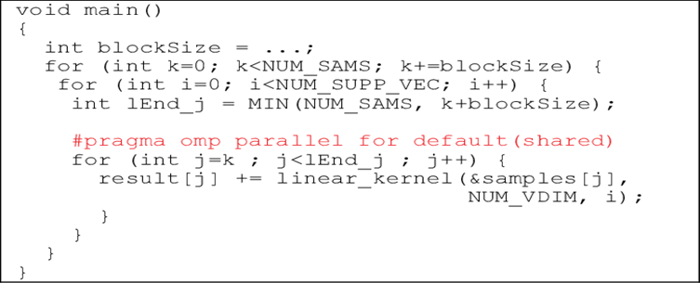
Performance analysis
In computer architecture, Amdahl's law is usually a speed-up theory that works as a framework in the execution of tasks. It improves the resources which are expected in a system when there is a fixed workload (Gustafson, 2018). There are two main tools used in this theory. They include the static, also known as the hybrid techniques. These techniques are usually focused and are designed to detect any error that may occur on the MPI/OpenMP dual programming model. These tools, specifically the PARCOACH [79] and [80]. These tools detect the deadlocks and other run-time errors which may occur in the dual programming model. It is essential and appropriate to combine the two programming models. Using both models will create real-time detection of errors that may be very minimal to detect. This makes the content error-free.
Relationship between the testing techniques and the targeted programming models

Testing techniques | MPI | OpenACC | OpenCL | OpenMP | hybrid
Static | 1 | 0 | 2 | 1 | 4
Dynamic | 14 | 0 | 4 | 1 | 10
Symbolic | 0 | 0 | 4 | 2 | 1
Hybrid | 0 | 0 | 1 | 1 | 2
debugging | 5 | 0 | 2 | 1 | 2

To summarize our classifications of the reviewed testing tools, the following three figures will be displayed. Firstly, Figure 1 depicts the reviewed testing tools classified by the used testing techniques. The figure clearly shows that coding is used more than on the other methods to detect run-time errors in dynamic testing.
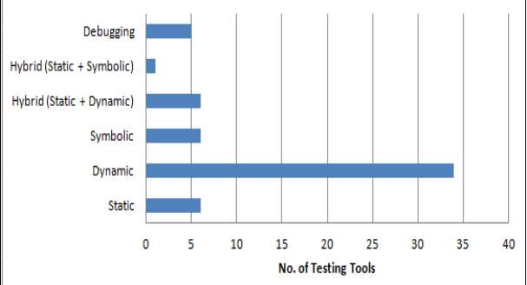

The below diagram shows testing tools for testing targeted programming models. Notably, MPI, OpenMP, and CUDA have been tested in several testing tools, which are considered the most targeted programming models in our survey. However, OpenACC has not been targeted as a tested programming model.
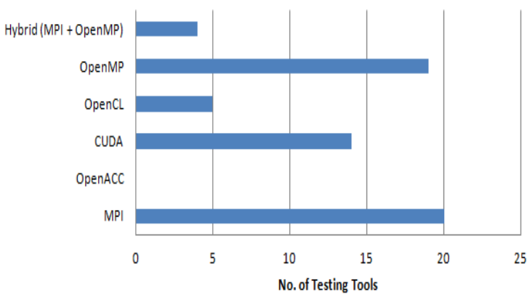

Our study tries to comprehensively review tools that test parallel systems to detect run-time errors because of their unpredictable behavior and the causes behind them to occur. Usually, compile-time errors can be seen by compilers and reported to developers to be corrected. Furthermore, detecting run-time errors in parallel systems is even more complicated because of the different behaviors of the programming models and their interaction with varying programming models. This is very important to the programmers and the users since they can detect and fix their errors. It helps in maintaining and fixing application programs. Debugging serial and parallel programs is time consuming. This is because one has to detect and compile the errors. They have to correct these errors. Before correcting them, the user needs to print statements to find and correct the rest of the errors.
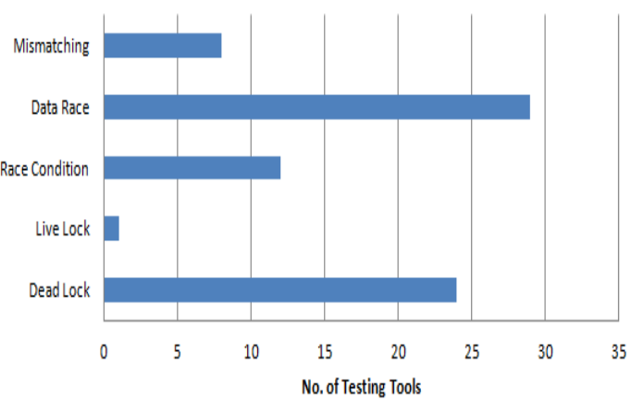

References
Almasi, G.S. and Gottlieb, A., 1994. Highly Parallel Computing Benjamin. Cummings,.
Gustafson, J.L., 1988. Reevaluating Amdahl's law. Communications of the ACM, 31(5), pp.532-533.
Gupta, M. and Nim, R., 1998, November. Techniques for speculative run-time parallelization of loops. In SC'98: Proceedings of the 1998 ACM/IEEE Conference on Supercomputing (pp. 12-12). IEEE.

