Assignment: Object Oriented Programming
Submit Assignment
- Due Friday by 11:59p
- Points 80
- Submitting a text entry box or a file upload

- This assignment is the fourth part a a project where you use earthquake data from http://earthquake.usgs.gov/ to understand earthquake trends.
- In this part of the assignment you will revise your previous stats.py solution to use object oriented programming concepts AND to us a Pandas dataframe to compute basic statistics.
- You will create at least two related classes (e.g. Earthquakes and Position) that will be initialized using data from the index..sqlite database.
- You will read Earthquakes from the database but instead of putting them into individual lists for each type of date, you will create a list of Earthquake objects.
- You will use the list of Earthquakes to populate a Panda's dataframe and then use the dataframe to compute basic statistics for the entire population of earthquakes, as well as for subsets of the data that are created by applying a filter to the dataframe.
- You should put the two related classes in a file Earthquake.py and use import to include it in the python program where you read earthquakes from the database, create a list of earthquake objects, create a pandas dataframe and compute statistics.
- You will be developing Earthquake.py and earthquake_stats.py for this part of the assignment.
- 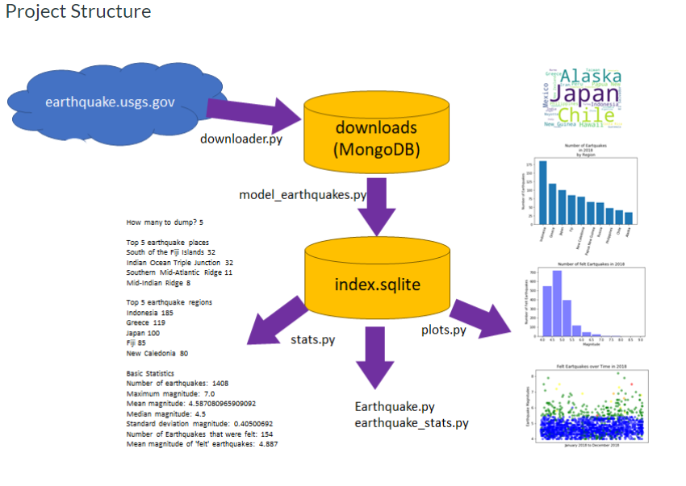

Earthquake.py
Write an Earthquake class that demonstrates the following aspects of OOP in Python:
- Create a basic class that can hold all relevant earthquake data saved in index.sqlite.
- Appropriately create a constructor to set all data values .
- Create a regular class method that returns all or part of the Earthquake data as a dictionary object.
- Override the __str__ method to print a reasonable string representation of an Earthquake.
- Use the @property decorator to make at least one property in your Earthquake class private.
- Use the @???.setter method to validate the private property in some way (e.g. check if its numeric, change it's data type, change it's length...) before setting its value.
Write a second class called Point, Position or Time to store one or more pieces of earthquake data.This class can be included in the Earthquake.py file.
- The class could store latitude & longitude OR latitude and longitude and depth OR timestamp
- You should use this class in the Earthquake class instead of storing the vales as primitive data types
- This class should include an __init__ method and a __str__ method. If you create class to stor time, the __str__ method should return a formatted string, not a timestamp.
You may use the Author and Article classes presented in lecture as a starting point for these classes.

Earthquake_stats.py
Write an Earthquake_stats class that uses the Earthquake object AND a Pandas dataframe to process earthquake data and display basic statistics.
- You should import the Earthquake module to use in this application.
- You will read Earthquakes from the database, just like in stats.py, but instead of putting them into individual lists for each type of date, you will create a list of Earthquake objects.
- You will list of earthquake objects to a Panda's Dataframe.
  - See https://stackoverflow.com/questions/47623014/converting-a-list-of-objects-to-a-pandas-dataframe (Links to an external site.) for an example of how to use a custom method to turn you object into a dictionary AND use list comprehension to create a list of Earthquake dictionaries to create your DataFrame.
- Display either the first 5 or last 5 earthquakes in the dataframe to the screen.
- Use the dataframe to compute basic statistics for the entire population of earthquakes
- Compute the same basic statistics for earthquakes filtered on Region. Computer a separate set of statistics for two different regions that have at least 200 earthquakes in your sample.
- Compute the same basic statistics for all earthquakes filtered by either felt, tsunami or depth
e.g felt > 0, tsunami > 0, depth < 50 or depth<100.
You can use stats.py, from the last assignment, and Pandas: Inspecting & Analyzing Data as starting points for this part of the assignment.

Submitting Your Work
Please Upload Your Submission:
- A screen shot/.ipynb files of the Earthquake_stats.py program tthat shows the basic statistics on the messages you have retrieved/analyzed.
- A zip file containing all of the .py/.ipynb and .sqlite files you created/used as a part of the assignment.
- 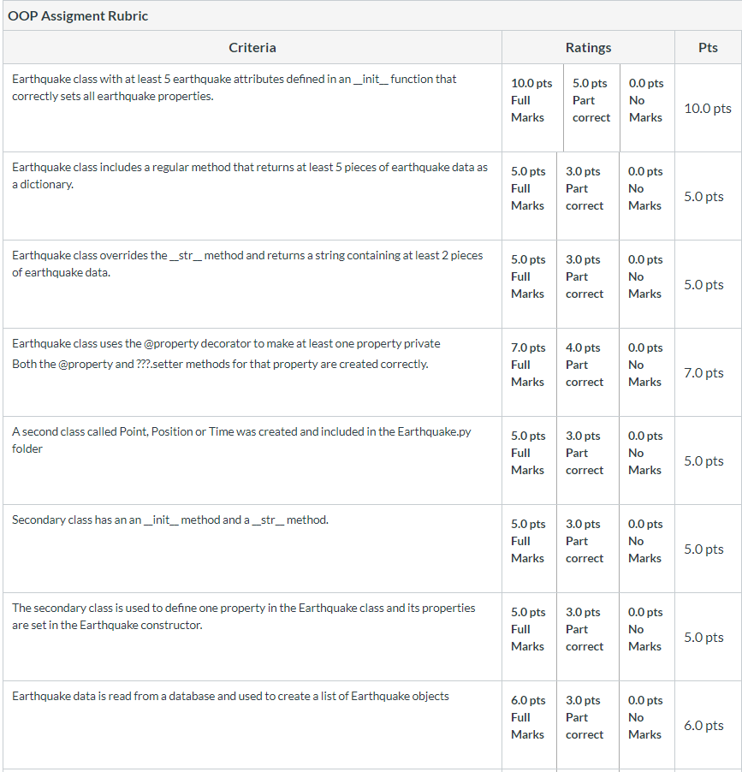

- 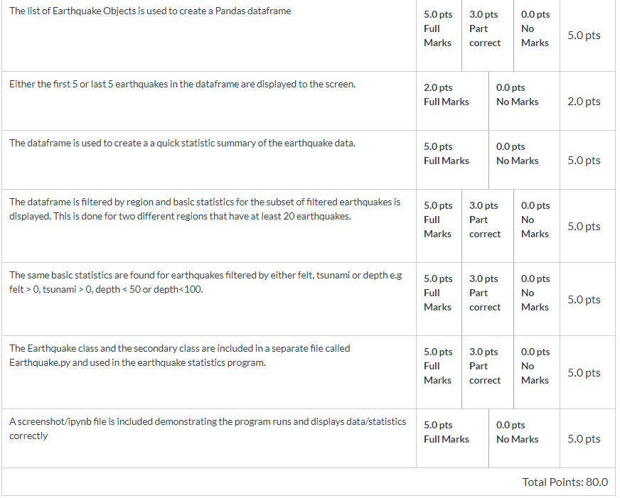
- Some sample code from previous assignment (just to give you an ideas below this line there is nothing related to requirement of current assignment)
- 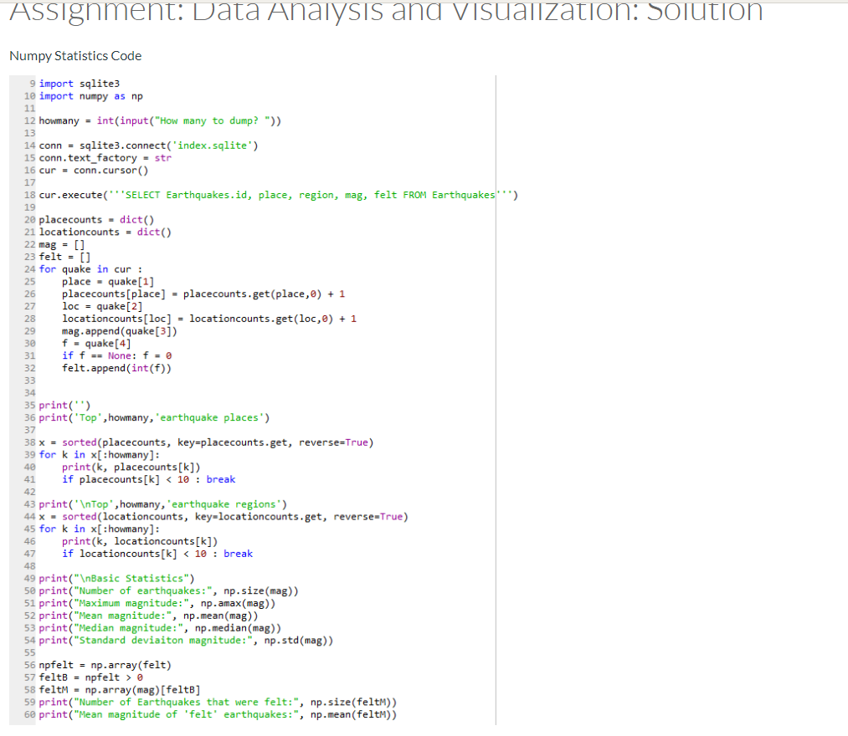
- 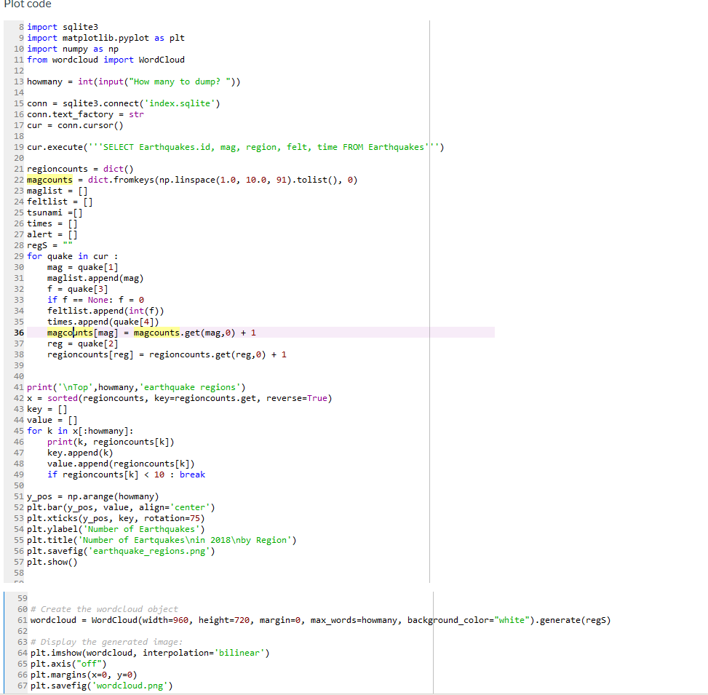
- 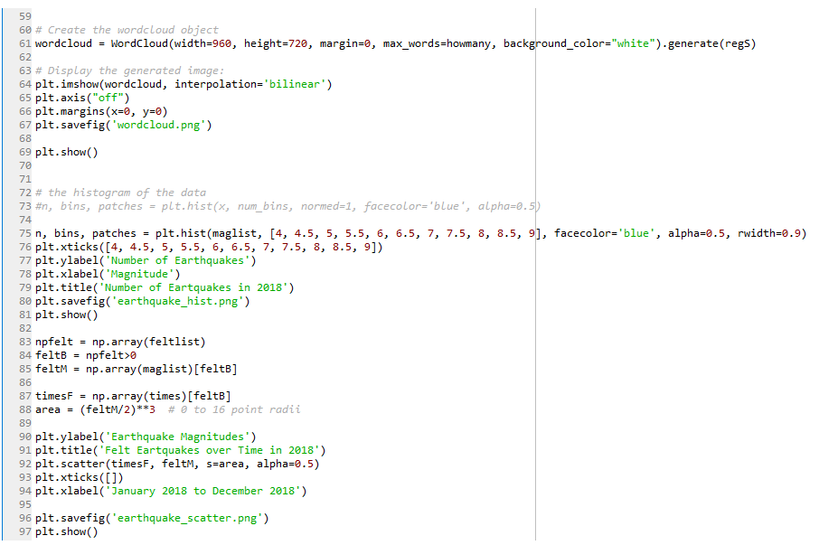

Assignment: Data Analysis and Visualization
Re-submit Assignment
- Due Nov 18 by 11:59pm

- Points 80

- Submitting a text entry box or a file upload

- This assignment is the third part a a project where you use earthquake data from http://earthquake.usgs.gov/ to understand earthquake trends.
- In this part of the assignment you will run an analysis to calculate some basic statistics about the data.
- You will then create at least three different types of visualizations of the earthquake data you have retrieved and processed and save some plots. For example:
  - Either a word cloud to or a bar chart to visualize the frequency distribution by region.
  - A histogram of the magnitudes of "felt" earthquakes in the data set.
  - A scatter plot to show how the data is changing over time.
- You will be developing stats.py and plots.py for this part of the assignment.

Project Structure
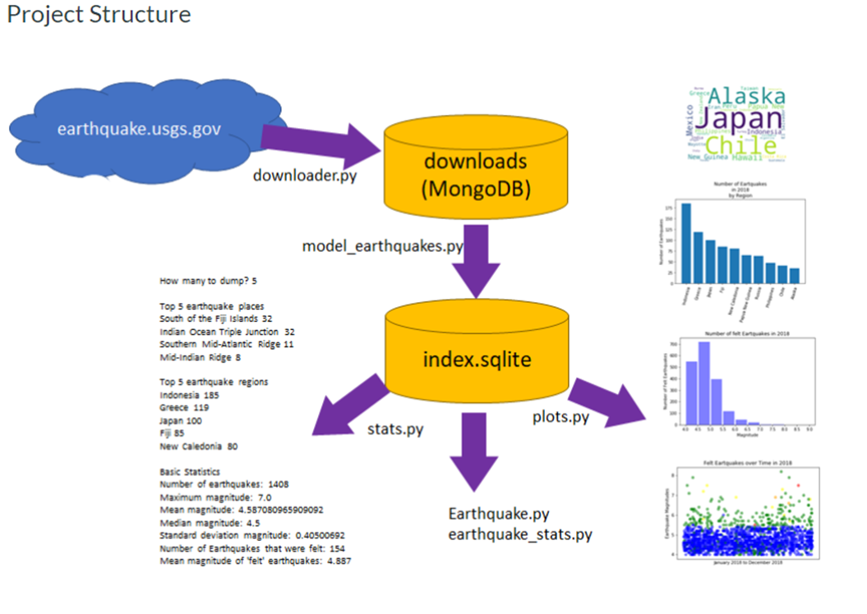

stats.py
The first, simplest data analysis is to do a simple analysis of the data to answer the following questions:
- How many earthquakes are in the data set?
- What "place" has the most earthquakes?
- What "region" has the most earthquakes?
- What was the "biggest" earthquake int he data set?
- What is the mean earthquake magnitude in the data set?
- What is the median earthquake magnitude in the data set?
- What is the standard deviation of the earthquake magnitudes in the data set?
- What are the same basic statistics for earthquakes filtered by either felt, tsunami or depth?
e.g felt > 0, tsunami > 0, depth < 50 or depth<100.
# -*- coding: utf-8 -*-
"""
Python program to calculate basic statistics about a sample of earthquakes
Created on Sat Dec 15 10:00:02 2018

@author: dawng
"""
# add necessary import statements
_________________
_________________

# ADD input validation to make sure an integer between 1 and 20 is provided
# Program should repeat request for a number OR exit if invalid input is provided
howmany = int(input("How many earthquake locations to show? "))
# connect to the output database and name it index.sqlite
conn = ______________________
# forces database to return strings for TEXT attributes
conn.text_factory = str
# get the cursor for the connection
cur = ___________________
# run select query on database to get data for statistics
________________________________________________________
# set up variables to hold database data
# will be counting earthquakes by place/region
# will just be storing data about magnitude, felt and tsunami
placecounts = dict()
regioncounts = dict()
mag = []
felt = []
tsunami = []
depth = []
for quake in cur :
# Get data from cursor and add to lists or dictionary
# Dictionaries will hold counts, Lists will append data
_____________________________
_____________________________
_____________________________
_____________________________
_____________________________

# Print out top earthquake places
print('')
print('Top',howmany,'earthquake places')

x = sorted(placecounts, key=placecounts.get, reverse=True)
for k in x[:howmany]:
print(k, placecounts[k])
if placecounts[k] < 10 : break

# Print out top earthquake regions
print('\nTop',howmany,'earthquake regions')
_____________________________________________________
____________________
_________________________________
_________________________________

print("\nBasic Statistics")
# Print out basic statistics like number of earthquakes, mean magnitude, median, standard deviation etc.
_____________________________________________________
_____________________________________________________
_____________________________________________________
_____________________________________________________
# Convert the "felt/tsunami/depth" list to a NumPy Array
npfilter = _______________________
# Create a NumPy array of Booleans where felt or tsunami" > 0 or depth < 50
filterB = ________________________
# Create a NumPy array of magnitudes for all of the filtered earthquakes
magF = _____________________________
# Print out basic statistics like number of felt earthquakes, mean felt earthquake ...
_____________________________________________________
_____________________________________________________
_____________________________________________________
_____________________________________________________

plots.py
- plots.py will be VERY similar to stats.py.
- You would start with stats.py, save as plots.py
- Add an import for pyplot
- Get data from the database and add it to dictionaries and/or lists
- Create at least three different types of plots using the ideas below:
  - Create a dictionary for earthquake regions but instead of printing out the regions, plot the top "howmany" regions, show them on a bar chart and/or a WordCloud
  - Create a histogram and/or scatter plot for "felt" earthquake magnitudes.
  - Create a histogram and/or scatter plot for all earthquake magnitudes
  - Create a histogram and/or scatter plot for "tsunami waning" earthquake magnitudes.
  - Create a histogram and/or scatter plot for felt earthquake depths.
  - Create any of the above histograms and/or scatter plots for a specific region (especially useful if you are tracking earthquake activity around a specific major quake)
- Create a title, xlabel and ylabel for each of your plots (except for a wordcloud)
- Call savefig for each of your plots and save as a png.

Submitting Your Work
Please Upload Your Submission:
- Submit either:
  - A screen shot of you running the stats.py program to compute basic histogram data and statistics on the messages you have retrieved.
  - A saved .png file each of the plots you made with plots.py.
- Or
  - Jupyter Notebook .ipynb file(s) that includes the code and shows the output statistics and plots.
- AND a zip file containing all of the .py, .ipynb and .sqlite files you created/used as a part of the assignment.

Rubric
Data Visualization
Data Visualization
Criteria | Ratings | Pts
This criterion is linked to a Learning OutcomeAn updated stats.py file that connects to the database, includes an appropriate select query and extracts data from the query. |  | 8.0 pts
  8.0 pts  Full Marks | 4.0 pts  Mostly correct but missing some required code or formatting. | 0.0 pts  No Marks
This criterion is linked to a Learning OutcomeThe updated stats.py file that displays the top regions AND places where earthquakes have occurred. |  | 7.0 pts
  7.0 pts  Full Marks | 4.0 pts  Missing some important program elements. | 0.0 pts  No Marks
This criterion is linked to a Learning OutcomeThe updated stats.py file that computes statistics for all earthquakes |  | 10.0 pts
  10.0 pts  Full Marks | 6.0 pts  Runs but missing some important program elements. | 0.0 pts  No Marks
This criterion is linked to a Learning OutcomeThe updated stats.py file that computes statistics for earthquakes filtered by either felt, tsunami or depth |  | 5.0 pts
  5.0 pts  Full Marks | 3.0 pts  Second set of statistics calculated but not filtered correctly | 0.0 pts  No Marks
This criterion is linked to a Learning Outcomeplots.py edited to produce at least 3 different types of visualizations. |  | 10.0 pts
  10.0 pts  Full Marks | 5.0 pts  one or more plots are submitted but they are not different types of visualizations | 0.0 pts  No Marks
This criterion is linked to a Learning OutcomeVisualizations set correct data, titles and axis labels and are saved correctly. |  | 10.0 pts
  10.0 pts  Full Marks | 5.0 pts  Visualizations missing some data, titles or axis labels or were not saved correctly. | 0.0 pts  No Marks
This criterion is linked to a Learning OutcomeAppropriate error checking on the input number of earthquakes was done. |  | 3.0 pts
  3.0 pts  Full Marks | 2.0 pts  An attempt at error checking was made - but commented out or does not work, | 0.0 pts  No Marks
This criterion is linked to a Learning OutcomeA screen shot/.ipynb file showing the output of you stats.py program. |  | 12.0 pts
  12.0 pts  Full Marks | 7.0 pts  Screenshot shows program runs but does not produce correct output or crashes | 0.0 pts  No Marks
This criterion is linked to a Learning OutcomeA screen shot, downloaded png, or .ipynb file showing 3 different types of visualizations based on the earthquake data you retrieved. |  | 15.0 pts
  15.0 pts  Full Marks | 8.0 pts  One or two plots submitted | 0.0 pts  No Marks
Total Points: 80.0

