Uber Eats Company

Student’s Name
Department, University
Course Number and Name
Instructor’s Name
Date
Executive Summary
The paper provides an analysis of Uber Eats Company that is based in the US. Uber Company seeks to ensure that illustrious food delivery is promoted to all its consumers. The company launched the Uber Eats online app where consumers can order food at affordable prices. Besides, the paper describes the business venture by examining its marketing plan, competitive analysis, and market analysis. The company rolled out an app that allows consumers and Uber Eats workers to connect food delivery. The paper expertly describes the marketing strategy adopted by the company. The American food industry has experienced significant growth and food delivery apps that consumers are utilizing. Customers can make purchases for their favorite food items.

Uber Company
Besides, the paper elaborates the operation issues of the business by explaining how the company will provide products. It highlights the location and facility decisions that the company will make. Also, operations requirements are addressed. The business plan explains the human resource requirement and financial projections conducted by the company. The objectives are created with the help of proper frameworks that ensure developmental processes are created in promoting transparency of the company's activities. The company's objectives are meant to ensure that its main goals are achieved in a systematic manner that protects the culture and activities of the workers. The human resource management of Uber Eats Company can develop a profound system that creates an enhanced performance of the company's activities.
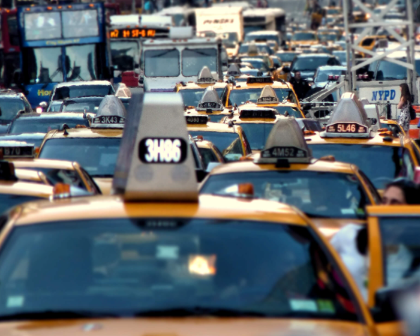
Figure 1: Analysis of Uber
Section 1: Company Overview
Uber Company developed Uber Eats delivery platform for its consumers in 2014. The company ensures delivery of food is done to its consumers in different parts of the world (Georgina Prodhan, 2019). Most people in America and Europe depend on consuming fast foods offered by companies. Uber Eat's goals include improving useful marketing programs, increasing motivation amongst the workers, and increasing sales to consumers. The target market of the company comprises college students, young adults, and low-income individuals. Research has shown that most US students have opted to use food delivery apps to purchase their favorite food, such as French fries and hamburgers. Most students like to consume such foods charged at affordable prices. Uber Eats provides appropriate food and snacks that consumers from different parts can receive after making an order.
Industry and Market Analysis
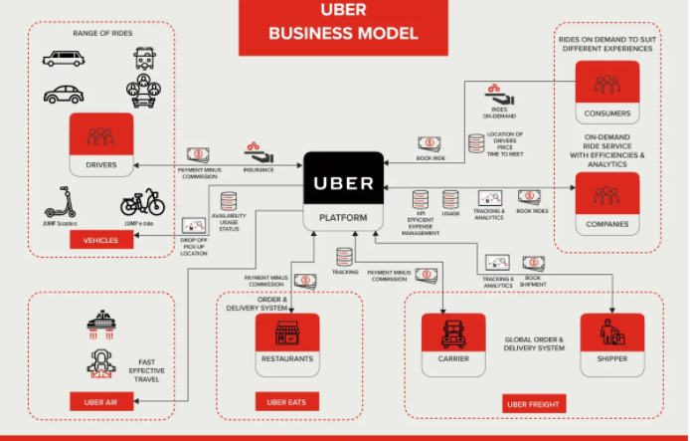
Figure 2: Uber Business Model
The American food industry is substantially growing thanks to the introduction of new food companies. Due to the high number of consumers in the country, retail shops and restaurants have increased. With the increased demand for food by people, food apps such as Uber Eats have utilized the opportunity by ensuring that customers can order foodstuffs at the click of a button (Meenakshi & Sinha, 2019). Annually, the US food industry generates about one trillion dollars in sales. The data shows that the food industry in America provides the potential for companies' growth in selling food. Since the demand for food has been high in America, food apps have helped potential consumers purchase food online. Most people benefit from the app that allows order and delivery of foods and snacks to be made efficiently. Uber Company will utilize the opportunity by launching an app where consumers can access menus and order food.
Various uncontrollable markets within America's food industry are myriad. They include competitor choices, weather, economic climate, as well as political climate. These are the risks that Uber Eats will face during its operation within the US (Meenakshi & Sinha, 2019). The food industry of America has grown substantially. The food marketing system supplied approximately $1.77 trillion worth of food products in 2019. It has been occasioned by the significant increase in food delivery apps in the US. These data unravel the well-developed food industry in America that is growing substantially.
Entry Strategy
Kentucky Fried Chicken and McDonald's use the same brand name to help attract most customers in various countries hence earning high profits. People like to purchase food products from the two companies. Uber Eats ensured it created an online platform strategy that reaches most customers and delivers the ordered food product. Search engine advertising is very effective in the growth of a business within a competitive market (De Araujo Leão Et al., 2019). Uber Eats has the opportunity to have its ads appear on the search pages of a computer. The development of an online platform is a strategy that assisted Uber Eats gets set to compete with other food companies. The pay-per-click ads will be essential in enabling the customers to obtain the price of the boots that have been posted. The search engines are significant in providing opportunities to advertisers to place their ads for customers to purchase the products. The services and products provided by Uber Eats are of high quality to enhance customer loyalty.
Section 2
Opportunities and Challenges of Expansion of Uber Eats
There are many opportunities that the expansion of Uber Eats into other countries has developed for the parent company. Foremost, there is increased profit earned by the organization. Most consumers are achieved in different areas in Europe where delivery of food is done in large volumes (Trivedi & Singh, 2021). Close to one million people order food delivery services using Uber Eats platform for their consumption. Thus, a large market base is increased by setting branches of Uber Eats in many countries. Uber Eats food is substantially growing thanks to the introduction of new food companies. Annually, the US food industry generates about one trillion dollars in sales. Due to the high number of consumers in the country, retail shops and restaurants have increased. With the increased demand for food by people, food apps such as Uber Eats have utilized the opportunity by ensuring that customers can order foodstuffs at the click of a button. Also, there is positive competition with other food companies that has led to many branches by Uber Eats. Companies like Starbucks, Wal-Mart, and McDonald's have remained the most prolific and successful companies in food production. Uber Eats has developed ways to help sustain its products within the market. There is high demand for food in America, and Europe which has led to the creation of the Uber Eats app to allow consumers to purchase food online (Trivedi & Singh, 2021). Therefore, Uber Company benefits from the developed food industry of the US. The company utilized the opportunity by launching an app where consumers can access menus and order food.
On the contrary, there are challenges that the organization face to ensure it promotes effective sales. The challenges affecting Uber Eats are one on the current workforce employed from the market. Challenges that exist within the workforce include a lack of social responsibility and illiteracy (Kalimuthu & Sabari Ajay, 2020). Illiteracy amongst some of the workers within the organization has made it a bit difficult for most of the activities to be performed properly. Uber Eats platform productivity is affected by illiterate workers who have not been trained to handle consumers online. The existence of the illiteracy gap through determining the level of expertise of customer care and the products produced. Secondly, social responsibility exists within the organization because the employees do not provide educative information about the use of the food products that are sold. Lack of social responsibility makes consumers unable to understand the proper food products that need to be consumed. These challenges affect the strategic goals of Uber Company aims to build employee retention and ability.
Marketing and R & D Strategies
Useful marketing programs have made Uber Eats Company provide quality organic foods to its consumers. The marketing programs that the company uses have helped in advertising the natural food products that are supplied. The marketing program has ensured the food products are sold at an affordable price. There is growth in the American food industry that has resulted in various food companies selling food (Kalimuthu & Sabari Ajay, 2020). Hence food delivery apps like Uber Eats have successfully ensured that customers can order food via their smartphones or computers. The reliance on smartphone delivery apps has significantly transformed the restaurant industry in the US by ensuring fast delivery of food to consumers. Uber Eats markets its food to a large population within different countries. The company has widened its customer markets across the world. Uber Eats app has ensured that customers can access their ordered food via the platform.
The target market of the company is college students in America. Mostly, millennials and young adults will be the main customers targeted by the company (Georgina Prodhan, 2019). The company strives to ease the financial burden college students’ face by using high sums of money in purchasing food by ensuring that it provides affordable food to customers. Thus it must address various target market specifics. Foremost, the company has to recognize its customers' location, age, lifestyle, and income levels (Kalimuthu & Sabari Ajay, 2020). Therefore, it must create engaging content for its customers. A budding business needs to stand out by developing fresh and exciting content to enhance its engagement with potential customers. The Uber Eats app will come in handy by using thoughtful content to woo customers. The company's marketing mix will encapsulate the 4Ps, which are important marketing strategies. It is because they will help the company attains its business goals and objectives. The product, pricing, distribution, and promotion have influenced food delivery.
R & D strategies create choices in organizational structure, workers, consumers, and processes run at Uber Eats. The talent development strategy within Uber Eats Company has been enhanced through the proper training of new members (Blade, 2021). The training of new members will effectively ensure that they are made to become competent with the organizational activities. Whole Foods Market has helped most of its employees be involved in various activities that have influenced the organization's growth. Through the talent development strategy, most of the employees have the expertise to perform tasks that they were not able to manage. For instance, most workers can determine the process of providing quality customer care skills to consumers. Developing a proper talent development strategy is significant in ensuring employees are motivated to perform their jobs.
Additionally, the talent development strategy of Uber Eats is aligned appropriately to the employee goals. The employees must aim to enhance customer loyalty by getting involved in the provision of adequate services and food products to the consumers. Uber Company must align the talent development strategy to the employee goals to increase sales to the consumers served. Talent strategy development has made employee goals within the organization be reached without difficulty (Blade, 2021). Customer loyalty is promoted through the employee goals that will ensure that adequate services and food products. Employee goals ensure that the company can make increased sales to its customers. The talent development strategy has made the employees come up with developments that can ensure growth is promoted.
In conclusion, a product focus strategy is essential in increasing the marketability of the doughnuts by ensuring that their taste is improved. The tastes of the snacks get increased through the product strategy process that allows for the sale of quality products. Uber Eats is an efficient way that helps in promoting fast delivery of food products ordered. The marketability of the foods is enhanced, and most consumers are attracted to purchase them in different areas. Proper marketing strategies will increase the rate at which the products are purchased. The creation of food delivery apps is an important aspect of the provision of food products to consumers. Uber Eats app helps provide millennials, young adults, and low-income earners with ready-made food that is environmentally friendly.

References
Blade, V. (2021). Influence in Talent Development. American Society for Training and Development.
De Araujo Leão, A., dos Santos Cabral, L., Pereira Gomes, R., Pereira Gonçalves, B., Lobo de Oliveira, J. M., & Barbosa de Alencar, D. (2019). ’shared economy: A uber-eats case study in Manaus City’. International Journal for Innovation Education and Research, 7(11), 450-466.
Georgina Prodhan, July 3, 2019. Uber Eats courts smaller European restaurants with new offer. Retrieved from https://www.reuters.com/article/us-uber-eats-europe/uber-eats-courts-smaller-european-restaurants-with-new-offer-idUSKCN1TX2ZJ
Kalimuthu, M., & Sabari Ajay, K. (2020). a Study on Customers Satisfaction Towards Uber Eats Online Food Delivery Services With Special Reference To Coimbatore City. EPRA International Journal of Environmental Economics, Commerce and Educational Management, 7(4), 37-47.
Meenakshi, N., & Sinha, A. (2019). Food delivery apps in India: wherein lies the success strategy?. Strategic Direction.
Trivedi, S. K., & Singh, A. (2021). Twitter sentiment analysis of app based online food delivery companies. Global Knowledge, Memory and Communication.

