Name: _____________________
Period: ____
Unit 5: Soil Salinization Lab
Background:
Through our discussions about the different layers of soil, types of irrigation, and downsides to irrigation we have learned that certain types of minerals such as salt can affect the growth of crops. If the water irrigating cropland does not absorb into the topsoil it can be lost due to evaporation and then cause a layer of salt to accumulate on the topsoil due to salt accumulated in the water. Depending on the amount of salt built up this can cause it to affect plant growth.
Purpose:
To discover how varying levels of salt concentrations effect the growth of seeds.
Materials:
Seeds
3 graduated cylinders
3 pipets
Tape and markers
5% salt solution
10% salt solution
Distilled water
Beakers
3 petri dishes
Paper towels
Lab Instructions
Day 1: Preparing the Lab
- Label the 3 petri dishes with the control, 5% salt solution, and 10% salt solution
- Fold a paper towel in half and place in each petri dish
- Obtain 5 seeds for each petri dish and put them onto the paper towel like shown below

- Using the pipet put 5 mL of the distilled water into one of the graduated cylinders. Do this for the 5% and 10% salt concentrations as well making sure to take note on which graduated cylinder holds each concentration and making sure to not cross contaminate.
- For each petri-dish put the appropriate solution into each by pouring the solution onto the seeds
- Cover the top of the seeds with the other half of the paper towel like shown below

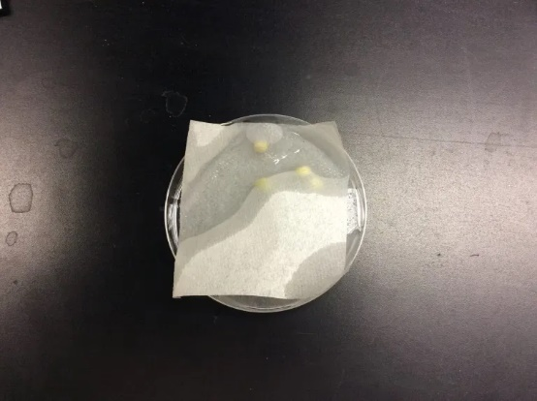
- Tuck in the sides of the paper towel into the petri dish. If the towels stick out they will obtain moisture from the dish and the dish will be ruined
- Stack your completed dishes and store away for observations on a later date
Day 2: (about 3-4 days later) Results
Take data on the number and % of seeds that germinated and measure the sprout length. To know if a seed germinated refer to the picture below. Use the chart to fill in the data.
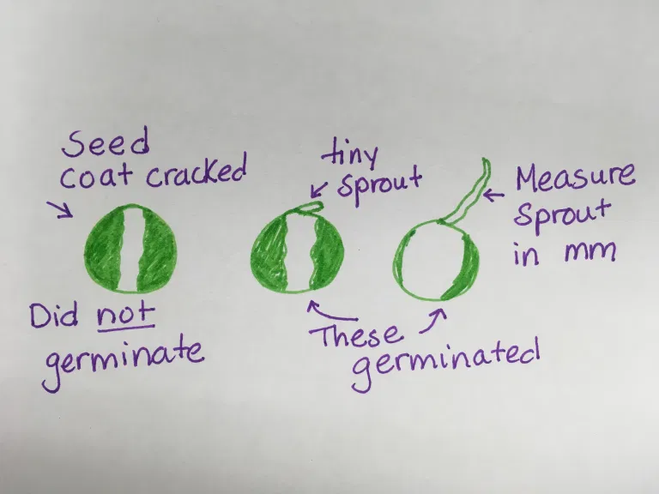

Data:
 | # of seeds germinated | % of seeds germinated | Average length of sprout (mm)
Control
5% salt solution
10% salt solution

Post-lab:
On a separate piece of paper, I want you to do mini lab report write up including the following:
- Abstract
  - Describe the purpose of the lab
  - Use background information acquired from class to reference the real-life application to this lab
- Data
  - Copy and include the data chart
- Results
  - Using what you know from class explain your results using this knowledge with making sure to include information about topsoil and soil salinization
  - Explain why you think you obtained the results you did
- Conclusions
  - Do some outside research on a place that has soil salinization problems and relate it to this lab
*Writing must at least be a page in length not including the data chart* (5 points)

Rubric:
 | 1 | 2 | 3 | 4 | 5
Abstract | Student does not accurately describe the purpose of the lab. sentences to describe the purpose of the lab. | Student uses only a couple sentences to describe the purpose of the lab. | Student describes the purpose of the lab. Knows how to apply background information to the lab, but not to real life application. | Student understands the material. Describes the purpose of the lab. Uses background class information and applies the information for lab and real-life application together. Shorter than a paragraph. | Student has a deep understanding of the material. Describes the purpose of the lab in full detail using more than one sentence. Uses background class information to apply to the lab and real-life application. Paragraph explanation.
Data | -  *0 points obtained for not including any of the data. | - | Missing more than one section of the data. | Missing a section of the data. | Copies and includes all data obtained under this section with correct data that was obtained.
Results | Student doesn’t accurately explain the results obtained in class. | Student briefly explains the results in the graph. | Student briefly explains the results and relates information to what we learned in class. | Student vaguely understands the material and vaguely knows how to relate the results to what we learned in class. | Student has a deep understanding of the material and knows how to relate the results to what we used in class using terms such as topsoil and soil salinization. Student shows a clear understanding of knowing what the results mean.
Conclusions | Student provides no research about soil salinization. | Student provides research about soil salinization. | Student provides some research and relates it to what we learned in class. | Student provides research of a location where soil salinization occurred and vaguely relates this to what was learned in the lab. | Student provides research of a location where soil salinization has occurred and deeply understands how to relate this information to the lab.
Grammar and Organization | Student has more than 10 grammar mistakes and doesn’t section the information under different sections. | Student has at least 10 grammar mistakes and puts some information under different sections. | Student has 5 grammar mistakes and structures the information under each section without combining the sections together. | Student makes a few grammar mistakes and structures the information under each section without combining the sections together. | Student has no grammar mistakes and structures the information under each section without combining the sections together.

