Unit 6: Training Methods Experiential Learning and Technology
1
© SHRM 2009
Unit 6, Class 1: Training Methods, Experiential Learning and Technology
2
• At the end of this unit, students will be able to:
> Describe the experiential learning cycle.
> Use the experiential learning cycle in an
activity.
> Apply learning criteria in choosing teaching methods and activities.
> Identify and use elements of effective
e-learning.
> Choose appropriate methods and activities
for training.
© SHRM 2009
Training Methods
• Traditional training:
> Presentation methods. > Hands-on methods. > Group building methods.
• Technology-based training:
> Synchronous learning. > Asynchronous learning.
• Blended learning.
3
© SHRM 2009
Training Methods
• The training program must be:
> Developed or purchased. > Available when needed. > Within budget.
> Appropriate to trainees’ needs and abilities. > Liked by trainees.
> Such that learning occurs.
> Such that learning is transferred to the workplace.
4
© SHRM 2009
Presentation Methods
• In a presentation method, content is presented to trainees who are passive recipients of information:
> Lecture.
> Lecture enhanced through audiovisual methods.
5
© SHRM 2009
Hands-on Methods (OJT)
• Hands-on methods require the trainee to be actively involved in learning:
> On-the-job training. > Self-directed learning. > Apprenticeship.
6
© SHRM 2009
Other Hands-on Training Methods
• Simulations
• Case studies
• Business games
• Role plays
• Behavior modeling
7
© SHRM 2009
Group-Building Methods
• Group-building methods are designed to improve team or group effectiveness.
• Experiential learning process:
1. Gain conceptual knowledge and theory.
2. Take part in a behavioral simulation.
3. Analyze the activity.
4. Connect the theory and activity with on-the-job situations.
8
© SHRM 2009
Group-Building Methods
• Adventure learning:
> Outdoor activities. > Wilderness training.
• Team training:
> Cross training. > Coordination training. > Team leader training.
• Action learning.
9
© SHRM 2009
Experiential Training
• Learner-centered training that uses active participatory methods.
• Relevant to adult learning needs.
• Provides opportunities for the learner to:
> Engage in an activity. > Critically review the activity.
> Draw useful insight from the analysis. > Apply the result in a practical situation.
10
© SHRM 2009
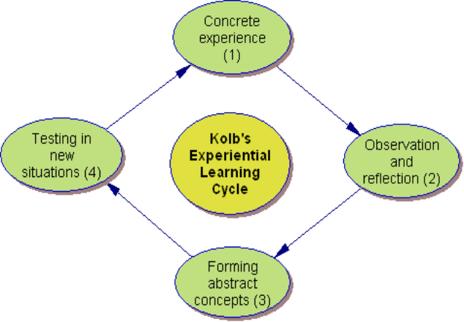Experiential Learning Cycle
Source: Learning-Theories.com
11
© SHRM 2009
Let’s Work Through an Example
• Group process:
> We’re going to work on a project as a group.
> Everyone has some experience with groups – some
more successful than others.
> What kinds of groups have you been a member of? > How did the groups work?
> We’re going to complete an experiential learning
activity.
12
© SHRM 2009
The Experience: Step 1
• In your groups, solve this problem:
> Cut a piece of paper to look like the shape shown on
the next slide.
> There are only two rules:
• You are only allowed to make ONE cut with the scissors and
• It must be a straight cut.
> You have seven minutes to complete the task.
13
© SHRM 2009
The Desired Shape
14
© SHRM 2009
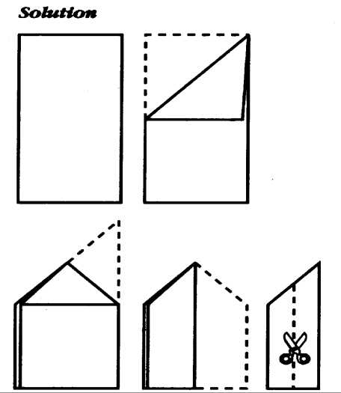The Solution
15
© SHRM 2009
Observation and Reflection: Step 2
• Was the task completed?
• What helped you to achieve the task?
• What got in the way?
• How did your group members work as a team?
16
© SHRM 2009
Forming Abstract Concepts: Step 3
• Draw conclusions.
• What did you learn about teamwork in dealing with this problem?
• What conclusions can you draw about how teams work?
17
© SHRM 2009
Testing in New Situations: Step 4
Now what?
Apply what you’ve learned:
• What would you do differently the next time you work with a team?
• How does what you learned about teams affect how you would facilitate a training session?
• What kind of action planning might be undertaken?
18
© SHRM 2009
Closure
• What were the main messages of the session?
• Any other questions?
19
© SHRM 2009
What Else Do We Know About Learning?
20
© SHRM 2009
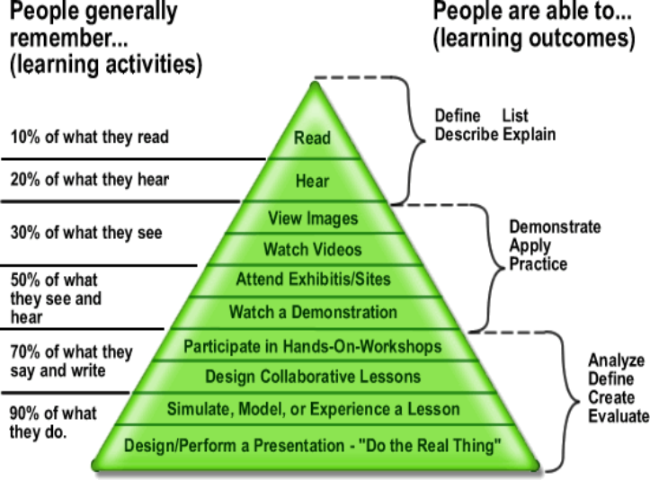Edgar Dale: The Cone of Learning
21
Source: Mesa Community College
•
© SHRM 2009
Advantages and Disadvantages of Training Methods
Method | Pros | Cons
Demonstration | Opportunity to provide feedback. | Does not involve everyone.
Role play | Good practice for participants and involvement. | May be dominated by a few participants.
Lecture | Good for high content if presenter is good. | Passive and not stimulating.
Case study | Good focus and high involvement. | May be dominated by a few participants.
Panel discussion | High content and variety of perspectives. | Low learner involvement.
22
© SHRM 2009
What About Lectures?
• Active lectures gain the learner’s attention.
• To maximize understanding and retention:
> Include an opening summary. > Use examples and analogies. > Include visual backup. > Involve participants. > Reinforce the lecture.
23
© SHRM 2009
What About Activities?
• Activities should have a(n):
> Objective > Method > Format
• Activities should be related to instructional objectives.
24
© SHRM 2009
Pros and Cons of VariousTraining Activities
Method | Pros | Cons
Field trips | Allow for sensory perception. | Needs prior preparation.
Small group tasks | Highly participatory and task oriented. | May be dominated by a few participants.
Video or film | Good focus and pre- designed. May enhance content. | Little participant interaction.
Large group discussion | Highly energizing and high participation. | May be dominated by a few participants.
Fishbowl activities | Develops understanding of concepts and differing perspectives. | Limited active participation in activity.  25
© SHRM 2009
Choosing the Training Method
• What learning outcome do you want to influence?
> Verbal information. > Intellectual skills. > Cognitive strategies. > Attitudes.
> Motor skills.
• What method best facilitates transfer of training?
• What will it cost?
26
© SHRM 2009
Training Methods and Activities
Plan training methods and activities for your training project.
27
© SHRM 2009
Unit #6 – Class #2 – E-Learning and Technology in Training
• Technology in training
• Economic considerations
28
© SHRM 2009
Why Use E-Learning?
• Organizational benefits
> Cost-effective – reduces training costs per employee
• No travel costs for employees
> Information can be readily updated > Easy tracking
• Can generate statistical reports.
– How many employees receive training?
– Who receives training, how often and how are they doing?
– Track return on investment > Can pinpoint training where it is needed
29
© SHRM 2009
Why Use E-Learning?
• Learner benefits:
> Training available 24/7 > No travel or time away from home > More variety in training
> Training can incorporate games, Internet resources
and social networking
> Wider access to resources – not just the trainer
30
© SHRM 2009
E-Learning
• Asynchronous:
> Most responsibility for learning is placed on the
learner.
> Learning available 24/7; any time, any place.
• Synchronous:
> Virtual learning; live and online.
> The learner must participate on a schedule through
message boards, video conference, text-chat or instant polling.
> Still, any place, but not always any time.
31
© SHRM 2009
Technology-Based Training
• Levels of technology-based training:
> Communication. > Online referencing. > Testing assessment. > Computer-based training.
• Asynchronous.
• Synchronous.
> Blended learning. > Expert systems.
32
© SHRM 2009
Features of E-Learning
• Content:
> Text, video, graphics, sound.
• Learner control.
• Collaboration between learners and trainers.
• Link to resources.
• Delivery: web-based or intranet.
• Administrative:
> Tracking and monitoring. > Return on investment.
33
© SHRM 2009
Effective E-Learning
• Organization must provide: > Management support.
> Technology resources and ongoing support.
> Employee time away from work for learning
to occur.
> Employee training in the use of e-learning
technology.
34
© SHRM 2009
Training Design: Which One?
• Traditional classroom.
• E-learning.
• Blended learning.
35
© SHRM 2009

