United States History II.
Name
Institution

United States History II.
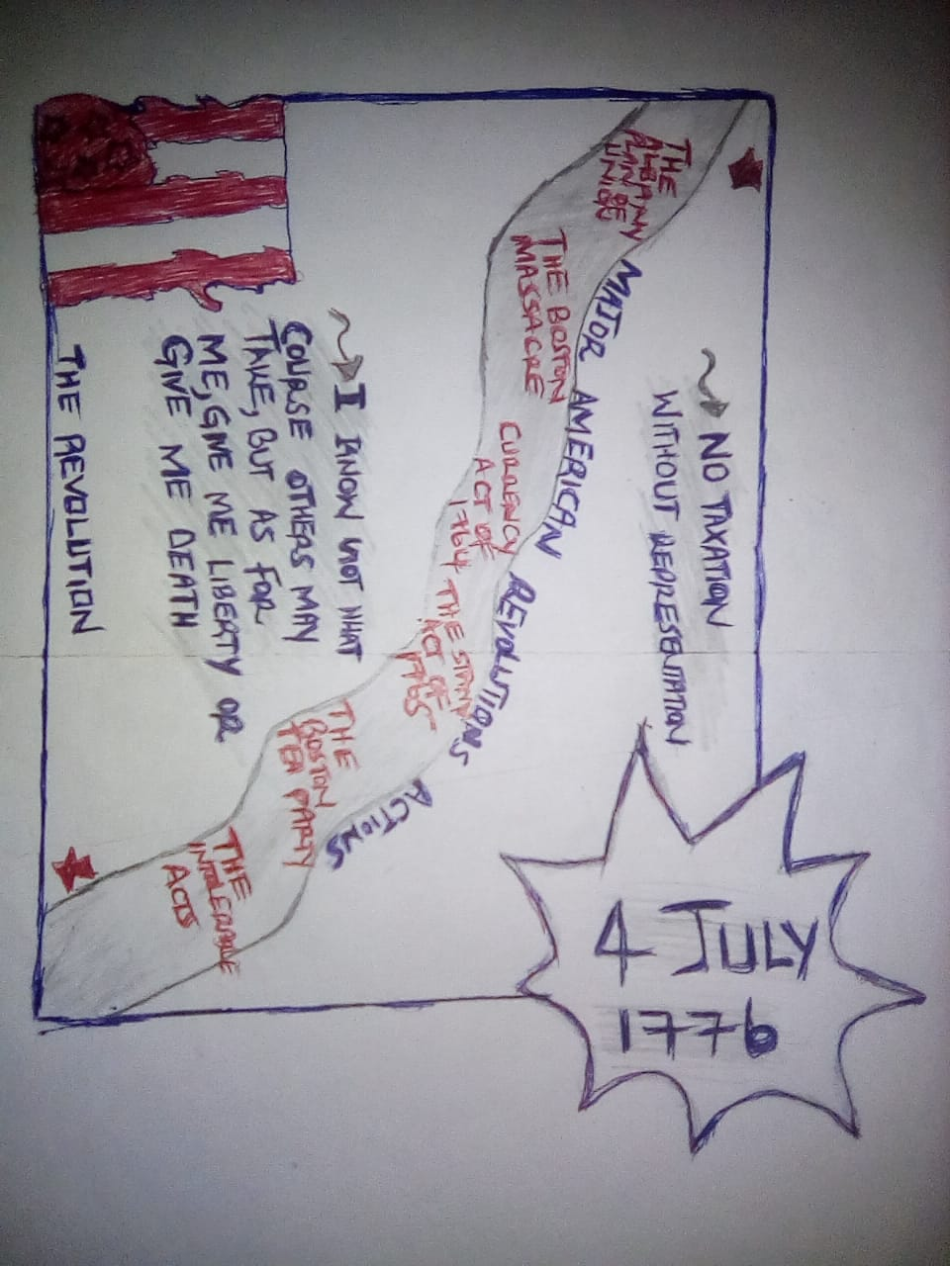
Root cause of American Revolution.

