ONLY PROBLEMS #S 1,2,5,6,8
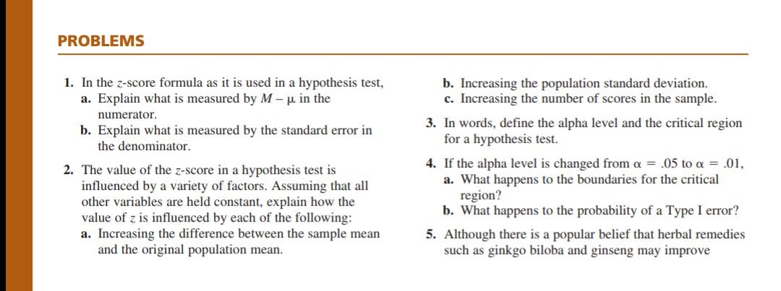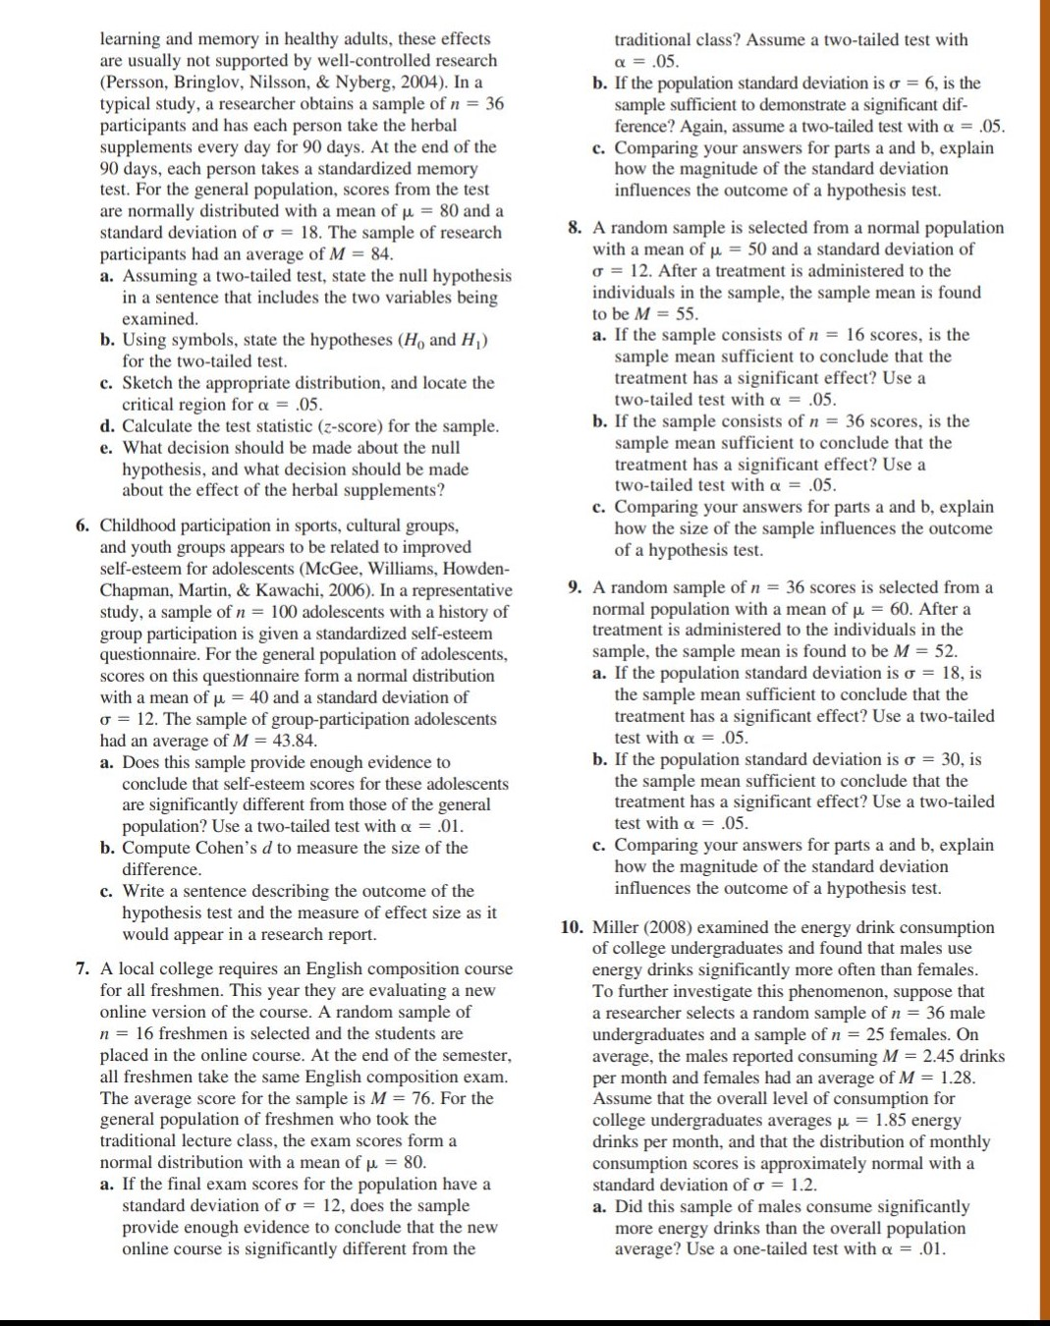
In Addition to the Problems from the book, COMPLETE ALL the problems below.
1) For a two-tailed hypothesis using a z-distribution, find the critical values (z-scores) that will give you a critical region with an alpha of the following values:
a) alpha = 0.20
b) alpha = 0.10
c) alpha = 0.05
d) alpha = 0.01
e) alpha = 0.001

2) For a one-tailed hypothesis using a z-distribution, find the critical value (z-score) that will give you a critical region with an alpha of the following values:
a) alpha = 0.20
b) alpha = 0.10
c) alpha = 0.05
d) alpha = 0.01
e) alpha = 0.001
3) For a two-tailed hypothesis using a z-distribution, determine your decision (reject Ho and accept H1 OR fail to reject Ho) and the type of error you may have committed for the following situation. Be sure to draw out your distribution, indicate your critical region plus the critical values and where each of the following z-scores fall in that distribution.
a) z = -1.97 with an alpha = 0.05
b) z= +2.00 with an alpha = 0.01
c) z = + 1.50 with an alpha of 0.10
d) z = -2.99 with an alpha of 0.001

ALSO MUST COMPLETE ALL THESE PROBLEMS SHOW ALL WORK!!
