For this week's discussion, we'll be looking at generic vs. vernacular architecture. Often times Postmodern architecture is seen as generic or unauthentic expressions of architecture. Pay attention to the order in which we ask that you do things this week.
First, review the presentation about generic architecture vs. vernacular architecture.
Second, select a project from the vernacular precedents given in the presentation.
Third, write the first part of your discussion post - this will be your first impressions of the precedent.
Fourth, watch the ted talk on The Danger of a Single Story and read the two articles from archdaily about vernacular architecture.
Fifth, write the second part of your discussion post - this will be your new perception of the precedent after reviewing the ted talk and the articles. Maybe your perception changed, maybe it didn't. Tell us if it did or did not and why. Please include an image of the precedent you have selected in your post. Your response should total a minimum of 150 words.
Sixth, don't forget to respond to 2 of your peers with a minimum of 50 words.

Presentation:
ARCH.101_(GAUDREAU-WACKER)_PRESENTATION_PROJECT-10_GENERIC VS VERNACULAR.pdf
ted talk:
https://www.ted.com/talks/chimamanda_ngozi_adichie_the_danger_of_a_single_story/transcript
two archdaily articles:
https://www.archdaily.com/155224/vernacular-architecture-and-the-21st-century
https://www.archdaily.com/638933/why-i-created-a-database-to-document-african-vernacular-architecture?ad_medium=widget&ad_name=recommendation

Post 1

The vernacular architecture that stood out to me the most was the reed islands of Lake Titicaca. My first impressions are that I did not know that they still used these building methods in the present day. I would assume that most people learned about these floating cities of Lake Titicaca in history classes about the Spanish conquest of the area. From the records of the time, the western world were surprised of the level of technology and planning of the cities of the time.
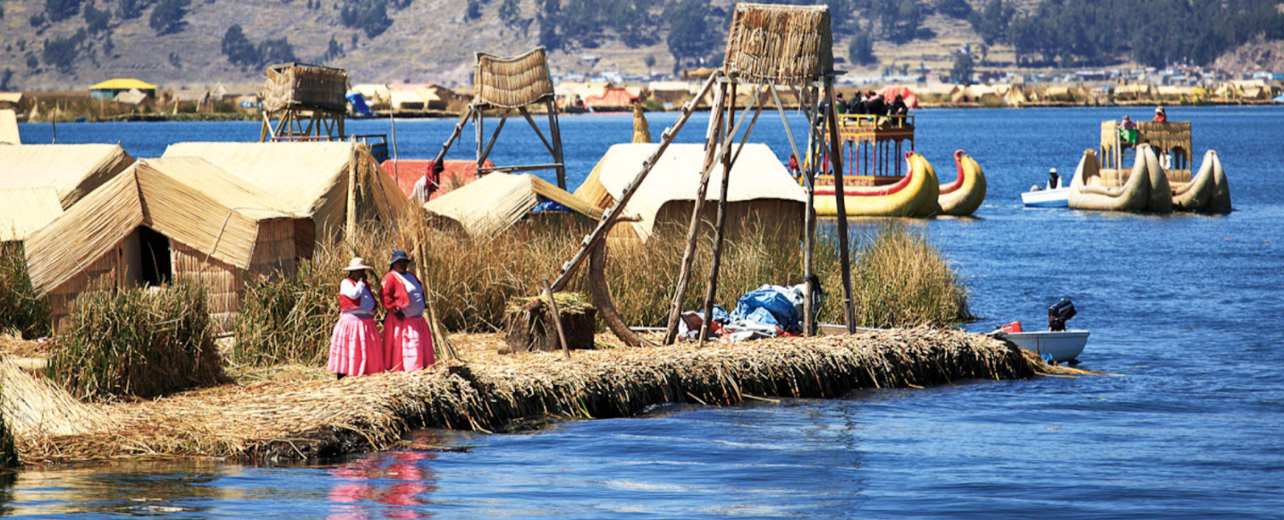
After watching the Ted Talk and reading the articles, my impression about the reed islands of Lake Titicaca changed dramatically. At first I was surprised that they still used the same building methods as centuries ago. But it make sense because their are not many modern architecture styles that are specifically for the floating over water. Instead of Modern building methods, traditional styles of building that have proved to work over the test of time, would be a better fit for the environment of Lake Titicaca.

Post 2

I chose the Lake Titicaca reed islands as my vernacular precedent. My first impression of this is that I am very impressed by the fact that these islands seem to be built by the people. I went to google to look up some more images but did not want to dive in too deep into how the islands are made or if they are natural because I want to keep my first impressions pure. From the photos, it seems as if these are floating islands that the inhabitants build houses on and live on. I find it fascinating that these people use the lake as their permanent residence. They must have a completely different way of life if they spend most of their time on the water.
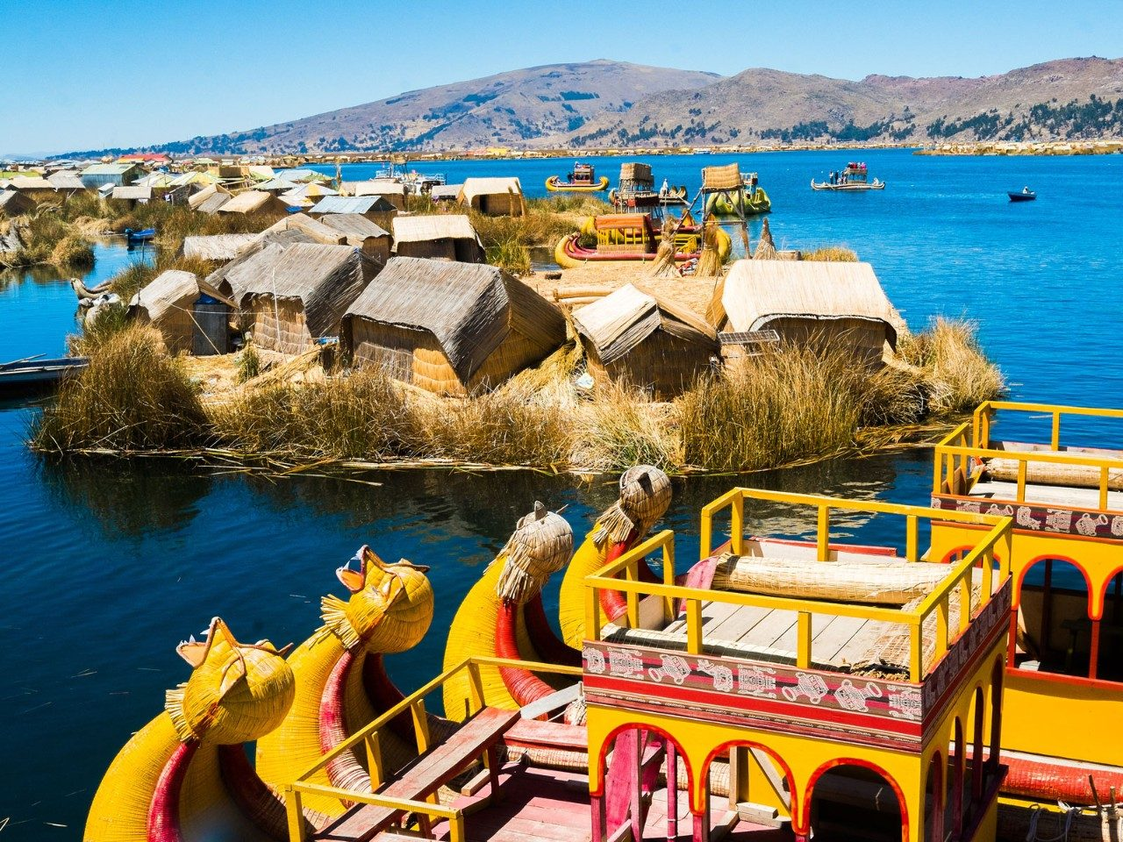
Coming back after listening to the TED Talk and reading the articles. My perception of the vernacular architecture did not change. I realized pretty early in my life about the power of a single story, and I always try to look for and listen to other opinions on different matters. Because of this, I did not see the Lake Titicaca people or their reed islands as anything other than what they were. I just thought about their way of life and what it would be like to live in them. Climate and location often impact what we build and live in, so I think that it is pretty cool that they are able to build these floating reed islands.

