3-4 outside sources required. 1-2 pagesWILL PROVIDE BOOK ACCESS ONCE ASSIGNED

Required text book! Armstrong, Michael. (2020). Armstrong's handbook of strategic human resource management (7th ed.). Kogan Page, Ltd. ISBN: 978 1 78966 172 9.

Prompt: : Select either the Cost Leadership business strategy or the Differentiation business strategy and the Overall HR Strategy of High-Performance Management and argue HOW the HR Strategies of Organizational Development Strategy and the Human Capital Management Strategy are horizontally aligned with the Overall HR Strategy, and argue HOW Overall HR Strategy is vertically aligned with the business strategy selected.

READ BELOW!

Weekly Topic Assignment #3 Lead-in:

Joel Arthur Baker, an American futurist, coined the phrase, “A plan without action is a dream; action without a plan just passes the time.” People are easily distracted performing tasks that are unrelated to an organization’s goals. This includes the implementation of a business strategy.
In chapter 9, Armstrong (2021) covered the implementation of HR strategy. A strategy plan without designed and directed actions is a dream. Implementing of a business strategy requires a partnership between HR managers and line managers (Fulmer & Genson, 2006). HRM develops specific HR strategies, initiatives, and programs that are aligned with functional-level strategies such as Operations, Marketing, Logistics, Finance, and IT. Line managers within the functional staff departments execute the HR strategies, initiatives, and programs designed to develop the performance competencies of employees to perform job-related tasks towards strategic goals. Armstrong (2021) outlined a four-stage model developed by Guest and Bos-Nehles (2013). A more detailed four-stage model is provided below:
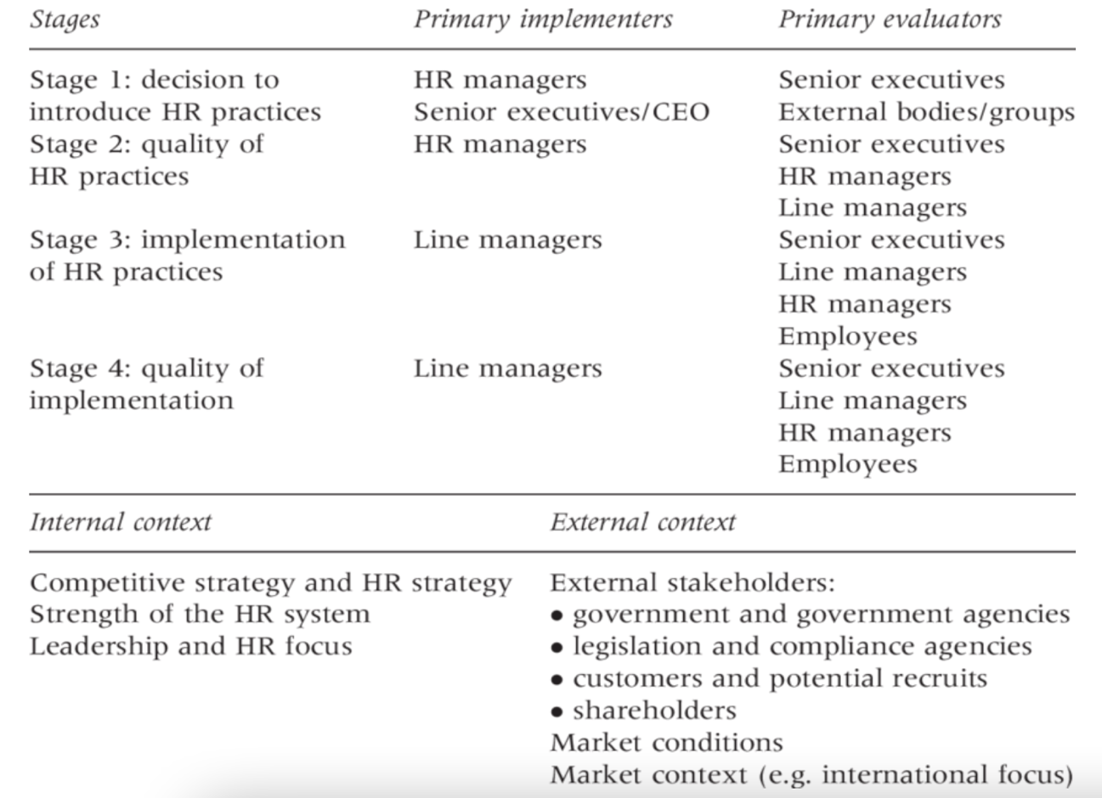

The four-stage model shows that the successful implementing of HR strategies occurs with the partnership of HR Managers and line managers.
In addition, Armstrong (2021) provided six steps within the four stages: Step 1 – Formulate practical strategies; step 2 – Involve line-managers and employees; step 3 – Communicate details of HR strategies to line managers and employees; step 4 – Develop skills to implement the business strategy; step 5 – Monitor and evaluate the effectiveness of HR strategies and make adjustments as needed, and step 6 – Manage the changes in processes and employees’ performance towards the implementation of a business strategy.

In chapter 10, Armstrong (2021) discussed the strategic role of HR professionals. He further discussed the partnership role of HR professionals with line managers. This partnership means that HR professionals and line managers jointly address and solve employees’ performance problems and jointly develop and implement new HR initiatives and programs. The strategic role of HRM has introduced the concept of the strategic business partner (Dyer & Holder, 1988; Tyson, 1985; Ulrich & Lake, 1990).
HRM develops an overall strategy for a business’s strategy and for each of the functional-level strategies. Within an Overall HR Strategy, such as High-Performance Management strategy, HRM develops specific HR strategies, such as a Talent Management Strategy. The role of the strategic business partner provides a critical link between line managers and HRM. This link provides effective two-way communication between the parties charged with implementing a business’s strategy.

Chapters 9 and 10 concluded a discussion of the general aspects of HRM and HR strategy. In summary of chapters 9 and 10, HRM must be seated at the Business Strategic Planning table. Businesses develop a strategy that takes one of two directions. The first strategic direction is called a Cost Leadership Strategy. This strategy focuses on the efficiency of operation and cost reduction programs to provide customers low costs products or services. A business executing a cost leadership strategy achieves a competitive advantage when it provides the lowest cost of operation in the industry. Drivers for a cost leadership strategy are efficiency, size, scale, scope, and cumulative experience of employees (Porter, 2011).
The second strategic direction is called a Differentiation Strategy, sometimes called a Uniqueness Strategy. This strategy focuses on creating products or services that are unique, different, and/or distinctive from rivals that customers prefer. To achieve a competitive advantage with a differentiation strategy a business must develop a culture that promotes innovation and creativity. Drivers for a differentiation strategy are a culture that is responsiveness to existing and emerging customer needs, provide integrity of products and services, provide quality in products and services, design a value chain that affects the internal process, and internal value chain coordination (Porter, 2011).
From a business’s strategic direction, HRM identifies an Overall HR Strategy that is aligned and integrated into a business’s strategy and the functional-level strategies. This Overall HR Strategy builds the base by which specific HR Strategies are developed and implemented through a partnership of HR managers, HR Business Partners, and Line Managers.

Chapters 11 and 12 begin the discussion of specific HR strategies.

Chapter 11, Organization Development Strategy, introduces the first of sixteen specific HR strategies. Strategy creates change. Strategy first changes a business’s structure. Structure changes change workflow processes; workflow processes change the network of jobs. New jobs are created within a network of jobs, current jobs are modified, and obsolete jobs are deleted. To create new jobs and to modify current jobs, HRM and line managers collaborate in conducting job analyses.
The aim of Organizational Development (OD) is to focus on and to improve the effectiveness and productivity of an organization (Cummings & Worley, 2009). The OD process begins with diagnosing and identifying people and structural problems within the organization. This process is a cyclic process that consists of seven stages: 1) Identification of a Problem, 2) Systems diagnostics, 3) Planned intervention, 4) Implement Intervention, 5) monitor implementation and gather data, 6) analyze data against desired results, 7) adjust intervention as needed and provide feedback (Lavoie & Culbert, 1978).
The HR Organization Development Strategy is a strategy developed from the SWOT analysis. The SW stands for internal Strengths and Weaknesses. As stated above, the OD process identifies people and structural problems. From the problem identification, interventions are planned and implemented to address these problems. These OD interventions are integrated into the business strategy, generating changes in people’s behavior to implement the business’s strategy. HRM and Line managers identify what HR initiatives and programs [interventions] address specific business issues and how HR initiatives and programs [interventions] will overcome specific business issues (Armstrong 2021).

Chapter 12 covered Human Capital Strategy (HCMS). Human Capital Management (HCM) emphasizes that a business can achieve a competitive advantage through its employees. Therefore, business leaders devise strategic investing plans that invest in assets that promote employee engagement, promote retention of talent, create opportunities for learning and development. HRM monitors and collects hard data on the direction and value-creation of HR [people] strategies. Data collected is analyzed and provides an evidenced-base management approach for making decisions on employees (Armstrong. 2021).
Human Capital Management Strategy (HCMS), as defined by Nalbantian et al. (2004) is “a blueprint securing, managing, and motivating the workforce needed to support the organization’s strategic goals” (p. 79). This definition reveals the key functions of HRM. The term “Securing” relates to the HRM function of “staffing,” which consists of recruiting and selection activities. The activity of recruiting is linked to the HRM function of HR Planning, which consists of job analysis and workforce forecasting (Mathis et al., 2010). The term “Managing” relates to the collaboration between HRM staff and managers in developing the appropriate management style that encourages employee engagement. Additionally, the term Managing” can be linked management styles such as managers and supervisors adopting the leadership role of job performance coaches (Achi & Sleilati, 2016). Finally, the term “motivating” relates to the collaboration between HRM staff and managers in developing employees’ performance towards strategic goals and providing incentives for both performance development and goal-related performance behavior (Mamdani & Minhaj, 2016).

This is a long lead-in to WTA #3 prompt. However, I thought it important that class members make the connections that the HRM staff, the HR Business Partner, and Line managers collaborate to implement a business’s strategy. The first two HR strategies discussed are the Organizational Development Strategy and the Human Capital Management Strategy. Whether a business chooses a cost leadership strategy or differentiation strategy, both strategies are implemented by people who perform within prescribed workflow processes. Therefore, both strategies require that HRM develop an Organizational Development Strategy and the Human Capital Management Strategy.

Requirements/RUBRIC attached below!!

Unacceptable  0.0 | Inadequate  1.0 to 7.0 | Adequate  8.0 | Proficient  9.0 | Exceptional  10.0 | Pts
WTA Posting Criteria 1. Content Understanding (the comprehension of the content under discussion)
Student did not present an understanding of key concepts or ideas relevant to the topic. | Student presented a partial understanding of key concepts or ideas relevant to the topic. | Student presented an adequate understanding of key concepts or ideas relevant to the topic. | Student presented a clear understanding of key concepts or ideas relevant to the topic. | Student presented an exceptional understanding of key concepts or ideas relevant to the topic.
Response was vague or abstract and the student did not apply key terms. | Response contained several vague or abstract remarks. Student applied few key terms. | Response contained some vague or abstract remarks. Student applied some key terms | Response contained little vague or abstract remarks. Student correctly applied most key terms | Response contained a clear discussion. Student correctly applied all key terms.

WTA Posting Criteria 2. Thesis and Argument (the ability to use the content to argue the issues, concepts, and/or theories.)
No stance thesis sentence was used to guide argument. | An inadequate stance thesis sentence was used to guide an argument. | An adequate stance thesis sentence was used to guide an argument. | A stance thesis sentence was used to guide an argument. | A clearly crafted stance thesis sentence was used to guide an argument.
Student’s response lacked critical thinking in the exploration of topics. | Student’s response contained little critical thinking. Only a surface exploration of the topics. | Student ‘s response contained some critical thinking with some in-depth examination of the topics. | Student’s response contained critical thinking with some in-depth exploration of the topics. | Student’s response contained critical thinking with an in-depth exploration of the topics.
Student did not define or explain key terms, concepts, or theories that supported a position argument. | Student provided few definitions or explanation of key terms, concepts, and/or theories that supported a position argument. | Student defined or explained some key terms, concepts, and/or theories that supported a position argument. | Student defined or clearly explained most key terms, concepts, and/or theories that supported a position argument. | Student defined or clearly explained all key terms, concepts, and/or theories that supported a position argument.
Student did not support claims and/or arguments with evidence. | Student supported few claims and/or arguments with evidence. | Student supported some claims and/or arguments with evidence. | Student supported most claims and arguments with evidence. | Student supported all claims and arguments with evidence.
Student did not use any sources to support claims. | Student cited the textbook or one outside source to support claims. | Student cited the textbook and one outside or two outside sources | Student cited the textbook and two outside sources or three outside sources | Student cited the textbook and three or more or four or more outside sources

WTA Posting Criteria 3. Application of APA Writing Style (7th ed.)
No application of APA writing style. | More than four APA errors. | three to four APA errors. | One to two APA error. | No APA errors.

WTA Writing Criteria 4. Language (English) Conventions and Graduate Level Writing
Response contained numerous syntax errors. | Response contained several syntax errors. | Response contained some syntax errors. | Response contained few syntax errors. | Response contained no syntax errors.
Response contained over six English convention errors. | Response contained five to six English convention errors. | Response contained three to four English convention errors. | Response contained one to two English convention errors. | Response contained no English convention errors.
Response displayed inadequate skills to write at a graduate level. | Student’s response displayed some writing skills at a graduate level. | Student’s response was written to an adequate graduate level. | Student’s response was written at somewhat a graduate level. | Student’s response was written at graduate level.

