Complete all items for Problem 14-47 in the textbook.
To complete all parts of the problems you should prepare an Excel workbook and Word document. Please note, you must show your work in Excel, which includes providing the formulas in the cells, not just the summary value. You may not earn full points if you do not show your work in detail. Provide supporting responses either as part of the Excel document or as a separate Word document (400-750 words), being sure to properly label each response.
At least two external sources should be cited, not including a textbook

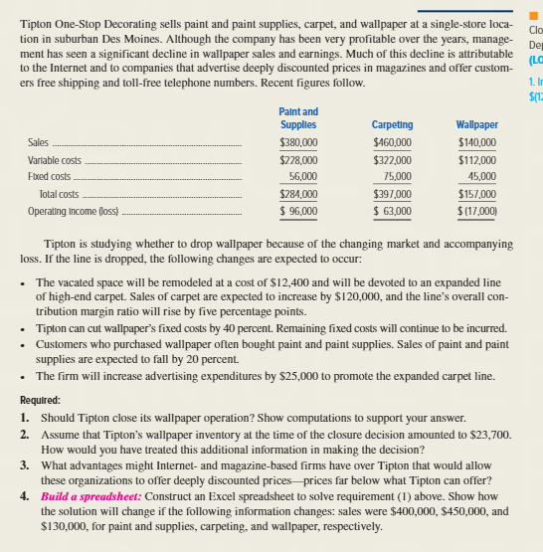

Textbook source
Hilton, R. W. (2016). Managerial accounting: Creating value in a dynamic business environment (11th ed.). New York, NY: McGraw-Hill/Irwin. http://www.gcumedia.com/digital-resources/mcgraw-hill/2016/managerial-accounting_creating-value-in-a-dynamic-business-environment_ebook_11e.php

