Assignment

1. Using Audacity and Praat (and a screen capture program as well as an image editing program), create a pure tone of any frequency you choose. Paste a copy of the waveform for the form below. Then, analyze the tone with Praat and create a frequency spectrum. Past the frequency spectrum below. Be sure to state what the frequency of your tone was and make sure to label your spectrum accordingly. Here is a sample video of how to accomplish this with Audacity and Praat (and the other software I use- yours may be different): https://youtu.be/4S19iylQm-c

Frequency: 500Hz

Waveform:
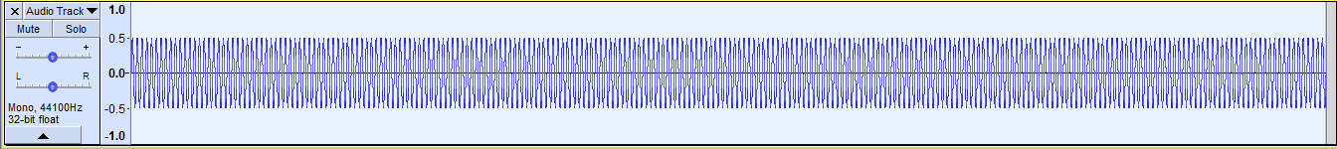

Frequency Spectrum:
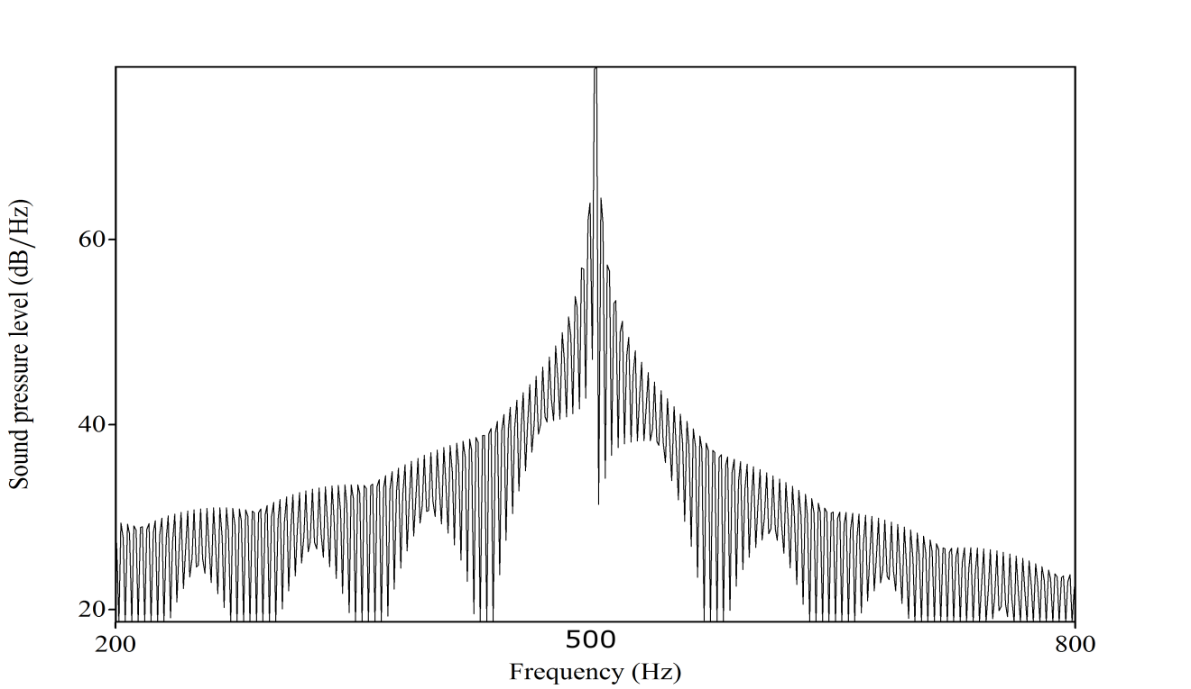
2. Using Audacity and Praat (and other required software), create a complex PERIODIC sound file made up of 8 frequencies (they must share the correct relationship to one another to make the sound periodic!). Provide the component frequencies you chose and show the final waveform by pasting it below. Then, create a frequency spectrum of the sound and paste it below. Be sure to label the spectrum accordingly. Here is a sample of how to create a complex sound in Audacity: https://youtu.be/DfmM0jOxdHU.

Frequencies: 500Hz, 750 Hz, 1000Hz, 1250Hz, 1500Hz, 1750Hz, 2000Hz, 2250Hz

Waveform:

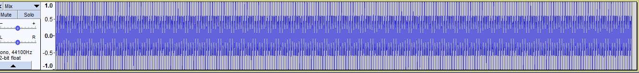

Frequency Spectrum:
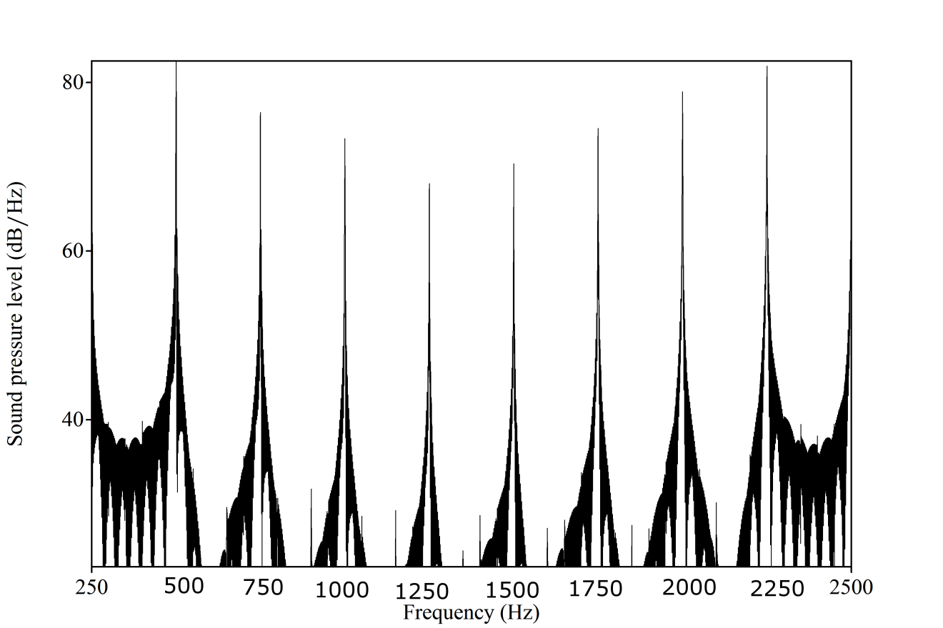

3. Do the same thing, but create an aperiodic sound, waveform and spectrum.

Frequencies: 250Hz, 400 Hz, 450 Hz, 500Hz, 570Hz, 700Hz, 850Hz, 1050Hz

Waveform:
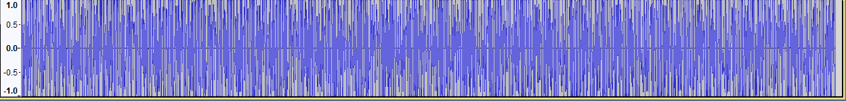

Frequency Spectrum:
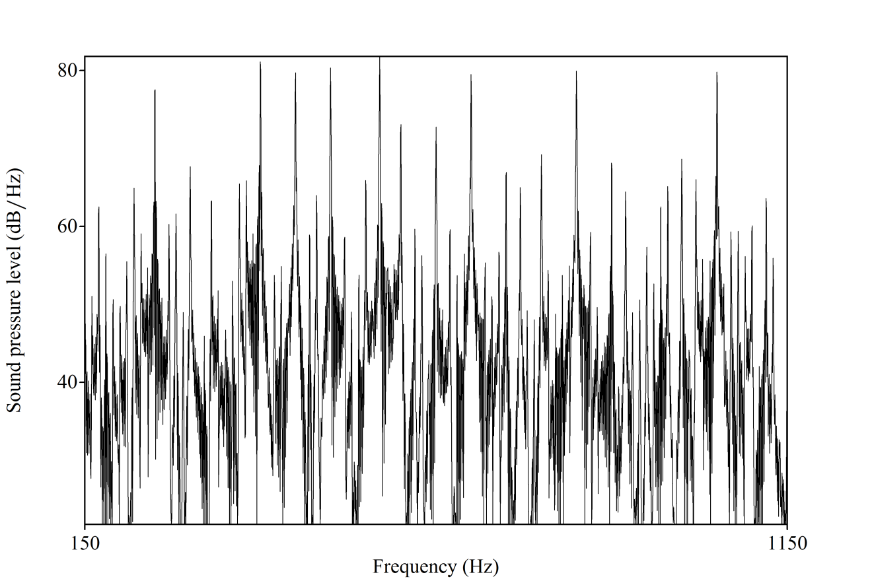

4. For fun, create a triangular wave using any frequencies you would like (they must be correctly related!) and provide the waveform and frequency spectrum.

Frequencies: 150Hz, 450Hz, 750Hz

Waveform:

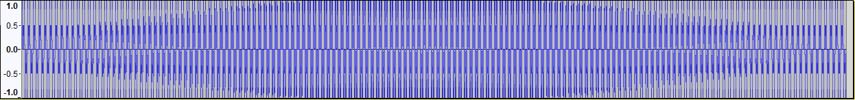

Frequency Spectrum:
