Music Portfolio

Name
Affiliation
Date

MUSIC
- Song selection for singing
Clean up song: by Cocomelon

Clean Up Song | Cocomelon Nursery Rhymes & Kids Songs

- Explain how and when you’d use the song
I would use this song to teach the children how to clean up and the essence of remaining tidy.
First, I’d stream the song for the kids to listen followed by some questions about it. Second, I'd replay it with lyrics and then ask the children to slowly sing the song noting how they pronounce each letter of the alphabets. Finally, I'd ask the whole class to sing along three times.

- Musical Instrument
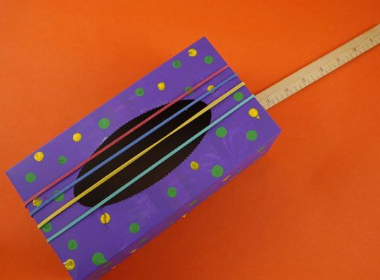
Rubber Band Guitar

Each student needs the following materials to complete the development of the rubber band guitar; box, or small cereal box with an oval hole cut in the front, Poster or acrylic paint, 2 loll sticks, long cardboard tube (for example, from a roll of foil or baking paper, Elastic bands of different sizes and thicknesses, Colored paper.
The steps should be followed as;
Place the end of the cardboard tube up against the tissue box's back and draw around it. Carefully cut out to create a hole. Paint the cardboard and loll sticks and allow them to dry.
Remove any plastic from the tissue box and then open out and lay flat. Paint the inside and allow it to dry. Cut a piece of colored paper and stick it to the base of the tissue box. (This will become the inside of the guitar).
Glue the box back together with the pained side on the outside and allow it to dry. Insert the cardboard tube into the hole you cut at the top, then secure the place with sticky tape.
Finish with decorations of your choice.
LESSON PLAN
Connecting to prior knowledge | Let me commence by narrating the story of the missing king. Raise your hand if you have heard the story of the missing king before. Can anyone tell me what they know about tidiness and hygiene? When I read the story, I will stop and point out the key things to know about cleanliness. After reading this story, I will play you the cleanup song by Cocomelon.
Teaching point | I want to teach you how to demonstrate a cleanup activity. We will use a rubber-band guitar, which we will develop in our classroom today.  Watch as I show you how to develop a rubber-band guitar.
Teach | First, we will watch the cleanup song and follow the moves made by Cocomelon as she makes every cleaning move.  After watching, please look at me make similar moves as I sing the song and play the song using the rubber band guitar we have made.
Active Engagement | Now it is your turn to try out.  Each of you will be part of a group that develops a rubber band guitar, using the skills I have taught you.  You will then choose a leader who presents the cleanup song before the class, playing it audibly, ensuring your rubber band guitar works.
Link check for understanding | We have learned about the cleanup process and the steps and essence of keeping our workplace and living premises clean. We were acquainted with how to put the steps into a simple song for memory purposes.  We were all thrilled by the knowledge of how simple it is to make simple rubber band guitar.  I will choose some students to show us their rubber band guitars and try playing the song the same way your group leaders did.


Local visiting performer: Demi Lovato

Demi Lovato
I chose Demi Lovato as my visiting performer since she is acquainted with children's entertainment and her roots in Texas. Her mother, Dianna De La Garza, is a former Cheerleader of the Dallas Cowboys. Although Demi Lovato did not attend college, her mother coached her Music career as she attended Cross Timbers Middle school. She does dozens of charity work as a Red Cross volunteer as well as fighting for LGBT rights.
I would reach Demi Lovato by calling her manager at (877-503-3645) or bookings@thehandbook.com. I would explain to her manager that Demi Lovato's influence would provide the children with a once-in-a-lifetime experience with a professional musician and actor. Her involvement would inspire the children to pursue their dreams despite how trivial they appear to be. I would also ask her to play the piano for the children and teach them how to transpose between various chords. I would also have the children sing along with her.


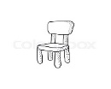
Music center floor plan and center information

RUG

TABLES

MIRROR

BOOKS FOR SINGING

TAMBOURINE

MIRROR

PIANO

TAMBOURINE

WHITE
BOARD

WHITEBOARD

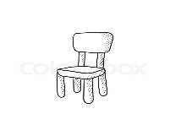
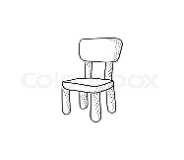
STORAGE

SHAKER STATION

- Rug- This is where the students can assemble and play with different musical instruments.
- Mirror- Here, the students can look at themselves playing various musical instruments.
- Storage- After a music lesson, the musical instruments are packed here.
- Tables- This is where the students sit when studying various music theories.
- Shaker station – This is where the students will learn to assemble a shaker.
- Whiteboard- Guidelines on how to play various instruments will be displayed on the whiteboard.

- Purpose of the center
Through the center, learners will develop confidence from learning to play various musical instruments fluently. The center will also help learners express their feelings and thoughts through music. Besides, the center is an opportunity for learners to use tools rarely present in households.
- Skills I want the students to develop.
Despite the Cleanup song by Cocomelon teaching learners the essence of staying tidy, I want learners to internalize teamwork skills by working in groups. I also wish to boost a learner's confidence by selecting individuals to make presentations before the music class. The learners will also acquire critical thinking and decision-making skills when choosing the melody and amount of energy they put into the singing activity.
- Necessary materials needed for the music center
Pianos, Tambourines, Violins, Drum set, triangles with striker
Mirror, books for singing, chair, movement props, beans, whiteboard, and a radio
- Guidelines and behavior expectations students will follow before the centers open.
Students will observe all school and classroom rules. They must respect each other in the center, each learner playing one instrument at a time and giving others a chance to have a shared experience. Any form of games and running up and down is not entertained in the music center. Books and learning materials must be returned to the storage space after usage. Foodstuff and drinks are not tolerated in the music center.

- Assessment Instrument

- Purpose of the assessment instrument
This tool's primary objective is to determine where the learner's clean up skills lie and whether the lesson has equipped the learner with essential knowledge. It will be accomplished using questions, and points will be awarded depending on how they phrase their answers.

I will assess the learners through a set of written questions.

RUBRIC |  |  |  | BONUS POINTS
Points | 3 | 2 | 1 | 4
All facts were mentioned orally by the learner | All truths from the whiteboard about the cleanup process put in Cocomelon’s song are mentioned. | Five or more facts about the cleanup process set in Cocomelon’s piece are mentioned. | Two or fewer points about the cleanup process put in Cocomelon’s song are mentioned. | If the learner added facts, they read from an article in their vocal response.
Sentence Structure | Each sentence carries a noun/ pronoun, verb, and proper tone. | Each sentence carries a noun/ pronoun and a verb. | Each sentence carries a noun/ pronoun. | If the learner added a metaphor/ simile/ proverb within their response.

