Written Assignment Chapter 2
Question 1: Bar Chart
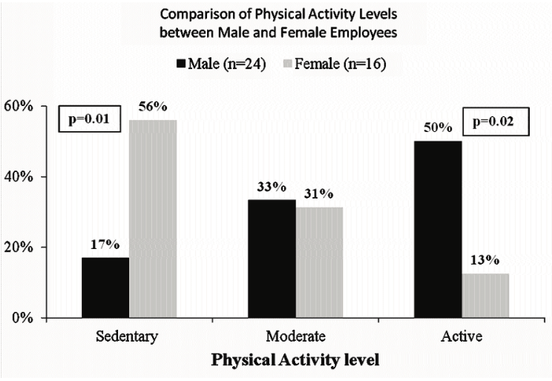
Source: https://www.researchgate.net/figure/Figure-1-Sample-showing-comparison-of-categorical-data-using-Bar-charts_fig1_250918002
- The bar chart has been labelled clearly. For example, the graph has a title and the horizontal axis has been labelled well.
- The width of the bars is similar hence it can be asserted that the graph does not violate the area principle.
- Yes, the accompanying article has profoundly addressed the W’s of the variable.
- Yes. The article has correctly interpreted and discussed the data. Proper conclusions have also been made concerning the data.
Question 2: Length of stay in a hospital for heart attach patients.
- Histogram

- Shape
The above histogram has a positive skewness
- Mean length of stay
8.24
- Standard deviation of length of stay
5.72
- Median length of stay
7
- Maximum Length of stay
38
- Minimum Length of stay
0
- Range
38
- First and third quartile
First quartile=4
Third quartile=11
- Interquartile range
7

