World War I: The U.S. Enters the War
How did key events shift American attitudes about World War I?
Key Events

Wilson's neutrality eventually collapses
When World War I began in 1914 most Americans saw no compelling reason to join a conflict 3,000 miles away. The war did not seem to directly threaten American lives or property. Woodrow Wilson served as president throughout World War I. He was a staunch supporter of American neutrality, but U.S. economic ties with Great Britain and France (Allied Powers) were far stronger than those with Germany, or any of the other Central Powers. In 1917, America’s neutrality and isolationism was challenged by significant events that shifted American attitudes.
Ultimately, Wilson’s decision to join the war euort stemmed from the need to prevent Germany from threatening U.S. shipping, the need to assure that Allied powers could repay their debts to the U.S., and the desire to make the world “safe for democracy.”
Let's review the events that led to that decision.

Key events that led to Word War I, and to the U.S. joining the war euort

Use information from these research sites to describe the events listed below and to analyze the impact of each.
Failure of European Diplomacy Watch movies 1-4. Assassination in Sarajevo
The Sinking of the Lusitania, 1915 Milestones: 1914-1920
The Zimmerman Telegram The U.S. Enters the War

 | Describe the event | Explain the event's significance
June 28, 1914:  Assassination of Archduke Ferdinand | Archduke Ferdinand was assassinated by Gavrilo Princip, a Yugoslavian. Ferdinand and his wife Sophie were shot long Appel Quay on his way from Town Hall. Initially, Ferdinand escaped on his way to Town Hall after bomb hurled at his motor failed to detonate is his car, instead, killing the occupants of the adjacent car. The assignation of Ferdinand was a calculated move that involve the town authorities considering they did not provide adequate security during his visit. | The assassination pf Archduke Ferdinand spark tension between Serbia and Austro-Hungarian border. The tension resulted in actual conflict the following day when Austro-Hungarian soldiers fired at Serbian reservists. Emperor Franz-Joseph of Austro-Hungary declared war against Serbia and mobilized its troops. Serbia and Austro-Hungary allies like Russia and Great Powers too marshaled their troops in response.
August 4, 1914: Great Britain Declares War on Germany | The Great Britain Prime Minister Herbert Asquith declared war against Germany after the latter failed to obey the ultimatum to vacate occupied Germany by midnight if August 3, 1994. Germany invaded Belgium to protect itself from getting surrounded by Russia and France. On the other hand, Great Britain view the move as a threat from the Germany. | The move by Great Britain to declare war against Germany was the actual beginning of the World War one. Great Britain and Germany had significant influence, both military and economic wise, making the declaration the first open conflict between major powers at the time. It further opened the war to other major players considering the two nations had pact with their allies to support them during war.
May 7, 1915:  Sinking of the Lusitania | Lusitania was a British ship owned by Cunard Line and was one of the biggest ships in transatlantic trade. The Germany sank the ship near the shows of Ireland on its way back to Liverpool from New York City. The German authorities defended their action since the ship had close to 173 metric tons of shells and ammunition. | The sinking of Lusitania played a critical role in the war by changing the U.S position from passive to active participant. The U.S. pointed out the use of submarines by Germany as justification to enter the war. Besides, it needed to protect the transatlantic route for its trades.
January 19, 1917: Zimmerman Telegram Intercepted by Britain | The interception of Zimmerman telegram from Germany to Mexico by British intelligence revealed the plan to solicit support from Mexico. The Germans wanted Mexicans to engage the U.S.in order to take Arizona, Texas, and New Mexico in case they got involved in the World war 1. | The interception resulted in outrage in the U.S and increased pressure for the declaration of war against Germany. Further, it cements the U.S position to support Great Britain and its allies instead of maintaining neutrality.
April 6, 1917: United States Declares War on Germany | The U.S. declared war against Germany on April 6, 1917 in response to the threats from Germany and its allies. The Senate and Congress approved the declaration of war by President Woodrow Wilson. In Senate, the motion was passed by 82 to 6 whereas Congress had 373 to 50. The Congress passed the motion at 3.00 a.m. and by 1.11 p.m. the president assented to it making official declaration. | The declaration of war meant that the U.S. would actively engage in the conflict. The declaration text described Germany as it foe in the conflict meaning the country sided with Great Britain and its allies to defeat the advancing Germans. The U.S. involvement in the war changed the course of the conflict to the advantage of Great Britain its allies. Its superior weapons and resources were essential in supporting its ally’s troops both in water and on land.

Changing Attitudes

Understanding the shift in attitudes toward war
Analyze the various messages communicated in the following speech and propaganda posters.

- In the article "War Is 'a Blessing, Not a Curse'," what precedents in American history are cited for the United States joining the war?

“War is a Blessing, Not a Curse” captures various incidents in the American history to justify going to war with Germany. Firstly, it cites the civil war that almost split the country into two between the North and South. Secondly, it cites the previous conflict between the US and Britain when the authors talk of “a century and forty years ago.”
- What does Senator Norris mean when he says, "It is now demanded that the American citizens shall be used as insurance policies to guarantee the safe
delivery of munitions of war..."? How does he suggest the U.S. could have avoided entry into the war?
The U.S. at the time was a major global power and had significant control over the transatlantic trade. Besides, it was neutral participant in the early years of the conflict and no country would attack a ship knowing it had US citizens. Every party in the conflict new they would face the wrath of the US if they attacked its citizens. In other words, the U.S citizens in the ships acted as “protection” for ships carrying ammunitions since the Germans would not attack them due to the risk of killing US citizens. Norris argued that not using U.S citizens as insurance policy would have prevented the country from engaging in the conflict since the declarations of war zones contravened international law.

Take a look at a few of the propaganda posters used during World War I and analyze their meaning.

 | Describe the poster's message. | Discuss the emotions conveyed and the desired impact.
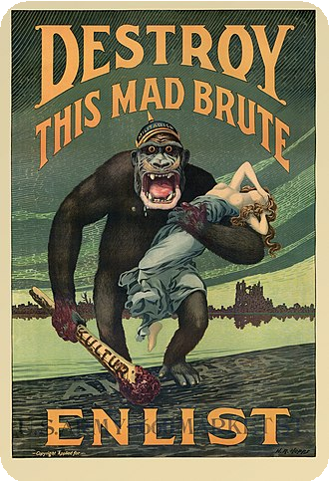  "Destroy this mad brute" context | The poster portray an image of gorilla carrying a helpless rabbit and bloody club. The image is caption “destroy this mad brute.” | The poster was designed to cause public anger against the Germans and portray them as brutal people with only intention to kill. Besides, the use of primate in the poster was deliberate attempt to dehumanize the Germans and gain public support.
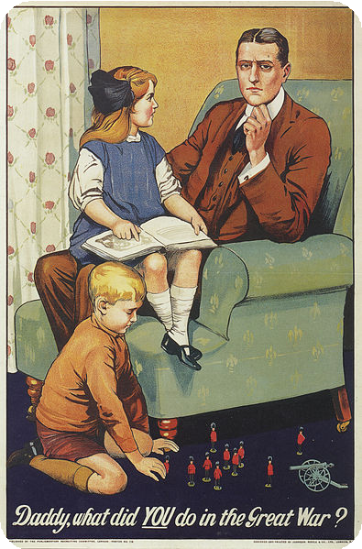  "Daddy,  what did you do in the Great War?" context | The poster shows father with his two children. The daughters are asking his contribution in the Great War. | The poster was designed to portray the support for World War 1 as personal responsibility. The poster was to make every citizen feel he or she is responsible for supporting and participating in the war for the future of their children.
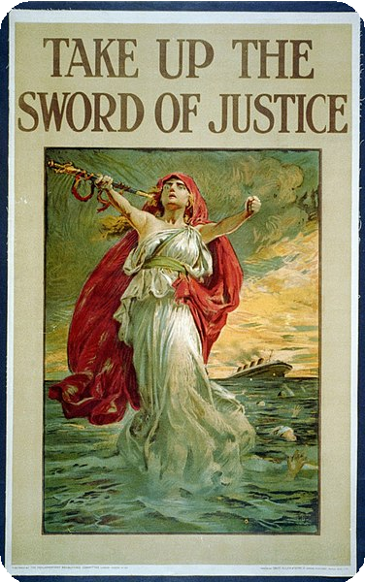  "Sword of Justice"  context | The portrait indicates a lady carrying a sword with caption “take up sword of justice.” The lady is in white robe with red hair. | It was designed to change the image of the conflict. It depicted the war as quest for justice rather than oppressing the weak. As a result, the public would endorse the declaration.

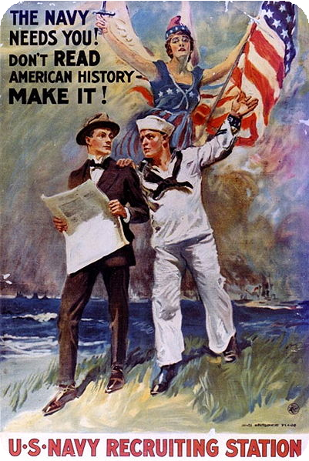  "The Navy needs you!"  context | The portrait has a U.S navy with a civilian wearing suit and another holding a flag. It is captioned “The Navy needs you.” | It was intended to marshal support for the U.S. navy involved in the war. The image was designed to portray the war as patriotic responsibility among all Americans.
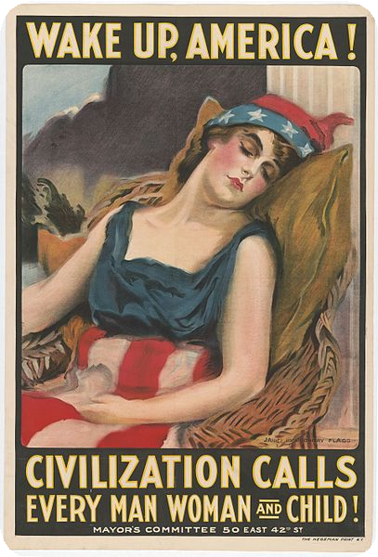  "Wake up, America!"  context | The image depicts a sleeping lady with caption” wake up America, Civilization calls every man, woman, and child. Also, the lady is donning American flag as skirt. | The image was designed to persuade the public to rise up and defend their nation and civilization. The sleeping lady represents people still reluctant to support the war whereas the caption depicts it as individual responsibility.

