Part A
Task 1
This assignment looks at how to plan a data flow diagram and specifically at the questions addressing the processes and how data flows in the store. The business scenario provided for this assignment includes a transaction processing system and a data store for storing customer information and genres of books they rent. The following is a list of all system requirements of the Hill Book-store system.

External Entities | Processes | Data Stores
Customers | Register for Membership | Business Databases (where transactions are recorded and where customer records are kept)
Hill Book-Store | Enter Username and Password to login
 | Provide Credit card details to complete the registration
 | Search for books one wants to rent
 | Transaction Processed
 | Record books rented
 | Generate Monthly reports

Task 2: Context Diagram
Context diagram is used to give an overview of an entire system. In a context diagram there is only one circle process that represents the entire system. The purpose of this diagram is to display the expecting inputs and outputs from the system to and from various external entities. Through this display, a system analyst can model what expected data is going to go into the system, then after it has been processed by the system, what information will be returning to the external entities.

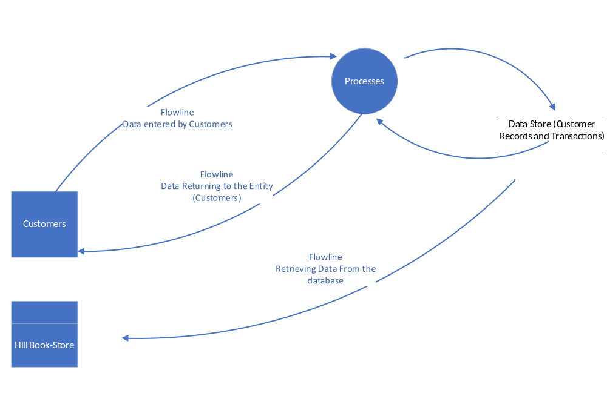
Figure 1: Context Diagram
Task 3: Level 0 Data Flow Diagram

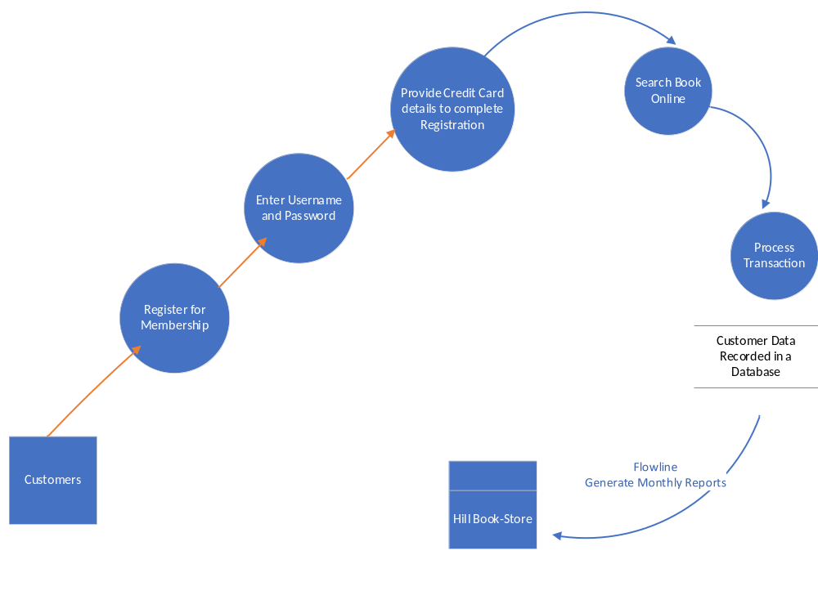

Task 4: Decision Table
The decision table is to decide whether to accept or reject a customer’s login or to reject card verification if the customer provides wrong details. There are three conditions:
- Login customers to the client database
- Access/Rent the book
The associated action depending on the combination of the conditions is either to login the customer or fail if wrong username and password are entered. The other action is to accept an order to rent the book if the credit card has enough money to pay for the book or reject the order if the credit card does not have enough money to complete the transaction.
If the system finds identical entries it should accept data input entered by the customer in the system. For example,
Conditions | Rule 1 | Rule 2
Username and Password Given | T | F
Payment Processed | T | F
Actions
Error Wrong Username Or Password | T | F
Payment Declined | T | F

Part B
Task 1: Entity Relationship for the Hill Book-Store System
Entity Relationship Diagram is a graphical representation of the data requirements for a database. There are several parts of an ERD, which include: entities, attributes, primary keys, relationships and cardinality. The following is an entity relationship diagram for Hill-Book Store. It is demonstrating various attributes, primary keys, entity name as well as the relationship.
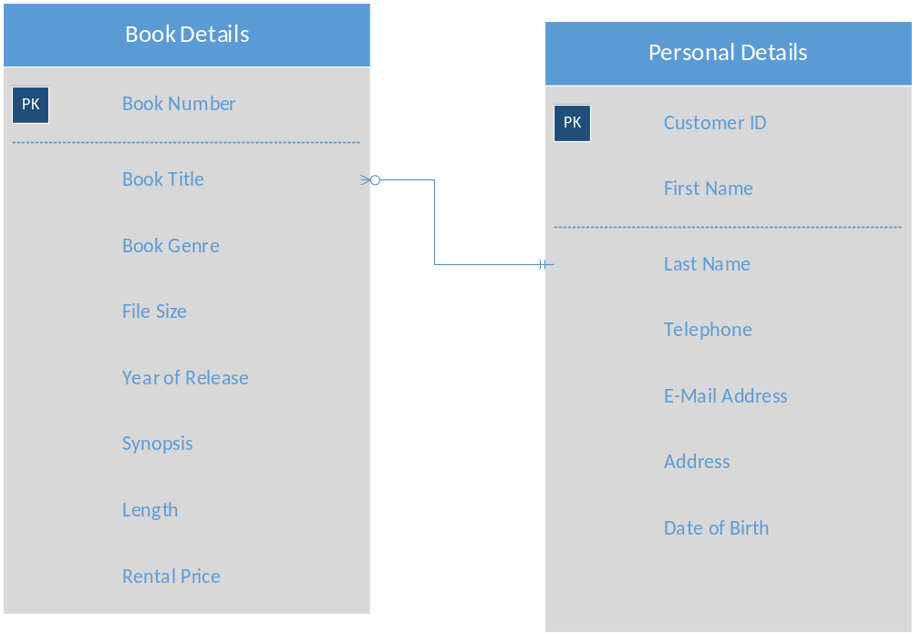
Task 2: Data Dictionary
The following is a comprehensive record of every field in the database. A data dictionary is a tool for recording, coordinating, and processing data the organization uses. In other words, data dictionary is a catalog for metadata.
Element Description
Data element name
Alias | Customer No/ID
Type | Text
Length | 8 Characters
Default Value | Default or Null Value
Acceptable Value | Username and Password
Description and Comments | Customer must provide username and password to login

