Economics ASSIGNMENT
Student’s Name
Course Title
Institution Affiliation

Question 1
- Price elasticity-low income patients-(-0.3)
Other income patients-(-0.05)
100%+10%=110%
110/100*(-0.3)
1.1*(-0.3)
=-0.33%
Low income patients=-0.33%
110/100*(-0.05)
1.1*(-0.05)
=-0.055%
Other income patients=-0.055%
Impact:
Level of income elasticity often change according to the type of products consumers mostly consume, in a situation where a commodity is a primary want, demand becomes less responsive to change in income. In this case, the change will result to elasticity being less than zero (negative)
Original price (low income patients) =$10
Original price (high income patients) =$30
100,000*10=1,000,000
110/100*10=11
100,000*11=1,100,000
200,000*30=6.000,000
200,000*33=6,600,000
Impact:
It can, therefore, be concluded that in a case where a product has inelastic demand, the government taxes it more than other products, this results in tax transfer to consumers who often feel the impact when purchasing products at high prices. In a case like this, production cost is never affected, hence, the government collects more revenue from the product. In our case, there will be an increase in revenue of the pharmaceutical product in high-income patients by $ 600, 000, this comes from an increase from the previous $ 600 000 to 6,600,000
Question 2
- The features of flu vaccine that impose it to externalities are: flu is a highly contagious disease which can largely affect a huge number of people if not properly handled therefore needing government intervention and regulation. Besides, the vaccination could contain side effects to consumers thus posing a negative externality to consumers. Furthermore, market forces and need for the vaccination might need regulation so as to cause market failures in the aspect of overcharging customers.
- (i) The government regulation in the flu vaccination to achieve efficiency posses positive externalities. In the market scenario with several consumers, the individual demands are culminated together to give the marginal private benefits since it measures and evaluats the benefits received by the consumers who purchased the flu vaccine in particular. Besides, market consumption provides incentives for discovering new technology this enticing firms generate higher returns to scales.
(ii) Due to the flu vaccine, there is creation of production externalities. For instance, pollution and depletion of natural resources, the production firm might generate unwanted costs of replacements and replenishments.

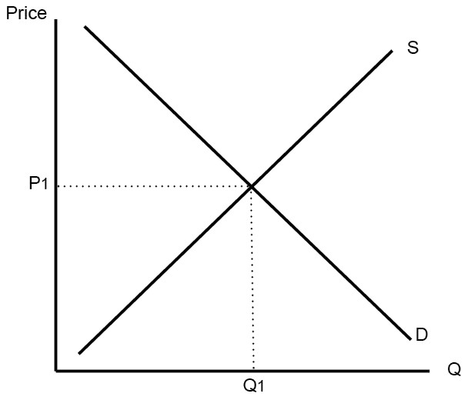
Whenever there is no government intervention, imposition of an externality causes production and the consumption level of the vaccination to cause third parties to incur unplanned expenditures. Besides, the equilibrium that is meant to bring the real balance between the buyers benefits and production costs cause market failures.
Question 3
Qty produced | Fixed cost | Variable cost | Total cost | Average total cost | Average variable cost | Marginal cost | Marginal revenue | Total revenue | Profit
0 | 25 | 0 | 25 | 0 | 0 | 0 | 0 | 0 | -25
1 | 25 | 35 | 60 | 60 | 35 | 25 | 25 | 40 | -20
2 | 25 | 60 | 85 | 42.5 | 30 | 12.5 | 25 | 80 | -5
3 | 25 | 80 | 105 | 35 | 26.7 | 8.3 | 24.9 | 120 | 15
4 | 25 | 95 | 120 | 30 | 23.8 | 6.2 | 24.8 | 160 | 40
5 | 25 | 105 | 130 | 50 | 21 | 29 | 45 | 200 | 70
6 | 25 | 125 | 150 | 25 | 20.8 | 4.2 | 25.2 | 240 | 90
7 | 25 | 155 | 180 | 25.7 | 22.1 | 3.6 | 25.2 | 280 | 100
8 | 25 | 186 | 211 | 26.4 | 23.2 | 3.2 | 25.6 | 320 | 109
9 | 25 | 225 | 250 | 27.8 | 25 | 2.8 | 32.4 | 360 | 110
10 | 25 | 280 | 305 | 30.5 | 28 | 2.5 | 25 | 400 | 95

(b) The marginal costs above depict the above pattern due to the essence of decreasing returns to scale. The marginal cost reduces with time with the introduction of new producer inputs and will increase only with the rise in consumption level.
(c) The firm will make profits where p=MR=MC. For this case MR=MC=p=25. Therefore, it means that the firm will make profits when the market price is $25 but at $40 the price will be high meaning that the MC>MR and hence there will be losses.
Question 4
Qd=500-5p
Qs=50+10p
- To find equilibrium price we have to find p.
The market is at equilibrium when demand function equals the supply function
That is Qd=Qs, so we will equate the two equations
500-5p=50+10p
500-50=10p+5p
450=15p
P=30
Equilibrium price=30 units

Equilibrium quantity
500-5(30)
500-150
=350
Equilibrium quantity=350 units

iii) The equilibrium point is the efficient point of consumption and production because it is the point where the quantity demanded equals quantity supplied.
Question 5
- Supplier induced demand is a market situation whereby there is no uniformity or homogeneity of information between consumers and producers (suppliers) and hence the producer can decide to use the superior information they enjoy to encourage consumers to demand for a service or good that they supply higher than the equilibrium level eventually leading to a welfare loss scenario.

S1
P
S2

P3
P1
Price
D3
P2
Quantity
Q

Q2
Q1
0
D2
D1

The deadweight losses are the shaded areas showing both the consumer surplus and producer surplus.
Producer Surplus
Consumer Surplus

Quality
DEMAND
SUPPLY
500=Q_{D}

