

Spring 2021

Calculations Worksheet

THIS DATA WILL BE USED FOR ALL THREE QUESTIONS IN THE DATA SECTION. You
may print and use this page as a worksheet or create your own. Some questions in the Multiple Choice/Short Answer section will refer to your work here.

A student is working on her thesis. She turns to you for help in analyzing her data. She is looking at the relationship between sensation seeking (a need or desire for excitement in one's life) and number of verbal arguments people report having in the last month. Sensation seeking is measured with a pen-and-paper instrument, and high sensation seeking scores indicating more need for excitement. The data are presented below.

NUMBER OF ARGUMENTS | SENSATION SEEKING
7 | 9
8 | 20
6 | 8
8 | 22
14 | 22
12 | 26
10 | 27
10 | 27

- Answer the questions below fully and completely on separate pages.
- Label and number each.
- Upload the images or pdfs to Blackboard. Submit all work, including all calculations.

DS1. Correlation (24 points)

DS1a. Calculate the correlation coefficient that describes the relationship between number of verbal arguments and sensation seeking score from the data presented above. (16 pts)

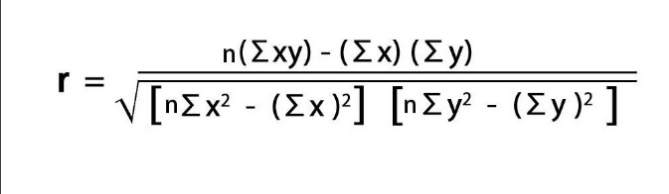

X | Y | XY | X² | Y²
7 | 9 | 63 | 49 | 81
8 | 20 | 160 | 64 | 400
6 | 8 | 48 | 36 | 64
8 | 22 | 176 | 64 | 484
14 | 22 | 308 | 196 | 484
12 | 26 | 312 | 144 | 676
10 | 27 | 270 | 100 | 729
10 | 27 | 270 | 100 | 729
∑X = 75 | ∑Y = 161 | ∑​​​​​​​XY = 1607 | ∑​​​​​​​X² = 753 | ∑​​​​​​​Y² = 3647

r = $\frac{8*1607- 75*161}{\sqrt{(8*753-{75}^{2})(8*3647- {161}^{2})}}$

= $\frac{781}{\sqrt{1298745}}$

= $\frac{781}{1139.624938}$

= 0.6853

DS1b. What does this correlation tell you about the relationship? Interpret the correlation fully. (4 pts)

The correlation coefficient (r) is positive implying there is a positive correlation between Number of arguments and Sensation seeking. As the Number of arguments increases, Sensation seeking increases.
The correlation coefficient (r) is close to 1 implies the correlation between Number of arguments and Sensation seeking is strong
Thus, the correlation suggests there is strong positive linear relationship between Number of arguments and Sensation seeking.

DS1c. What proportion of variability in sensation seeking is accounted for by the relationship with the number of verbal arguments? (4 pts)

R-squared gives the proportion of variability in the dependent variable (Sensation seeking) that is accounted for by the independent variable (Number of arguments)

R² = ${0.6853}^{2}$
= 0.4697

Thus 46.97% of variability in Sensation seeking can be explained by Number of arguments.

DS2. Significance of a Correlation (20 points)

DS2a. Perform a hypothesis test to determine if the correlation you calculated in 1A is significant. Use .05 as the level of significance. Show all four steps of hypothesis testing. (16 points)

Hypotheses:

Null hypothesis: The population correlation is zero

H_{o} : ρ = 0
Alternative hypothesis: The population correlation is not zero
H_{a} : ρ ≠ 0

Significance level: α = 0.05

Test statistic:

t = $\frac{0.6853*\sqrt{8-2}}{\sqrt{1- {0.6853}^{2}}}$

= 2.305

P-value:

df = 8 – 2 = 6

p = P(|t| > 2.305)

= 0.0607

Conclusion:

Since the P-value (0.0607) is greater than the Significance Level (0.05), we fail to reject the null hypothesis. Therefore, based on the sample correlation provided, it is concluded that there is not enough evidence to claim that the population correlation ρ is different than 0, at the α=0.05 significance level.

DS2b. Which is possible for your decision and conclusion for this hypothesis test, a Type 1 or a Type 2 Error? (4 points)

Type 2 Error: Failure to reject a false null hypothesis
Since we did not reject the Null Hypothesis in our Hypothesis test, a Type 2 Error is a Possibility.

DS3. Regression (20 points)

DS3a. Construct a prediction equation that will allow you to predict the sensation seeking score from knowing the number of verbal arguments. Note: Pay close attention to which variable is the predictor. (8 points)

ŷ = bX + a
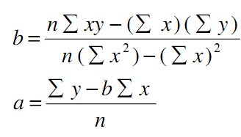

b = $\frac{8*1607-75*161}{8*753-{75}^{2}}$

= $\frac{781}{399}$

= 1.957

a = $\frac{161-1.957*75}{8}$

= 1.774

Regression equation: ŷ = 1.957X + 1.774

DS3b. What sensation seeking score can be expected from a person who has 7 verbal arguments? (3 pts)

Taking X = 7
ŷ = 1.957* 7 + 1.774

= 15.5

DS3c. Is the prediction you made in 3b a valid prediction? WHY or WHY NOT? (3 pts)

This is a valid prediction, Because the prediction value lies in the given data.

DS3d. What sensation seeking score can be expected from a person who has 15 verbal arguments? (3 pts)

Taking X = 15
ŷ = 1.957* 15 + 1.774

= 31.1

DS3e. Is the prediction you made in 3d a valid prediction? WHY or WHY NOT? (3 pts)

This is not a valid prediction, Because the prediction value lies outside the given data.

